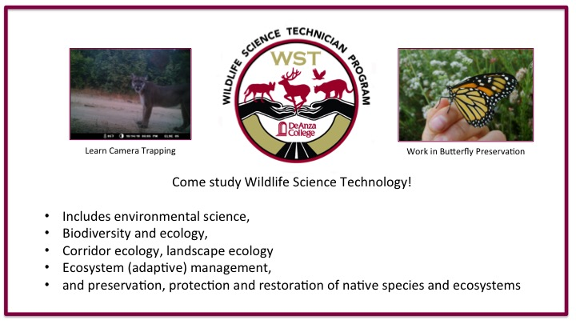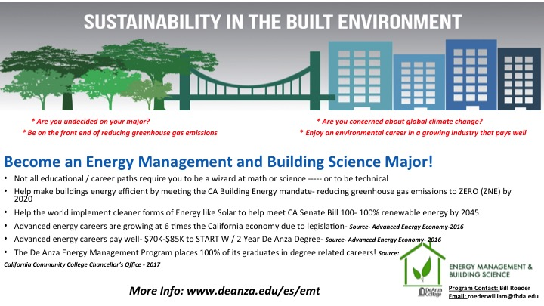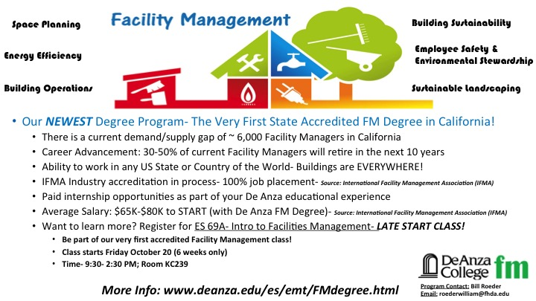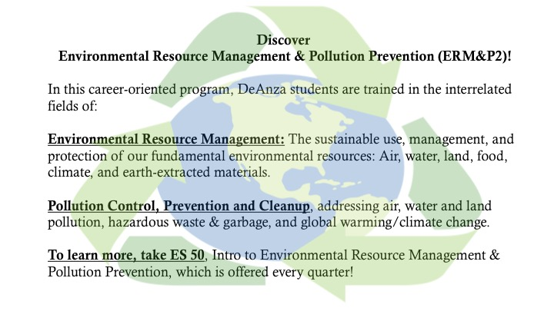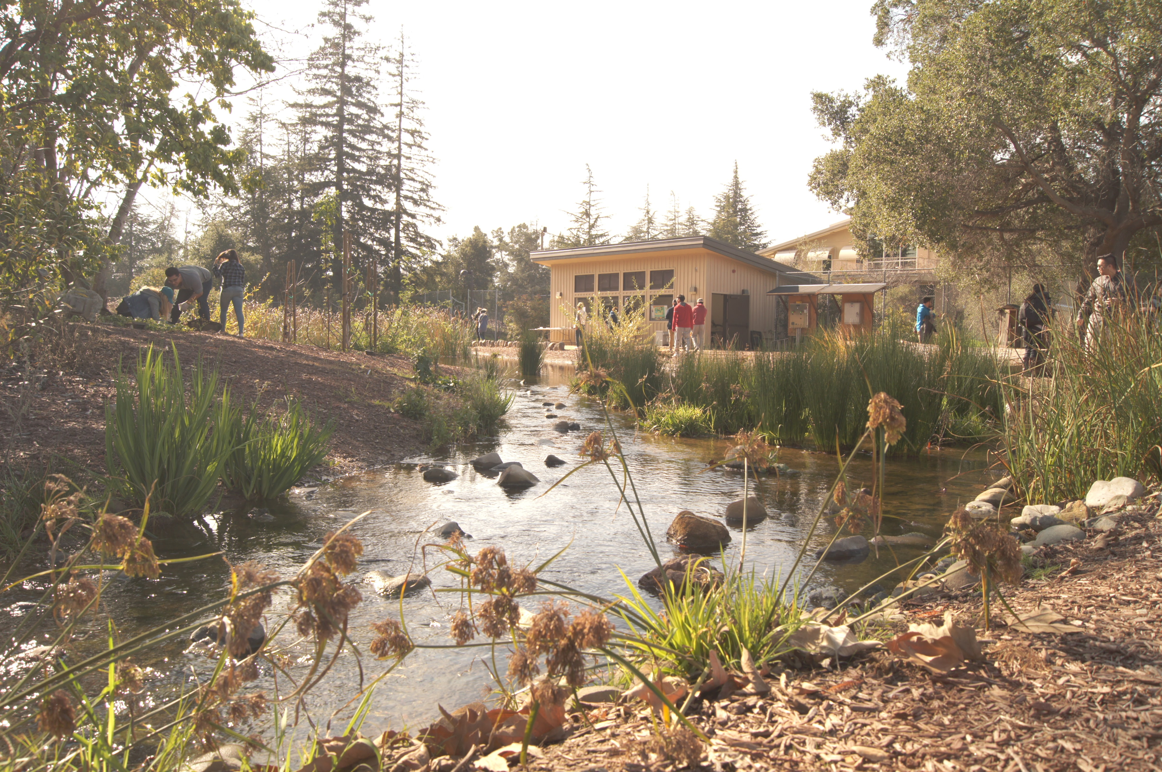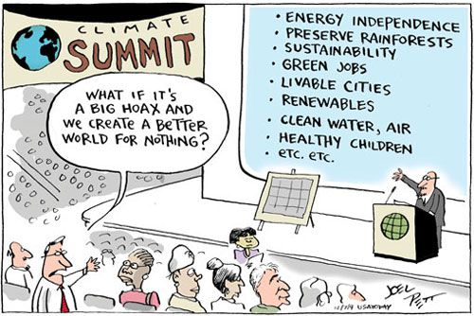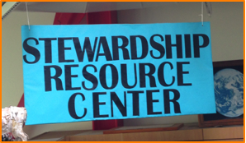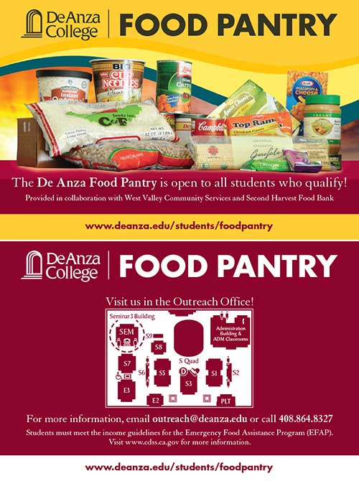

**Welcome to the**

**Kirsch Center for Environmental Studies**



**#Kirsch\_Center**

##### [**GE & Transfer Courses in ES & ESCI**](https://www.deanza.edu/es/gecourses.html)

##### [**Energy Management and Building Science**](https://www.deanza.edu/es/emt/BH_CertDeg_1617-1-2.pdf)

* **[Environmental Resource Management and Pollution Prevention](https://www.deanza.edu/es/pdf/es_environ_resource_mgmt_2016-17.pdf" \o "Environmental Resource Management and Pollution Prevention Degree and Certificate Spec Sheet" \t "_blank)**
* **[Facility and Sustainable Building Management](https://www.deanza.edu/es/Facility%20and%20Sustainable%20Building%20Management%20Degree_2017_2018.pdf" \o "FSBM Degree" \t "_blank)**
* **[Wildlife Science Technician](https://www.deanza.edu/es/pdf/es_wildlife_science_2016-17.pdf" \o "Wildlife Corridor Technician Degree and Certificate Spec Sheet" \t "_blank)**

## Our Paths of Study include:

# We’re in this together…

The current sociopolitical dynamic nationally and globally has created a stronger need for us to have cohesive community around many issues, particularly in environmental areas. Now, more than ever we need to understand the outfall of policy decisions on the environment and society. We at the Kirsch Center, fellow students, faculty, and staff are committed to assisting you to obtain a better understanding of the importance of environmental knowledge. Come learn alongside us, either through one of our major areas, vocational trainings, or GE and transferrable courses.

Together we can create positive change!

~Alicia De Toro,

Morgan Family Chair for Environmental Studies

Fall 2017

**De Anza Supports DACA students!**

Visit: http://www.deanza.edu/students/undoc-students.html

for more information.



**Keep current!**

**Visit De Anza Civics Watch:**

<http://www.deanza.edu/civicswatch/>

For information on civil rights, the environment, and economic policy

##### Suspendisse sed leo eget dolor venenatis rhoncus. Vestibulum ante ipsum primis in faucibus orci luctus et ultrices posuere cubilia Curae; Integer pretium. Ut vulputate tincidunt elit. Etiam purus nulla, vulputate ac, lobortis a, egestas vitae, mauris.

[**ESA hours for Fall**](https://www.deanza.edu/es/esa/)**Mon- Thurs**

**9am – 6pm,**

**Fri**

**9am-2pm**

[**SRC hours for Fall**](https://www.deanza.edu/es/studentinfo/resources.html)

**Mon- Thurs**

**9am – 6pm,**

**Fri**

**9am-2pm**

**In other news…**

**Aquatic Restoration Ecology**

**Volunteers needed!**

Contact Diana Martinez @

<mailto:martinezdianna@fhda.edu>

Welcome to Fall Quarter at De Anza College!

If you are a Environmental Studies/Sciences major (or would like to be!), come visit us at the Kirsch Center. We love meeting our students and would be happy to chat with you about your course of study and how it fits into what we do.

If you haven't decided what you want to study or have chosen another field - ES and ESCI can still be applicable to you! Our courses focus on environmental issues happening in the world TODAY. Many courses still have available spots and we look forward to meeting you! ~ The ES Dept ☺

Visit us online at: <https://www.deanza.edu/es/>

Che