Math 217 - Lab 4 – Crosstabulation and Two Way Tables

Open the Minitab file popular.mpj from the website Here is a description of the data collected from elementary schools in Michigan:

1. Gender: (Boy, Girl)
2. Grade: 4, 5 or 6
3. Age: Age in years
4. Ethnicity: White, Other (Yes, sadly that was the way ethnicity was reported when this data was collected!)
5. Location: Rural, Suburban, Urban
6. School: 1=Brentwood Elementary, 2=Brentwood Middle, 3=Ridge, 4=Sand, 5=Eureka
6=Brown, 7=Main, 8=Portage, 9=Westdale Middle
7. Goals: Student's choice in the personal goals: 1=Make Good Grades, 2=Be Popular, 3=Be Good in Sports
8. Grades: Rank of "make good grades" (1=most important for popularity, 4=least important)
9. Sports: Rank of "being good at sports" (1=most important for popularity, 4=least important)
10. Looks: Rank of "being handsome or pretty" (1=most important for popularity, 4=least important)
11. Money: Rank of "having lots of money" (1=most important for popularity, 4=least important)

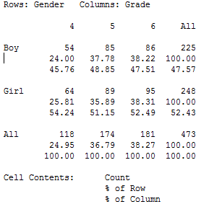
Cross Tabulation is a method of taking pairs of categorical variables and creating a two-way table. The command can be found on the menu bar MINITAB>STAT>TABLES>CROSSTABULATION. Choose two data items and check that you want count, row percents and column percents. The example shows gender cross-tabulated with grade level:
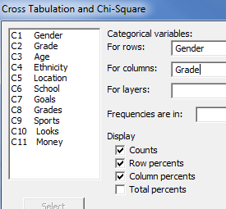

You can also make a stacked bar 100% graph: MINITAB>graph>bar graph and then select the stack option. Choose the two variables, then click Chart Options and choose Show Y as a Percent and Within categories at level 1.
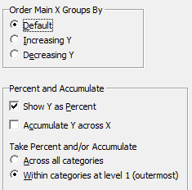
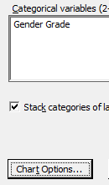
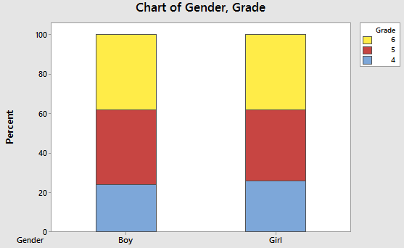
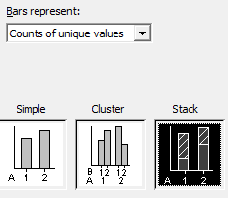
There are three questions with parts on the next three pages. Be sure to answer them all.
- Cross-tabulate Gender with Goal and create a two-way table. Paste it here.

  - What is the probability a randomly selected student chooses sports as the most important goal? What type of probability is this (Marginal, Joint, or Conditional)?

  - What is probability that a randomly selected student is a boy? What type of probability is this (Marginal, Joint, or Conditional)?

  - What is probability that a randomly selected student is a boy and chooses sports as the the most important goal? What type of probability is this (Marginal, Joint, or Conditional)?

  - What is the probability a randomly selected boy chooses sports as the most important goal? What type of probability is this (Marginal, Joint, or Conditional)?

  - Create a 100% stacked bar graph for these two variables and paste it here. What conclusions can you make about Gender and Goal?

- Cross-tabulate Location with Goal and create a two-way table. Paste it here.

  - What is the probability a randomly selected student chooses sports as the most important goal?

  - What is probability that a randomly selected suburban student chooses sports?

  - What is the probability a randomly selected rural student chooses sports?

  - What is the probability a randomly selected urban student chooses sports?

  - Create a 100% stacked bar graph for these two variables and paste it here. What conclusions can you make about Location and Goal?

- Cross-tabulate any two variables of your choice and create a two-way table. Paste it here.

  - Calculate and explain any marginal probability of your choice.

  - Calculate and explain any joint probability of your choice.

  - Calculate and explain any conditional probability of your choice.

  - Create a 100% stacked bar graph for these two variables and paste it here. What conclusions can you make about these two variables?

