Math 217: Lab 5 - Simulating Random Variables

Put group members in box above and attach this competed document to email with header Math 217 Sec xx Lab05. Make sure you copy all members in the group.

For this lab, start with an empty Minitab project.

This lab covers simulation of Continuous Random Variables using the Random Number Generator in Minitab. Simulation means to create a random sample from a population where the shape, mean and standard deviation are known. We are going to run simulation for 3 random variables. Start by opening an empty workbook in Minitab.

- Simulate a Uniform Random Variable
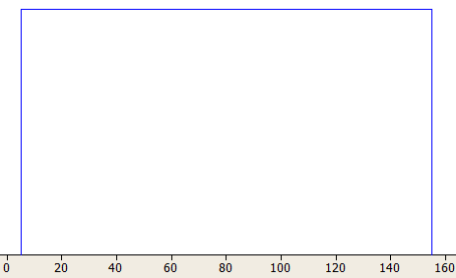
The Uniform random variable is described by two parameters, the minimum and the maximum. Each value between the minimum and the maximum has the same probability of being chosen, so the uniform random variable has a rectangular shape. In this simulation, we will model the amount of concrete in a building supply store which follows a uniform distribution from 5 to 155 tons.

  - Create a column heading for this Random Variable in the cell under C1 and simulate 1000 trials in Minitab (use the menu item CALC>RANDOM DATA and choose Uniform.)

  - Using the command STAT>BASIC STATISTICS>GRAPHICAL SUMMARY to calculate the sample mean, sample median and sample standard deviation of the simulated data as well as a box plot and histogram and paste the output here.

  - Describe the shape of the histogram. Does it appear to match the rectangular shape of the population probability graph shown above?

  - Identify the minimum and maximum values. Are they near the values 5 and 155 that you used to define the model?

  - The population mean and median of this random variable are both 80 tons and the population standard deviation is 43.3 tons. How do the sample statistics in the simulation compare to these population values?

- Simulate an Exponential Random Variable
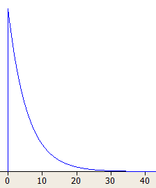
The Exponential random variable is described by one parameter, the expected value or . The shape of the curve is an exponential decay model that we studied in Module 4. This random variable is often used to model the waiting time until an event occurs, where the future waiting time is independent of the past waiting time. In this simulation, we will model trauma patients arrive at a hospital’s Emergency Room at a rate of one every 5.6 minutes (5.6 minutes is the expected value.)

  - Create a column heading for this Random Variable in the cell under C2 and simulate 1000 trials in Minitab (use the menu item CALC>RANDOM DATA and choose Exponential. The scale box will be and the Threshold box should remain at 0.0 )

  - Using the command STAT>BASIC STATISTICS>GRAPHICAL SUMMARY to calculate the sample mean, sample median and sample standard deviation of the simulated data as well as a box plot and histogram and paste the output here.

  - Describe the shape of the histogram. Does it appear to match the exponential decay shape of the population probability graph shown above?

  - Identify the minimum and maximum values. Does the maximum value appear to be an extreme outlier?

  - The population mean and standard deviation of this random variable are both 5.6 minutes and the population median is 3.88 minutes. How do the sample statistics in the simulation compare to these population values?

- Simulate a Normal Random Variable
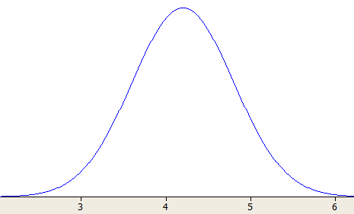
The Normal random variable is described by two parameters, the expected value and the population standard deviation . The curve is bell-shaped and frequently occurs in nature. In this simulation, we will model the cooking time for popcorn which follows a Normal random variable with μ=4.2 minutes and σ=0.6 minutes.

  - Create a column heading for this Random Variable in the cell under C3 and simulate 1000 trials in Minitab (use the menu item CALC>RANDOM DATA and choose Normal.)

  - Using the command STAT>BASIC STATISTICS>GRAPHICAL SUMMARY to calculate the sample mean, sample median and sample standard deviation of the simulated data as well as a box plot and histogram and paste the output here.

  - Describe the shape of the histogram. Does it appear to match the bell-shape of the population probability graph shown above?

  - Identify the minimum and maximum values. Determine the Z-score of each. Do these values seem to be extreme outliers?

  - Compare the sample mean, median and standard deviation to the population values.

