Math 217 - Lab 1 – Creating Dot Plots from Data

Open MINITAB file rateMP.mpj from the website. This data represents information 700 instructors from the popular website ratemyprofessors.com. All instructors are sampled from the Foothill-De Anza Community College District. Here is a description of the data:

College: Foothill or De Anza
Smiley: Positive Neutral Negative
Photo: Instructor has a photo
Hot: Instructor has a chili pepper
Gender: Male or Female
Dept: Academic Department (example - Mathematics)
Division Academic Division (example - PSME)
Num Number of Ratings for that faculty member
Overall Average Overall Quality Rating (1-5 scale, lowest to highest)
Easiness Average Easiness Rating (1-5 scale, hardest to easiest)

We are going to use Minitab to make some dot plots for this data. Specifically we are going to look at Average Overall Quality Rating and try to make some comparisons of groups. First, let's ask some questions about this data.

- Identify the quantitative variables.

- Identify the categorical variables.

- Is this an observational study or an experiment? Explain.

- What is the population?

- What is the sample?

- Do you think this is a fair sample of instructors? Explain.

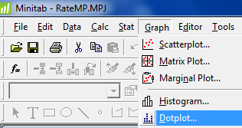
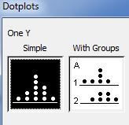
Now we are going to make some dot plots of the Average Overall Quality Rating which can be found under the GRAPHS menu command in MINTAB

- Make a dot plot of all instructors' Average Overall Quality Rating. (Simple Dot Plot). Paste the graph here and analyze the dot plot. (You may describe the data's shape, center and spread)

- Make a dot plot of all instructors' Average Overall Quality Rating by gender. (With Groups Dot Plot). Paste the graph here. Do you see any difference in overall quality between males and females?

- Make a dot plot of all instructors' Average Overall Quality Rating by college. (With Groups Dot Plot). Paste the graph here. Do you see any difference in overall quality between Foothill and De Anza instructors?

- Make a dot plot of all instructors' Average Overall Quality Rating by hotness. (With Groups Dot Plot). Paste the graph here. Do you see any difference in overall quality between "Hot""and "Not Hot" instructors?

- Write a paragraph summarizing your results. Do you see any problems or bias with this study?

