Math 217 - Lab 2 – Descriptive Statistics

Open MINITAB file rateMP.mpj from the website. This data represents information 700 instructors from the popular website ratemyprofessors.com. All instructors are sampled from the Foothill-De Anza Community College District. Here is a description of the data:

College: Foothill or De Anza
Smiley: Positive Neutral Negative
Photo: Instructor has a photo
Hot: Instructor has a chili pepper
Gender: Male or Female
Dept: Academic Department (example - Mathematics)
Division Academic Division (example - PSME)
Num Number of Ratings for that faculty member
Overall Average Overall Quality Rating (1-5 scale, lowest to highest)
Easiness Average Easiness Rating (1-5 scale, hardest to easiest)
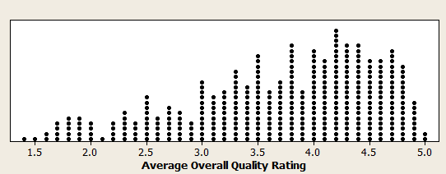
In Lab 1, we made some dot plots and made some interpretations of Average Overall Quality Rating. In Lab 2, we will look at other graphs and statistics that measure center, spread and relative standing.

- Above is a dot plot you made of Average Overall Quality Rating in Lab 1. Make a histogram of the Average Overall Quality Rating. Paste the graph here. Are both graphs showing the same center, spread and shape? Explain your answer.

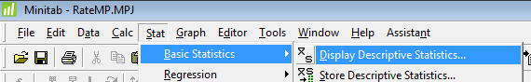
Descriptive Statistics can be found in Minitab under STAT>BASIC STATISTICS.

- Use this command to determine the sample mean and sample median for the Average Overall Quality Rating. Paste the results here and answer these questions:

  - Which statistic is a better measure of center for this data? Explain your answer.

  - Are the values of the sample mean and median consistent with the shape of the histogram? Explain your answer.

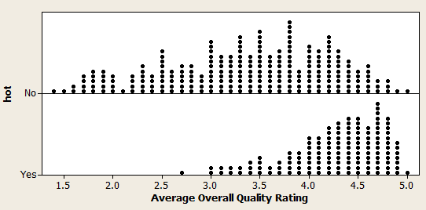
Here are dot plots comparing Average Overall Quality Ratings of instructors who are rated "hot" vs. those who are rated "not hot" that you made in Lab 1.

- Under the GRAPHS menu bar in Minitab, create box plots with groups of Average Overall Quality Ratings comparing "hot" and "not hot" instructors. Paste the results here and from the box plots, answer these questions.

  - Which group has a higher sample median?

  - For the "hot" instructors, between what values would you find the middle 50% of ratings?

  - For the "not hot" instructors, between what values would you find the middle 50% of ratings?

  - Are there any possible outliers for the "hot" instructors? Explain.

- Under the GRAPHS menu bar in Minitab, create box plots with groups of Average Overall Quality Ratings comparing Divisions. Paste the results here and from the box plots, answer these questions.

  - Which divisions have the highest and sample median?

  - Which divisions have the highest and lowest interquartile range?

  - Describe the shape of each of the divisions.

  - Are there any possible outliers in any of the divisions? Explain.

