Math 217 - Lab 3 – Correlation and Regression

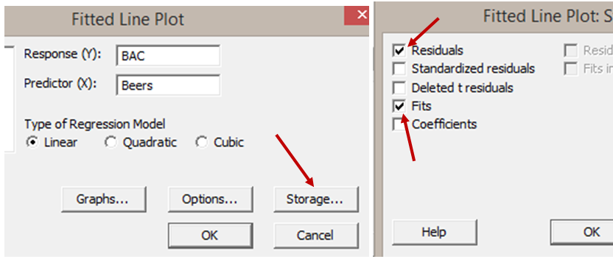
Minitab commands needed for this lab:

To find correlation coefficients:
STAT>BASIC STATISTICS>CORRELATION
To find get scatterplot and regression line:
STAT>REGRESSION>FITTED LINE PLOT
To find get residuals and fits under fitted line plot, click Storage and then select Fits and Residuals

(Questions 1-6)
Open MINITAB file beers.mpj from the website which are the results of the following study:

16 student volunteers drank a randomly assigned number of cans of beer. Thirty minutes later a police officer measured their blood alcohol content (BAC) in grams of alcohol per deciliter of blood.

- Make a scatterplot of the data where the explanatory variable is the number of beers consumed and the response variable is the BAC. Explain correlation between the variables (positive or negative, strong or weak, linear or non-linear.) Also, explain why the fit is not perfect, what other factors do you think affect BAC.

- Determine the equation of the regression line. Copy and paste the scatterplot with regression line below. Interpret the slope and y-intercept in the context of this problem.

- Determine the correlation coefficient (the r statistic we learned in class). Is the result of this statistic consistent with the scatterplot?

- Which two points have the largest positive residual error and largest negative residual error? List the points below in (x,y), the fit for each point and the residual for each point.
- Use the regression line equation to determine the predicted BAC for a student who drinks 1 beer, a student who drinks 5 beers and a student who drinks 30 beers. In your opinion, how reliable are each of these predictions? Explain your answers.

- The legal limit for BAC in California for driving is 0.08 g/dl. Estimate how many beers a student would need to drink to be classified as driving over the legal limit.

(Questions 7-9)
Open MINITAB file rateMP.mpj from the website. This data represents information 700 instructors from the popular website ratemyprofessors.com. All instructors are sampled from the Foothill-De Anza Community College District. We will focus on these quantitative variables:
Response Variable: Overall Average Overall Quality Rating (1-5 scale, lowest to highest)
Explanatory Variable: Easiness Average Easiness Rating (1-5 scale, hardest to easiest)

- Make a scatterplot with the regression line for these two variables.

- Use the regression equation to predict the overall quality rating for an instructor with an easiness rating of 3.2. In your opinion, how reliable is this prediction?

- Discuss causation vs. correlation in this example and give two possible "causes" for the correlation between overall quality and easiness rating. Include a discussion of possible confounding (lurking) variables.

(Questions 10-13)
Open MINITAB file CalRainfall.mpj from the website. This data represents information about 16 California cities. We want to predict Annual Precipitation based on geographical data about the cities: Latitude (degrees north from the Equator), Altitude (How high the city is above sea level) and Distance from the Coast.

- Before using Minitab, predict which of the three geographical variables will have the strongest correlation in predicting annual precipitation. Explain your reasoning.

- Make 3 scatterplots where Annual Precipitation is the response variable and Latitude, Altitude and Distance from Coast are explanatory variables. Then calculate the correlation coefficients for each of these graphs. Based on the scatterplots and the correlation coefficients, which geographical
variable has the strongest predictive value. Is How does this compare to your answer in question 10?

- Determine the equation of the regression line where Annual Precipitation is the response variable and latitude is the explanatory variable. Interpret the slope in the context of this problem.

- Use the equation from Question 12 to predict the annual precipitation for Garberville which is at latitude 40.1 degrees North. Explain how accurate is this prediction?

