Math 17 - Lab 1 – Central Limit Theorem

This lab is to illustrate the 3 important part of the Central Limit Theorem, which describes how the sample size affects the center, spread and shape of the distribution of the sample proportion.

Open MINITAB file CLT.mpj from the website. This data represents 1000 trials of rolling a six-sided die 5, 10, 50, 100 or 500 times, and determining the sample proportion of times a 6 was rolled.

We are going to use Minitab to make some dot plots for this data to determine the center, spread and shape of the distribution of the sample proportion.

- First, let's identify the population proportion. If you roll a six-sided, what proportion would you expect to come up 6? Write this as a fraction and a decimal.

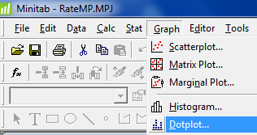
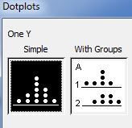
Now we are going to make some dotplots of these proportions under GRAPHS menu command in MINTAB

- Make a Simple dotplot of the sample proportion for sample size n=5. Paste the graph here an describe the center, shape and spread of the data.

- Make a Simple dotplot of the sample proportion for sample size n=50. Paste the graph here an describe the center, shape and spread of the data. Compare your results to the prior question 2.

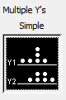
- Now we are going to make a Multiple dotplot for all 5 sample sizes using the Multiple Y's Simple option. Paste the graph here and answer the 3 questions about the distribution of the sample proportion.

  - How has the center changed as the sample size increased?

  - How has the spread changed as the sample size increased?

  - How has the shape changes as the sample size increased?

