Math 17 - Lab 10 – Chi Square Test of Independence

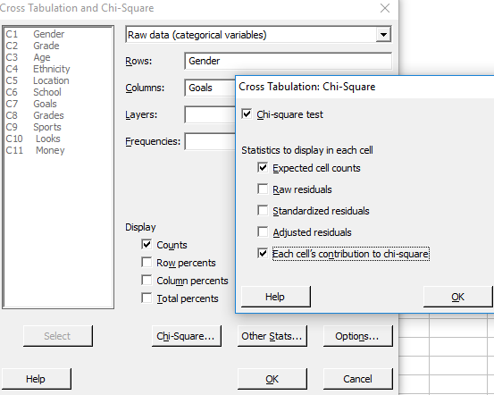
In this lab, we will conduct hypothesis tests for dependence of two categorical variables, using MINITAB to get choose the appropriate models and the p-value.
For questions 1 and 2, use the file popular.mpj and the MINITAB command Stat>Table > Crosstabulation/Chi Square. Choose Raw Data. To run the test, Click Chi-square and check the options as shown. Run these tests at a significance level of 5%
- Test for dependence between location and goal for elementary school students.
  - State the null and alternative hypotheses.

  - Run the test and paste the results here.

  - Do you reject or fail to reject Ho? Then state your conclusion in the context of the problem.

- Test for dependence between gender and goal for elementary school students.
  - State the null and alternative hypotheses.

  - Run the test and paste the results here.

  - Do you reject or fail to reject Ho? Then state your conclusion in the context of the problem.

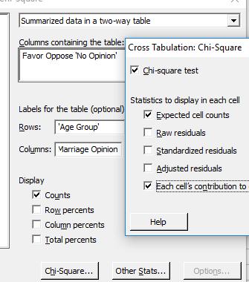
- Pew Research conducted a poll of 2000 American adults asking whether they Favor or Oppose same-sex marriage. The data is summarized in the two-way table shown below. Conduct a hypothesis test to determine if American's opinions about same-sex marriage are age related?

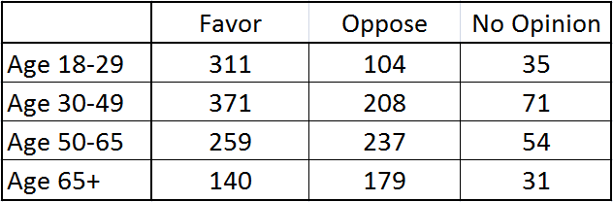

  - Before conducting the test, determine the percentage in each group that support same sex marriage. Describe the trend.

  - Now we will conduct the test. State the null and alternative hypotheses.

  - What model are you choosing and what assumptions are needed?

  - The table above has been entered in columns 12 to 15 of the POPULAR Minitab file. Conduct the test at a significance level of 1%, using MINITAB command:
Stat>Table > Crosstabulation/Chi Square. Choose Raw Data. Highlight columns that contain the table. Paste the results here.

  - Do you reject or fail to reject Ho? Then state your conclusion in the context of the problem.

