Math 57 - Lab 2 – Confidence Intervals for Proportions

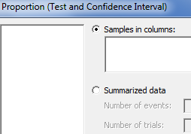
Confidence Intervals for proportions can be run in Minitab using the command
STAT>BASIC STATISTICS>1 PROPORTION.

- 800 students at De Anza College were asked where they lived and 310 said San Jose.

  - Determine the sample proportion of students who live San Jose.

  - Find and Interpret a 95% confidence interval for students who live in San Jose.

  - What is the Margin of Error for this poll?

- In a different survey, 1600 students at De Anza College were asked where they lived and 660 said San Jose

  - Determine the sample proportion of students who live San Jose.

  - Find and Interpret a 95% confidence interval for students who live in San Jose.

  - What is the Margin of Error for this poll? Why is it different that the Margin of Error for the prior poll?

  - Notice these two polls gave different point estimates for the population proportion. Does this mean one of the polls is wrong? Explain.

- Open the data for Rate My Professors that we used last quarter: RateMP.MPJ

  - Find a 95% Confidence Interval for the proportion of male instructors. What is the Margin of Error.

  - Interpret this confidence Interval.

  - Would you support a claim that women are underrepresented at these colleges? Explain

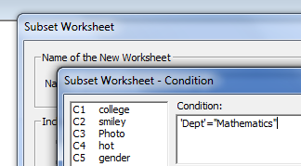

You can use the command DATA>SUBSET WORKSHEET to look at an individual department, for example. We want create a worksheet of just Mathematics Instructors, so select Condition and set 'Dept'="Mathematics".

- Find a 95% Confidence Interval for the proportion of male mathematics instructors.

  - Interpret this confidence Interval.

  - Would you support a claim that women are underrepresented in the Mathematics Departments at these two colleges? Explain

