Math 17 - Lab 4 - Comparing Two Population Proportions.

Harris Poll did a survey in 2005 and repeated it again in 2013 asking American adults if they had a religious affiliation. In 2005, 285 out of 413 sampled said they had a religious affiliation. In 2013, 192 out of 320 sampled said they had a religious affiliation.

In order to understand this poll we are going to first look at some simulations of possible random samples. Then we are going to create a confidence interval for the difference of these two polls.
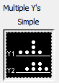
- Open the file 2Proportions.mpj. This data represents 1000 simulated sample proportions of adults who said they had a religious affiliation. In 2005, we are assuming 69% are affiliated with a religion and a sample size of 413. In 2013, we are assuming 60% are affiliated with a religion and a sample size of 320. Create a Multiple Y's Simple Dotplot of these two simulations and paste the result here.

- Describe the shape and center of each group.

- Remember each dot represents a random sample. Would it possible to obtain two random samples where it shows the proportion of those who had a religious affiliation has increased? Explain

- We are now to take the difference of each simulation. We will use the blank column labeled difference in the Minitab worksheet. Select Calc>Calculator, calculate the difference between Simulation 2005 and Simulation 2013, storing the result in difference. Then go to the next question.
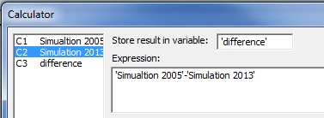
- Make a simple dotplot of the new variable difference and paste it here. Describe the shape and center of the graph. Would it be unusual to have a difference less than 0?

- Using the command Stat>Basic Statistics>Display Descriptive Statistics, determine the sample mean and sample standard deviation of the variable difference and paste the results here.

- Compare the sample values in question 6 to the population values that you will determine by the formulas:

