Math 17 - Lab 6 – Central Limit Theorem for Means

This lab is to again illustrate the 3 important part of the Central Limit Theorem, which describes how the sample size affects the center, spread and shape of the distribution of the sample mean
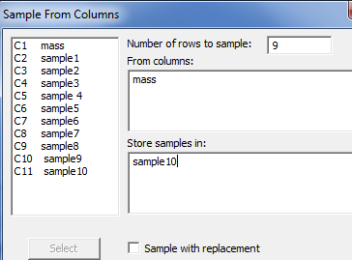

PART A

- First, we want to use MINITIB to take a random sample from data. Open the file AcornWeight.MPJ which represents the mass of 400 acorns we studied in Module 10.1.1. Using the command CALC>RANDOM DATA>SAMPLE FROM COLUMNS choose a sample of 9 form this data. Repeat this 10 times and store the data in each of the ten blank columns

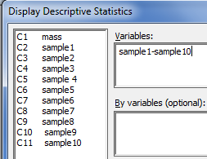
- Using the command STAT>DISPLAY DESCRIPTIVE STATISTICS, determine the mean and standard deviation for each of the ten samples.

- Create a new column called Means, and manually enter the ten sample means from question 2 in the column. Create a dot plot of this new data. Describe the shape and estimate the mean of this data.

- Calculate the descriptive statistics for the column of sample means. Compare the mean and standard deviation to the mean and standard deviation of the ten samples from question 2. What is the same and what is different?

PART B

The lifetime of optical scanning drives follows a skewed distribution with and . Open the File CLTforMeans.MPJ which represents 1000 simulated random samples of 1, 5, 10, 30, and 100 from this population.
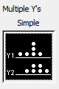
- Make dot plots of all 5 sample sizes using the Multiple Y's Simple option and paste the result here.

  - As the sample size changes, describe the change in center.

  - As the sample size changes, describe the change in spread.

  - As the sample size changes, describe the change in shape.

- Using the command STAT>DISPLAY DESCRIPTIVE STATISTICS, determine the mean and standard deviation for each of the five groups. Paste the results here.

  - As the sample size changes, describe the change in center.

  - As the sample size changes, describe the change in spread.

- What you have observed are the three important parts of the Central Limit Theorem for the distribution of the sample mean In your own words, describe these three important parts.

