Asian Pacific American Heritage Month

May 2005

De Anza College

Asian Pacific Americans Pushing Boundaries

Vietnamese Student Association’s Cultural Night “Our Story”; Saturday, May 7, 2005, 6:00pm-9:00pm

Flint Center, Admission Fee $8 in advance, $10 at the door

VSA Dance; Saturday, May 7, 2005, 9:00pm-12:00am; Conference Rooms A & B, Hinson Campus Center
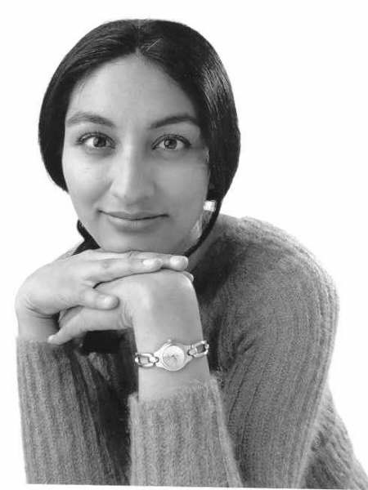

VSA students pull out all the stops for a dynamic evening of dance, music, and performance that has become
a proud De Anza tradition. After the Cultural Night, join VSA for a dance in Conference Rooms A & B.
Contact: Alfonse at 408-386-2652.

Shailja Patel – Spoken Word Performance & Lecture

Tuesday, May 10, 2005, 11:30am-1:00pm; Conference Rooms A & B, Hinson Campus Center

Kenyan Indian explosion on the national spoken word scene, slam poet Shailja Patel is “provocative, hilarious and highly political” (Asian Week). Shailja will address political, social, artistic, economic, and sexual boundaries and how the current generation of Asian Pacific Americans is challenging them. Her words have generated response from activists and academics worldwide. Winner of national and Bay Area slam championships, Shailja appeared recently at the Lincoln Center, New York and shared the stage with Li’l Kim and Rosie Perez at Manhattan’s Move-Against-Aids Danceathon..

Asian Pacific American Heritage Month Reception; Tuesday, May 10, 2005, 1:30pm-3:00pm; California History Center

Please join us for refreshments after Shailja Patel’s performance to celebrate the start of APA Heritage Month .
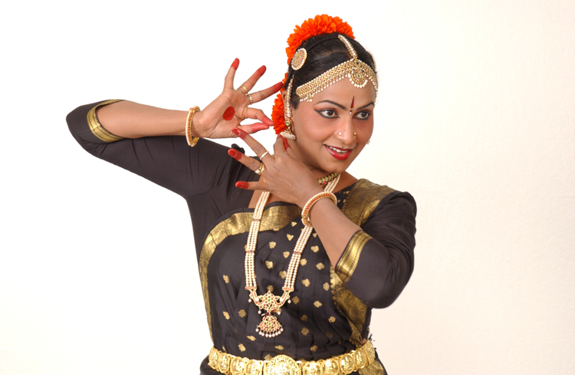

Nirmala Madhava – Classical Dance from India; Wednesday, May 11, 2005, 12:30pm-1:30pm
Conference Rooms A & B, Hinson Campus Center

Nirmala Madhava is a master dancer, choreographer and instructor from the Prabhath Academy for Music and Performing Arts (PAMPA). Nirmala is recognized as a master solo performer in Bharathanatyam and Kathak dance forms and was featured in the 2004 San Francisco Ethnic Dance Festival, which is acclaimed as one of the most significant festivals of its type in America.

30th Anniversary of the Fall of Sai Gon – Panel Discussion; Tuesday, May 17, 2005, 1:30pm-3:30pm
Conference Rooms A & B, Hinson Campus Center

In the 30 years since the fall of Sai Gon, over a million Vietnamese fled their country and risked their lives in search of freedom, democracy, and economic prosperity. Today, over 2.7 million Vietnamese are living abroad in different countries, including 150,000 Vietnamese living in the Bay Area. This panel will provide a forum to discuss the continuing impact
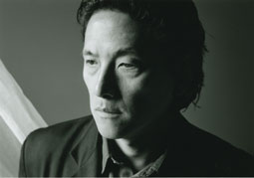
of this historic event.

Li-Young Lee – Poetry Reading and Q & A; Wednesday, May 18, 2005, 1:30pm-3:00pm
Conference Rooms A & B, Hinson Campus Center

Recipient of an American Book Award, Li-Young Lee’s poetry and prose weave together dialogue across generations and cultures. Lee’s simple but striking use of images and memories express the complexities of exile, cultural alienation, and parent-child relationships. Born and raised in Indonesia, Lee and his family fled anti-Chinese violence and were exiled in Hong Kong, Macau, and Japan before relocating to the United States.

De Anza APA Student Film Showcase; Wednesday, May 25, 6:00pm-9:00pm
Conference Rooms A & B, Hinson Campus Center

Winning entries from De Anza student filmmakers will be screened at this special showcase featuring appearances and commentary from the directors and others involved in the productions. Free pizza will be served!

APA Queer Identities Panel; Thursday, May 26, 2005, 10:30am-11:20am;
Conference Rooms A & B, Hinson Campus Center

What are the experiences of, and issues facing, gay, lesbian, bisexual, and transgendered Asian Pacific Americans? Join our student and community panelists to find out! Panel members will include Donny Arelis (member of GLBTA, Gay Lesbian Bisexual Transgender Association, San Jose State University); Stephanie Sayo (founder of EMPAQ, Embracing the Movement of Pinays and Queers); and Teresa Peralis (member of GLBTA, San Jose State University).

The Next Movement: Expressions From The Hip Hop Generation; Tuesday, May 31, 2005, 6:00pm-9:00pm
Conference Rooms A & B, Hinson Campus Center
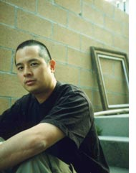
An evening of electrifying music and spoken word performances, with an introductory talk by Jeff Chang, author of the new critically acclaimed book, Can't Stop Won't Stop: A History of the Hip-Hop Generation.
Guest artists include: The Jimi Handtrix Experience; Sleepwalkin Audio; Jocelyn de Leon; Head Hunters; Soul Sector; Machine Gone Fownk; B-SYDE; Trademark; Rey Resurreccion; Dandiggity; and Lyrical Discipline.

Asian Pacific American Heritage Month

Background on the celebration…

May is designated by the United States Congress as National Asian Pacific American Heritage Month. It is a time to recognize the contributions that Americans of Asian and Pacific Islander ancestry have made to enrich the history and culture of this country. The initiative began in 1977 with a joint resolution by former House Representatives Frank Horton (R-HY) and Norman Y. Mineta (D-CA) proclaiming the first ten days of May as Pacific/Asian Heritage Week.

In 1992, President George H.W. Bush signed the legislation into law designating May of every year as Asian Pacific American Heritage Month, which the 102nd Congress unanimously approved in the same year.

ALL EVENTS ARE FREE TO THE PUBLIC (UNLESS OTHERWISE NOTED) AND WHEELCHAIR ACCESSIBLE.

Sign language interpreter available upon request by contacting Karen Chow at chowkaren@deanza.edu or by telephone at 408-864-5763 at least five (5) business days prior to event date.

For more information about any of the events listed…
Contact Karen Chow at 408-864-5763 or chowkaren@deanza.edu or Lena Chang at 408-864-8728 or changlena@deanza.edu.

Funded by De Anza Associated Student Body (DASB) and several of our sponsors. Thank you for your support.

Program Sponsors

De Anza Associated Student Body (DASB)
Asian Pacific American Staff Association (APASA)
Asian Pacific American Leadership Institute (APALI)
Asian Pacific American Students for Leadership (APASL)
California History Center (CHC)
De Anza College Student Activities

Intercultural/International Studies Division (IIS)
Language Arts Division
Multicultural Staff Association (MSA)

Vietnamese Student Association (VSA)
Visiting Speaker Series (VSS)

De Anza College 2005 Planning Committee

Lena Chang, Co-Chair

Michael Chang
Karen Chow, Chair
Marshall Hattori
Herminio Hernando
Tom Izu
Duane Kubo
K.D. Le
Mae Lee
Godfrey Ramos
Rowena Tomaneng
La Donna Yumori-Kaku

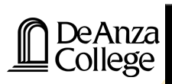
21250 Stevens Creek Boulevard
Cupertino, California 95014

