DE ANZA COLLEGE
Vietnam in Viet Nam – 2013
Chapter FIVE : EDUCATION

30/05/2012

1 million high-school students to sit graduation exams

A total of 963,571 students will take their high-school graduation examinations from June 2-4, according to the Ministry of Education and Training.
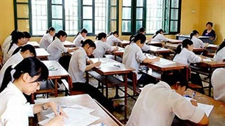
Of the figure, 856,271 are full-time candidates and the rest are continuing-education students, said Ngo Kim Khoi, Head of the Ministry’s Educational Testing and Quality Assessment Department.
The number of students doing exams fell by 8.5 percent compared to last year’s figures, he said.
Full-time graders will be tested in six subjects, namely literature, chemistry, geography, history, mathematics and a foreign language of English, Russian, French, Chinese, German or Japanese.
Those who attend high-school part-time or evening courses will take a physics exam instead of a foreign language exam.
Multiple choice tests will be used for the foreign language, chemistry and physics while essay tests will be used for the remaining subjects.
More than 124,000 teachers and educational officers will be responsible for supervising examinations, which need 40,620 classrooms nationwide.
VNA

Printer-Friendly Version

Open Doors 2008
Report on International Educational Exchange
Figure 2B: Top 20 Leading Places of Origin of International Students, 2006/07 & 2007/08
 |  |  |  | 2007/08 | %
Rank | Place of Origin | 2006/07 | 2007/08 | % of Total | Change
 | WORLD TOTAL | 582,984 | 623,805 | 100.0 | 7.0
1 | India | 83,833 | 94,563 | 15.2 | 12.8
2 | China | 67,723 | 81,127 | 13.0 | 19.8
3 | South Korea | 62,392 | 69,124 | 11.1 | 10.8
4 | Japan | 35,282 | 33,974 | 5.4 | -3.7
5 | Canada | 28,280 | 29,051 | 4.7 | 2.7
6 | Taiwan | 29,094 | 29,001 | 4.6 | -0.3
7 | Mexico | 13,826 | 14,837 | 2.4 | 7.3
8 | Turkey | 11,506 | 12,030 | 1.9 | 4.6
9 | Saudi Arabia | 7,886 | 9,873 | 1.6 | 25.2
10 | Thailand | 8,886 | 9,004 | 1.4 | 1.3
11 | Nepal | 7,754 | 8,936 | 1.4 | 15.2
12 | Germany | 8,656 | 8,907 | 1.4 | 2.9
13 | Vietnam | 6,036 | 8,769 | 1.4 | 45.3
14 | United Kingdom | 8,438 | 8,367 | 1.3 | -0.8
15 | Hong Kong | 7,722 | 8,286 | 1.3 | 7.3
16 | Indonesia | 7,338 | 7,692 | 1.2 | 4.8
17 | Brazil | 7,126 | 7,578 | 1.2 | 6.3
18 | France | 6,704 | 7,050 | 1.1 | 5.2
19 | Colombia | 6,750 | 6,662 | 1.1 | -1.3
20 | Nigeria | 5,943 | 6,222 | 1.0 | 4.7

Office at a Glance
Open Doors Data 2012:
Origin sending country rankings, all institutions: 8th
Origin sending country rankings, Community Colleges: 3rd
2011/2012 academic year:
Total Vietnamese students: 15,572
72.2% undergraduate
17% graduate students
5.5% other
5.2% OPT (Optional Practical Training)

Last update 17/02/2011
Vietnamese intellectuals
August 19, 2010 marked an unforgettable day in the history of Vietnamese science: International Mathematical Union awarded the Fields Medal – known as “the Nobel prize in mathematics” – to Professor Ngo Bao Chau. Professor Chau said the Fields Medal was important because it boosted people’s confidence in the ability of Vietnamese.

Vietnam’s development definitely depends much on Vietnamese intellectuals. Tuoi tre Tan Mao magazine published Professor Ngo Bao Chau’s reflection on this subject, as well as the views of other researchers/scholars and young people.

Luong Phuong Thao: Different seeds
In my point of view, every country has excellent and gifted individuals. However, they are not the only contributors to the country’s development. Normal citizens have their contributions as well. We should remember that personal development, our own good lifestyle and happiness also make contributions to our country.
I used to ask myself: “What is the definition of a genius?” Is it possible that each of us is a genius only our talents have not been thoroughly explored yet? There are many ways to define a talent. We should encourage diversity and accept new and strange things, so that our horizons will be expanded.
A girl who likes drawing in class or a boy who likes creating new games is also as precious and excellent as a student who wins gold medals in International Mathematical Olympiad. In my opinion, this is the best way to foster new “seeds” of knowledge.
As for me, after winning, in my third year, the highest reward of the television program “Way to Olympia peaks” - a scholarship to Monash University (Melbourne City, Australia), I decided to major in international trade and marketing.
going abroad is a big opportunity but studying in Vietnam is also an opportunity. The most important thing is how we use these opportunities. I am now working for an advertising company. Focusing on the job is the source of my happiness.

Huynh Cong Thinh: I want to be the one who spreads enthusiasm
Huynh Cong Thinh, born in 1987, is the youngest person who received the MVP award (Most Valuable Professional) twice. This big award of Microsoft is to recognize and honor excellent individuals who made contributions to the information technology.
Graduating from Telecommunication University (HCM City), Huynh Cong Thinh decided to stay at the university to become a lecturer and continue studying IT application.
Looking back to 2010, he immediately mentioned Professor Ngo Bao Chau’s being awareded the Fields Medal. “That is a meaningful event and it not motivates everyone who study and work in science to follow”, said Thinh.
being a student who participated in the program” Way to the Olympia peak” in his fifth year and received many rewards, he is always aware of young people’s responsibilities toward their country. His motto is “Change yourself, don’t wait”.
Cong Thing said:” I made friends with my computer and chose it to be my companion on the way to conquer the world of IT . Many people doubted me saying: “Why don’t you choose other job and make more money instead of being a lecturer?” To these questions, I answered that my happiness comes from learning new things and sharing the new knowledge with e all my students. As for me, it is a way for the gifted to remain enthusiastic and transmit this spirit to the next generations.

Nguyen Hoai Dam: I want to think outside the box
Dam has become a member of Vietnam Communist Party when he was still a student at Le Huu Trac 1 High School (Ha Tinh Province). He was born in 1990 and in 2008received Hoa Trang Nguyen prize, which is awarded to excellent national and international students, and the ones who come first in entrance exams to universities and in high school graduation exam.
Dam used to be a member of and then became a contributor to popular television shows, such as “Way to Olympia Peak”, “Ring golden bell”… Recently, Dam has received a governmental scholarship to study journalism at the Irkutsk National University (one of the top ten colleges) in Irkutsk City, East Siberia Capital. He talked with us about Vietnamese intellectuals.

In your opinion, is it necessary to go abroad to gain knowledge?
Nguyen Hoai Dam: My aim instudying abroad is to learn to think outside the box, to explore and acquire new things. If not, this would not make a difference.
After graduating from university, will you come back to Viet Nam or go to another country to continue your studies?
Dam: I think that it doesn’t matter where you go as long as you contribute meaningfully to other people’s lives and your own country. It’s our effort that is the breath of youngsters to the country’s developments.
Having the chance to meet the young talents in “Hoa Trang Nguyen” program (a program to honor the ones who come first in the entrance exam to universities and who win golden prize in international examinations…) every year, how do you feel about the ability of the Vietnamese?
Dam: I see that many young Vietnamese people are becoming more and more mature and excellent, not only in their studies but also in extra-curricular activities. Everyone is making great efforts everywhere around the world. All those efforts make me proud and encourage me to try harder.
Source: Tuoi Tre Magazine

Last update 18/02/2011

A revolution in Vietnam’s education?
VietNamNet Bridge – The Ministry of Education and Training looks for candidates for the key posts in the ministry. Vietnamese universities look for rectors by advertising their vacancies in foreign newspapers. This has never happened before in Vietnam.



After advertising a vacancy fora deputy director, the Posts and Telecommunications Institute of Technology received six applications. All the six candidates have returned from overseas, graduating from reputable universities.
However, only two candidates will be selected for the posts of training manager and scientific research and technology transfer manager. The candidates must at least hold a doctorate degree be trained in economic t or training management. They also must be fluent in at least one common foreign language.
Prior to that, the Ministry of Education and Training announced the plan to recruit for the posts of department directors and deputy minister. This was a surprise, because in the past such important positions were filled only by appointment, not through open competitions.
Local education and training departments in Bac Giang, Da Nang and Phu Tho also used open competitions to recruit headmasters and deputy head masters for many schools in their localities.
analysts say that recruiting from the public for key positions marks a revolution in the education sector i, indicating that schools and management agencies want to employ the most talented and righteous.
Most recently, on December 13, 2010, the Tan Tao University which had just been licensed by HCM City, advertised a vacancy for the rector’s positionon The Chronicle of Higher Education, a well known US newspaper on university and higher education.
On the official website of the university, there are also vacancy announcement for lecturers. the university offers very attractive working conditions. Foreign lecturers are given subsistence allowance in addition to the salary, healthcare insurance, $1500 for airfare and a preferential rate for renting houses in Vietnam.
Meanwhile, the FPT University has announced its PhD scholarship program for 2011. The university will choose the top 30 students out of already excellent 400 graduates of100 high schools in Vietnam. The selected students will be granted scholarships for a doctorate degree in computer science.

In order to obtain the scholarships, which allow them to study both in Vietnam and overseas, candidates have to have excellent academic results, a passion for information technology and research.
After placing two advertisements on the US newspaper, the Tan Tao University recruited a rector. he is a Vietnamese, the well known Professor Vo Tong Xuan, once President of An Giang University.
Xuan told VietNamNet that the university received 200 applications. The school interviewed 52 persons and shortlisted 23, including 10 from Vietnam, who graduated from foreign universities, once got VEF or Fulbright scholarships. There were also foreign candidates from the US, Canada, Australia, Hungary and Russia.
When asked if advertising on the US newspaper was a “PR trick” for Tan Tao University, Professor Vo Tong Xuan said that the university is ready to pay high salaries to its lecturers because it wants them to work for a long term, and because the university really needs talented educators.
“Only the weak financially weak schools use visiting lecturers, i.e. lecturers who only work for a short time and then return to their countries. This means that students do not have opportunities to contact the lecturers,” he said
The lecturers selected for Tan Tao University all have doctorate degrees, and good research achievements. Their salaries range from 21,000 dollar to 26,000 a year. lecturers with teaching experience from foreign universities, can get $36,000 a year or higher.
Tu Uyen – Kieu Oanh

28/01/2011
Student are not graduating university, why?

VietNamNet Bridge – In some majors, the number of students who graduate school is very modest, at 20-30 percent of total students.

Students do not like their courses



In 2009, only 30 percent of students of the intermediate training program (2-year training) of the Saigon Tourism Vocational School graduated the school. According to Phan Buu Toan, MA, Deputy President of the school, a half of the undergraduate students skipped class too much and they did not attend their exams, while others changed to other majors or sought employment even when they had not finished studying. A lot of students fell tired of their majors or they thought they could not continue studying. Meanwhile, many other were too busy working parttime jobs to earn a living and could not pass the exams.

The number of students finishing the intermediate training system of the HCM City Natural Resources – Environment Junior College in 2010 was also very modest, at 30 percent. “Most of the students were not passionate about the majors they chose,” explained Huynh Chuc, MA, Deputy President of the school. “Some students asked to change to another major, though they could not give reasonable explanations about why they decided so”.

Dr Le Quang Duc, Lecturer of the Automatic Control class at the HCM City Transport University, said that he teaches this class to four sections and students of two of the sections have to repeat the class. “This is really a difficult class. However, the main problem is that students think that the material will not be useful, and they do not want to study hard,” Duc said.

Deputy President of the HCM City Transport University said that the percentage of graduates is very low in some majors, at about 40-45 percent, for example, mechanical engineering or waterway works. “It is partially because of the low capability of the students registering for the major, and partially because these are very difficult subjects. “Nearly 20 percent of the students who cannot pass the exams, have asked to shift to junior college training or in-service training courses.

Dr Le Bao Lam, President of the HCM City Open University, also said that a lot of students of the school cannot finish their training courses because they choose the majors unsuitable for them. Some students decided to give up school after a period of studying because they thought they made mistakes in choosing their major.

For the last four years, Phuc Kien in District 10 in HCM City has been seeking a job. Kien was interviewed by many companies, but he was refused because he did not have a bachelor degree.

In fact, Kien believes that he is very good at information technology and he can undertake all work relating to information technology and network. “However, my problem is that I still do not have a university degree,” Kien said.

He related that he was once a student of the Information Technology Faculty of the Nha Trang Fisheries University, HCM City Branch. However, he quit school after two years of studying. After that he studied information technology at the HCM City University of Natural Sciences, and then he passed the exams to the corporate governance faculty of the Open University because he planned to set up a business of his own. However, as there were too many lessons burdening him, he did not pass the exams and was forced to study at the junior college level. Feeling discouraged, he decided to give up school. As the result, he has no university degree now, even though he once studied at three universities.

Tran Dinh Ly, MA, Head of the Students’ Affairs Division under the HCM City University of Agriculture and Forestry, said that following studies at two schools at the same time is now quite common because young people want to have deep and specialized knowledge to be able to find good jobs. However, many students assume the grass is greener on the other side and therefore do not concentrate on their studies. As the result, they are unable to complete any university degree.

Sharing the same view, Phan Huu Tan Duc from Nguyen Tat Thanh Junior College said that following many studies at the same time would be a double-edge sword. “They would know many things but they do not have deep knowledge in any fields. A lot of people are no not qualified, but still want good jobs with high salaries,” he said.

Source: Tien phong

Last update 22/02/2011
Foreign languages remain a nightmare for Vietnamese students
VietNamNet Bridge – Foreign language centers have been mushrooming in Vietnam, especially in big cities like Hanoi or HCM City. However, despite the the number of foreign language centers, foreign languages remain a nightmare for Vietnamese students.

Foreign languages are barriers?

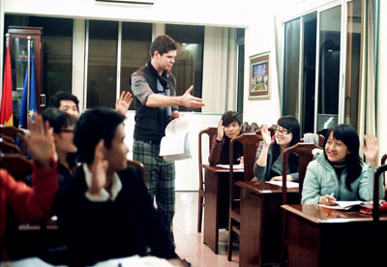

A mini survey conducted by VietNamNet’s reporters on 300 students from six high schools and universities in Hanoi, Da Nang and HCM City in November 2010 showed that most of student are “afraid of learning foreign languages”.

263 polled students said that foreign language exams are always their biggest fear in every exam season. Analysts say that most students just learn foreign languages in order to pass exams and get university degrees, while they do not think they will use foreign languages in their future jobs.
A noteworthy observation from the survey is that 78 percent of students said they cannot speak a grammatically correct sentence. Meanwhile, 81 percent of students said they cannot understand foreigners in conversations.
Foreign language teachers also say they can feel the fear of foreign languages from students. Nguyen Huy Hoang, Head of the English Division under the Huynh Thuc Khang High School in Quang Ngai province, said that though students are forced to learn foreign languages for seven years at high school, most of Vietnamese students, after finishing high school, still cannot speak any foreign languages.
“Vietnamese students are much inferior to regional students in listening and speaking,” he noted.
The same is occurring with university education. Dr Lam Quang Dong, Dean of the English Faculty under the Foreign Language University of the Hanoi National University, said that university lecturers regularly have to reteach what students learned in high school because many students are “foreign language illiterate again”.
Dr Dong thinks that the training curriculums now applied in Vietnam’s education system is still problematic, which does not allow students to intensively practice the four necessary skills of listening, speaking, reading and writing. Meanwhile, teachers do not have many opportunities to go abroad to practice English to improve their knowledge, while learners do not spend much time or effort to learn foreign languages.
Therefore, bad foreign language skills are the biggest barrier which prevents many talented students from going abroad to continue their studies. Even though they meet requirements to enroll in prestigious universities in the world, many students have to give up their dream of going studying abroad simply because they are not proficient in English.

What to do?
In order to improve foreign language skills, many students go to foreign language centers, where they are told that they can practice the four necessary skills intensively. However, many of them have not fulfilled their dream.
Hoang Hai Long, a fourth year student at the Agriculture University, said he went to three foreign language centers. Especially, he spent 4-5 million dong on a training course for intensive preparation for the IELTS exam. However, despite his efforts, Long still does not have the “ticket” to go studying abroad.
Pham Nguyen Y Ly, a 12th grader at the Vietnam Germany High School in Hanoi, said she has given up on a famous foreign language center, because her French has not improved after six months of learning there.
VietNamNet’s reporters interviewed two learners of IEC Cambridge to try to find out why the English skills of many learners do not improve even though they have attended several different training courses. Nguyen Thi Cam Van, who has scored a 7.0 on the IELTS, said that not all foreign language centers can provide high quality training. Nguyen Thanh Tung, who scored a 7.76 on the IELTS and is now a student at UK Aston – Birmingham University, said every training school has its own advantages, and learners need to choose the school which can satisfy their requirements.
Tuyet Ngan

April, 21 2012
Email Print
Programme to teach science in English ineffective
HCM CITY — A pilot programme to teach natural science subjects in English at high schools for the gifted has proven ineffective because of a lack of qualified teachers, standard textbooks and unclear salary policies and assessment criteria.
Under the programme, which is part of an Education and Training Ministry project on high schools for the gifted for the 2010 – 2020 period, mathematics, physics, chemistry, biology and computers are taught in English at several high schools for the gifted nationwide.
The main purpose of the ministry's pilot programme is to familiarise students with specialised terminology in English, which would help students read a wide source of English-language materials, improve their self-study skills, and apply for international study abroad.
Started in 2010, the programme has faced a number of challenges as many high schools lack standard textbooks and qualified teachers who are unable to teach effectively in English.
Last year, the Tran Dai Nghia High School for the Gifted in HCM City's District 1 taught maths and physics in English, but was faced with writing its own textbooks in English.
Pham Quoc Viet, vice president of Tran Dai Nghia High School, said Viet Nam had no such books, and as a result, staff were sent abroad so they could help write new textbooks for teaching natural science subjects in English.
The city's Education Department makes the final decision on whether the books are approved.
A lack of qualified teachers is another problem.Veteran teachers know their subject area but lack English ability, while younger teachers have a higher level of English but are inexperienced.
Because of the shortage, Viet's school hired two young Vietnamese teachers who majored in maths and physics from reputable universities in the US to teach at
the school.
However, Viet said the school was still looking for people who could teach chemistry in English.
Another problem facing the pilot programme is the lack of regulations on scheduling courses taught in English.
Because class schedules are full, this additional class has burdened students at Tran Dai Nghia High School who are already overloaded with many assignments.
Viet said the school had decided to cut one weekly 45-minute class session taught in Vietnamese to allow teaching in English.
Although the pilot programme applies only to grade 10, the school might extend it to grades 11 and 12 if results are satisfactory.
Another programme participant, Nguyen Thi Minh Khai High School in HCM City's District 3, is teaching maths and physics in English for grades 10, 11 and 12.
However, it cannot find high-quality English textbooks. A representative from the school management board said the school relied too much on textbooks or materials brought back from teachers who went abroad under training programmes.
Le Qui Don High School in HCM City's District 3 takes part in the pilot programme, but because it has a training cooperation with a UK-based college, the challenge of finding qualified teachers and English-language textbooks was not that critical.
But the students' level of English is another barrier, according to Pham Van Phiet, principal of Le Qui Don High School.
He said the school offered grade-10 courses in math, physics and chemistry taught in English.
However, only two out of 15 classes in grade 10 are taught in English. The number of students dropping out of the classes with instruction in English has gradually increased because of the students' low level of English.
Phiet said that many students did not want to learn or were not capable of learning English, so the course was offered only on demand.
He said that if the pilot programme was expanded to most high schools across the country, there would be a huge shortage of teachers qualified to teach the subject in English.
Worse still, if qualified teachers were not paid well, they would move to private schools, he added.
Many education officials agree, saying that the ministry's programme goals are worthy but not feasible.
Phiet recommended that the Ministry of Training and Education develop short-term projects on improving teachers' English ability, and publish quality English-language textbooks on academic subjects taught in high school. — VNS

Last update 27/01/2011

Poor research is universities' Achille's heel
VietNamNet Bridge – For Associate Professor Tran Hoang Linh, teaching is fun but a busy lecturing schedule keeps him away from his true love, research.

"I can only conduct research in the evening at home," said the deputy head of Ha Noi University of Technology' Electricity Department.
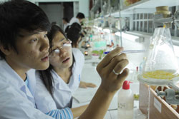
Students at HCM City's University of Natural Sciences take part in an experiment. Lack of funding and complicated administrative procedures are discouraging university staff from conducting research, expert says. (Photo: VNS)
Linh has to teach full time almost every day because his department is severely short staffed.
He is not the only university lecturer in Viet Nam who misses his research.
Only 6.5 per cent of his colleagues at provincial universities and 15 per cent of lecturers at national technology universities are involved in university-level academic research, according to a recent report by the Ministry of Education and Training's (MoET) Science and Technology Department.
Research is apparently now an Achilles' heel for many of Viet Nam's universities, a challenge that the country needs to tackle to achieve its goal of bringing its universities up to international standards.
MoET's report, conducted across 34 Vietnamese universities, indicated that technology universities had the highest percentage of lecturers involved in academic research - 4.8 per cent at a national-level and 12 per cent at a ministry-level. The figures were far smaller at provincial universities - just 0.5 per cent and 1.2 per cent, respectively.
The ministry report suggested a poor standard of university research that was preventing Viet Nam from fulfilling its target of breaking into the world's top 200 universities by 2020.
In many countries, including those at the forefront of education such as the United States and Britain, research is one of the key elements of a university.
Professor Frank Webster, head of the City University London's Sociology Department, said in his department, which was fairly typical of sociology departments in universities across the UK, staff spent an equal amount of time on teaching and research.
Broadly speaking, he said that 30 per cent of their time was spent on lectures and classes, 30 per cent on research and writing, and 30 per cent on administrative roles and office work.
"As a department head, I have little time for research. I try to keep abreast of my subject, but have little time to write, a loss I feel badly," said Webster. "Mostly at weekends, it's research I do if at all possible."
Professor Thom Hudson from the Department of Second Language Studies at the University of Hawaii, also said it was very important for university lecturers to spend a sufficient amount of time on research.
"Research is very important at the University of Hawaii for promotion and tenure. I would estimate that about half of one's time is concerned with research and writing," he said.
In Viet Nam, however, not that many university lecturers have such a passion for research.
Doctor Le Thi Hanh from the Education Management Institute said many Vietnamese university lecturers underestimated the role of research.
Doctor Tran Hoang Hao from HCM City's National University said most research projects were conducted by prestigious scientists.
According to Professor Dao Trong Thi, chair of the National Assembly's Committee for Culture, Education and Youth, low research budgets and complicated procedures were among the factors discouraging university staff from conducting research.
MoET's report showed that 248 research projects at a country-level were carried out between 2006 and 2009 with a total budget of VND136 billion (US$6.8 million), or roughly $27,400 for each project.
About 5,500 university-level projects were reported during the same period, with a budget of VND53 billion ($2.65 million), or $480 per project.
That's why the major source of income for most university staff in Viet Nam comes from lecturing.
Some of them were doing two or three times as many lectures than the required amount, which was already very high compared to other countries, said Nguyen Quoc Vong, a lecturer from the Ha Noi Agriculture University.
The high ratio of university staff to students in Viet Nam (1:30) also made it difficult for them to find time for research, he said.
Doctor Nguyen Thi Canh from HCM City's National University said many research projects were impractical.
Professor Dao Trong Thi said the poor research record of Viet Nam's universities could not improve unless there was a change in the methods of management and the way educators thought.
"To inspire university staff to conduct research, a massive budget isn't necessary, but a good way of using that budget is," he said.
He said the importance of a project should be taken into consideration before a budget was allocated.
"To inspire university lecturers, we need to wake up the passion inside them by managing and judging their research in a fair way," he said.
Making research part of the criteria to classify university staff - such as for pay rises and higher academic titles - would also be a good way of improving the standard of research, he said.
"In my opinion, we need to manage in a way that encourages lecturers to move forward with their careers, and to move forward, they will need to have qualified research," said Thi.
The current performance assessment, which was based on class hours, undoubtedly led to the fact that university staff preferred teaching, he concluded.
VietNamNet/Viet Nam News

Last update 31/01/2011
University lecturers absorbed by teaching, have no time for research
VietNamNet Bridge – University lecturers spend most of their time on teaching and giving extra classes to earn their living, which explains why they do not have time for research.

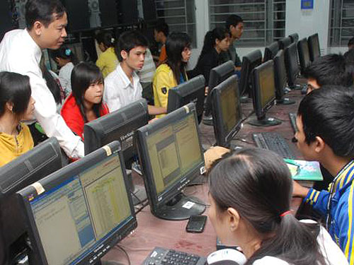
Besides teaching students, big universities in other countries also act as the research centers to boost innovation and transfer of technology. Meanwhile, Vietnamese universities are still far from being considered scientific centers

Heavy in theories, light in applications
Dr. Le Thi Tuyet Hanh from the Education Management Institute says that many university lecturers think that research is not an important part of their work. They have a more important work to do: teaching as many hours as possible in order to get money.
That explains why the Hanoi National University, one of the biggest universities in Vietnam, has to refund hundreds of million or billions dong a year, because it did not spend all the money on research projects.
Every year, the state budget allocates money to the universities nationwide to serve as research fund. However, many universities do not use the money because they do not have many research projects.
Scientists and educators agree that the current mechanism of registering research projects is too complicated and time-consuming. In fact, Vietnam does not lack talented scientists, but they face complicated procedures of project registration and disbursement
Phan Kim Ngoc from the HCM City University of Natural Sciences relates that after registering a research project, he received money. However, the sum was only enough to buy an old screen with low quality. Ngoc decided to use his own money to buy a bigger and better screen. However, then, he had to explain the reason and had to change invoices to prove that he used the money for the right purpose.
Ngoc also says that the low salaries have forced many university lecturers to take extra jobs. Some teach extra hours, while others have to take the jobs which in no way related to their profession.
Ngoc now earns only 4 million dong a month teaching at the university.
Dr. Tran Hoang Hao and Huynh Duc Thien (MA), from the HCM City University for Social Sciences and Humanity, also admitted that very few lecturers want to do research. If they do, the research mostly focuses on theory, while they do not have high application levels.

How much can university lecturers earn?
According to Le Minh Tien from the HCM City Open University, the main income source of lecturers is teaching.
Nguyen Quoc Vong, Lecturer of the Hanoi Agriculture University and RMIT in Hanoi, said that most lecturers have to teach long hours, 200-300 percent more than required.
As the ratio of lecturers per students in Vietnam is very high, 1/30, and lecturers have to teach longer hours, they do not have time for research.
Under the current regulations, every professor and associate professor has to teach 380 hours a year, every main lecturer 360 hours, and normal lecturer 280 hours.
State owned schools are now facing the so called “brain-drain”. As Bui Van Mien from the HCM City Agriculture and Forestry University says, non-state schools pay lecturers better, and it would be “ foolish to refuse to teach at non-state schools”.
His university, for example, pays 25,000 dong per hour to regular lecturers, and 50,000 dong per hour to the lecturers with doctorate or professorship. Meanwhile, non-state schools pay 80,000-120,000 dong per hour.
Source: Nguoi lao dong

50% of school teachers regret career choice: report
Tuoitrenews
Updated : Thu, August 9, 2012
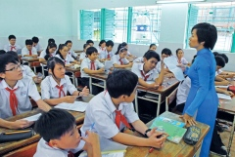

An English class at Nguyen Van Troi Middle School in Go Vap District, Ho Chi Minh City

Photo: Tuoi Tre
About half of local school teachers regret choosing teaching as their career, a survey says.
>> Would-be teachers don’t know how to teach: report

Over 40 percent of the polled elementary school teachers said they would make a different career choice, said Dr Vu Trong Ry with the Vietnam Institute of Educational Sciences, who conducted the survey on 526 teachers in five provinces and cities. The percentages for middle and high school teachers are 59 and 52.4, respectively.
Low income is to blame, survey results show, elaborating that teachers have to do side jobs, i.e. private tutoring and farming, or ask for help from family members to survive.
The scientist pointed out that a pedagogical school graduate can merely earn VND2 million (US$96) a month, only enough for meals for half a month, and many still rely on their parents for other expenses.
He then rejected conjecture that teaching is an easy job, and thus teachers should not complain about their low pay.
Dr Ry cited from his survey that elementary school teachers have to work 1.5 times more than the 40-hour weekly limit capped by the government, whereas middle and high school teachers often spend up to 70 hours a week on teaching and other related duties.
They have to try to meet high expectations and suffer serious pressure from parents, education management officials and society at the same time, the pundit said.
Dr Ry warned that teachers will not have the drive to continue teaching if salary remains a challenging issue.
They would simply try to fulfill their minimum responsibility without developing a love for their career, he said, cautioning that good students and useful citizens for the country will not be produced this way.
Teaching staff problems like this will never lead to a high-quality education as Vietnam expects, he concluded.

Would-be teachers don’t know how to teach: report
Tuoi Tre
Updated : Thu, July 19, 2012


This photo illustration displays local English teachers discussing at a training course recently organized by the Ho Chi Minh City Department of Education and Training.

Photo: Tuoi Tre
Local pedagogical students are very weak in teaching skills even though they have a sound understanding of the subject they will be teaching, educators said Wednesday at a conference in Hanoi, citing their research project.
Assoc Professor Vu Trong Ry, a project member who is with the Vietnam Institute of Educational Sciences, complained that the majority of pedagogy majors have no ability to plan their teaching and behave in particular circumstances, especially when dealing with misbehaving students, when it comes to microteaching.
They do not know how to prepare lesson plans and arrange teaching spans in class, Prof Ry said, adding the would-be teachers even fail to explain themselves smoothly and raise questions for students despite having solid expertise in their subject.
He blamed all those weaknesses on teacher training schools, which often spend most of the time providing the majors with only technical knowledge.
Prof Dinh Quang Bao, another research team member, pointed out that teaching methodology accounts for less than 20 percent of math and literature disciplines’ curricula at two leading teacher training schools, Hanoi National University of Education and Can Tho University, whereas it should be at least triple that percentage.
This should be adjusted to produce good teachers for the educational system, according to Prof Hoang Tuy, a prominent academic who is also on the research team.
“Without good teachers, it is impossible to have a good educational system,” Prof Tuy said.
Prof Bao complained that it is very difficult to have competent teachers as pedagogical schools are increasingly lowering their academic standards to admit students.
“Qualified teachers can hardly come from low-performing enrollees.”
Meager salary
Prof Tuy said that teachers deserve higher salaries, as many are trying to do side jobs to survive while still having to spend 60 to 70 hours a week on teaching and other related duties.
The research project showed that 50 percent of the polled teachers live on an income lower than the VND3.8 million (US$182) average salary, while a teacher with 25 years of experience receives a mere VND4.1 to 4.7 million (up to $226) a month.
Meanwhile, a fresh college graduate can earn as much as VND5 million ($240) per month if he chooses to work in the private sector.
Fewer and fewer applicants go for pedagogy at the undergraduate level because expectations for them are high, but income is not, said Nguyen Quang Kinh, another member of the team.
Kinh asserted that hiking the teacher salary is a must if Vietnam wants to improve its education.
“An educational system would have no future if its teachers have to teach to make ends meet,” he added.

Vietnam education system rejects what it produces
Tuoi Tre
Updated : Fri, August 17, 2012,
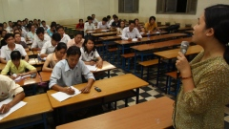

This photo shows an evening class at Saigon University. Many employers in the education sector now shun part-time degree holders on quality grounds.

Photo: Tuoi Tre
Vietnamese educators’ efforts to create a fair and advanced education system have yet to pay off as they are now experiencing a splitting headache: that same system refuses its own products.
Education officials have repeatedly insisted that no distinction should be made between part- and full-time degree programs, but the reality is always harsh.
In fact, many local education departments have officially announced they will not consider applicants with a degree earned from what Vietnamese call ‘in-service mode,’ which provides people who are working with part-time training programs – mostly of lower academic standards than their full-time counterparts – when they look for teachers and staff members.
In a recent teacher recruitment notice, the education department in the northern province of Ha Nam said that it would only accept applications by graduates of top-tier universities and noted point blank that candidates with a part-time degree would surely be turned down.
Nam Dinh, Ha Nam’s neighbor, has long dodged part-time degrees when recruiting employees for the education sector because it does not want to waste time screening applications with a very high likelihood of failing to meet its requirements in the first place, as elaborated by the provincial home affairs department, which supervises recruitment.
It will follow the same procedures this year, the department has said.
Another northern province, Vinh Phuc, lying northwest of Hanoi, has also said ‘no’ to part-time graduates since last year.
Down south, Ho Chi Minh City is no exception, as a personnel manager of the municipal education department says graduates from full-time programs will be given high priority during its teacher staffing process this year.
“I think full-time graduates are better,” Van Cong Sang, the manager, said.
Quality difference
A former education official in Ha Nam cited quality discrepancy as the reason for the province’s recruitment policy, which he said dated back to seven years ago.
“Teachers are the most important element to give birth to a good education system, so our way is completely justified,” explained Nguyen Quoc Tuan, former director of the local education department.
The majority of part-time students yield very disappointing performance, according to Assoc Prof Hoang Dung, with the Ho Chi Minh City University of Education.
Dr H., who is teaching in-service programs at many universities in Ho Chi Minh City, revealed that course directors are always lenient with part-time students, as most of them have to go to work during the day.
“We often give easier end-of-semester tests,” H. said, “because it is an unspoken assumption that academic bars should be lowered in this case.”
The lecturer recalled an incident when a school refused to renew a contract with him after he had failed too many students in a part-time course.
Part-time students themselves reported that many lecturers even cut their curriculums by up to a third, and that cheating is not uncommon in final exams.
The game should be fairer
Early elimination of part-time degree holders is unfair no matter what reason is given, local educators have complained, calling for equal opportunity for both part- and full-time graduates.
Candidates should not be judged by their diplomas, they said.
The education law stipulates that part- and full-time degrees are equally valid, said Dr Nguyen Kim Hong, vice president of the Ho Chi Minh City University of Education.
“So why not put everyone in the same selection process instead of disregarding some?”
My Giang Son, academic affairs head at Saigon University, gave his agreement, and added that a candidate’s capability can only be seen through real tests.
These employers’ refusal may stem from their own past experiences with certain people with a part-time degree, but that does not mean their evasion of the rest is defensible, according to Vu Thuy Quynh, dean of the part-time training department at the Hanoi-based University of Languages and International Studies.
This kind of discrimination would discourage serious attempts by schools to gradually bridge the quality gap between different training modes, Dr Hong, the vice president, said.
In Vietnam, universities are believed to compromise on the quality of their part-time training programs, and thus recruit as large a number of students as possible to simply reap profit.
i'm the one of part-time graduate.and i think it's unfair for the full-time graduates to take the priority while the part-time ones are likely to be turned down by the recruiters.it's true that not all the full-time graduate are good at working as well as not all part-time graduates are unable to do their jobs well. i like the way of recruitments of westerners.no matter who you are,what they pay attention to is how you prove your real ability in the interview.i think it's quite fair for both the two kinds of graduates and it also makes benefits for the employers cause they can recruit the best candidates for their companies.
Written by hongtham , 22 August 2012

Last update 31/01/2011

Students avoid social sciences
VietNamNet Bridge – The study of social sciences and humanities has become unpopular among youth, with many students opting to pursue majors in subjects such as information technology, marketing or finance.

It's an alarming trend to some experts, and the battle to lure more students to humanities and social sciences will be tough.
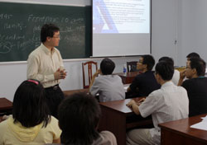
Students at the HCM City University's Faculty of Sociology attend an English language lecture. Students are showing little interest in the study of social sciences and humanities. (Photo: VNS)
In part, these majors are unpopular as many young students see humanities and social sciences as mundane subjects that leave graduates with few job prospects.
"The hot degrees are now in the economics field," says one parent. "That's because social sciences and humanities, including subjects such as psychology, offer such low-paid incomes that nobody would want to pursue this type of job."
Both parents and students are increasingly viewing social science and humanities as degrees with poor prospects.
Statistics reveal a sharp fall in student applications at the University of Social Sciences and Humanities at the National University of HCM City, from 17,466 in 2008 to 12,947 in 2009 and 12,752 last year.
"Youngsters instead flood faculties such as International Relations, Journalism, Public Relations and Oriental Studies," said Pham Tan Ha, deputy head of the Training Department at the university.
Ha said many assumed social sciences and humanities focus too much on theoretical subjects such as philosophy and dry lessons on the history of Communism.
According to the Training Department, most students at social sciences faculties hope to become university lecturers or win jobs at other education institutions.
According to Ha, their job prospects are quite good.
A study carried out by the university shows that 95 per cent of social sciences and humanities graduates are employed within six months of graduating. Students from faculties such as International Relations land jobs even faster, usually within three months.
"It is ridiculous to say there will be no job prospects for us after graduation," said Kieu Hong Hanh, a fourth-year student at the University of Social Sciences and Humanities.
"Students in their third and fourth year are already able to make good money."
After completing a scholarship in Japan last year, Hanh said many local enterprises had offered her positions after her graduation. Most of these jobs came with a monthly salary of at least US$400.
Hanh said about 90 per cent of her classmates had been in touch with companies that are willing to pay them VND 6-7 million ($300 – 400) per month to work as interpreters, secretaries and market researchers.
VietNamNet/Viet Nam News

Last update 18/02/2011

SOS: students give up school to earn money
VietNamNet Bridge – The high percentage of drop-outs cause a headache to the provinces in the central region and Mekong Delta. Many students have given up schools because they are busy working to earn money for their families.

It has been one week since The schools in Quang Ngai province have returned to their normal working after a long Tet holiday. However, hundreds of students in six mountainous districts, including Ba To, Son Ha, Minh Long, Son Tay, Tra Bong and Tay Tra, still have not come back to school.
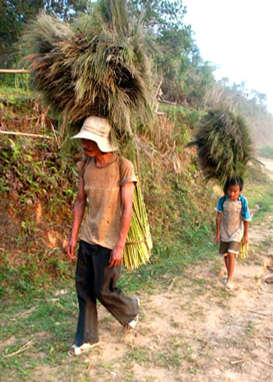
Chief Secretariat of the Quang Ngai provincial education and training department Nguyen Ngoc Tuu has confirmed that in these districts, only 85 percent of students have returned to classes, and that hundreds of students have not turned up.
Explaining this, Tuu explains that it is now the harvest season for dot tree (a type of tree used to make brooms), therefore, many students have to help their families to earn their living. Besides, some other students want to prolong the Tet holiday, therefore, they have not come to class. Tuu says that the students will come back to school in the second half of the first month of the lunar year.
Director of the Education and Training Department of Binh Dinh province Tran Van Quy reports that 2000 students in the province have given up school after the end of the first semester. Especially, high schools have the highest percentage of drop-outs:1400 students. Their bad results at school and difficult financial situation have been cited as the main reasons.
Thanh Hoa province has also reported that many students in the province have given up school to pick dot and bong lau trees to earn money. These trees are called by local residents as the “gifts from the forest” and are harvested only in dry season. Every student can earn 50,000-70,000 dong a day from picking and selling dot and bong lau, therefore, they would rather go working than to school.
The report released by the Thanh Hoa Education and Training Department on February 16 showed that by the end of the first semester of the 2010-2011 academic year, 2000 students had reportedly dropped out. Most of them are living in mountainous areas. These include 1172 high school students and 841 secondary school students.
The same is happening in Mekong River Delta. Teachers in the provinces have to go to students’ families to persuade parents to let their children go to school. But without success because most students are still busy working with their parents to earn the living.
In Ca Mau, not only students in remote areas, but also those in the city have also given up school. After the Tet holiday, 240 students of the Ca Mau High School reported that they have to work for money.
The number of students at the Ca Mau High School has dropped from 4160 to 3920. The school headmaster Tran Hong Chau says that the regulation that tuitions for the year have to be paid in one installment has caused big difficulties for poor households. As a result, many students have to give up school because they do not have the money.
In Soc Trang province, Pham Thi Cam Tu, Headmaster of Nguyen Khuyen High School said that the number of students has decreased by 4.7 percent. “We have been told that many students have given up schools to go working,” she says.
The high percentage of drop-outs causes a headache to many provinces. However, there is no easy solution because parents say their children need to earn their living first before thinking of going to school. Some parents have told teachers that they will only let their children return to school if local authorities give them rice and food.
Headmaster of Tu Diem Primary School in Soc Trang province Nguyen Van Von said that the sea water has penetrated the poor district and flooded the farm lands. Therefore, local residents have to leave villages for other localities to work for other people. As children follow their parents and drop out from schools.

C. V

http://www.nytimes.com/2013/02/10/world/europe/german-education-chief-quits-in-scandal-reflecting-fascination-with-titles.html?ref=todayspaper&pagewanted=all

German Fascination With Degrees Claims Latest Victim: Education Minister

Tobias Schwarz/Reuters
Education Minister Annette Schavan, left, with Chancellor Angela Merkel on Saturday.

By NICHOLAS KULISH and CHRIS COTTRELL

Published: February 9, 2013

BERLIN — For 32 years, the German education minister’s 351-page dissertation sat on a shelf at Heinrich Heine University in Düsseldorf gathering dust while its author pursued a successful political career that carried her to the highest circles of the German government.
Enlarge This Image
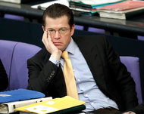

Michael Sohn/Associated Press
Karl-Theodor zu Guttenberg in 2011, the year he stepped down as defense minister.

The academic work was a time bomb, however, and it exploded last year when an anonymous blogger published a catalog of passages suspected of having been lifted from other publications without proper attribution.
The university revoked the doctorate of the minister, Prof. Dr. Annette Schavan, on Tuesday (she retains the title pending appeal), and on Saturday she was forced to resign her cabinet post. It was the second time a minister had resigned from the government of Chancellor Angela Merkel over plagiarism in less than two years.
In an emotional news conference, Dr. Schavan said that she would sue to win back the doctorate, but in the meantime she would resign for the greater good. “First the country, then the party and then yourself,” she said.
Standing beside her, Dr. Merkel, who herself has a doctorate from the University of Leipzig, said that she accepted Dr. Schavan’s resignation “only with a very heavy heart,” but that politically there was no alternative.
Coming after Karl-Theodor zu Guttenberg was forced to step down as defense minister over plagiarism charges in 2011, Dr. Schavan’s déjà-vu scandal can only hurt Dr. Merkel ahead of September’s parliamentary election. But the two ministers are far from the only German officials to have recently had their postgraduate degrees revoked amid accusations of academic dishonesty, prompting national soul-searching about what the cases reveal about the German character.
Germans place a greater premium on doctorates than Americans do as marks of distinction and erudition. According to the Web site Research in Germany, about 25,000 Germans earn doctorates each year, the most in Europe and about twice the per capita rate of the United States.
Many Germans believe the scandals are rooted in their abiding respect, and even lust, for academic accolades, including the use of Prof. before Dr. and occasionally Dr. Dr. for those with two doctoral degrees. Prof. Dr. Volker Rieble, a law professor at Ludwig Maximilian University of Munich, calls this obsession “title arousal.”
“In other countries people aren’t as vain about their titles,” he said. “With this obsession for titles, of course, comes title envy.”
A surprising number of doctors of nonmedical subjects like literature and sociology put “Dr.” on their mailboxes and telephone-directory listings. The Web site of the German Parliament, the Bundestag, shows that 125 of 622 people elected to the current Parliament (including Dr. Schavan and Mr. Guttenberg) had doctorates when sworn in.
Dr. Merkel appointed Prof. Dr. Johanna Wanka, the state minister of science and culture in Lower Saxony, to take over Dr. Schavan’s position. Prof. Dr. Wanka got her doctorate in 1980, the same year as Dr. Schavan.
The finance minister, Wolfgang Schäuble, is a doctor of law. The vice chancellor, Philipp Rösler, is an ophthalmologist and thus the only one most Americans would call “doctor.”
For the plagiarism scalp hunters, the abundance of titles provides what in military circles is known as a target-rich environment, and digging up academic deception by politicians has become an unlikely political blood sport.
There is even a collaborative, wiki-style platform where people can anonymously inspect academic texts, known as VroniPlag.
Here in the homeland of schadenfreude, the zeal for unmasking academic frauds also reflects certain Teutonic traits, including a rigid adherence to principle and a know-it-all streak. “I just think that many Germans have a police gene in their genetic makeup,” Dr. Rieble said.
The University of Heidelberg revoked the doctorate of Silvana Koch-Mehrin, former vice president of the European Parliament and a leading member of Germany’s Free Democratic Party, in 2011, and she is still fighting the charges in court.
Another German member of the European Parliament, Jorgo Chatzimarkakis, saw his doctorate of philosophy revoked by the University of Bonn in 2011 after the VroniPlag Web site uncovered a number of dubious passages. Florian Graf, head of the Christian Democrats’ delegation in the Berlin city legislature, lost his Ph.D. last year after admitting to copying from other scholars’ works without properly crediting them.
In many countries, busy professionals with little interest in tenure-track positions at universities do not tend to bother writing dissertations. In Germany, academic titles provide an ego boost that lures even businesspeople to pursue them.
Prof. Dr. Debora Weber-Wulff, a plagiarism expert at the University of Applied Sciences in Berlin and an active participant in VroniPlag, suggested getting rid of superfluous doctoral titles outside of academia. “A doctor only has meaning at a university or in academia,” she told German television. “It has no business on political placards.”
But she is originally from Pennsylvania. Here the attitudes are deeply ingrained, and few think habits will change anytime soon. “It is a proof that you can handle academic stuff and that you can keep on task for quite a while,” Dr. Peter Richter, a correspondent in New York for the newspaper Süddeutsche Zeitung, said in an e-mail.
It can be a shock to Americans unfamiliar with the practice, as Dr. Richter has experienced in New York. “Here people instantly think that I’m a medicine man when they read my name,” he said.
Even within Germany the practice differs by region, he said, with those in the conservative south insisting on titles more than those in northern cities like Hamburg. There are other divides, with many members of the counterculture generation of 1968 rejecting titles, though many have come to enjoy them as they have grown older.
Dr. Schavan, 57, whose parliamentary district is in the southwestern state of Baden-Württemberg, was granted her doctorate in 1980; her dissertation was titled “Person and Conscience.” Despite that title, she was not shy about chastising Mr. Guttenberg, once an up-and-coming star from neighboring Bavaria, when his plagiarism scandal struck in 2011. One of her fellow cabinet member’s most prominent and outspoken critics, she told Süddeutsche Zeitung that she was “ashamed, and not just secretly,” about the charges against him.
The accusations against Dr. Schavan surfaced the following year on a bare-bones, anonymous Web site. The accusations were particularly significant for Dr. Schavan because she led the federal Ministry of Education and Research.
When Dr. Schavan’s doctorate was revoked, Dr. Merkel said through a spokesman that she had “complete trust” in her. While that may have sounded like a show of support, it was also exactly the same phrase she used for Mr. Guttenberg, right before he had to resign for plagiarizing passages of his dissertation.
Unlike Mr. Guttenberg, Dr. Schavan was widely known to be a friend and a confidante of Dr. Merkel’s, but few here expected that to save her job. The two women met privately on Friday evening to discuss the matter, announced at the chancellery building on a snowy Saturday afternoon. Dr. Merkel was unstinting in her praise for the departing minister but ultimately chose politics over personal ties.
“A health minister doesn’t need to be a medical doctor, but if he is one, then he can’t have committed malpractice,” Dr. Rieble said. “An education minister doesn’t need to have a Ph.D., but if he does, then his dissertation cannot be plagiarized.”
Victor Homola contributed reporting.

A version of this article appeared in print on February 10, 2013, on page A6 of the New York edition with the headline: German Fascination With Degrees Claims Latest Victim: Education Minister.

http://tuoitrenews.vn/education/11276/hanoi-students-pray-for-luck-prior-to-college-exams
Hanoi students pray for luck prior to college exams
Tuoi Tre
Updated : 07/03/2013

“Please give me luck during my exams.”
Tuoi Tre
PrevNext
Hanoi high school students are resorting to spiritual elements in the hope of increasing their chances at the upcoming national college admission exams.
As in previous years, thousands of students jostled Tuesday for a place at the Temple of Literature, thought to be Vietnam's first national university, built in the 11th century, and thus a ‘sacred’ place for praying for luck in exams, to perform observances which they believe will bring them good luck during the exams.
Ceremonies ranging from burning paper votive offerings and lighting incense to touching the stone turtle heads, donating small change, and buying calligraphy papers were carefully observed.
Vietnamese 12th-graders will sit for the admission exams, administered by the Ministry of Education and Training (MoET), either on July 4 and 5 or July 9 and 10, depending on their majors.
Every year local applicants must pass the MoET tests on a set of three subjects chosen from math, physics, chemistry, literature, history, geography, biology, and foreign languages to be admitted to the college of their choice.
Official figures show that about 800,000 candidates will start taking their tests tomorrow.
The exams are seen as the most important of their kind to local high school students because an undergraduate degree is considered a passport to success in this fast-growing country.
See how Hanoi university hopefuls sought luck in the following photos taken yesterday at the temple by a Tuoi Tre reporter.
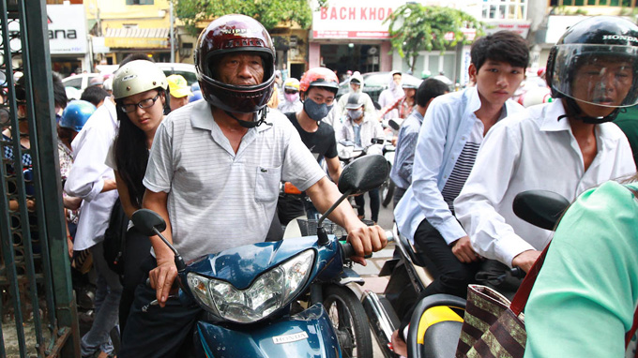
A father brings his daughter to the gate leading to the Temple of Literature.
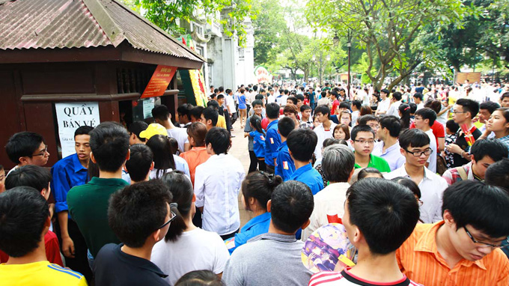
Candidates gathering around the box office at the temple

Praying at the Temple of Literature
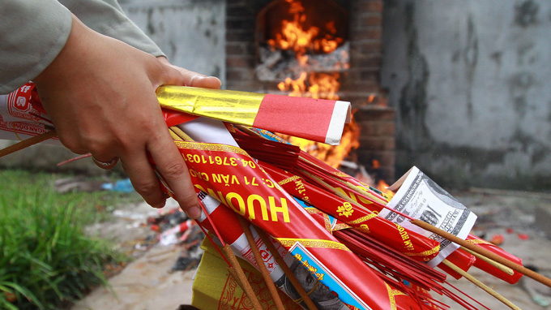
Incense and paper votive offerings to be burnt in return for luck
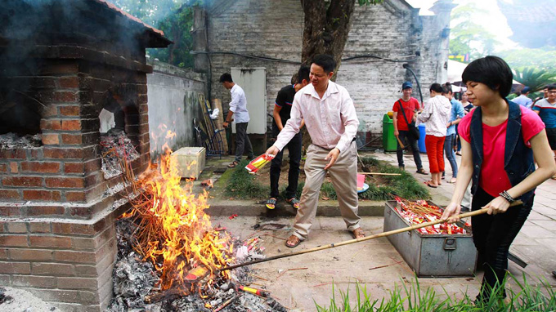
Burning paper votive offerings
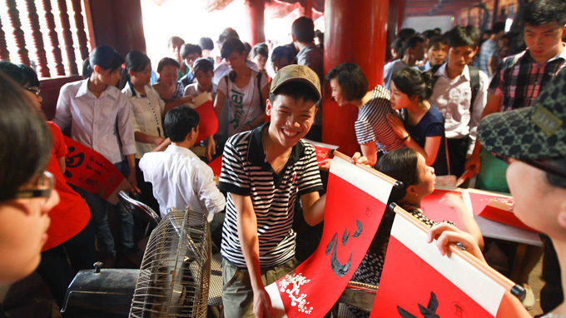
A candidate is seen smiling after buying red calligraphy paper for VND100,000 (US$4.8). The black word means ‘heart’ in English.

Students and parents planting incense in a big censer

These students are pretending to write their names on a red board, which was used to display the names of brilliant graduates in the past, in the hope that this would help them make it through the exams.
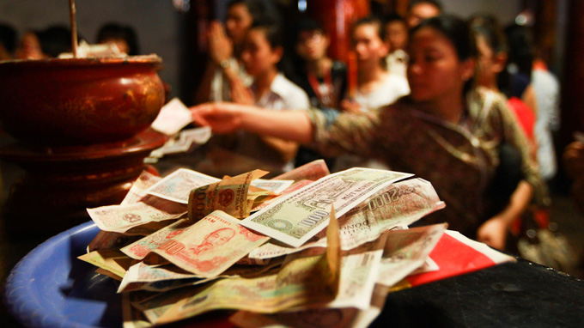
People leave small-denomination banknotes at the temple as charitable donations to receive luck in return.

Calligraphy papers, believed to bring luck to buyers, on sale for VND15,000 (71 US cents) at the temple
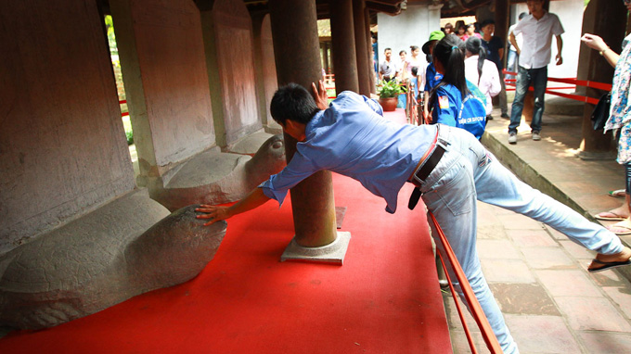
A male student trying to touch the head of a stone turtle statue, a practice to seek luck before exams

END OF CHAPTER FIVE

