VIETNAM in VIET NAM -- 2013
chapter FOUR : DIASPORA

http://www.eyedrd.org/2011/09/portrait-of-vietnamese-americans-by-census-2010.html

Portrait of Vietnamese Americans By Census 2010
Posted on September 8, 2011 by eyedrd
The official documentation of the Census 2010, which has been released, suggests that a Vietnamese community that is dynamic, younger than the national average, and the fourth largest among Asian immigrants in the United States. Although the population growth rate of Vietnamese origin is slower in 10 years, our community “which speaks Vietnamese at home” is higher than the other races. In 10 years, the population of Vietnamese origin has increased by nearly half million , bringing the total number of Vietnamese in the United States to 1,548,449
The Vietnamese community in the United States is comprised of a total of 1,548,449 people, according to official announcement of the 2010 census (Census 2010). 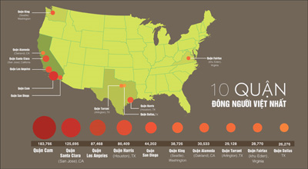
10 counties have the largest community of Vietnamese origin in the United States, according to Census 2010 population statistics. All three belong to the district head of the state of California. (Image: Khoa Vu / Nguoi-Viet)
Therefore, within a decade, from 2000 to 2010, the Vietnamese community in the United States has increased by 425.921 people, or 38%.
The Vietnamese community ranks 4th among the Asian communities in the United States, after China (nearly 3.5 million), India (almost 3 million) and Philippines (2.5 million).
Asian Population in the United States:
- China 3,347,229
- India: 2,843,391
- Philippines: 2,555,923
- Vietnam: 1,548,449
- South Korea 1,423,784
- Japan: 763.325
- The other Asian ethnicities: 2,192,151
About 3/4 Vietnamese-Americans are concentrated in 10 states; the largest concentration is in California; second largest is in Texas ,and third is in Washington.

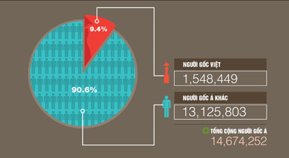
Vietnamese immigrants make up more than 9% of Asian immigrants in the United States. (Image: Khoa Vu / Nguoi-Viet)
The ten states with the most populous of Vietnamese origins include: California (581,000), Texas (210,000) Washington (67.000), Florida (58.000), Virginia (54.000), Georgia (45.000), Massachusetts (43.000), Pennsylvania (39.000) ; New York (29.000) and Louisiana (28.000).
Vietnamese Community, 2000-2010:
2000: 1,122,528 people
2010: 1,548,449 people
Increased by 425.921 people (37.9%)
Among the urban areas (metropolitan area), Los Angeles – Long Beach – Santa Ana is concentrated with the most Vietnamese, with 271,000 people. Next is the San Jose – Sunnyvale – Santa Clara with 126,000 people; the Houston – Sugar Land – Baytown with 104,000 people; Dallas – Fort Worth – Arlington with 72.000 people, and Washington DC – Arlington – Alexandria 59.000 people.

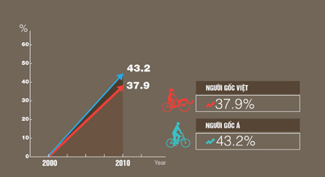
In 10 years, from 2000 to 2010, the community of Vietnamese origin population increased 37.9%, lower than other Asian ethnic groups. (Image: Khoa Vu/ Nguoi-Viet)
Among the cities and in absolute numbers, the most populous cities of Vietnamese origin include: San Jose 59.000 people, Garden Grove 47.000 people, Westminster 36,000 people, Houston 35,000, and San Diego 33.000.
The highest relative percentage of Vietnamese residents in areas or county is Midway, California, with 41% of residents are of Vietnamese origin.
Behind Midway, the next areas with highest percentage of Vietnamese residents are also located in California: Westminster (40%), Garden Grove (27.7%), and Fountain Valley (21%).
Morrow City of Georgia has a high percentage of Vietnamese origin: 20%.
10 States with the most Vietnamese in:
- California: 581.946 (30% increase in 10 years)
- Texas: 210.913 (56% increase in 10 years)
- Washington: 66.575 (up 44% in 10 years)
- Florida: 58.470 (up 76% in 10 years)
- Virginia: 53.529 (up by 43 % in 10 years)
- Georgia: 45.263 (up 56% in 10 years)
- Massachusetts: 42.915 (up 26% in 10 years)
- Pennsylvania: 39.008 (up 30% in 10 years)
- New York: 28.764 (up 21% in 10 years)
- Louisiana: 28.352 (up 16% in 10 years)

Every 100 people of Vietnamese origin in the U.S., 12 people are living in poverty. Under this standard, the Vietnamese community ranks only “richer” than the other two Asian community, the Hmong and Cambodia. (Image: Khoa Vu / Nguoi-Viet)
From the 1970s to the 1990s, the population of Vietnamese origin in the United States increased significantly, partly due to high waves of immigrants. Since 2000, the population growth rate of Vietnamese origin has begun to slow down, at 38%.
Census 2010 statistics cited the results of American Community Survey (ACS), which was published in 2007, which compared to other communities, Vietnamese immigrants have high rates “of speaking their mother language at home,” the largest increase (511%), from 1980 to 2007.
Regarding to age, ACS said the median age of the community of Vietnamese origin was 35.4, compared with 35.7 of Asian ethnicity, and 36.8 of the entire United States.
10 Cities of largest Vietnamese concentrations in:
- San Jose, California: 100.486
- Garden Grove, California: 47.331
- Westminster, California: 36.058
- Houston, Texas: 34.838
- San Diego, California: 33.149
- Santa Ana, California: 23.167
- Los Angeles, California: 19.969
- Anaheim, California: 14.706
- Philadelphia, Pennsylvania: 14.431
- New York City, New York: 13.387
Among a total of 1.6 million Vietnamese people living in the U.S., Vietnamese youth group of age under 17 accounts for 26%, compared with 44% of the Hmong community, 28% of the Cambodians, and 27% of Laotians, and compared with 20% of national average.
The Vietnamese origin over 65 years in the United States accounts for 8%, compared with the oldest Japanese community (22%) and compared with 13% nationally.
In regarding to marital status, 57% of Vietnamese are married, 31% have never married, about 7% divorced , 1% separated, and 4% widowed
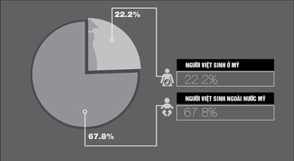
22% Vietnamese-Americans born in the United States; the rest born outside the United States. (Image: khoa Vu / Nguoi-Viet)
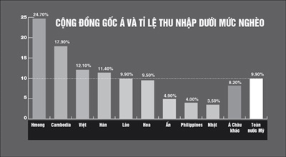
Economically, Vietnamese family living below the poverty line accounts for 12%, compared with 25% of the Hmong (poorest), and with 10% national average. Poverty level in 2011 defined by the federal government for a family of 4 with income under $ 22.350 a year.
The average family’s income and the median income of a Vietnamese family of 4 is $ 59,000 a year compared with $ 47,000 of the Hmong (lowest), $ 99,000 of India (highest), and $ 62,000 nationally.
The percentage of Vietnamese aged over 16 having a job is 67%, ranking 4th in the Asian communities, which is slightly higher than the national rate, 65%.
Approximately 65% of Vietnamese are homeowers (same percentage with the Filipino community) compared with 48% of Hmong and 66% of the country.
Census 2010 cited the report of the Survey of Business Owners (SOB) published in 2007, which indicates the number of businesses owned by Vietnamese people has increased by 56% since 2002, compared to 40% increase among the other Asian communities.
Also according to the same report of the SOB in 2007, the Vietnamese business owners have increased to 229,000, which represents the same rate of 15% as other Asian communities, with revenues of $ 28.8 billion a year.

In five years, from 2002 to 2007, the Vietnamese business community in the U.S. has generated more revenues. (Image: Khoa Vu / Nguoi-Viet)
Nearly 30,000 of these businesses employ a total of 166,00 employees, with revenues of $ 21 billion in 2007, which has increased by 82% compared to 2002.
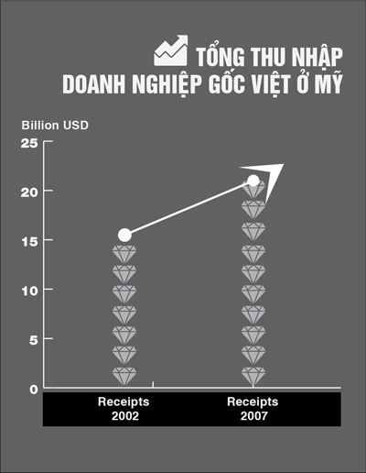
Nearly 67% of the Vietnamese American business concentrates in maintenance, repair, personal services, laundry and retail, accounting for the highest among Asian immigrant groups.
In the exercise of citizenship, the overall Asian-American registration to vote and actually vote is less than the national average.
Census 2010 cited the results of Current Population Survey (CPS) published in 2008, which showed that the voting rate of Asian Americans in the voting age is quite low, 55% compared with 71% of the country.
Moreover, only 48% of the voting age are registered to vote, compared with 64% on national average.
According to CPS results, the naturalized Asian Americans are registered to vote more than native-born Asian Americans.
According to the ACS data for the period from 2007 to 2009, approximately 68% of Vietnamese were born outside of the United States, of which 73% had American citizenship.
Generally speaking, the Vietnamese community in the United States is relatively young, in terms of age (35.4), the proportion of young people under 17 years of age (26%), and the percentage of people older than 65 (8%) compared to the national average 36.8, 20% and 13%, respectively.
With family trends, the Vietnamese American divorce rate is 6%, which is lower than national average (11%), and the family size (3.9 persons / family) is also larger than national average, (3.1 persons/family).
In economic status, the Vietnamese community earns an annual average slightly lower ($59,000) than the national average with $ 62,000 . However, the percentage of homeownerships in the Vietnamese community is 65%, comparable to 66% of the national average, which shows the trend of economy saving and successful settling of the Vietnamese community in America.

FOR IMMEDIATE RELEASE: WEDNESDAY, MARCH 21, 2012

Brief
Press kit

2010 Census Shows Asians are Fastest-Growing Race Group

The U.S. Census Bureau today released a 2010 Census brief, The Asian Population: 2010 [PDF], that shows the Asian population grew faster than any other race group over the last decade. The population that identified as Asian, either alone or in combination with one or more other races, grew by 45.6 percent from 2000 to 2010, while those who identified as Asian alone grew by 43.3 percent. Both populations grew at a faster rate than the total U.S. population, which increased by 9.7 percent from 2000 to 2010.
Out of the total U.S. population, 14.7 million people, or 4.8 percent, were Asian alone. In addition, 2.6 million people, or another 0.9 percent, reported Asian in combination with one or more other races. Together, these two groups totaled 17.3 million people. Thus, 5.6 percent of all people in the United States identified as Asian, either alone or in combination with one or more other races.
Asians Grew by 30 Percent or More in Nearly Every State

The Asian alone-or-in-combination population grew by at least 30 percent in all states except for Hawaii (11 percent increase). The top five states that experienced the most growth were Nevada (116 percent), Arizona (95 percent), North Carolina (85 percent), North Dakota (85 percent) and Georgia (83 percent). These same five states also experienced the most growth in the Asian alone population.

Asians Represent More Than 50 Percent of the Population in Hawaii

The states with the highest proportions of the Asian alone-or-in-combination population were in the West and the Northeast. The Asian alone-or-in-combination population represented 57 percent of the total population in Hawaii. California had the next highest proportion at 15 percent, followed by New Jersey (9 percent), Nevada (9 percent), Washington (9 percent) and New York (8 percent). These same six states had the highest proportions of the Asian alone population.

New York City had the Largest Asian Population among Places

The 2010 Census showed that New York had the largest Asian alone-or-in-combination population with 1.1 million, followed by Los Angeles (484,000) and San Jose, Calif. (327,000). Three other places — San Francisco, San Diego and Urban Honolulu — had Asian alone-or-in-combination populations of more than 200,000 people. This ranking was identical for the Asian alone population.

The places with a total population of 100,000 or more with the greatest proportion of the Asian alone-or-in-combination population were Urban Honolulu (68 percent) and nine California cities — Daly City (58 percent), Fremont (55 percent), Sunnyvale (44 percent), Irvine (43 percent), Santa Clara (41 percent), Garden Grove (39 percent), Torrance (38 percent), San Francisco (36 percent) and San Jose (35 percent).

Among Asians, the Largest Multiple-Race Combination was Asian and White
Of the 17.3 million people who reported Asian, 2.6 million, or 15 percent, reported multiple races. Of the multiple-race Asian population, the majority (1.6 million or 61 percent) identified themselves as both Asian and white. The next largest combinations were Asian and “some other race” (9 percent), Asian and black (7 percent), Asian and Native Hawaiian and Other Pacific Islander (6 percent), and Asian and white and Native Hawaiian and Other Pacific Islander (5 percent).

Detailed Asian Groups

The 2010 Census also provided information on detailed Asian groups. For example, the Chinese, Filipino, Asian Indian, Vietnamese, Korean and Japanese populations each had 1 million or more people.

Chinese (4.0 million) was the largest detailed Asian group, with 3.3 million people reporting Chinese alone and an additional 700,000 people identifying as both Chinese and one or more additional detailed Asian groups and/or another race. Filipinos (3.4 million), followed by Asian Indians (3.2 million), had the next largest number of people who reported one or more detailed Asian groups and/or another race.

Among the Asian alone population that only reported one detailed Asian group, the order of the second and third largest groups switched — the Asian Indian (2.8 million) group was the second largest, followed by Filipino (2.6 million). The Chinese alone population remained the largest.

Among the detailed Asian groups with populations of 1 million or more, the Japanese population had the highest proportion that reported multiple detailed Asian groups and/or another race (41 percent). The Filipino population had the next highest proportion, in which 25 percent of Filipinos reported multiple detailed Asian groups and/or another race.

Geographic Distribution of Detailed Asian Groups

The geographic distribution of the detailed Asian groups focuses on the population that reported one or more detailed Asian groups and/or another race. Among detailed Asian groups with a population of 1 million or more, Japanese (71 percent) and Filipinos (66 percent) had the largest proportions living in the West. Large proportions of Chinese (49 percent), Vietnamese (49 percent) and Koreans (44 percent) lived in the West as well. A much lower proportion of Asian Indians (25 percent) lived in the West.

Among all detailed Asian groups, the Asian Indian population was the largest in 23 states, of which 13 were in the South, six in the Midwest and four in the Northeast. For every state in the West, either the Filipino population or the Chinese population was the largest detailed Asian group. The Filipino population was the largest detailed Asian group in 11 states, the Chinese population was the largest in nine states and the District of Columbia, the Vietnamese population was the largest in five states, and the Hmong population was the largest in two states.

Among the 20 metropolitan statistical areas with the largest Asian alone-or-in-combination populations, Chinese was the largest detailed Asian group in six of the 20 metro areas (New York, Los Angeles, San Francisco, San Jose, Boston and Seattle). The Asian Indian population was also the largest detailed Asian group in six of the 20 metro areas (Chicago, Washington, Dallas-Fort Worth, Philadelphia, Atlanta and Detroit). Filipinos were the largest in five of the 20 metro areas (San Diego, Riverside, Las Vegas, Sacramento and Phoenix), followed by Japanese, Hmong and Vietnamese in one metro area each (Honolulu, Minneapolis-St. Paul and Houston, respectively).

Race Definitions

People who reported only one race on their 2010 Census questionnaire are referred to as the race “alone” population. For example, respondents who marked only an Asian category or categories would be included in the Asian alone population. This population can be viewed as the minimum number of people reporting Asian.

Individuals who chose more than one of the six race category options on the 2010 Census form are referred to as the race “in combination” population, or as the group who reported more than one race. One way to define the Asian population is to combine those respondents who reported Asian alone with those who reported Asian in combination with one or more other races. Another way to think of the Asian alone-or-in-combination population is as the total number of people who reported Asian, whether or not they reported any other races.

CB12-CN.22
Public Information Office
301-763-3030
e-mail: pio@census.gov

The link to the chart will be
http://2010.census.gov/news/img/cb12cn22_chart.jpg

http://www.nytimes.com/2013/06/23/us/communist-is-still-a-dirty-word-in-vietnamese-immigrant-enclaves.html?emc=tnt&tntemail0=y&_r=0&pagewanted=all

‘Communist’ Is Still a Dirty Word in Vietnamese Immigrant Enclaves
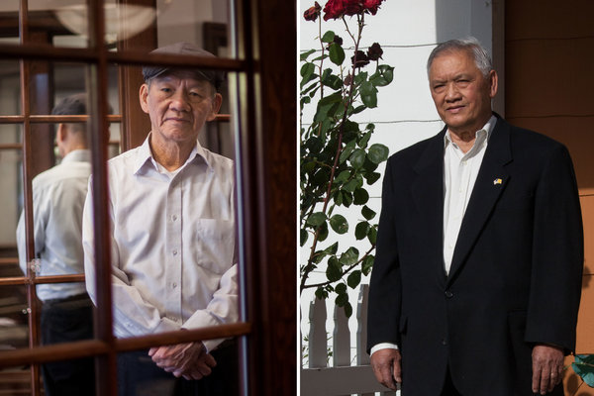
Photographs by David Ryder for The New York Times
Duc Tan, left, filed a libel suit after he was accused of being a communist sympathizer by Norman Le, right.

By KIRK JOHNSON

Published: June 22, 2013

OLYMPIA, Wash. — The cold war may have ended, but in the Vietnamese community here in Washington State, the muscle memory persists.
Enlarge This Image
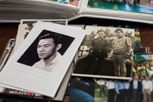

David Ryder for The New York Times
Photographs of Mr. Tan in his younger days, including one of him in his South Vietnamese military uniform.
Enlarge This Image
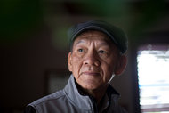

David Ryder for The New York Times
Duc Tan said he believed the accusations of his being a communist sympathizer stemmed from a dispute over a civic group.

Aging refugees who lived through the Vietnam War and the fall of Saigon in 1975, many of them scarred by the experience, have not forgotten, nor forgiven. Even now, an accusation of sympathy with the Communist government — real or imagined — can shatter a reputation.
Or settle a score.
That is apparently what happened in the case of Duc Tan et al vs. Norman Le et al, according to the Washington Supreme Court, in a civil defamation case that has offered a rare glimpse into the gut-punching, passionate inner life of Vietnamese America.
Tensions and worries about free speech have surged in recent days all over the nation amid the controversy over federal monitoring of telephone and Internet traffic for national security. And many of those anxieties are heightened in immigrant communities, especially those from the Middle East, where the terminology of religious extremism can raise red flags.
Here in Olympia, the combatants were men of spare build and thinning hair. One was accused of being a Communist, the other of being a slanderer. Both worked for the South Vietnamese government or military. Both became leaders in local groups that strove to keep Vietnamese language and tradition alive in Western Washington.
But starting about a decade ago, Mr. Le, who is 78, said he became convinced that Mr. Tan, 69, was a secret sympathizer with the Communists in their birth country. He eventually went public with his assertions, which were published in the Vietnamese press and spread through social media.
Some elements of the proof Mr. Le cited might sound comical to outsiders. A cooking apron used at a community fair, for example, was produced at the trial showing a jolly, cap-wearing figure that Mr. Le said was a clear representation of Ho Chi Minh, the Communist leader, but which Mr. Tan said was in fact none other than Santa Claus.
A musician brought in by Mr. Tan for a function struck up the first bars of the national anthem of modern Vietnam, before awkwardly stopping and resuming with what people had expected to hear: the South Vietnamese anthem, theme song of a country that no longer exists. Conspiracy, Mr. Le said; accident, said Mr. Tan.
Mr. Tan ultimately sued in 2004 for defamation, itself a rare occurrence in Vietnamese-American communities, where disputes are usually hashed out internally. A civil court jury found Mr. Le and his co-authors liable.
An appeals court overturned that verdict, but then last month Washington’s highest court restored the jury’s original finding, and the $310,000 award to Mr. Tan and the Vietnamese Community of Thurston County, a civic group. Mr. Le’s lawyers have asked the court to reconsider.
But the scorched-earth battle has already changed the community, residents said.
A Vietnamese language school, which Mr. Tan once led as principal, shrank in the aftermath of the controversy: from 120 students a decade ago to about 60 now, the current principal said. Large gatherings once common for cultural celebration in the Olympia area, like the New Year, have faded or stopped entirely in the last few years.
“We are trying to avoid additional conflict, or labeling,” said Hiep Tran, 50, a transportation analyst for the state.
Mai Vu, 55, said she became convinced in the 1970s, after a few years in America, that rallies and demonstrations were futile in ridding Vietnam of the Communists. But now, she said, she feels a concern that not being seen as anti-communist enough could invite attack.
“When we don’t go out in the street and denounce and say, ‘Down with the Communists,’ then we are communist sympathizers,” she said. “That’s the trouble that I see, and I have a problem with that.”
Mr. Tan said an interview here in his lawyer’s office (where Mr. Tran and Ms. Vu were also interviewed, invited by Mr. Tan and his family to speak about the community) that he is not a Communist, and that the very idea is insulting. Speaking through an interpreter, he said he believed the accusations by Mr. Le arose over a personal dispute about leadership of a civic committee.
“I believe it was a personal disagreement, a personal vendetta,” Mr. Tan said.
Mr. Le, in an interview in his daughter’s house in nearby Lacey, remained adamant, too. He spoke the truth, he said, and regrets nothing.
“We need to speak up, because what brings us here is freedom of speech,” Mr. Le said, sitting in a living room where the yellow and red stripe flag of South Vietnam fluttered at the entryway beside a United States flag, near a portrait of President Ronald Reagan.
Charges of Communist collaboration or sympathy — sometimes accompanied by violence and even killings — tore apart many Vietnamese enclaves in America in the years after the war. And the tough, nuanced personal choices of the period still resonate: Mr. Tan, according to the court record, signed a loyalty oath to the Communist government to secure his release from a re-education camp before fleeing the country in 1978.
But the war generation’s political passions no longer dominate the way they did, said Jeffrey Brody, a professor of communications at California State University, Fullerton, who has studied and worked in the Vietnamese community for many years. For many of the children and grandchildren of refugees, he said, acceptance of the current Vietnamese government’s right to exist, though rarely an applause line, has at least become a legitimate debating point.
“The younger generation is much more politically tolerant of free speech,” he said.
Mr. Le, who spent more than nine years in a Communist labor camp after the war, testified at the trial that people who lived through the takeover have “a different perspective” about communism, and an understanding about communist methods that American courts and jurors could probably never really grasp.
One justice on the State Supreme Court, James M. Johnson, agreed. In a sharply worded dissenting opinion, he called the majority’s ruling “a miscarriage of justice for Mr. Le and all those who have risked everything to enjoy the protections of the United States Constitution.” He added: “The respondents’ experiences with communism are most certainly relevant to this analysis.”
Mr. Le, in the interview, scoffed at the idea, however, that Vietnamese Communists are out to take over or undermine America. The effort, he said, is all about image and control, fostering good opinion about the government in the diaspora among refugees and their children.

A version of this article appeared in print on June 23, 2013, on page A18 of the New York edition with the headline: ‘Communist’ Is Still a Dirty Word In Vietnamese Immigrant Enclaves.

September, 28 2012
Overseas Vietnamese conference opens
by Xuan Hiep

HCM CITY (VNS)— About 1,000 delegates from around the world gathered yesterday in HCM City for the opening of the second Overseas Vietnamese conference.

Politburo member and permanent member of the Communist Party of Viet Nam Central Committee Secretariat Le Hong Anh with the participants at the conference attended by about 1,000 Overseas Vietnamese. — VNA/VNS Photo Thanh Vu
The conference, titled Vision towards 2020 – Overseas Vietnamese Community integrates and grows with Homeland,is being organised by the Ministry of Foreign Affairs State Committee for Overseas Vietnamese. It will run until Sunday.
Speaking at the opening session, Deputy Minister of Foreign Affairs Nguyen Thanh Son, the chairman of the State Committee for Overseas Vietnamese, said the conference would review the development and integration of the Overseas Vietnamese community with its homeland.
The conference will feature four parallel sessions – The Community's Future: Economic Integration and Growth Issues; Cultural Characters and National Traditions: Impetus for Community Solidarity, Linkage with Fatherland; Overseas Vietnamese Intellectuals with the Country's Industrialisation and Modernisation: from Potential to Reality; and Overseas Vietnamese Businesspeople's Contribution to the Future of the Community and Fatherland.
The community of Overseas Vietnamese was represented by academics, businesspeople, writers and artists, leaders of organisations, and youths.
The conference was also attended by Vice President Nguyen Thi Doan, former vice president Truong My Hoa, officials from ministries, Government agencies and local administrations nation-wide, and representatives of Vietnamese agencies and Overseas Vietnamese associations in foreign countries.
Hoa underlined the significant contributions made by the Overseas Vietnamese community to the country's socio-economic development.
She hoped more Government policies would be implemented to encourage the Overseas Vietnamese community to contribute to their fatherland through investments.
Phuong Kim Vy, a Vietnamese-Canadian and CEO of the Cliff Resort and Residences, said this was her second such conference.
"The conference plays an important role in connecting Government leaders and policy makers with Overseas Vietnamese by offering them an opportunity to share opinions and understand each other better so that more policies can be implemented to encourage Overseas Vietnamese to invest in the country," she said.
It is good that Viet Nam has allowed Overseas Vietnamese to have dual nationality and ownership of property in the country, Vy said.
Overseas Vietnamese not only contributed to the country through remittances, intellectual (or white-collar) skills, and technology transfer but also helped create a stable market for Vietnamese products in their home countries.
Vu Kim Huong, a Vietnamese-French businesswoman, dismissed negative comments about doing business in Viet Nam, saying: "To me there is no place better than our homeland, if we know how to adapt well, we can do business successfully anywhere.
"I think that we have a lot of opportunities to do business in Viet Nam, especially in tourism because Viet Nam has a favourable climate and long beautiful coastline, which is an advantage to develop tourism."
Helena Van, who owns three companies in Sweden, said the biggest challenge for Overseas Vietnamese to invest in Viet Nam is the complicated and time-consuming administrative procedures, which frustrate many foreign investors.
The country should improve it as soon as possible, she said.
Around 4.5 million ethnic Vietnamese live in more than 100 nations and territories around the world, according to the State Committee for Overseas Vietnamese.
They include over 400,000 scientists and experts working for research institutes and universities in developed countries.
Remittances and investments by Overseas Vietnamese totalled nearly $20 billion every year, while the intellectual skills of the community would be a treasure for the country's socio-economic development if the country could effectively take advantage of them.
Their remittances topped US$6 billion in the first eight months of this year, compared with $9.4 billion in the whole of last year.
The community has invested $6 billion in 2,000 projects in Viet Nam.
Today, the conference will continue with the four parallel sessions.
The first Overseas Vietnamese conference was held in Ha Noi in 2009. — VNS

27/01/2013

800 overseas Vietnamese entrepreneurs to group up in HCM City

VietNamNet Bridge – On January 28, the Overseas Vietnamese Business Club (OVBC) and the Overseas Vietnamese Association in Ho Chi Minh City will host the first meeting in 2013 with 800 overseas Vietnamese businessmen.
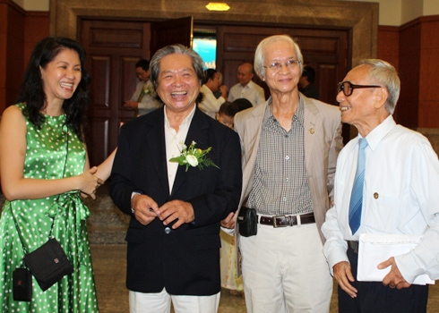
Overseas Vietnamese at a reunion to celebrate the New Year, held by the HCM City People's Committee.
This will be the first event in 2013 of the Overseas Vietnamese Business Club, with the aim of helping the overseas Vietnamese community looking for investment opportunities in their homeland.
The club chair, Mr. Nguyen Ngoc My, said, in the context of global economic recession, many more Vietnamese people in the United States, France, Germany and especially the Eastern European countries are returning to the homeland to do business. This is why the club organizing the meeting to provide investment promotion support for this community.
My said, about 500,000 overseas Vietnamese return to Vietnam annually to visit their family and do business. There are 3,500 firms founded or invested by overseas Vietnamese, with a total registered capital of $8.4 billion.
In addition, overseas remittances sent home by overseas Vietnamese is not small. "If we can promote this capital flow, it will be a great resource for the economy," My said.
Formed in 1999, the Overseas Vietnamese Business Club has 800 members who are overseas Vietnamese entrepreneurs working in the fields of clean energy, pharmaceuticals, information technology, real estate, travel, entertainment, etc., in which the largest proportion is high-tech.
Compiled by S. Tung

dissertation on 'Viet kieu' returning to Vietnam
 | 9/18/12
  Oscar Salemink o.salemink@anthro.ku.dk via mailman1.u.washington.edu
On September 10th Priscilla Koh Siew Im successfully defended her doctoral dissertation ‘Vietnam's Familiar Strangers – Narratives of Home, Homeland and Belonging Among the Second Generation Việt Kiều in Sài Gòn’ at VU University Amsterdam. The dissertation is based on 18 months of field research in HCM City, and was supervised by Dr. Ellen Bal and myself, with Vietnam expert John Kleinen as a member of the doctoral examination committee. A brief abstract follows below.

Vietnam's Familiar Strangers – Narratives of Home, Homeland and Belonging Among the Second Generation Việt Kiều in Sài Gòn.

Vietnam has experienced several periods of mass emigration in the 20th century, driven by war, poverty, political change and the search for better living abroad. The result is that overseas Vietnamese or Việt Kiều are not a homogeneous entity. Groups that left at different periods, for various reasons, bear distinct relationships with the Vietnamese state, and possess varying notions of homeland and nation. Likewise, the state’s attitude towards the diverse groups of overseas Vietnamese is markedly different. It is the post-1975 refugees that the contemporary Vietnamese state has the most difficult ties with, especially those in the United States, where almost half of nearly three million Việt Kiều reside. Koh’s study focuses on the second generation Việt Kiều who have relocated back to Vietnam over the past decade, in light of positive developments in the country's socio-economic structure and policies towards overseas Vietnamese on the one hand, and in its diplomatic relations with the US on the other. The research was carried out in the southern metropolis of Sài Gòn, which remains the most popular destination for Việt Kiều returnees. The "return" experience of this group is unique in that they left Vietnam as children at the end of the Second Indochina War, following the Communist takeover of South Vietnam. The younger generation returnees are interesting research subjects because, although they have not directly experienced the trauma of war and forced flight, they were born into the psychosocial, political and economic context of being a refugee. They represent a generation who have not experienced war directly, but whose lives have nonetheless been shaped by their families' and ethnic communities' memories and experiences of wartime and post-war Vietnam. Members of this generation can also be seen as "going back" to a country which is still governed by the political regime their families' once fled, against the backdrop of the politics of remembrance (anti-communist politics) in the exile community.

The key issue in the research is whether and how the "returns" contribute to new understandings of home, homeland and belonging among the second generation overseas Vietnamese. In what forms do such new understandings take shape? By examining the diverse narratives surrounding the return of the second generation Việt Kiều, the research aims to contribute to current scholarship on citizenship, homeland and notions of belonging. Koh described the diverse motivations for wanting to leave the country where they grew up – standing out and not feeling “at home” in the “host societies”, but also a sense of adventure. She described how these second generation “returnee migrants” did not find “home” in Vietnam, but found a country that often felt alien. Simultaneously Vietnam – or more precisely: HCM City – offered different opportunities than the countries where they came from. Oftentimes, the returnee migrants created “home” in what Koh calls “third cultural spaces” in the City. The research aims to shed light on everyday notions of practical belonging and cultural citizenship to show that constructions of home, belonging and identity are embedded in the "micro-politics" of returnees’ everyday life on the one hand, and in state policies and the official discourse which frame the return experience. Vietnam’s returning Việt Kiều are a relevant and useful case study that can promote understanding of home and homeland issues of other diasporic groups who have experienced similar trajectories.
Please join me in congratulating Pris Koh!
Oscar Salemink
Professor in the Anthropology of Asia

Department of Anthropology
Faculty of Social Sciences
University of Copenhagen, Denmark
o.salemink@anthro.ku.dk
http://anthropology.ku.dk/staff/academicstaff/?id=403491&vis=medarbejder

http://www.nytimes.com/2013/05/16/opinion/arana-the-migrant-cash-lifeline.html?ref=todayspaper

The Migrant Cash Lifeline

By MARIE ARANA

Published: May 15, 2013
WASHINGTON
Enlarge This Image


Clay Blackmore

Every month, Tanita Alfaro, a diminutive night-shift office cleaner in Rockville, Md., puts aside $150 to send to her parents in an impoverished village near the Salvadoran city of San Miguel. Her husband walked 1,700 miles from their war-torn land to the United States-Mexico border 25 years ago and, several years later, she followed.
Ms. Alfaro apportions the money “right away, payday, before I buy so much as a stick of gum” — before she manages the budget that feeds their three young children. For her parents, it is a lifeline. “Between my brothers and me — all of us here, working hard — we keep them alive,” she told me. “We pay our parents’ rent, food, medicines. Everything.”
It’s a scenario immigrants know well. Last year, according to the World Bank, migrants sent $401 billion to their families in developing countries. That’s eight times the United States’ budget for foreign aid, including military and economic assistance. It’s roughly equivalent to the gross domestic product of Austria or South Africa. By 2015, the number could rise to $515 billion.
For India or China, which together receive nearly a third of the remittances, the cash flows have a negligible impact on their burgeoning economies.
But for Latin America and the Caribbean, immigrant largess means $62 billion a year the region wouldn’t otherwise have, a bulwark against poverty. It suggests, rightly or wrongly, that emigrating — for all its risks — might be the best thing the poor can do for their countries.
Remittances account for at least one-fifth of Haiti’s economy. In Honduras, El Salvador and Guatemala — the largest sources of undocumented migrants in the United States, apart from Mexico — officials know that, without that financial windfall, they’d lose as much as 19 percent of their national income. With it, their governments can boost their credit ratings and borrow more. The $23 billion a year that Mexicans send home from the United States may amount to only 2 percent of Mexico’s gross domestic product, but it has pulled whole villages out of poverty.
As colossal an economic engine as $401 billion represents, its true impact is probably even larger. What of the funds that are never counted: stealth dollars that bypass the system entirely? Unlike Ms. Alfaro, I don’t send remittances through an international bank. The money I’ve sent for years to support an elderly aunt in my native city of Lima, Peru, is delivered by family members, in dollars. The Peruvian currency I mail to a 15-year-old girl I know in an Andean town near the border with Bolivia is tucked into packages containing shoes, clothes and school supplies. Remarkably, not one package has ever been stolen.
The money sent home from Maryland by Clara Gonzalez, a native of Venezuela, is paid in cash to a friend in Miami whose sister owns a beauty parlor in Caracas. The friend buys wholesale cosmetics in Miami and ships them to Venezuela. Bolivares, in return, appear magically on the doorstep of Ms. Gonzalez’s shambling old family house in La Guaira. Economic relief flows in such novel ways.
But there is exploitation, too. Every Friday, lines of immigrants coil out the doors of Western Union, MoneyGram and other transfer services, which often charge exorbitant fees. Last year, the Justice Department reported that, between 2003 and 2009, rogue agents at MoneyGram tricked regular customers, including many migrant workers, into wiring them money, by posing as family members. The scheme robbed them of more than $100 million.
There’s also the question of economic volatility. During the 2007-9 downturn, many migrants in the United States — gardeners, busboys, construction workers, maids — were the first to be let go. They were barely able to subsist, much less send money home. Ms. Alfaro’s husband, then working in a convenience store, was laid off. The family’s sudden impoverishment was felt keenly in a little village in El Salvador. Much the same is happening today to Latin Americans in Spain. Which raises the question, are remittances little more than Band-Aids? Or can they help build a foundation for lasting economic development?
The World Bank is bullish, especially in view of immigration reforms being debated in Congress. Over time, the bank says, legalizing 11 million unauthorized workers could have a huge positive economic impact on Latin America.
“It’s all about the interconnection between countries,” says Tamar Jacoby, director of ImmigrationWorks USA, an alliance of businesses that support an immigration overhaul. “The outside knows us better than we know them. It’s so asymmetrical.”
Certainly, the Salvadorans Ms. Alfaro grew up with see us Americans more clearly than we see them. The hemispheric lens is already pointed in both directions, even when we aren’t looking.
Marie Arana, a biographer of Simón Bolívar and a senior adviser to the librarian of Congress, is a guest columnist.

A version of this op-ed appeared in print on May 16, 2013, on page A27 of the New York edition with the headline: The Migrant Cash Lifeline.

Vietnam earns dollars from three main sources: Former governor
VNBN -- 4/16/11
Vietnam is always suffering a large trade deficit of approximately 20 percent against exports every year and in 2010, the lowest trade gap was also up to 16.8 percent, according to Cao Sy Kiem, former governor of the State Bank of Vietnam (SBV).
Thus, foreign exchange earnings in the export‐import operations are always negative, about $20 billion, and $12 billion in 2010.
Meanwhile, fortunately, Vietnam always enjoys remittances, mainly US dollars sent home by workers. The balance from this source is always positive, about almost $10 billion. In 2010, the remittance was estimated at $8 billion.
Foreign investment flows into Vietnam, including non‐refundable aid (ODA) and direct investment (FDI) was estimated tens of billions of US dollars each year.
Thus, if separately calculating the amount of foreign currency revenues from export and import, the balance will be negative, but calculating the three sources of foreign currency flows to Vietnam, the balance will always be positive.
However, the weakness is that, for several years, Vietnam has published the balance of payments with errors at $6‐10 billion, and the question is where this amount goes.
According to some sources, then, this errored amount can flow abroad or in the form of smuggling. The government is clearly determined with this error.
Kiem acknowledged that the foreign currency management of Vietnam is quite loose, such as accepting payment in US dollars on the market. Therefore, the dollar was circulated in every place, maybe in overseas accounts, located at banks and the people.
State authorities do not know the specific numbers of dollars in circulation and therefore the dollars cannot be managed, Kiem said.
According to Kiem, the amount of US dollars in the population is estimated at about $15 ‐ 17 billion. Also according to the data of the State Bank, the figure is about $570 million. – Vietbiz24

Feb 6th, 2013
Banking-Finance | By VBN

Remittances hit four-year highest level
Overseas remittances to Vietnam were estimated to total 10 billion USD last year, the highest figure for the last four years.
Most of the remittances were sent through banks, according to the State Committee for Overseas Vietnamese Affairs, compared to previous years when a lot was exchanged on the black market. The committee reported that the remittance volume was up 10 percent on 2011.
Around 4.5 million Vietnamese, including more than 400,000 guest workers, are living in more than 100 countries and territories worldwide, with over 80 percent of them in developed nations.
The remittances sent home by Vietnamese guest workers from Japan, the Republic of Koreas, Malaysia, Taiwan and elsewhere in Asia have increased considerably, while these from Europe and the US have decreased, according to Maritime Bank’s foreign remittance department.
Vietnam plans to sent 90,000 people to work abroad this year, mainly to the RoK, Malaysia, Russia and Taiwa, according to the Ministry of Labour, War Invalids and Social Affairs. Last year’s number was about 80,000.
The increase in oversea remittances is attributed to the renovation in money transfer to make transactions faster and easier.
Meanwhile, Nguyen Hoang Minh, deputy director of the State Bank’s HCM City branch, said normally the remittance volume sent to the city accounts for between 42-43 per of the country’s total.
About 4.1 billion USD in foreign remittances were sent to HCM City last year. Of this figure, 70 percent went into production and business, 23 percent into real estate and 6 percent to relatives.
A leader of a commercial bank in Hanoi said that in previous years, a large volume of remittance was sent to Vietnam through unofficial channels due to the high disparity in exchange rate between the banks and the free market.
However, with new policies and measures put in place last year to keep the exchange rate relatively stable, thus helping narrow the gap between commercial banks and the black market, most of the remittances sent to Vietnam last year were made through commercial banks. -VNA

http://businesstimes.com.vn/foreign-remittances-estimated-at-10bn-usd/?utm_source=feedburner&utm_medium=email&utm_campaign=Feed%3A+VietnamBusinessWeek+%28Vietnam+Business+News%29
Feb 4th, 2013
Banking-Finance | By VBN

Foreign remittances estimated at 10bn USD
Last year’s overseas remittances into Vietnam have been calculated between 9.5 billion USD and 10 billion USD, considerably exceeding the total of 9 billion USD for 2011.
The Ministry of Industry and Trade estimated Vietnam’s 2012 total export revenues to be around 114.5 billion USD. If the year’s all foreign remittances reach 10 billion USD, it will be represent almost 8.74% of the export performance.
Vietnam’s 2011 foreign remittance result of 9 billion USD was equal to 92% of the country’s trade deficit.
Around 4.5 million Vietnamese, including some 500,000 guest workers, are living in more than 100 countries and territories worldwide, according to the State Committee for Overseas Vietnamese Affairs. Over 80% of them are settling in developed nations.
Vietnam plans to send 90,000 people to work in foreign countries and territories in 2013, mainly to South Korea, Malaysia, Russia and Taiwan, according to the Vietnamese Ministry of Labour, Invalids and Social Affairs. Last year’s number was about 80,000.
At present, remittances sent back home by Vietnamese guest workers from Malaysia, Taiwan and elsewhere in Asia have increased considerably, while those from Europe and the U.S. have decreased, according to Maritime Bank’s forex and foreign remittance department.

Apr 22nd, 2012
Stock | By VBN

Overseas Vietnamese shun stocks
Overseas remittances have increased steadily year by year, and while a large proportion of remittances end up being invested in real estate, just a tiny proportion has been put into the nation’s stock market, Gardners&Partners Investment Joint Stock Co general director Nguyen Tien Thanh has said.
Just five years ago, most remittances flowed directly into consumer spending, but more Vietnamese expatriates were now paying greater attention to investment opportunities in the home country, Thanh said.
Overseas remittances hit a record high of US$9 billion in 2011, an impressive increase over 2010′s $8 billion and accounting for 9 per cent of the nation’s GDP. This moved Viet Nam into the list of the top 16 nations around the world in terms of overseas remittances received.
Amost 50 per cent of these remittances last year were invested in the real estate sector while deposits in banks accounted for 24.7 per cent and consumer spending 19.4 per cent. Only 0.9 per cent were put into the stock market.
Few Vietnamese expatriates were keen on Viet Nam’s stock market due to heavy speculative tricks and insider trading, Thanh said. Many Vietnamese expatriates were also afraid to entrust money to investment or fund management companies for fear of wrongdoings.
“The possibility of detecting such deeds, and the penalty levels in Viet Nam are limited,” he said.
Overseas remittances were forecast to reach over $12 billion this year, Thanh said, and if only 10-20 per cent of this amount were poured become the stock market, it could help the stock market become a more effective channel for enterprises to raise capital.
“It will take some time to lure this money into the stock market,” he said. “The length of time will depend on how successfully the market can be reformed.” — VNS

Few foreigners buying apartments in Vietnam
The Ministry of Natural Resources and Environment’s General Department of Land Management reported that while overseas Vietnamese bought apartments in the country, foreigners rarely did so.
According to statistics, around 300 overseas Vietnamese and foreign individuals and organisations bought apartments in Vietnam before the Lunar New Year festival in 2012.
Vietnam has policies on selling apartments to overseas Vietnamese and foreigners that were put in place in 2008 by Resolution 19/2008/QH12 and Decree 51/2009/ND-CP.
The policies were expected to create breakthroughs in the domestic real estate market but they did not create as much interest as expected.
Experts said regulations on property trading for overseas Vietnamese and foreigners were now too strict; for example, they could own their own apartments but not their own houses.
VOV/VNA
VBN -- 2/6/2012

Sep 25th, 2012
Investment | By VBN

Viet Kieu desire to enrich homeland
Phung Kim Vy, chairman of the Cliff Resort & Residences in Mui Ne, Binh Thuan province on Vietnam’s southern central coast, is a Vietnamese Canadian business woman well known among the Viet Kieu business community in Vietnam. As an entrepreneur, she has made substantial contributions to the homeland and now is deputy chief of the Overseas Vietnamese Club. Vy talks to VIR’s Tuong Thuy.
You have been serving as a bridge for overseas Vietnamese to return to their homeland to do business. What are the reasons?
In the 1990s when Vietnam started the doi moi reform, I had the opportunity to be one of the first Viet Kieu companies organising tours from North America. At that time, several Viet Kieu policies were not carried out for reasons such as the Vietnamese State’s inadequate awareness of the strengths of the Viet Kieu community of about three million people. There were prejudices against Viet Kieu at that time. But that did not diminish Viet Kieu desire of returning to their homeland.
During my visits to Vietnam, I and other Viet Kieu had the opportunity to make suggestions on state policies related to investment, remittance, travel and so on. As 20 years have passed, many things seemed to be very difficult to be implemented, but was later well accomplished. The fact that Viet Kieu can now acquire Vietnamese nationality to be investors in the country is an example. I and my family are enjoying incentives from the Vietnamese government while still being a Canadian citizen.
Vietnam’s open-door policy and its recognition of Viet Kieu as an integral part of the country, have been catalysts to lure many Viet Kieu to return and contribute to their homeland.
In your opinion, what kind of Viet Kieu expertise that the country should tap into for its development?
Now, more and more Viet Kieu are returning to their homeland to live and work. Not only Vietnamese in North America and Europe have made big contributions to the motherland in terms of remittance, expertise and knowledge. Many Viet Kieu from Russia and Eastern Europe have found investment and business opportunities in Vietnam, operating many large corporations in finance, real estate, consumer goods and other fields.
In North America and Europe, the second Viet Kieu generation which includes young people with expertise in information technology, finance, banking and other areas, has seen Vietnam as a promising market. Meanwhile, Vietnamese students studying abroad and Vietnamese guest workers overseas are also strong human resources. In addition, I know that many Vietnamese companies are investing in other countries. All could make contributions to Vietnam’s development.
What is your advice or message to overseas Vietnamese who are returning or have plans to return to the motherland to do business?
My experience is the ability to adapt to the reality in Vietnam is important to make a success, besides professional skills, capital and social relations. Do not compare Vietnam with North America in terms of working conditions like traffic, pollution, social evils, bureaucracy, or a fact that ‘relationships speak louder than talent’.
Taking such issues into consideration, Viet Kieu investors might lose their heart easily. Many Viet Kieu have come and done, again and again. But there are also many stories of success. The current global economic downturn has affected global investment but Vietnam is showing signs of recovery, such as already curbing high inflation and more banking services available. These are encouraging us.
Why did you choose tourism as your business scope?
I established a travel company in April, 1986 in North America. In 1990, I operated a tour for visitors to Vietnam. In the past, for a Vietnam tour, we had to make a transit in Thailand, Singapore, Hong Kong or other countries. I sometimes felt sad to see Vietnam’s tourism develop too slowly and the gap between this sector of Vietnam and other regional countries still big.
But Vietnam’s hospitality industry has so far established a foothold and determined its strengths.
In 2004, we set up Seahorse Resort in the beach city of Phan Thiet. We were no longer a seller of products, we became a maker of products to serve international markets. Vietnam with more than 3,000 km of coastline and about 2,000 islands, together with lots of natural resources, has good conditions to develop a marine economy. Because of that, I made my mind to make tourism my business scope.
What are your business expansion plans?
We made the official opening for the Cliff Resort & Residences this August 2012, and it is our second resort in Mui Ne area of Phan Thiet. We have made great efforts to put the project online.
Given with our business experience in tourism in the region, we feel confident in our products.
The Cliff Resort & Residences has condos, villas and about 150 rooms, and is located right in the gateway to Mui Ne – the hub of resorts. I’d like to say that this asserts a Viet Kieu’s spirit of taking challenges to return to do business in the homeland. I have never regretted this decision.

http://www.nytimes.com/2012/08/12/opinion/sunday/what-we-dont-know-about-vietnam-can-still-hurt-us.html?src=recg&pagewanted=all

Opinion

Exploding the Myths About Vietnam

By LIEN-HANG NGUYEN

Published: August 11, 2012
AS the war in Afghanistan drags on with no definitive victory in sight for the United States and American troops begin to withdraw, comparisons to the Vietnam War are once again in the air, 50 years after both Washington and Hanoi decided to beef up their forces in South Vietnam. “Just take a run through the essential Vietnam War checklist,” wrote Tom Engelhardt in Mother Jones magazine, noting “there’s ‘quagmire’ ” and “the idea of winning ‘hearts and minds’ ” as well as “bomb-able, or in our era drone-able, ‘sanctuaries’ across the border” and even “a one-man version of My Lai.” Although these analogies are particularly attractive to critics — who see America’s battle in Afghanistan as even more futile than Vietnam and advocate a quick exit — they are deeply flawed.
Enlarge This Image
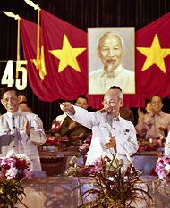

Nihon Denpa News/Associated Press
The Communist Party first secretary, Le Duan, left, with Ho Chi Minh at a rally in Hanoi in 1966.

Among the many problems with drawing lessons from Vietnam and applying them to Afghanistan is that the history of the Vietnam War is often completely misunderstood. The war’s history is constantly evolving as new evidence emerges, particularly from the other side. Since too little attention was paid to understanding the enemy’s motivations, internal dynamics, and foreign relations, we have always had an incomplete and incorrect picture of that war.
If we are to learn from the past, then, it’s worth parting the bamboo curtain that has long concealed decision making in North Vietnam to dispel some ingrained myths of that oft-invoked war.
IT is commonly believed that North Vietnam decided to go to war in 1959-60 to save the southern insurgency from eradication and that the Communist Party enjoyed the unflagging support of the Vietnamese people until the war’s end in 1975. But recent evidence reveals that the party’s resolution to go to war in South Vietnam was intimately connected to problems at home. Revolutionary war was an effective way to deflect attention from domestic problems, including a devastating land reform campaign, a dissident intellectual movement and an unsuccessful state plan for socialist transformation of the economy.
One of the greatest misconceptions of the Vietnam War is that Ho Chi Minh was the uncontested leader of North Vietnam. In reality, Ho was a figurehead while Le Duan, a man who resides in the marginalia of history, was the architect, main strategist and commander in chief of North Vietnam’s war effort. The quiet, stern Mr. Duan shunned the spotlight but he possessed the iron will, focus and administrative skill necessary to dominate the Communist Party.
Along with his right-hand man, the indomitable Le Duc Tho, who would later spar with Henry A. Kissinger during the Paris peace negotiations, Mr. Duan constructed a sturdy militarist empire that still looms over Hanoi today. Their hawkish policies led North Vietnam to war against Saigon and then Washington, and ensured that a negotiated peace would never take the place of total victory.
Mr. Duan ruled the party with an iron fist and saw Ho and Gen. Vo Nguyen Giap, renowned for defeating the French at Dien Bien Phu, as the greatest threats to his authority. He sidelined Ho, General Giap and their supporters when making nearly all key decisions.
In 1963-4, Mr. Duan blackmailed Ho into silence when the aging leader opposed the controversial decision to escalate the war and seek all-out victory before American forces could intervene. And in 1967-8, there was a large-scale purge in Hanoi when Ho, General Giap and their allies opposed Mr. Duan’s plans for the Tet Offensive. Although the southern war initially rallied North Vietnamese to support the party, it soon became a quagmire. Mr. Duan and Mr. Tho reacted by creating a garrison state that labeled any resistance to their war policies as treason. By increasing the powers of internal security forces and ideological police and subjugating the southern insurgency to Hanoi, they were able to wage total war at their discretion until 1975.
The rivalry between China and the Soviet Union also played a major role in determining the course of the war. China’s emerging radicalism and the Soviet Union’s lack of commitment to third world revolutions allowed Mr. Duan to tilt toward China and advance full-scale war in the South in the early 1960s. As American involvement grew in 1965, Soviet aid poured into North Vietnam. By 1968, competition between Beijing and Moscow for influence in Hanoi had become intense.
Mr. Duan sought to assert Vietnamese autonomy by launching both the 1968 Tet Offensive and the 1972 Easter Offensive — moves that Beijing and Moscow disapproved of. In 1972, Richard M. Nixon’s visits to China and the Soviet Union marked the pinnacle of Sino-Soviet obstruction of North Vietnam’s war effort. Both allies exerted pressure on Hanoi to end the war on Nixon’s terms as they competed for Washington’s good graces. Rather than waiting for a “big power sellout,” Mr. Duan and his comrades launched the Easter Offensive, with the aim of toppling the Saigon government and striking a critical blow to America’s détente with the Soviet Union and China.
Finally, it is a myth that America defeated itself in the Vietnam War. In fact, the Vietnamese were anything but puppets or passive players in their war; they shaped American actions in Vietnam as well as the global cold war order. It was Mr. Duan’s bid for victory in 1964 that prompted America to intervene decisively. And America’s allies in Saigon delayed the United States’ withdrawal.
They doggedly pursued their own interests, even when those proved detrimental to the Washington-Saigon alliance. Slowing down American withdrawal in 1969 and sabotaging the Kissinger-Tho peace negotiations in 1972-3, South Vietnamese leaders greatly complicated America’s exit from Southeast Asia. Although Washington possessed its own internal and geostrategic reasons to intervene and remain in Vietnam, it was leaders in Hanoi and Saigon who dictated the nature and pace of American intervention.
Fighting the last war is always a danger. It becomes even more problematic when the historical analogies driving current policy are based on an incomplete and flawed understanding of America’s past failures. As new historical evidence revises our understanding of the Vietnam War and renders any direct analogies untenable, we can at least draw one lesson: to be rigorous in our analysis of the enemy’s war effort.
TALIBAN leaders have conflicting views over peace negotiations, the prospect of reconciliation with the Afghan government, and the movement’s direction. With Mullah Muhammad Omar acting only as the Taliban’s spiritual head, the opportunity has emerged for an enterprising faction with a driven commander — as was the case with Mr. Duan — to unify or dominate the divided Afghan insurgency. This new leadership will inevitably be militant, particularly if America strikes an unpopular bargain with Taliban officials in Pakistan.
And even if increased casualties eventually lead some militants to favor peace, the Pentagon’s policy of classifying all males who happen to be in the vicinity of drone strikes as militants could undermine that impulse, in much the same way that America’s heavy bombing of “free fire zones” and “specified strike zones” in Vietnam drove many embittered villagers to join the Communist ranks.
It is also crucial for the United States to understand the role that regional actors — like Pakistan’s security services — play in internal Taliban politics. While Chinese-Soviet rivalry allowed Hanoi to maintain its autonomy while extracting maximum aid from both countries, the Afghan insurgency enjoys no such advantage, especially since neighboring Iran’s influence is limited. America therefore enjoys more leverage in Afghanistan than it did in Vietnam.
Finally, the United States envisions a complete pullout by 2014, but as history shows, our allies may not always comply with our wishes. It may be up to Hamid Karzai’s government or its successor to set the pace of American withdrawal from Afghanistan. For as we saw in Vietnam, we cannot assume that we alone can dictate our actions.
Lien-Hang Nguyen is an associate professor of history at the University of Kentucky and the author of “Hanoi’s War: An International History of the War for Peace in Vietnam.”

A version of this op-ed appeared in print on August 12, 2012, on page SR4 of the New York edition with the headline: Exploding the Myths About Vietnam.

http://tuoitrenews.vn/cmlink/tuoitrenews/education/education-news/u-s-college-appoints-vietnamese-to-highest-professorship-1.83078

U.S. college appoints Vietnamese to highest professorship
Tuoitrenews
Updated : Tue, August 14, 2012,


Dam Thanh Son, a Vietnamese physicist who has been appointed to University Professor at the U.S.-based University of Chicago

Photo: Tuoi Tre
A Vietnamese academic was appointed last week as University Professor, a title higher than Professor, at the U.S.-based University of Chicago, the institution said on its news website.
Dam Thanh Son, a 43-year-old Hanoian, will work as University Professor of Physics at the university from September 1 this year.
The professorship represents the highest scholarly aspirations of the University of Chicago, which already has an ambitious plan to recruit outstanding theoretical physicists from around the world.
The college selects University Professors from outside institutions because of their internationally recognized eminence and for their potential for broad impact.
Son is the school’s 19th University Professor, and the seventh active faculty member holding that title. He is the second appointment this year, and the fourth in the last two years.
The Vietnamese academic currently serves as a professor of physics and a senior fellow at the University of Washington Institute for Nuclear Theory.
Son gained international prominence for his application of ideas from string theory to the understanding of nuclear matter under high temperature and high density.
With interests ranging across atomic, condensed matter, and particle physics, his research has demonstrated links between such seemingly unrelated areas of physics as nuclear physics and black holes.
“Son is one of the top few theoretical physicists of his generation, and of that elite handful of people, he’s probably the broadest in terms of the impact of his research,” said Emil Martinec, professor in physics and director of the University of Chicago Enrico Fermi Institute.
The physicist has a rare ability to explore physics as a universal, undivided discipline, according to Paul Wiegmann, the Robert W. Reneker Distinguished Service Professor in Physics at UChicago.
“[Son] will provide tremendous intellectual leadership that will mark the opening of a new era in the University’s storied tradition of physics research,” said Robert Fefferman, dean of UChicago’s Physical Sciences Division.
The scientist said he felt extremely honored to join the university, which he called “a world-renowned institution with a long tradition in physics.”
Son earned his master’s degree in physics from Moscow State University in 1991, and his doctorate in physics from Moscow’s Institute for Nuclear Research four years later.
He then held postdoctoral appointments at the University of Washington and the Massachusetts Institute of Technology.

http://www.mercurynews.com/health/ci_19526142?IADID=Search-www.mercurynews.com-www.mercurynews.com

Vietnamese residents of Santa Clara County suffer health gap

By Karen de S�
kdesa@mercurynews.com
Posted: 12/11/2011 04:44:53 PM PST
Updated: 12/11/2011 08:43:27 PM PST

Vietnamese residents of Santa Clara County suffer from higher rates of cancer, tuberculosis and heart disease than most other racial and ethnic groups, concludes a new report being released Monday by county officials.
Vietnamese community leaders say the grim findings can help in the development of better, more strategic outreach programs, screenings and public health campaigns.
"The report really confirms what we suspected, but we didn't know how severe the problems were," said Van Lan Truong, who served on the advisory board for the Status of Vietnamese Health survey conducted by the public health department. "A study like this helps policy makers, elected officials, funders, government agencies and community-based organizations -- anybody who really works with the Vietnamese population -- to have a better understanding and hopefully improve existing services."
Truong, who serves as chair of the National Congress of Vietnamese Americans, said the first-ever study is critical in a region that is home to more Vietnamese than practically anywhere else in the country.
According to the report called for by Board of Supervisors President Dave Cortese, cancer was the leading cause of death among the county's Vietnamese residents -- accounting for a larger percentage of total Vietnamese deaths in 2011 than for the county as a whole. The report found Vietnamese adults more likely than other racial and ethnic groups to suffer and die

from liver, lung and cervical cancer. The rates for heart disease, diabetes and high blood pressure were also disproportionately high.
The health problems have been exacerbated by a lack of health insurance and limited attention by researchers, noted Public Health Director Dan Peddycord. "Prior to this assessment, data for this population in our county had been scant at best," Peddycord said, adding that the report can be used to improve public policy and the delivery of health care services.
Santa Clara County's Vietnamese population has burgeoned in recent decades, from 11,700 residents in 1980 to 134,525 people last year -- roughly 8 percent of the total population. San Jose has the largest number of Vietnamese of any American city, and the number of county residents is surpassed only by Orange County.
But inadequate English language skills, a lack of employer-sponsored health coverage and a difficult-to-navigate health system, many Vietnamese fare worse than their counterparts in every other racial or ethnic group -- aside from Latinos, the report states. Researchers found 1 in 4 of the county's adult Vietnamese residents lacked health coverage.
Still other ills are prevalent but more difficult to measure. Forty percent of survey respondents said in the past year they suffered from a mental health problem that interfered with their daily activities. And although culturally, family connections are paramount among the Vietnamese, domestic violence, substance abuse, intergenerational conflict and youth gang membership continue to strain peace at home.
That's why the county needs more effective strategies to reach low-income Vietnamese, said Quyen Vuong, executive director of the International Children Assistance Network. One in 10 local Vietnamese residents lived in poverty between 2007 and 2009.
Outreach about topics from the importance of Pap smears to parenting classes must be "culturally sensitive," Vuong said, not just the translation of a mainstream American curriculum. Given their great numbers in the local population, "the programs ought to be designed with the Vietnamese clients in mind."
Contact Karen de S� at 408-920-5781.

Canada’s newest senators assume office
By Cynthia Münster | Sep 25, 2012 9:08 pm | 1 Comments
Prime Minister Stephen Harper’s latest Senate appointees had their swearing-in to the Chamber Tuesday afternoon. Diane Bellemare, Tobias C. Enverga Jr., Thanh Hai Ngo, Thomas Johnson McInnis and Paul E. McIntyre, who filled vacancies in Quebec, Ontario, Nova Scotia and New Brunswick, were escorted by their respective sponsors and welcomed by at least two Cabinet Ministers-Defence Minister Peter McKay and Immigration Minister Jason Kenney- who waited outside the Chamber to greet the newcomers. Before their swearing in, each had their photo taken with their sponsor and Leader of the Government in the Senate Marjorie LeBreton.
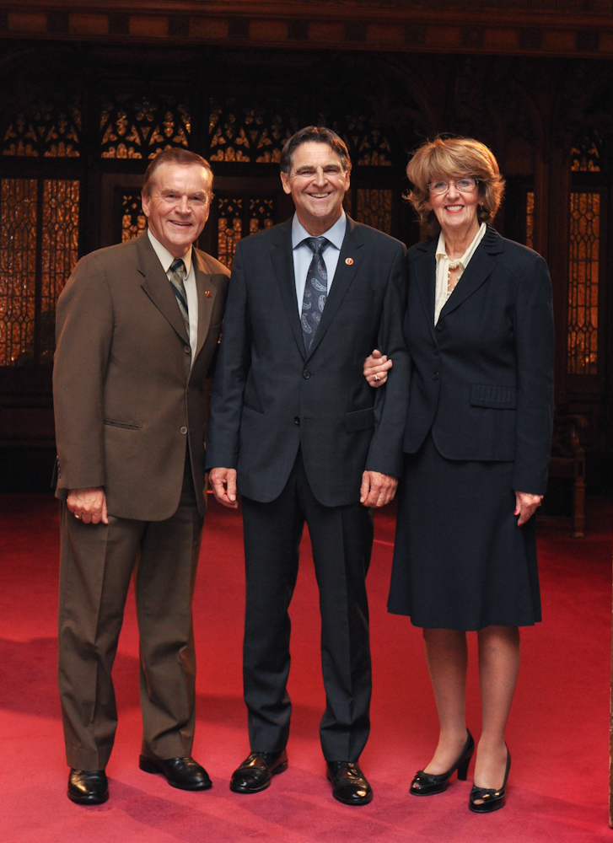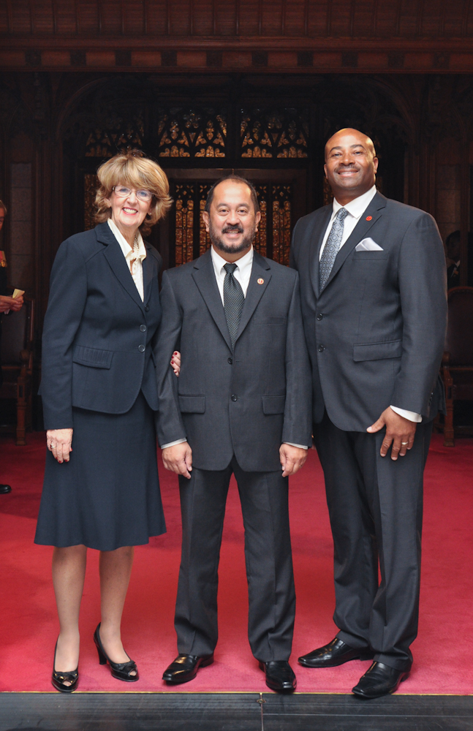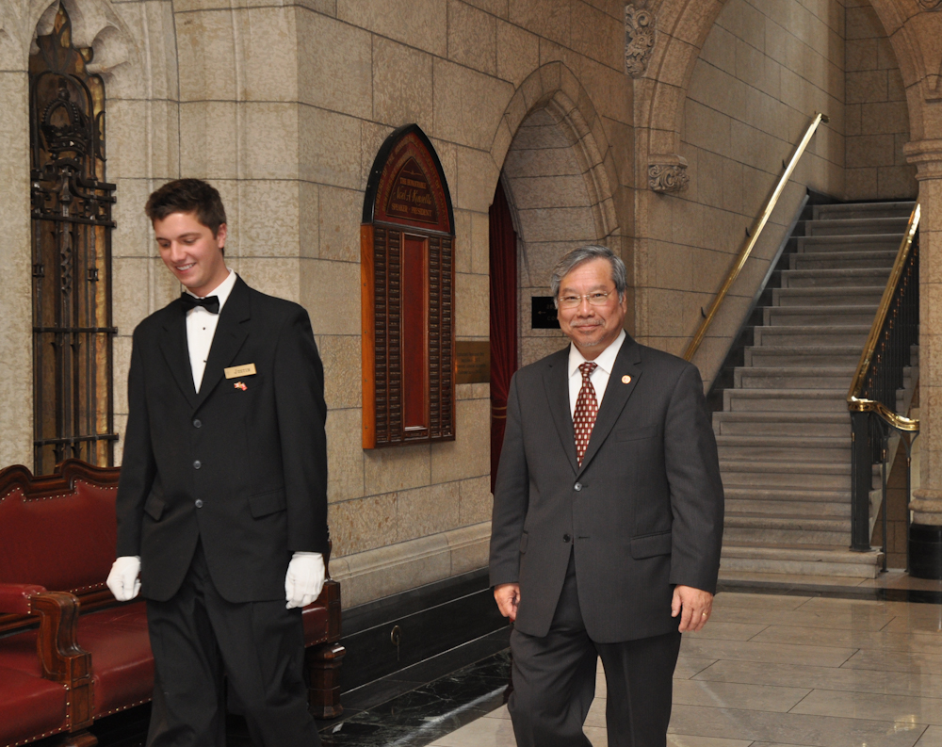

Tuesday, January 5, 2010

Joseph Cao Visits Vietnam, Expresses "Continue Relationship"
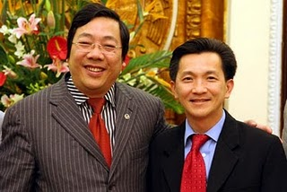

US Congressman Joseph Cao, a junior congressman from New Orleans, is currently visiting Vietnam. Cao is a close friend of State Assemblyman Van Tran and Dr. Thang Nguyen, executive director of Boat People SOS. Last year, State Assemblyman Van Tran and his cohorts brought Cao to Little Saigon and arranged for two fund raising events. Above is the recent picture from the trip of Cao and Deputy Foreign Minister Nguyen thanh Son.
See the breaking news in English on Vietnam Net.
http://english.vietnamnet.vn/politics/201001/First-VietnameseAmerican-congressperson-visits-Vietnam-887923/

Asked by the press about his feeling about visiting VN, Cao answered: " Tôi rất vui mừng khi trở về Việt Nam trong chuyến đi này. Năm 2001, tôi đã có dịp trở về Việt Nam. Sau 9 năm trở lại, Việt Nam đã phát triển rất nhiều. Tôi hy vọng hai chính phủ Việt Nam và Mỹ sẽ tiếp tục làm việc với nhau."

"I am very happy to be back to VN. In 2001, I had a chance to visit VN. After 9 years, I can see that VN has grown tremendously. I am hoping that our two countries will continue to work with each other."

Last year, Cao visited San Jose and garnered support from the Vietnamese American Community of Northern California. The same group that was behind the recall of Madison Nguyen while calling her a communist sympathizer.
The irony here of course is that this is the same communist government that would not allow US Congresswoman Loretta Sanchez (D) to visit because of her human rights and anti-communist rhetorics.

Sacramento to designate 'Little Saigon' district
By Stephen Magagnini
smagagnini@sacbee.com
Published: Sunday, Jan. 31, 2010 - 12:00 am | Page 1B
Last Modified: Sunday, Jan. 31, 2010 - 11:35 am

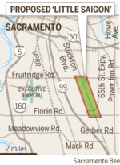

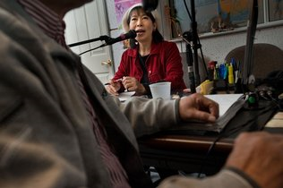
Nancy Tran broadcasts Thursday from Vietnamese Radio TNT. She sees efforts to identify a section of Stockton Boulevard as "Little Saigon" as positive. "For a lot of Vietnamese immigrants, Saigon has a deep meaning – it reminds us of freedom," Tran says.

Thirty-five years after the fall of South Vietnam, Sacramento's growing Vietnamese community will ask the City Council on Tuesday to designate a two-mile stretch of Stockton Boulevard as "Little Saigon."
The business corridor south of Fruitridge Road – chock full of restaurants, nail and hair salons, jewelry stores and Asian markets – would become Sacramento's first official ethnic neighborhood.
Community leaders hope the branding will provide an economic shot in the arm that will defuse some of the crime along Stockton Boulevard.
"It's a positive thing to recognize the community that has turned this section of the street that used to be full of gangsters and prostitution into a very lively, prosperous business district," said Nancy Tran, director of Vietnamese Radio TNT.
Community leaders expect "Welcome To Little Saigon" signs on Stockton and Highway 99 to draw tourists, shoppers and investors.
"To name it Little Saigon will bring credibility to the area, that people can shop here, try the food and not be afraid," said Stephanie Nguyen, 30, program director of Asian Resources.
There was a gang-related homicide at Pho Ga Hung Vietnamese Cuisine just off the boulevard last Wednesday afternoon, police said.
Though the area has been known as Little – or Mini – Saigon since Vietnamese refugees began revitalizing the boulevard 20 years ago, the official naming of Little Saigon is a point of pride for the county's more than 20,000 Vietnamese Americans.
With the communist victory in 1975, "Saigon was taken from us and renamed Ho Chi Minh City," Nguyen said. "Back in Vietnam they're not allowed to call it Saigon anymore. For my parents' generation, it's nice to bring a place they called home here."
The old red-and-yellow South Vietnamese flag waves over Vietnamese Radio TNT, and about half a dozen business names include Saigon.
"For a lot of Vietnamese immigrants Saigon has a deep meaning – it reminds us of freedom," said Tran, 56, who grew up in Saigon and is part of a "flood of people moving here" from San Jose's large Vietnamese community in search of affordable housing.
In San Jose's politically charged Vietnamese community, a bitter fight erupted last year over the official naming of the Vietnamese commercial corridor.
But in Sacramento, more than 500 Vietnamese spanning generations have joined forces, said Mai Nguyen, vice chairwoman of the Little Saigon Of Sacramento Committee.
"This is the first time in 35 years the Vietnamese community has come out as one," said Mai Nguyen, the daughter of a South Vietnamese officer. "We've all said we need to recognize the past, but we also have to plan for the future."
Mai Nguyen, marketing director for the Design Copy and Print Center on Stockton Boulevard, is among the 30-somethings who have taken the lead on Little Saigon.
"It's like a movement, a reawakening of our youth," said tax and financial adviser Tido Hoang, 36, who canvassed about 50 businesses for support and helped organize a Jan. 17 community meeting attended by 500 people.
"My parents are proud of what I'm doing," said Hoang, who was born in Saigon and raised in the projects at Elder Creek Road and 65th Street Expressway. "In college I started going back to my roots and realized Stockton Boulevard was a part of me."
Hoang joined the Little Saigon movement because he saw mom-and-pop nail salons, pho restaurants and other small businesses "struggling big-time. … Everybody told us there needs to be an image change to create a sense of identity, a sense of ownership."
Lao, Hmong, and Latino businesspeople also have signed on.
"I think it's a good idea to help clean up the boulevard and make it nice," said Jorge Limon of Ixtapa Auto Sales.
About 70 percent of businesses from Fruitridge to Florin are Vietnamese, alongside entrepreneurs from India, Ukraine, Thailand and Eastern Europe, said Terrence Johnson, executive director of the Stockton Boulevard Partnership. "In general the Asian businesses haven't actually faltered" in the recession, he said. "They shop with each other, employ one another, and there's a lot of room for growth as the economy comes back."
City Councilman Kevin McCarty initiated the campaign after seeing a "Welcome To Little Saigon" freeway sign in Santa Ana. He called the recognition overdue.
McCarty acknowledged the problem of Southeast Asian gangs, but said he hoped "this designation will bring more resources and commerce, because nothing addresses the problems of our youth more than a good job." He recalled that when four teenage Vietnamese gunmen took over the Good Guys electronics store on Stockton Boulevard in 1991, "one of the things they said they wanted was jobs and to be productive members of community." Three gunmen, two store employees and one customer died and 11 people were wounded in the eight-hour standoff.
McCarty expects the City Council to designate 1 1/2 miles of Stockton Boulevard from Fruitridge Road south to Riza Avenue as Little Saigon. A half-mile from Riza to Florin Road outside the city limits is expected to be approved Feb. 9 by Sacramento County supervisors, McCarty said.
The Vietnamese community will hold a design contest and raise about $20,000 to pay for the signs.
© Copyright The Sacramento Bee. All rights reserved.

Vietnamese Nail Salons: Helpful or Harmful?
By Ngoc Kim Le, Esq.
Vietnamese women have taken over the nail salon business. What? Youre not surprised? Of course not. Its hard to walk into a nail salon where the manicurist is not Vietnamese. In fact, according to an LA Times article published in 2008, 80% of all nail technicians in California are Vietnamese. While its well known that Vietnamese women have dominated the nail salon industry, it is not well known that breast cancer is the leading cancer among Vietnamese women. Is there a link between prolonged exposure to nail polish ingredients and cancer? Researchers are trying to find out.
Many nail products may contain toxic chemicals such as formaldehyde, which is a known carcinogen, and toluene and dibutyl phthalate, which have been linked to miscarriages and birth defects. The U.S. Food and Drug Administration (FDA), however, has not banned the use of such ingredients in nail products because the percentages of those ingredients are below the threshold considered unsafe for human use.

In reaction to the FDAs seemingly passive stance on the issue, groups such as the Campaign for Safe Cosmetics have lobbied Congress for stricter regulations of the FDA. Representative Janice Schakowsky (D-IL) introduced a bill called the Safe Cosmetics Act of 2011 on June 24, 2011 which sought to amend the Food, Drug, and Cosmetic Act and require the establishment of labeling requirements, safety standards, manufacturing guidance, and lists for safe and unsafe ingredients. Unfortunately, the bill was stalled in Committee.
Even though the FDA has not banned the use of certain ingredients in nail polish because of the relatively low amount of carcinogenic chemicals, many nail salon workers have increased exposure to those chemicals for prolonged periods of time. While policy makers are trying to reform cosmetics laws, researchers have taken to nail salons to interview nail technicians and find a possible link between working in nail salons and incidences of cancer and other diseases.
The California Breast Cancer Research Program interviewed 200 Vietnamese women in Alameda County in a pilot study. They found that a majority experienced some health problem as a result of working in the industry, particularly acute health problems that are likely associated with high-level solvent exposure, such as skin and eye irritation, breathing difficulties, headaches and asthma. The researchers believe that the health problems are likely to be work-related since symptoms subsided when the workers were away from work for more than one day. While they were not able to find a direct causal relationship between chemicals found in these nail salons and cancer at that stage, they believed that further investigation was necessary because of the combination of routine use of carcinogenic and endocrine-disrupting chemicals, prevalent health concerns about such chemicals, high level of acute health problems, and the predominance of Vietnamese female immigrant workers.
Health dangers have not been limited to products used in nail salons. In fact, about 80,000 chemicals on the market in the United States are largely unregulated and insufficiently studied for safety, and more than 74 billion pounds of chemical products are produced or imported into the country each day. This is still relevant particularly to Vietnamese women because there are many Vietnamese-owned and operated businesses that use cosmetological and other products which may contain dangerous chemicals.
The manufacturer of the popular hair straightening product called Brazilian Blowout just settled a $4.5 million class action against it. There were complaints from stylists that the product was causing nosebleeds, breathing problems and eye irritation. The product emits formaldehyde gas when heated. Consumers will still be able to get Brazilian Blowout, but the manufacturer can no longer represent it as formaldehyde-free and will have to give detailed instructions for safe use.
Bringing a toxic tort claim for injuries resulting from exposure to dangerous chemicals is complex. In Bockrath v Aldrich Chem. Co. (1999) 21 C4th 71, 80, 86 CR2d 846, the court found that to prove causation when harm is caused by long-term exposure to products containing multiple toxic substances, there must be proof that the product was a substantial factor in bringing about the injury, and that proof must be established to a reasonable medical probability. And in order to bring the case in the first place, you have to identify each product, the toxins it contains, and the specific illnesses resulting from exposure. Bringing such cases are expensive and time-consuming. They typically require expert witnesses, like doctors, and extensive searches for other possible plaintiffs to join in a class action.That raises the litigation costs significantly. On the other hand, although bringing such cases can be long and complicated, the potential payouts can be substantial.
Additionally, the action must be brought within the applicable time limit. Under California Code of Civil Procedure section 340.8(a), you have to file a suit within two years of when you get hurt or when you realized or should have realized that you were injured and what may have caused it.It may be difficult to figure out exactly when you “should have” known about an injury and what may have caused it, so anything that triggers your attention or causes your first awareness should not be taken lightly and should prompt you to take the appropriate actions, including, but not limited to, contacting an attorney.If there is a death caused by exposure to such chemicals, California Code of Civil Procedure section 340.8(b) requires that the case must be brought within two years of the death or the first date the person suing on behalf of the decedent knew or should have known of the cause of death.
A person that is harmed by a product can sue any person or entity that participated in making or marketing the defective product or in placing it in the stream of commerce, including the manufacturer, distributors, and retailers, regardless of which entity created the defect. This means that you can sue the maker of the product, the people who brought it to the stores, and even the stores who sold it.
If you believe that you have been injured by a cosmetic product, it is best to consult an attorney as soon as possible to discuss whether you have a case that can be pursued.

Early sale VNHELP's annual fundraising concert
info@vnhelp.org | July 26, 2012
ANNOUNCEMENT

**Bản thông cáo tiếng Việt đính kèm theo email này (attachment)**

VNHELP proudly presents

Mua Thu Cho Em 18
Featuring Thu Phuong, Ha Anh Tuan and Quang Linh

3:00PM Sunday, October 7, 2012
Santa Clara Convention Center Theater
5001 Great America Parkway
Santa Clara, CA 95050

3:00PM Sunday, October 14, 2012
Saigon Performing Arts Center
16149 Brookhurst Street
Fountain Valley, CA 92708

VNHELP is pleased to announce the 18th annual Mua Thu Cho Em fundraising concert. This year’s concert features Thu Phuong, Ha Anh Tuan, and Quang Linh—three wonderful solo artists who are sure to entertain, inspire, and delight. They will sing solos, duets and trios. Their live singing will be accompanied by the live musical arrangements of The Brothers Band.

About the singers:

Thu Phuong is one of the biggest names in Vietnamese and Vietnamese American entertainment. She has been honored with many awards and titles throughout her career. She was a recipient of the Vietnamese Golden Disk Award in 1997 and was consistently voted among the top 10 favorite singers for various music polls from 1997 to 2000. In 1998, she won the “Làn Sóng Xanh” music award and followed that up by winning “Song of the Year” in 1999. Thu Phuong moved to the United States in 2002.

Hà Anh Tuấn, a self-taught singer, has been musically inclined since he was a child. In 2002, he was recognized as a crowd favorite at the National Students’ Music Contest. In 2006, he became a household name when he placed in the Top 3 of “Sao Mai Điểm Hẹn,” one of the most distinguished televised music contests in Vietnam. Since then, Hà Anh Tuấn’s live performances have continued to draw large audiences and his albums have gone on to become commercial hits.

Quang Linhlaunched his musical career at the age of 19. With a sweet and expressive voice, Quang Linh’s songs are redolent of Hue imagery and sounds. He is most known for his pop and folk songs, but his vocal talents span a wide range of genres. In recent years, Quang Linh has surprised fans by his beautiful interpretations of songs by Pham Duy and Lam Phuong.

VNHELP would be honored by your presence at the concert. Please lend us your support by purchasing tickets or becoming an event sponsor. Sponsorship opportunities and tickets are now available at the VNHELP office. Give us a call at (408) 586 – 8100 or send an email to concert@vnhelp.org.

Ticket prices: $40, $50, $75, $100

All proceeds from the concert will benefit VNHELP’s charity and development projects in Vietnam. If you buy tickets early, before August 15, you will enjoy a $5 discount per ticket (excluding $100 tickets).
_______________________________________________
List10 mailing list
List10@box525.bluehost.com
http://box525.bluehost.com/mailman/listinfo/list10_vnhelp.org
2 attachments — Download all attachments
MTCE18_Announcement_VNmese.pdf
113K View Download

Sponsorship_info.pdf
93K View Download

Saturday, April 28
7:00 - 9:00 p.m.

3rd SF Vietnamese American Poetry and Art Festival
African American Arts and Culture Complex
762 Fulton St., San Francisco

Hosted by Andrew Lam, the festival features nationally recognized writers and artists from around the United States. They include spoken word artists Bao Phi, Fong Tran and Sahra Vang Nguyen; poet Nguyen Do with Paul Hoover, and writers Andrew Pham (Catfish and Mandala) and Aimee Phan (We Should Never Meet). Bao Phi will be reading from his new book Song I Sing and Aimee Phan from her new novel The Reeducation of Cherry Truong. The program will conclude with a performance by Cai Luong artist Quang Chanh. A reception will follow featuring artworks by Binh Danh, Christine Nguyen, Truong Tran, Trinh Mai and Khoi Nguyen.
Cost: $10 for students and $15 for general public

ORGANIZERS: Asian Pacific Islander Cultural Center (APICC), founded in 1996, supports and produces multi-disciplinary art reflective of the unique experiences of Asian Pacific Islanders living in the United States. the Diasporic Vietnamese Artist Network (DVAN), an epicenter of professional Vietnamese American artists, writers, and academics, aims to promote artists from the Vietnamese Diaspora.
For additional details and information please contact Isabelle Thuy Pelaud (ipelaud@sfsu.edu), Thang Dao (thangdao@usc.edu) or Rebekah Chung (rebekahc@mail.sfsu.edu).
The festival is hosted and sponsored by the Asian Pacific Islander Cultural
Center, the Diasporic Vietnamese Artist Network and co-sponsored by the
Cesar E. Chavez Institute and the Asian American Studies Department at San Francisco State University.

Vietnamese in elementary schools
Bao Nguyen

Dear friends,
I'm organizing to give parents the choice to have their children receive instruction in Vietnamese language in our local elementary public schools in Orange County, California. Please find the press release below and support us by signing our petition at www.iviet.org. If you support the petition with your name, please also share why it's important to you on the petition site.

Thank you,
Bao
714-251-6885

(Vietnamese below.)

FOR IMMEDIATE RELEASE
Contact: Vy Hoang, 714-548-5658, vyhoang@live.com

Community Gathers for Vietnamese Dual Language Immersion

April 29, 2013 - Garden Grove, Calif. - The Vietnamese English Language Immersion (VELI) organizing committee invites the public to attend its first community forum on Saturday, May 4, 2013 from 2 to 4 p.m. at the Vietnamese Catholic Center (1538 N. Century Blvd. Santa Ana, CA 92703).

Currently, over 50,000 students are enrolled in a two-way dual language immersion program in over 300 California public schools. However, none of those programs are available in Vietnamese. A community organizing effort led by GGUSD Trustee Bao Nguyen is proposing that the District implement the first Vietnamese English language immersion program in California.

Texas has successfully implemented a similar program and Washington state has developed a program to be implemented in Fall 2013. If approved by the GGUSD board, the program would be third in the nation.

The VELI organizing committee has gained the support of The Association of Vietnamese Language and Culture Schools of Southern California, which represents over ninety Vietnamese language schools; the Union of Vietnamese Student Associations of Southern California; and local civic, business, and educational leaders.

Confirmed attendees include: GGUSD board president Dr. George West, newly appointed Superintendent Dr. Gabriela Mafi, and Assistant Superintendent of Elementary Education Ms. Sara Wescott.

For more information about VELI, please visit our webpage: www.iViet.org.

SF Global Vietnamese Film Festival

The San Francisco Global Vietnamese Film Festival (April 26-28, 2013) is a biennial film and video showcase centering Vietnamese filmmakers in Việt Nam and the diaspora-a international vision reflecting a transnational reality.
SFGVFF is the first and only festival of its kind in the Bay Area. With an Opening Night Gala ($10, 7:30-10pm, 4/26) at Artists Television Access (992 Valencia St), the SFGVFF runs from 2:30pm to midnight each day, April 27-28, 2013, at the historic Roxie Theater (3117 16th Street) built in 1909 in the Mission district of San Francisco.
This year, the SFGVFF features narrative, documentary, and experimental films and videos. Each screening is $10, and may include multiple films or events.

Sponsored in part by the Diasporic Vietnamese Artists Network and the Asian Pacific Islander Cultural Center, SFGVFF is part of the 2013 United States of Asian America festival. For a complete schedule or to buy advanced tickets, visit the festival website at: sfgvff.wordpress.com.

Film Screening

AO2GEN (2012)
Directed by Thuy Tran



Decades after the Vietnam war, there are people who still suffer from the aftermath. This new documentary tells stories of the second generation of Agent Orange survivors in both Vietnam and the U.S., who, despite personal sorrow, have striven to lead meaningful lives and to heal the wound that history left them with.

The director, a Fulbright Fellow from Vietnam, is a student in New York University's News & Documentary graduate program, part of the Arthur L. Carter Journalism Institute.

See the trailer here.

This screening is organized by students in the Haas School of Business.
Contact: Tuyet Vu, tuyet_vu@berkeley.edu

Thursday, March 7
6:00 p.m.
102 Wurster Hall

VietUnity - HBT Organizing School/training application
Inbox | x

Thuỳ Trang Nguyễn

to Ha, bcc: me

Hi everyone,

I made a mistake in sharing about the HBT training date, the correct training is scheduled for June 28th, 29th and 30th of 2013 (Friday - Sunday), and it's correct date on the application; just in the last email it was written down for August. Please help spread the word and forward the pdf application to any of your contacts especially who work with college aged students in NorCal.

Thank you so much and sorry!
-thuy trang
On Wed, Feb 27, 2013 at 2:02 AM, Thuỳ Trang Nguyễn <phuquok@gmail.com> wrote:
Dear VietUntiy Community, Friends, and Family,

We are excited to announce a new summer organizing school for college aged Viet youth in Norcal: the Hai Bà Trưng School for Organizing. The HBT school was found in Socal in 2011 after the first state-wide Viet gathering, conducting a local and national power analysis, we’ve decided to take on this project to begin and to continue to address gap in trained Viet community organizers. We see the summer training project as one among various Viet efforts currently taking place (Common Ground, HBT School Socal, etc.), as well as in solidarity with longstanding training programs like Serve the People, Summer Activist Training, and we hope to work together as part of a larger progressive movement in the Viet community and beyond. VietUnity is thrilled to organize this year HBT 2013 Bay Area organizing school for the very first time!, after two years of trials and errors from SoCal Organizing Team.

Many thanks to the HBT founding team and the participants of the first California state-wide Viet gathering in SoCal for leading the work!!

Named after two celebrated women warriors who led one of the Viet peoples' first major revolts against colonialism, the goal is to start to develop a base of progressive Vietnamese American organizers and activists. Outcomes are that participants will develop a progressive Viet identity, learn the basics of organizing theory and skills, and connect to local Viet organizers and work in the VA community. What's key about the training is that we will focus on best practices and challenges unique to organizing in the Viet community. The Hai Bà Trưng School for Organizing training will be held from August 26 to August 28 (Friday-Sunday); we plan to have about 16-20 participants ages 18-30s for our pilot year in the Oakland, Bay Area.

In order to successfully pull off this first year, we need your support! Here's two ways how:

1) Donate. We are relying largely on grassroots fundraising to make our budget of $5,000. Please consider sponsoring a youth participant - $100 will allow one young person to attend, with full lodging, food and transportation provided. Your support at any level helps. Please make checks to "Trang Nguyen note: HBT School 2013" Mail checks to: CHAA 268 Grand Ave Oakland CA 94610. In-kind support (such as food or meeting supplies) is also wonderful. Contact hbt.bay@gmail.com if you are interested.

2) Help spread the word. The application form is attached. Please forward it to your contacts - we are looking for a diverse group of college aged youth in NorCal who are committed to progressive social change and organizing in the Viet community and beyond. There is no cost for participants. Food, housing and local transportation will all be provided.

In Solidarity,
Phuong Vuong, Kathy Huynh, Vo Hai and Thuy-Trang Nguyen
The Hai Ba Trung School for Organizing –Bay Area Organizing Committee
hbt.bay@gmail.com

The Department of South and Southeast Asian Studies, UC Berkeley
presents three lectures by

Linh Dinh
2013 Avenali Resident Fellow, Townsend Center for the Humanities, UC Berkeley

Linh Dinh is a Vietnamese-American poet, fiction writer, and essayist. He is the author of two collections of short stories, five books of poems, a novel, and numerous translations of Vietnamese poetry and fiction. He is the recipient of a Pew Foundation grant, the David T. Wong Fellowship, a Lannan Residency and the Asian American Literary Award.

Avenali Residencies support month-long campus visits by scholars, writers, artists, and others with whom Berkeley faculty and students might not otherwise have direct or sustained contact. The program is administered by the Doreen B. Townsend Center for the Humanities.

Thursday, March 7
Collapsing Vietnam, Collapsing America

In his first public lecture, Linh Dinh will describe his preoccupation with collapse, including how the fall of South Vietnam in 1975 has influenced his work, as seen in his recent novel, Love Like Hate (2010), and how this formative event in his life has colored his view of the world and of history.

Geballe Room, Townsend Center for the Humanities
220 Stephens Hall
4:00 p.m.

Friday, March 8
Nativating Languages: Challenges and Opportunities of the Non-Native Writer

In his second talk, Linh Dinh will read from the writing he has done in Vietnamese, and discuss how it differs from what he writes in English, and why he feels compelled to write in this language, as well as in English.

Geballe Room, Townsend Center for the Humanities
220 Stephens Hall
4:00 p.m.

Thursday, March 14
The Deluge: New Vietnamese Poetry

In his final lecture, Linh Dinh will discuss his translations of contemporary Vietnamese poetry and literature, and outline his thinking about translation, how he chooses works to translate and how he approaches writers.

3335 Dwinelle Hall
4:00 p.m.

Co-sponsored by the Center for Southeast Asia Studies. Contact CSEAS: (510) 642-3609

Published on Sunday, February 26, 2012 by Common Dreams

Missing Foundations
by Linh Dinh
Americans are living on borrowed time, economically. Like air conditioners, copper pipes and aluminum siding of a foreclosed home, what remains of our prosperity will be violently stripped away. There is no economic recovery because the foundations for such are simply not there. Jobs still leave the country, and the only way we can compete with foreign slaves is to become slaves ourselves, and don’t think for a moment that this isn’t by design.
We fancy ourselves indebted middle-class, but this mirage is quickly evaporating. Most of us are indebted slaves. Banks conjure money out of thin air to enslave most of us for life. We must go into debt to buy a house, a car or go to school. Many of us go into debt just to eat. Like you, you and you, I will carry my shitty credit score to a mass paupers’ grave, with my hearse a U-Haul. There is a renewed emphasis on going to college as a means to success, but in this economy, a degree will likely only impoverish you further, since you will be in hock to the banksters even as you work a job completely unrelated to your dubious education. If you can even get a job, that is. Joining winos and bag ladies with smudgy and off-target makeup will be legions of useless scholars.
Still, there are perks to being house slaves of the empire, since even homeless Americans sport brand name shoes, and our poor are generally the most obese, meaning they have enough to eat, even if what they’re ingesting may shorten their lives by decades. We are unique in having thousands of fat people moving about on so-called mobility scooters, though their only handicap is overeating. Some of our grossest even star on TV, where they can sob in self-pity while competing to lose tonnage.
Though we may be stuffed and surrounded by stuff, our lives are not quite secure, because few of us own outright the roofs over our heads, as in many other countries, even if theirs are of tin or even grass. And since most of us owe more than we own, any financial slippage can mean an instant catastrophe. Surrounded by gadgets, an American can go from wealthy, by global standards, to being worse off than a Third-World slum dweller, if this Yank suddenly finds himself sleeping on a sidewalk, under a bridge or in a tent, when he’s not being shooed away by cops. With no floor under us, what good are our cumbersome arrays of possessions?

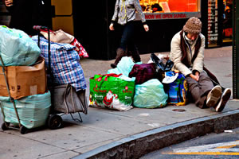(Photo/Linh Dinh)

In Philly, there is an elegant and homeless woman of about 55. Since shelters don’t let you in until evening, if they accept you at all, and promptly kick you out by dawn, this woman has to spend all of her waking hours outside, like most homeless folks. What makes her unusual is the amount of stuff she’s still trying to hang onto to, and I’ve seen her outside for nearly three years now. With a dozen or so boxes and bags, and an odd suitcase, she can only walk about 30 feet at a time, shifting each container one by one without losing sight of any of them.
Like individual Americans, America also spends more than it earns, a situation made possible only because this is an empire with military bases worldwide and war ships off every shore. We are an extortion racket the world is trying to shake off, and when that happens, our living standards will truly plummet. Many Americans like to depict themselves as the oppressed 99%, but from the world’s perspective, we are an insufferable 5% that are milking the world dry when not bombing it into submission. As long as we partake in the ill-gotten fruit of empire, we are complicit in its crimes. We! Are! The 5% that will pulverize you if we don’t get our ways!
Foot soldiers of empire, we do our share to prop it up, everyone from the poor who enlist to kill foreigners for bogus reasons, to spineless academics who stay clear of political taboos, to cynical journalists who mouth obvious nonsense daily. The Obama-voting liberal who drives an SUV and frets about gas price is a clear beneficiary of empire, but so am I, though I attack its bloody policies and own next to nothing. What I do buy would cost a lot more, however, if America withdrew all of its overseas goons. Without American missiles pointed at the world’s temple, the dollar would become asswipe overnight. That’s why even domestic foes of Bellum Americanum should be prepared to suffer personally for its cessation.
There are those who think that we can power down, trim our holdings and lose weight gracefully, that as this murderous edifice crumples, a saner arrangement will rise up, and I, too, hope that a humane revolution is in the offing, though I suspect that as the physical empire goes down, its worst mental aspects will blossom. Its ideology will harden and shoot. Deprived of their toys, many Americans will demand that their government does whatever is necessary to restore the good old days, so there will be more desperate wars, and more repression of those who oppose this American way of life. Meanwhile, the media will serve up opulent fantasies to feed a nostalgia for this lost and glorious past. The poorer we become, the richer we will look on television.
Americans will have less, and our lives will be harder, but no one wants to talk about this decline, least of all politicians, since that would be the quickest way to not get elected, but even if we had a wise and ethical leadership, our country will still go into decline, because the resources for infinite growth are simply not there. They never were, of course, since this is a finite planet, after all, where natural limits must be reached sooner or later. That moment is now, unfortunately.
Don’t kid yourself that the fiery anger burning through Greece, Spain and elsewhere won’t be but a tame prelude to what will happen here, what with our robust sense of entitlement, deep alienation and trigger happy ways. Our government seems to anticipate as much, for it has put into place all of the physical and legal means to clamp down on us hard, when things do explode.

Linh Dinh is the author of two books of stories, five of poems, and a just released novel, Love Like Hate. He's tracking our deteriorating socialscape through his frequently updated photo blog, State of the Union.

END OF CHAPTER FOUR

