DE ANZA COLLEGE
Vietnam in Viet Nam – 2013
Chapter SIX : ENVIRONMENT

Infinite Cave in Vietnam
January 12, 2011
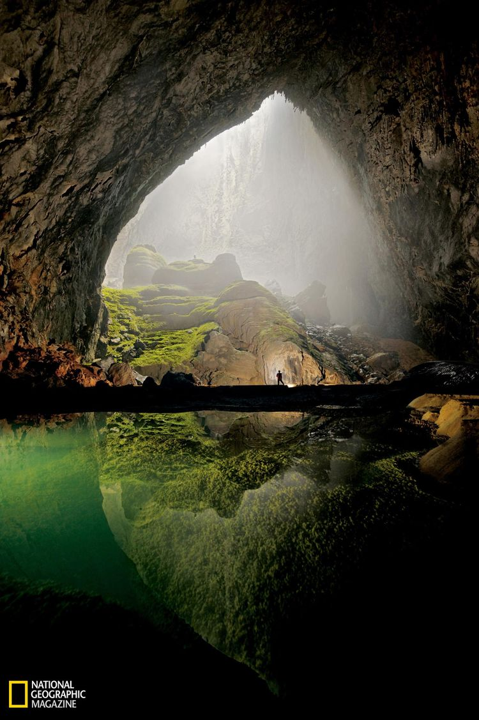
Photographer: Carsten Peter/©National Geographic Magazine,
Summary Author: Mark Jenkins/©National Geographic Magazine; Jim Foster
The amazing photo featured above was taken in a huge cavern complex within the bowels of central Vietnam – in Phong Nha-Ke Bang National Park. During the spring of 2009, a team of spelunkers began exploring a mountain river cave in Vietnam and discovered a passage carved by a subterranean river millions of years ago. Like a castle on a knoll, a limestone formation shines beneath a skylight in Hang Son Doong Cave. A monsoon storm had just filled the pool in the foreground, signaling that exploring season was ending. Referred to as the "infinite cave" this underground labyrinth is more than 2.5 mi long (4.0 km). Photo taken in May 2009. For more about this incredible cave, see the January 2011 issue of National Geographic Magazine. See also tomorrow’s Earth Science Picture of the Day (Carlsbad Cavern).
- Hang Son Doong Cave Coordinates: 17.53722, 106.15125
- Related Links
  - National Geographic Online
  - Full Gallery of Cave Photos by National Geographic's Carsten Peter
  - Jenolan Cave
- Earth Observatory
  - Heavy Rain in Vietnam
  - Monsoon Rains Flood Vietnam

http://ngm.nationalgeographic.com/2011/01/largest-cave/jenkins-text

Vietnam Cave
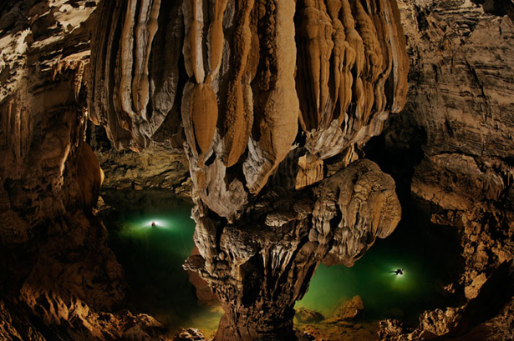

Conquering an Infinite Cave

There’s a jungle inside Vietnam’s mammoth cavern. A skyscraper could fit too. And the end is out of sight.
By Mark Jenkins
Photograph by Carsten Peter (National Geographic – Jan. 2011)

“Past the hand of dog, watch out for dinosaurs,” says a voice in the dark.
I recognize Jonathan Sims’s clipped, British military accent but have no idea what he’s talking about. My headlamp finds him, gray muttonchops curling out from beneath his battered helmet, sitting alone in the blackness along the wall of the cave.
“Carry on mate,” growls Sims. “Just resting a buggered ankle.”
The two of us have roped across the thundering, subterranean Rao Thuong River and climbed up through 20-foot blades of limestone to a bank of sand. I continue alone, following the beam of my headlamp along year-old footprints.

In the spring of 2009, Sims was a member of the first expedition to enter Hang Son Doong, or “mountain river cave,” in a remote part of central Vietnam. Hidden in rugged Phong Nha-Ke Bang National Park near the border with Laos, the cave is part of a network of 150 or so caves, many still not surveyed, in the Annamite Mountains. During the first expedition, the team explored two and a half miles of Hang Son Doong before a 200-foot wall of muddy calcite stopped them. They named it the Great Wall of Vietnam. Above it they could make out an open space and traces of light, but they had no idea what lay on the other side. A year later, they have returned—seven hard-core British cavers, a few scientists, and a crew of porters—to climb the wall, if they can, measure the passage, and push on, if possible, all the way to the end of the cave.
The trail disappears before me into a difficult pile of breakdown—building-size blocks of stone that have fallen from the ceiling and crashed onto the cave floor. I crane my head back, but the immensity of the cave douses my headlamp’s tiny light, as if I were staring up into a starless night sky. I’ve been told I’m inside a space large enough to park a 747, but I have no way to know; the darkness is like a sleeping bag pulled over my head.
I switch off my headlamp just to feel the depth of the darkness. At first there is nothing. But then, as my pupils adjust, I’m surprised to make out a faint, ghostly light ahead. I pick my way through the rubble, almost running from excitement, rocks scattering beneath my feet and echoing in the invisible chamber. Traversing up a steep slope, I turn a ridge as if on a mountainside and am stopped in my tracks.
An enormous shaft of sunlight plunges into the cave like a waterfall. The hole in the ceiling through which the light cascades is unbelievably large, at least 300 feet across. The light, penetrating deep into the cave, reveals for the first time the mind-blowing proportions of Hang Son Doong. The passage is perhaps 300 feet wide, the ceiling nearly 800 feet tall: room enough for an entire New York City block of 40-story buildings. There are actually wispy clouds up near the ceiling.
The light beaming from above reveals a tower of calcite on the cave floor that is more than 200 feet tall, smothered by ferns, palms, and other jungle plants. Stalactites hang around the edges of the massive skylight like petrified icicles. Vines dangle hundreds of feet from the surface; swifts are diving and cutting in the brilliant column of sunshine. The tableau could have been created by an artist imagining how the world looked millions of years ago.
Jonathan Sims catches up with me. Between us and the sunlit passage ahead stands a stalagmite that in profile resembles the paw of a dog.
“The Hand of God would be just too corny,” he says, pointing at the formation. “But the Hand of Dog does nicely, don’t you think?”
He clicks off his headlamp and unweights his gimpy ankle.

“When we first got to the collapsed doline, that skylight up there, I was with another caver and we both had four-year-old sons, so we were experts on dinosaurs, and the whole scene reminded us of something right out of Sir Arthur Conan Doyle’s novel The Lost World,” he says. “When my partner went exploring forward into the sunlight, I told him to ‘watch out for dinosaurs,’ and the name stuck.”
Two decades ago, the leaders of this expedition, Howard Limbert and his wife, Deb, became the first cavers to visit Vietnam since the 1970s. Back then, the country’s caves were legendary but unexplored. In 1941 Ho Chi Minh had planned his revolution against the Japanese and French in Pac Bo Cave north of Hanoi, and during the Vietnam War thousands of Vietnamese hid from American bombing raids inside caves. The Limberts, experienced cavers from the Yorkshire dales of northern England, made contact with the University of Science in Hanoi and, after obtaining sheaves of permits, mounted an expedition in 1990. They’ve made 13 trips since, not only discovering one of the longest river caves in the world—12-mile Hang Khe Ry, not far from Son Doong—but also helping the Vietnamese create 330-square-mile Phong Nha-Ke Bang National Park, which now attracts a quarter million Vietnamese and foreign visitors a year. Tourists, who dramatically increase the income of local villagers, come to see the park’s namesake show cave, Hang Phong Nha, which workers light up like a psychedelic rock concert.
Because of the dense jungle, the Limberts might never have found the caves without help from area residents. “Mr. Khanh has been with us from the beginning,” Howard says, nodding toward a thin man smoking a cigarette beside the campfire. We’re squatting around the fire just inside the entrance to Hang En, the mile-long portal that tunnels beneath a ring of mountains into the lost world. “Couldn’t have done it without him,” Howard says. Ho Khanh’s family lived in a nearby village. His father was killed in the war, forcing Khanh at a young age to fend for himself in the jungle. For years he hunted all over this border country, taking refuge in caves when it rained, or rained bombs.
“It took three expeditions to find Hang Son Doong,” Howard says. “Khanh had found the entrance as a boy but had forgotten where it was. He only found it again last year.”
Stands of bamboo and other vegetation cover mounds of limestone here, making the place all but impenetrable. Below the surface, this part of Vietnam is one immense limestone block, says Darryl Granger, a geomorphologist from Purdue University. “The whole region was squeezed upward when the Indian subcontinent smashed into the Eurasian continent 40 to 50 million years ago,” he says. Hang Son Doong was formed two to five million years ago, when river water flowing across the limestone burrowed down along a fault, scouring out a giant tunnel beneath the mountains. In places where the limestone was weak, the ceiling collapsed into sinkholes, creating the gigantic skylights.
Anette Becher, a German caver and biologist, has found wood lice, fish, and millipedes inside the cave that are all white, which is common for creatures that live in the dark. And Dai Inh Vu, a botanist from the Vietnam Academy of Science and Technology, has identified the plants growing beneath the skylights, finding basically the same mix that grows in the forest above. But such science on the run is not the real focus of this expedition, whose central purpose is exploration. For cavers like the Limberts, discovering a cave as big as Hang Son Doong is like finding a previously unknown Mount Everest underground. “We’ve just scratched the surface here,” Howard says of the national park, which was named a World Heritage site in 2003 for its forests and caves. “There is so much more to do.”
When Howard and Deb first saw these enormous spaces, they felt certain they had discovered the largest cave in the world—and they might be right. There are longer caves than Hang Son Doong—the Mammoth Cave system in Kentucky, with 367 total miles, holds that record. There are deeper caves too—Krubera-Voronja, the “crow’s cave,” plunges 7,188 feet in the western Caucasus Mountains of Georgia. But for giant passages, there are few caves that can compare. At the time of the Limberts’ discovery of Hang Son Doong, the largest passage was thought to be Deer Cave in Malaysian Borneo’s Gunung Mulu National Park, which was recently surveyed at 1.2 miles long, 500 feet wide, and 400 feet tall. But as the explorers would eventually determine, using precise laser instruments, Hang Son Doong is more than 2.5 miles long with a continuous passage as wide as 300 feet and, in places, over 600 feet high.
“We weren’t actually searching for the largest cave in the world,” Deb says. But she’s thrilled that the cave’s newfound fame might improve the lives of local villagers.
After five days of hiking, hauling, and crawling, the expedition is still only halfway into the cave. Counting all the cavers, scientists, a film and photography crew, and porters, we are a team of more than two dozen, which seems to have slowed us down. Besides that, the going gets dangerous as we climb through the breakdown in Watch Out for Dinosaurs: One misstep on slick boulders could mean a fall of more than a hundred feet.
When we reach the next skylight, the Garden of Edam (another cheesy pun), it’s even bigger than the first, almost as wide as the roof of the Superdome in New Orleans. Below the opening is another mountain of breakdown with a jungle of hundred-foot-tall trees, lianas, and burning nettles. As our time and supplies begin to run out, Howard decides the moment has come to send an advance team ahead to the Great Wall of Vietnam, to see if an assault is really possible.
The wall lies more than a mile away at the end of a corridor shaped like a V with a foot-deep trench of water at the bottom. Mud walls, sticky as peanut butter, rise 40 feet high on either side. It is not possible to walk in the trench, only to stumble. By the time you reach the wall, you’re so covered in mud you appear to have gone swimming in chocolate pudding. The cavers named this passage Passchendaele, after the trench warfare battle of World War I in which the Allies lost 310,000 soldiers to gain only five miles of ground near the Belgian village of Ypres.
Climbing an overhanging 200-foot-tall wall of mud is technical, risky business, so you need just the right type of madmen. Luckily, Howard has handpicked Gareth “Sweeny” Sewell and Howard Clarke for the advance team. The two have been caving together for 20 years in the nastiest potholes in England. Clarky is a bull semen salesman, and Sweeny is a legal specialist who somehow convinced his wife that they should sell their one and only car so he could keep heading off on caving expeditions.
The first day at the base of the wall, as Clarky belays, Sweeny begins boldly working his way upward, drilling hole after hole. Almost all of the holes are too hollow to hold a screw from which to hang their ropes.
For 12 hours they jabber in their expletive-laden Yorkshire vernacular—“ez bloody crap covered wit mood,” Sweeny says at one point. Neither says a word about the true dangers of the task. Were any of the six-inch screws to pop out, the rope Sweeny is hanging on would lose its anchor and he’d likely zipper the rest of the screws and plummet to his death.
On the second day of the climb, after bivouacking at the bottom of the wall for the night, Sweeny returns to his previous high point, with Clarky belaying again. Soon enough the whirring of his drill echoes through the domed blackness, Sweeny so high up we can see only the glimmer of his headlamp. At two in the afternoon—of course it doesn’t matter a bit what time it is when it’s dark 24/7—after 20 hours of drilling holes and climbing higher, Sweeny finally disappears over the wall and some minutes later we hear: “AAIIOOOOO!!”
Clarky ascends the rope next, then yells down for me, the words bouncing through the cave: “Well, ye comin’ up or wat!”
At the top of the Great Wall of Vietnam we can literally see light at the end of the tunnel and start howling our heads off. The rest of the expedition will later tell us that they actually heard our hallos more than a mile away in the cave. Measurements made at the top of the wall will reveal that from the bottom of Passchendaele to the ceiling is 654 feet. It’s just the three of us now, exploring. No human has ever been here before. We drop down off the backside of the Great Wall and begin ascending a staircase of rock toward the exit.
“Will ye look at deese!” roars Clarky, kneeling beside a dried-up pool. Sweeny and I gather around. Inside the pool, illuminated by our headlamps, are cave pearls.
Cave pearls are formed when a drop of water from the ceiling hits the limestone floor and throws up a speck of rock. This grain is jostled in its little cup of stone every time a drop hits it. Over thousands of years, a solid, almost perfectly round calcite pearl is formed.
Pearls are rare and in most caves are no larger than a marble. The cave pearls here are the size of baseballs, larger than any the cavers have ever seen. (Their preternatural size may be due to the enormous distance the ceiling waterdrops fall.)
“I ’ereby christen this passage Pearl ’arbor,” Clarky announces.
Twenty more minutes and we’re scrambling up and out of the cave. It is raining in the jungle. We hack our way far enough out into the forest to recognize a horizon and determine that this is not just another skylight, but that we have discovered the end of Hang Son Doong. Sweeny and Clarky are far too humble to openly express that we’ve just completed the first push through what is very likely the largest cave passage in the world.
Mark Jenkins is a contributing writer for the magazine. Carsten Peter last photographed "Mexico’s Cave of Crystals" for our November 2008 issue.

Conquering an Infinite Cave
There’s a jungle inside Vietnam’s mammoth cavern. A skyscraper could fit too. And the end is out of sight.

Apr 18, 2011

Asian 'unicorn' gets nature reserve in Vietnam
By Wendy Koch, USA TODAY

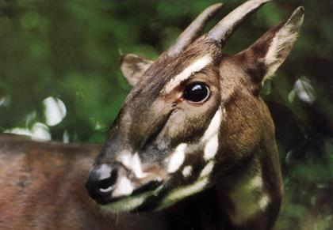
An undated handout image taken at an unknown location in Vietnam shows a saola, a relative of antelope and cattle. The establishment of a nature reserve in Vietnam has brought new hope for the survival of a mysterious twin-horned creature nearing extinction, conservation group WWF said.
CAPTION
By WWF, AFP/Getty Images
"The loveliest of all" animals, the late Shel Silverstein once wrote in a popular children's song, is the unicorn. He would probably have been pleased that a nature reserve has been set aside in Vietnam for the critically endangered saola, also known as the Asian "unicorn."
The antelope-like species, numbering from a few dozen to a few hundred, are threatened by poachers wanting its horns according to the conservation WWF, previously known as the World Wildlife Fund. The WWF, which discovered the saola in a 1992 survey with the Vietnam Department of Forestry, says none has survived captivity.
"The establishment of this new Saola Nature Reserve shows a strong commitment by the Vietnamese Government and Quang Nam Province in the conservation of this highly threatened endemic species," Tran Minh Hien, country director of WWF Vietnam, said in a statement last week announcing the reserve.
FOLLOW Green House on Twitter
Vietnamese rangers and WWF forest guards are daily patrolling the reserve in the Annamite mountains along the border of Vietnam and Laos. They've removed thousands of snares and destroyed illegal hunting camps within the first few months of their joint enforcement program. WWF says the reserve, characterized by narrow valleys and waterfalls, will promote the conservation of lowland tropical forest and other globally threatened species.

Last update 12/01/2011
Vampire flying frog discovered in Vietnam
VietNamNet Bridge – An Australian female scientist’s discovery of a strange frog species in Vietnam has surprised many Vietnamese scientists.

Vu Ngoc Thanh, who has spent 30 years on biology studies at the Biology Museum of the University of Natural Sciences under the Hanoi National University, said: “I have never seen the vampire flying frog that the Australian scientist Jodi Rowley discovered in the south, though I have been to this area many times. The frogs live in small water puddles in tree’s cavities, and therefore, it is very difficult to see them.

Why was the discovery not made by a native person?
In biology, like in all sciences, there is no concept of borders, territories and countries. All are common to the human kind.
Vietnam has opened its doors 20 years ago, and the scientific cooperation with foreign countries has been strengthened. Therefore, the discovery of an Australian scientist in Vietnam should be seen as a normal thing. Vietnamese scientists also make similar discoveries in Laos.

The forests in Vietnam have been severely damaged. How come new species can still be found?
These living beings do not have the capability to move far. They do not need large forests to live like elephants and tigers. They will still survive until natural forest exists. This shows Vietnam’s biodiversity.
We sometimes joke that there is nothing more to research in northern forests, because there is no more forest. However, in fact, a lot of new species have been found in the north in the past few years. while in the US, for example, no new species has been found in the US ver the past 20 years.

Can this be explained by the fact that the US has a large and powerful force of scientists, who have already found everything in the US, while Vietnam does not have qualified scientists and they still cannot find all the species living in Vietnam?
We have to admit our weak points in researching biodiversity. The species live in Vietnam, but they have been discovered by foreigners.
In 2008, my Vietnamese and German colleagues and I discovered a species of frog living in small puddles in tree cavities, and I called it Ech Cay Quyet. Quyet is the name of an old student of mine, who has made big contribution to the biodiversity preservation in Vietnam.
In fact, we have many problems, from the bad management mechanism to the lack of enthusiasm.

How areVietnamese scientists rewrded when they discover a new species?
Nothing, though they have to spend time, money and can even be physically injured during the scientific research. It sometimes takes scientists 10 years or even more to complete the research process. But they only get one million dong for every article published in scientific journals.

Vietnam has carried out a lot of surveys on the biodiversity of natural reserves and national parks, right?
Not really. It is true that there are many such projects, especially when we prepare to set up sanctuaries or national parks. However, the works are simply just to list the already known species or to come to the conclusion that there exists areas where some species live. We need scientists who have deep knowledge in specific fields.
For example, Jodi Rowley, who discovered the vampire flying frog, specializes amphibian-reptile studies, particularly in frogs in South East Asia. Meanwhile, most of the Vietnamese scientists try do to everything. They seem to know many things in many fields, but in truth, they do not have deep knowledge in any. Therefore, it is difficult for them to discover a new species.

Source: Tien phong

Rare species of gibbon found in Vietnam
- From: AFP
- July 18, 2011
THE lively morning calls of a rare species of gibbon has led to the discovery of the only known "viable" community of the talkative primates in remote Vietnamese forests, conservationists say.
A "substantial" population of 455 critically endangered northern white-cheeked crested gibbons were found living at high altitudes and far from human settlements on the border with Laos, Conservation International (CI) said today.
Researchers, who had previously found sparse groups in other areas, used the animals' "loud, elaborate and prolonged" calls to locate the creatures in Pu Mat National Park in Nghe An province, northern Vietnam.
The community represents two thirds of the total number in Vietnam and the "only confirmed viable population" of the variety worldwide.
"This is an extraordinarily significant find, and underscores the immense importance of protected areas in providing the last refuges for the region's decimated wildlife," said CI president Dr Russell Mittermeier.
Gibbons, which are threatened across the world, are considered the "most romantic" of primates as they mate for life and serenade their partners with song.
Habitat loss and hunting for the pet trade and the "assumed medicinal value of primate body parts" are among the major threats to the creatures in Vietnam, the CI statement said.
White-cheeked gibbon numbers are thought to have declined by as much as 80 per cent in the last 45 years, according to the International Union for Conservation of Nature and Natural Resources (IUCN) Red List of Threatened Species.
Mittermeier, who also works with the IUCN, described the species as "on the brink of extinction".
They are believed to be "functionally extinct" in China and while there could be significant numbers in Laos, CI said a lack of research means the situation in the country is unclear.
But CI said plans to build a road through the Pu Mat area to increase patrols on the Vietnam-Laos border pose a "serious threat" to the future of the rare primates.
"The major issue will be the hunting of these gibbons that were previously protected by the harsh terrain; so gun control will be vital," said primatologist Luu Tuong Bach, a consultant to CI who led field surveys for the research.
"Without direct protection in Pu Mat National Park, it is likely that Vietnam will lose this species in the near future."

http://www.guardian.co.uk/science/2013/apr/07/vietnam-hat-palm-lanonia-centralis#ixzz2UgHAqHXq

New to nature No 101: Lanonia centralis
The palm used to make traditional Vietnamese cone-shaped hats has been elevated to its own genus
- The Observer, Sunday 7 April 2013
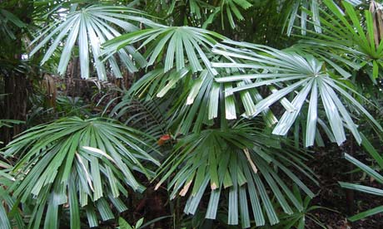
Lanonia centralis: its unexpanded young leaves are prized by Vietnamese milliners. Photograph: courtesy Amdrew J Henderson
Sampling across the 137 species of the palm genus reveals three geographic areas of high species diversity: the Sunda Shelf of the Malaysian peninsula and Borneo, home to about 80 species; the Sahul Shelf of New Guinea, which includes 40 species; and third in species richness, Vietnam, where the number of known species has more than doubled in the past five years to more than 20. Recently discovered diversity is not limited to numbers of species.
Dr Andrew J Henderson of the New York Botanical Garden and Dr Christine D Bacon of Colorado State University have documented, based on detailed anatomical comparisons and sequences of seven gene regions, a highly distinct group within this complex ranking and elevated it to new genus status as Lanonia, a name based on the common local Vietnamese name "la non" for hat palms. Interestingly, Lanonia centralis, the species primarily found for sale as the raw material used for the making of the typical conical hats worn by the Vietnamese, was only described and named in 2008 by Dr Henderson with co-authors NK Ban and NQ Dung. It is one of the eight species formerly included in Licuala transferred to the new genus. Six of these species are endemic to Vietnam and one each is from Hainan and Java.
The species of Lanonia are dioecious, with distinct "male" and "female" plants, although there is evidence that they are not always strictly so, such as a cultivated specimen which had both staminate and pistillate flowers developed on one inflorescence. This is in contrast to all species of Licuala as now constituted, which possess hermaphroditic flowers. Further, the staminate and pistillate inflorescences are dimorphic in size, shape, and branching. Perhaps most distinctive, however, are the leaves of Lanonia in which the petiole extend into the blade of each leaf. While this "costa" tapers, it can be followed along the central leaf segment to the tip.
Lanonia centralis is an evergreen, broad-leaved palm with stems as tall as five metres. It can be found growing in closed forests situated on steep slopes over limestone, sandstone and shale substrates in central Vietnam and neighbouring Laos. L centralis often occurs in very large numbers, even in secondary forests, from 20-1,000 metre elevation. It is the unexpanded young leaves that are prized by milliners and found for sale in local markets across the country. Now that we have a scientific name for la non you might say that a botanical cone of silence has been lifted.
Quentin Wheeler is director of the International Institute for Species Exploration, Arizona State University
Read the full article at: http://www.guardian.co.uk/science/2013/apr/07/vietnam-hat-palm-lanonia-centralis#ixzz2UhVYQoMG

http://scientistatwork.blogs.nytimes.com/2013/04/12/in-search-of-slow-lorises/

April 12, 2013,

In Search of Slow Lorises
By MARY E. BLAIR

Mary E. Blair is a postdoctoral researcher in the American Museum of Natural History’s Center for Biodiversity and Conservation, where she coordinates the Enhancing Diversity in Conservation Science Initiative.
Tuesday, March 12
When I left New York City this morning, it was a rainy, dreary day full of traffic and cars and concrete. What awaits me may be similarly soggy, but the traffic will be in the trees and on the forest floor as I explore the jungles of Vietnam at night.
I am at the beginning of my first expedition to Vietnam as a part of my postdoctoral research for the American Museum of Natural History. This expedition is jointly organized by the museum and the Center for Natural Resources and Environmental Studies at Vietnam National University, Hanoi.
I study primates. And this time, I am searching for the pygmy and Bengal slow lorises.

Nolan Bett A Bengal slow loris at the Endangered Primate Rescue Center, Cuc Phuong National Park, Vietnam.

Slow lorises are small nocturnal primates found in South and Southeast Asia. Little is known about their status or ecology in Vietnam. We do know the pygmy and Bengal species can be found here. We also know they are very hard to find, let alone study. These animals’ lives are very cryptic, and their numbers are spread thinly throughout dense, intimidating terrain. But where they can be found, they are hunted. Slow lorises are showing up in local, regional and international trade as pets and for traditional medicine. Their appearance, dead and alive, on the black market is one unfortunate way we know their natural populations are declining.
So I am well aware that our expedition may be quite difficult. It will be especially challenging for me, as it will be my first time surveying for animals at night. I have a lot of experience conducting daytime surveys from my past fieldwork on squirrel monkeys in Costa Rica. If lorises are the near hermits of the jungle, squirrel monkeys are like teenagers at the foliage mall. They travel in groups of up to 60, and they are constantly chattering with one another, making it relatively easy to find them in a forest.
Surveying for slow lorises at night will be a very different and unique experience for me. I suppose as a New Yorker I am a bit nocturnal — but walking around in a forest in Vietnam at night is going to be very different from walking around the Lower East Side. Luckily, my postdoctoral adviser, Eleanor Sterling, happens to have considerable experience searching for primates at night: She is considered one of the world’s experts on the aye-aye, a nocturnal lemur found only in Madagascar. She will be joining me and sharing her wisdom for the first of my three survey trips to nature reserves across Vietnam.
The main objective of our expedition will be to gather essential population data. Essentially, we will count slow lorises. More precisely, we will keep track of how often we encounter them while walking on trails or transects at night (more on that later). This work will help conservation managers to more effectively protect these species from further population decline.
I have never seen a slow loris in the wild, and as I write this post during my layover in Seoul, South Korea, I am trying to imagine what it will be like to see my first one. I can’t wait to tell you all about it.

This expedition is financed by the Margot Marsh Biodiversity Foundation and the Eppley Foundation for Research.

http://scientistatwork.blogs.nytimes.com/2013/04/17/waiting-for-the-dark/

April 17, 2013,

Waiting for the Dark
By MARY E. BLAIR
Mary E. Blair is a postdoctoral researcher in the American Museum of Natural History’s Center for Biodiversity and Conservation, where she coordinates the Enhancing Diversity in Conservation Science Initiative.
Monday, March 18
At night, we all see things very differently. Our senses shift: Sounds are louder and things that you easily see during the day close in on you. Have you ever driven at night in a secluded, rural area without streetlights? It can feel as if you were driving in a tunnel. You are only aware of the road right in front of you, illuminated by the headlights, and the rest feels like a deep dark ocean of the unknown. Now, picture walking in the dark in a Vietnamese forest where you can see only the tiny area right in front of your feet, illuminated by a flashlight or a headlamp. The forest feels as if it were closing in on you from above, behind, to the left and to the right. Imagine trying to do your work in this dark world.
Granted, I survey wildlife for a living, but this is my first time doing that work at night. I have a lot of experience surveying during the day, and I love to look for frogs and snakes at night for fun. But it is very different when you’re trying to collect data at night. I really took it for granted that the species I studied for my dissertation, the Central American squirrel monkey (Saimiri oerstedii), was a day-walker just like me. Now, the idea of being on the same sleep cycle as my study species seems like such a luxury. But I could not be happier so far on this trip.

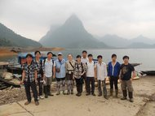The slow loris finders include, from left: Dao Van Cau, Nguyen Van Thanh, Minh Le, Eleanor Sterling, Mary Blair, Duong Thuy Ha, Chien, Truong, Huan, Lam and Thach Mai Hoang.

We have arrived at the site of our first five-day survey for pygmy and Bengal slow lorises: Na Hang Nature Reserve in Tuyen Quang Province in northern Vietnam. It took us two days just to get here. First, we had an eight-hour drive from Hanoi to Na Hang Village, broken up by a quick breakfast stop — pho, the soupy staple of Vietnam — and then a coffee break in Tuyen Quang City, the provincial capital.
We arrived in Na Hang to spend the night. In the morning we bought food for ourselves and for the forest rangers we would meet inside Na Hang Nature Reserve. Then we trekked to the dock to take a boat about 45 minutes up a river. From there, we hiked about an hour up a very steep slope to the ranger station to set up camp. Luckily, the rangers used their motorcycles to haul our supplies.

Mary E. Blair Dao Van Cau, a forest ranger in Na Hang, helped to carry luggage up the steep slope to the ranger station.

Na Hang Nature Reserve is a good first location. Our consultant and survey coordinator, Hoang Thach Mai, has been working here for several years studying snub-nosed monkeys, and he knows the rangers quite well. Using their expertise, we are able to design trails to survey several different habitats so that we can better understand where slow lorises are found in this region. We will survey mixed bamboo and limestone forest, regenerating secondary forest, magnolia plantations and secondary forest, among others.

We have spent our first couple of days (or, should I say, nights) survey training. We have two graduate students with us, Duong Thuy Ha and Nguyen Van Thanh from Vietnam National University in Hanoi. It’s their first fieldwork experience, but they are learning quickly and are already keeping the right pace (a slow and steady quarter-mile per hour) as we navigate the dark trails at night.

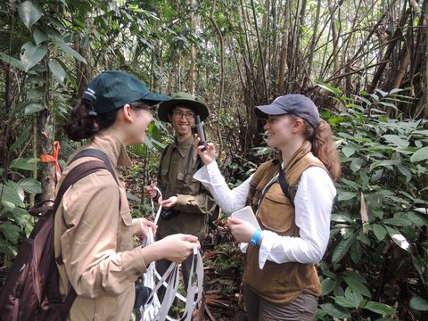Minh Le Duong Thuy Ha and Nguyen Van Thanh, graduate students from Vietnam National University, with the writer on a survey.

For our night surveys, we are following in the carefully placed footsteps of the few other intrepid loris explorers in the world. We are a small, close-knit community, in part because night work can be so challenging and very few researchers are willing to do the double duty of marking trails all day and then forgoing sleep at night to survey.
In our surveys, teams of three to four people spaced about 30 feet apart slowly traverse our marked trails for a few hours beginning at dusk. We scan all levels of vegetation using headlamps with red filters to detect lorises’ bright orange eyeshine. When we spot a loris, one of us shines a halogen spotlight on the animal to get a really good look at it, confirm the species and, with luck, take a photograph. The photographs are extremely important because loris facial markings, such as stripes or patches of dark colors on the face, are a key way to describe species-level variation. I will discuss in a later post why we think there may be more species of slow loris than have been described so far — and how we hope to use facial markings as well as genetic information from droppings, hair and museum specimens to examine that hypothesis.

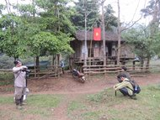Mary E. Blair The ranger station in Na Hang Nature Reserve. Thach Mai Hoang, of Vietnam National University, left, and Dao Van Cau prepared to mark trails in the forest.

So far, our surveys and training sessions have gone pretty well. We saw a slow loris on our first night. Unfortunately, we were not ready for such quick success. By the time I swung my camera to focus on the loris frozen in the headlight, it had already run away. But we’re getting better, and the next set of wide, bright eyes won’t sneak away without capture. We are pretty sure it was a juvenile Bengal slow loris (Nycticebus bengalensis). This is the edge of the range for the Bengal and pygmy slow lorises, and so we were not sure how many we would see. Even seeing just one at this point is very exciting and has given us hope that we will find more.
As I write, I sit next to a solar panel I brought to charge my camera. We hope to get some great shots of the animals we find in the next few days before we head back to Hanoi to prepare for our next two survey sites. But it’s time to sign off. There are some water buffalo nearby, and I don’t want them to trample me, or my panel!

http://scientistatwork.blogs.nytimes.com/2013/05/01/telling-eyes-in-the-dark/

May 1, 2013,

Telling Eyes in the Dark
By MARY E. BLAIR
Mary E. Blair is a postdoctoral researcher at the American Museum of Natural History’s Center for Biodiversity and Conservation, where she coordinates the Enhancing Diversity in Conservation Science Initiative.
March 20, 2013
Two bright red-orange eyes stared back at me in the dark. I hooted, “Hoo! Hoo!”— our signal for a positive sighting. I wiggled my headlamp to keep the animal’s attention and prevent it from turning away. We didn’t want to lose this one in the dark. The bright halogen beam swept into my own, as my team members that night, Dao Van Cau, Minh Le, and Nguyen Van Thanh, found the animal. I slowly lifted my binoculars up to my face. I was staring at a beautiful pygmy slow loris (Nycticebus pygmaeus). I could identify it as a pygmy loris based on its size — pygmies are much smaller than Bengal slow lorises — and by its tawny fur and the reddish brown stripes that run from its eyes and ears to the crown of its head.
Slow lorises’ eyes, like those of many other nocturnal mammals, are quite large, and they possess a reflective layer behind the retina called the tapetum lucidum. This layer is the source of their bright eyeshine, and it also provides them with superior night vision compared with animals (like humans) that lack this layer. Most of the slow lorises’ primate cousins, including Old World and New World monkeys, great apes, humans, and also tarsiers, have lost the tapetum lucidum, presumably because of a common ancestor that was active during the day rather than at night.

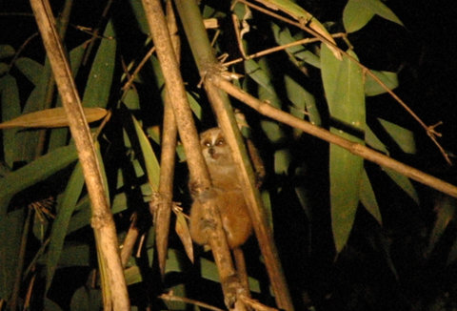Minh Le Pygmy slow loris (Nycticebus pygmaeus) in Na Hang Nature Reserve, Tuyen Quang Province.

When I first saw this loris — my second sighting on this trip — my heart started pounding and I felt awe, wonder, and joy. I also knew what it meant scientifically: we can now confirm that both species known to occur in Vietnam are present at this site. Perhaps I felt more pride in this loris sighting because I was the first one to see it, or because, unlike before, our team was ready and pulled off a fantastic photo of the animal.
Today we are leaving Na Hang Nature Reserve, heading back to Hanoi for a few days before our next field survey. But our trip to Na Hang certainly could not have ended on a better note. On the same night that my team saw a pygmy loris, the other team of Thach Mai Hoang, Duởng Thúy Ha, and Dr. Eleanor Sterling saw two pygmy slow lorises together. We think that these two animals were probably a mother and her offspring, even though they were about the same size. Slow loris offspring may stay with their mothers for a relatively long time, until the next infant is born.
By the end of the trip, we have become eyeshine experts. Small eyeshine that does not blink or move is most likely from an invertebrate, like a spider. We saw a lot of spiders during our night surveys — they were probably our most commonly sighted animals. And although they were not lorises, some of them were quite beautiful and very exciting to see.

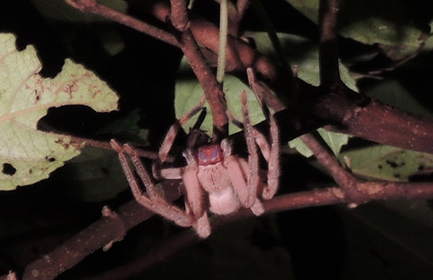Mary Blair A spider from the family Sparassidae spotted during our night surveys in Na Hang Nature Reserve.

Sometimes it can be very challenging to tell what is shining back at you in the dark. If you saw the eyeshine below during a night survey, what would you think it was?

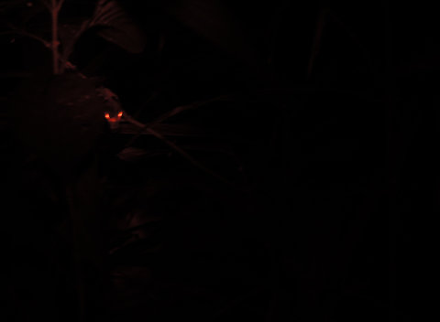Mary Blair Is this “eyeshine?”

Once we got a close look with the spotlight, we realized that the shine we saw here is from insect larvae. Other things that have confused us (besides spiders and larvae) by shining brightly in the night include raindrops, geckos, and frogs.

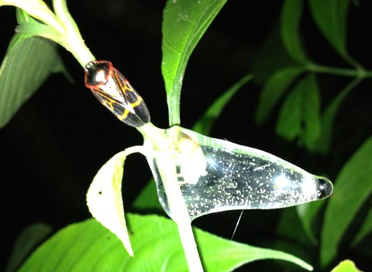Duởng Thúy Ha Insect larvae like this shines brightly in the dark, sometimes confusing us as we are looking for eyeshine.

http://scientistatwork.blogs.nytimes.com/2013/05/10/rummaging-among-skins-and-skulls/

May 10, 2013,

Rummaging Among Skins and Skulls
By MARY E. BLAIR
Mary E. Blair is a postdoctoral researcher in the American Museum of Natural History’s Center for Biodiversity and Conservation, where she coordinates the Enhancing Diversity in Conservation Science Initiative.
March 23, 2013
The room smells of mothballs and formalin. Following such an inspiring field experience in northern Vietnam’s Na Hang Nature Reserve, where I spotted the first slow loris I ever saw in the wild, this indoor environment seems decidedly unromantic. But, sometimes, the best research is accomplished by poring over boxes of old primate skeletons and skins. I am spending the day working in the zoological museum at Vietnam National University in Hanoi, where some of my research collaborators are faculty members and students.

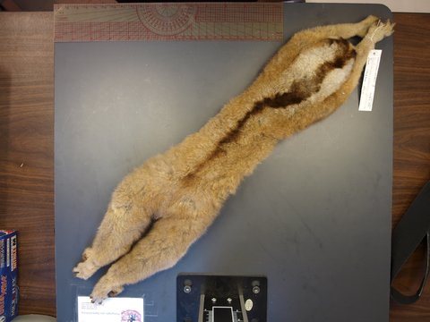Mary E. Blair A preserved Javan slow loris (Nycticebus javanicus) in the American Museum of Natural History’s mammalogy collection in New York.

As a supplement to our field surveys, museum collections can help us understand variation in slow lorises across their ranges. For example, the Bengal slow loris (Nycticebus bengalensis) can be found from India all the way to Vietnam in the east and Peninsular Malaysia in the south. Other scientists have noted some variation in fur color across this wide range. Pulling together our observations from museums and the field, we might have a better chance to show that the animals’ fur color and markings vary depending on where they live.
The Pygmy slow loris (N. pygmaeus) has a distribution that is restricted to the east of the Mekong River, a much smaller range than that of the Bengal slow loris. But this animal can still be found throughout almost the entire length of Vietnam, spanning from subtropical forests in the north to tropical forests in the south.
For many other primates in Vietnam, such as gibbons or doucs, there are three or more different species, occupying different parts of the long north-south spine of the country. Colleagues who have done similar work in Java and Borneo, also using a mix of moving and stiff animals, believe they have found new species in those Indonesian islands. Will slow lorises vary across Vietnam in a similar way to their primate cousins – as geographically diverse species with regionally specific looks?

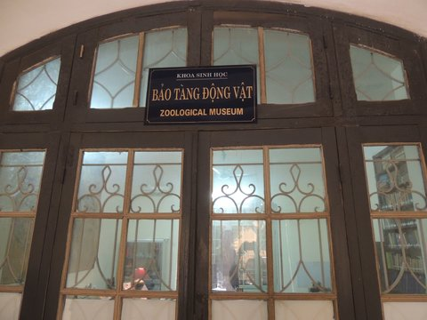Mary E. Blair Vietnam National University, home of the Centre for Natural Resources and Environmental Studies and the zoological museum.

Sitting among the boxes, I know what I’m looking for. Back in the United States, I collected data on slow lorises at the American Museum of Natural History and the Smithsonian National Museum of Natural History with the help of colleagues and interns. I came armed with pictures of individuals’ fur color and stripe patterns, a set of loris face shapes and exact skull dimensions. Put all of these pieces together and we have what amounts to a unique record for each animal — like a fingerprint, but for the whole body. It’s these bodyprints that help us compare individuals to one another.
Even as I measured and scribbled, hunched over skeletons and furs, I knew that we would soon be back in the dark hum of the forest at our next field site. But between this manufactured quiet and that natural one sits the bustling Vietnamese capital.
To shake off the feeling of being indoors all day, a colleague took me out for some Hanoi street food, for which this city of about 2.6 million is famous. My favorite: a potato cut in a spiral, fried on a stick and covered in hot sauce.

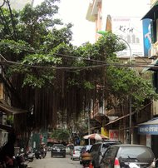Mary E. Blair A tree overhanging Hang Hanh Street in the old quarter of Hanoi, Vietnam.

Your senses are surrounded here. The nose fills with the fantastic street food smells (like my beloved fried potatocicle). The eyes gape at all the colorful banners and lights. And the ears fill with the ever-present drone of motorcycle engines.
A profusion of parked motorbikes fills the sidewalks pushing most people out onto on the streets. On wider sidewalks, there are lines on the concrete for people to play badminton.
Soon the only lines we will see will be the imaginary ones we trace through the dark forest — transects drawn in our heads to search for more slow lorises.
You can follow Mary on Twitter: @marye_blair

http://scientistatwork.blogs.nytimes.com/2013/05/20/thwarted-by-moonlight/

May 20, 2013,

Thwarted by Moonlight
By MARY E. BLAIR
Mary E. Blair is a postdoctoral researcher in the American Museum of Natural History’s Center for Biodiversity and Conservation, where she coordinates the Enhancing Diversity in Conservation Science Initiative.
March 28, 2013
The full moon rose above our field site in southern central Vietnam, bathing the trees in a pale glow, and foretelling how few lorises we would find that night.
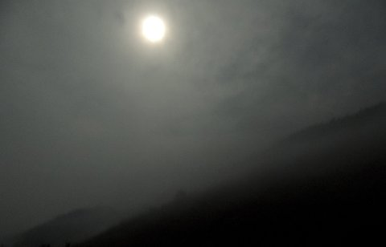Mary E. Blair The moon rises over Bidoup Nui Ba National Park.

The activity of many nocturnal mammals, and especially prey species, is affected by the intensity of the moonlight. In most cases, their activity decreases on nights when the moon is especially bright. This is likely because bright moonlight may increase the vulnerability of these animals to predators. There are a few nocturnal mammals that actually increase their activity on bright nights – like spectral tarsiers and some galagos – presumably because bright nights may increase their success in foraging for insects and ripe fruits.
But it seems that lorises are, sadly, in the majority; a slow loris research team working in Cambodia recently found that moonlight and temperature interact to influence pygmy slow loris activity. On very dark nights, the lorises were always active – but on nights with bright moonlight, animals were only active when the temperature was also high. This pattern is related to the cryptic antipredator behaviors of lorises: in order to avoid their predators, including civets, pythons, predatory birds and monitor lizards, lorises may be even more eager to avoid detection on bright nights when they are more likely to be seen by sets of eyes with hungry jaws attached.
On cold nights we would also expect less activity because of the increased risk of heat loss. During our surveys in here in southern central Vietnam, the temperature has been quite cool, and the moon has been very bright. Result? No slow loris sightings.
It also did not help that we simply did not have much time to survey here, mostly because getting here was so hard.
The first part of the journey was easy – we flew from Hanoi to Da Lat, the city of flowers – located at the southern end of the central Annamite (Truong Son) mountain range. The city and the surrounding landscape were exceptionally beautiful. There were flowers everywhere, including an Eiffel Tower made of flower pots in the middle of a traffic circle.

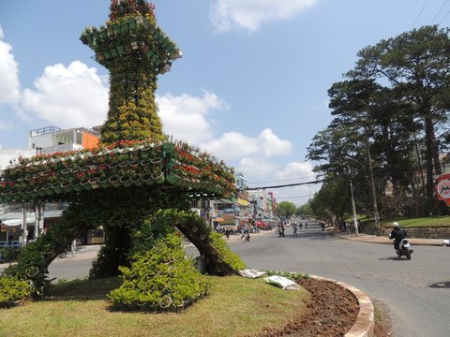Mary E. Blair An Eiffel Tower made of flower pots in Da Lat, Vietnam.

But the ornamental flowers and the paved roads ended there. The staff of Bidoup Nui Ba National Park picked us up from our hotel in Da Lat in a large Russian military S.U.V. — a first hint of the rough road ahead.
We started on our long and muddy drive into the park. And then there was a hailstorm. Hard, marble-sized white pellets banged on the roof and windows. We pulled over and stared in awe, as they grew larger and larger, pounding harder and harder. It sounded like they would cave in the roof — or at least leave it permanently pockmarked. After 15 minutes of pounding, the storm passed as quickly as it had started. The roof was unaffected. Our blood pressures were not so lucky.

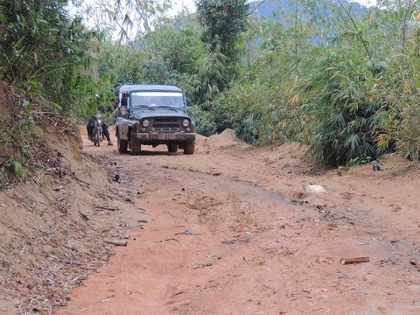Mary E. Blair The dangerous road to Đạ Long.

We arrived at the Đạ Long ranger station as it was getting dark, without enough time to hike to our intended survey site. So we laid low that night and started fresh the next morning. After an hour of motorcycling over bamboo bridges, mud and brush, followed by a deep stream crossing by foot, gear hoisted above our heads, we arrived not so fresh at the site. We now only had one night, instead of the two we had planned, to survey for lorises. And that’s when we walked straight into a bright moon.

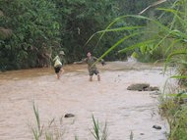Mary E. Blair Trương Quang Cường, left, and Thạch Mai Hoàng crossed the stream to get to the survey site in Bidoup Nui Ba National Park.

We learned the hard way. Now we know to incorporate moonrise times and phases when we are planning our work schedule. We also know to allow for extra days of hard travel and sudden hailstorms.
But the perturbing moon wasn’t all bad. I came out the experience with some really interesting questions for future studies. For example, would the effect of bright moonlight on the activity of pygmy lorises in Vietnam vary from habitat to habitat? Would moonlight show a stronger effect on loris activity in more open habitats as opposed to more closed forests where moonlight may not penetrate through the dense leaves as easily?

Mary E. Blair A message to visitors at the ranger station in Bidoup Nui Ba National Park, written in charcoal.

I learned a lot from the wonderful national park staff we were able to work with during the trip. The staff is very interested in thinking about how cultural diversity and biological diversity relate in their park. One of our colleagues told me that the K’Ho ethnic group — the people who live in and around Bidoup Nui Ba National Park –believe that slow lorises are cursed. They say if someone goes out into the forest and sees one, they must move to a completely different piece of land to cultivate their crops. This story made me wonder about slow loris populations in the area and how different ethnic groups may value them differently. Understanding local folklore is vital to informing not only our research on slow loris diversity and distribution, but also how to approach their long-term conservation in Vietnam.
When it comes to slow loris conservation, human cultural diversity and biological diversity are intertwined. I will continue to think and discuss these issues with my Vietnamese colleagues as we head to the final protected area on our journey, Bu Gia Map National Park in southern Vietnam.
You can follow Mary on Twitter: @marye_blair

http://scientistatwork.blogs.nytimes.com/2013/05/22/a-forest-denizen-at-risk/

May 22, 2013,

A Forest Denizen at Risk
By MARY E. BLAIR
Mary E. Blair is a postdoctoral researcher in the American Museum of Natural History’s Center for Biodiversity and Conservation, where she coordinates the Enhancing Diversity in Conservation Science Initiative.
April 4, 2013
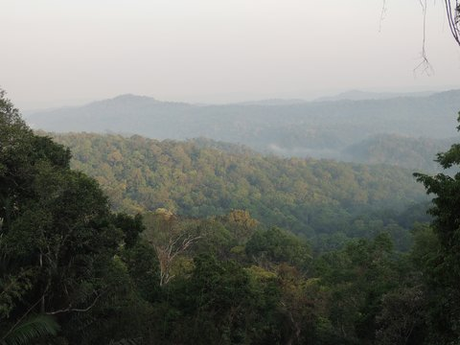Mary E. Blair A view of Cambodia from the roof of the ranger station on the Vietnamese border.

In the dark quiet of a Vietnamese forest at night, it is easy to feel completely alone. But unfortunately, we are not the only ones going out to look for small, wide-eyed primates in these forests. Although my research team seeks only to study and take photographs of the slow lorises we find, others want to take the animal itself.
Local, regional and international commercial trade in wildlife is one of the most important threats — if not the most important — to the survival of many species in Asia. Indeed, trade in wildlife is the third most profitable illicit industry in the world, behind narcotics and human trafficking.
Primates like slow lorises are especially vulnerable to even low levels of hunting for the trade because of their biology. Unlike rodents and some other mammals, primates generally live longer and have slow reproductive rates. And relatively speaking, they are older when they first reproduce, they spend more time raising young and they have fewer offspring at a time.
It’s a game of numbers — and slow lorises have bad odds to start.
The death or removal of even just a few individuals as pets or for traditional medicine can have devastating effects on primate populations. Local extinctions of slow lorises have been reported recently in parts of India, Cambodia and Vietnam, and the wildlife trade is often considered a major reason for the decline in slow loris populations, combined with forest loss.
So why would someone want to trade in slow lorises? Here at the final protected area we are visiting on our journey, Bu Gia Map National Park, rangers have told us that slow lorises in this region might be killed, dried, ground up and mixed with rice wine or honey and used to treat stomach disease. This is very similar to what other researchers have reported in Cambodia.

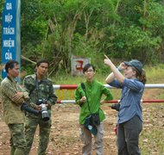Thach Mai Hoang The research team, from left: Toai Nguyen, Khuong Huu Thang, Duong Thuy Ha and Mary Blair.

By contrast, in northern and central Vietnam, it is more common to keep slow lorises as pets rather than using them in traditional medicine. Bu Gia Map National Park is very close to the border between Vietnam and Cambodia, so it was really interesting to find out that the cultural values related to slow lorises here are perhaps more similar to those from Cambodia than those in northern or central Vietnam. After hearing the park employees’ stories, it was with a renewed sense of urgency that our survey team pulled back to the task at hand.

Mary E. Blair A pygmy slow loris (Nycticebus pygmaeus) sighted during a night survey in Bu Gia Map National Park.

Our two teams headed out to survey as the sky turned dark gray. When we met up back at the station around midnight, everybody had good news. My team saw a beautiful pygmy loris, pictured above, and the other team saw some as well.
Mary E. Blair Red jungle fowl, a wild ancestor of domestic chicken.
It was hard to sleep after such an exciting night, and being field biologists, we were anxious to see what other wildlife we might come across at this beautiful site. So we headed out early the next day to explore some more. Park workers had said that if we were lucky we might see black-shanked doucs (Pygathrix nigripes) at this site. We were amazed when we came across a group of them — and also wild red jungle fowl, a green dove, a green barbet and many other wonderful animals.
Mary E. Blair A green dove.
In this beautiful place, packed with life of all kinds, I feel inspired to continue my work and especially to try to better understand the links between human cultural diversity and the biological diversity present here. The conservation of biodiversity depends on these links — on the relationships between social and ecological systems
On Twitter: @marye_blair

Red River faces bleak future

Last updated: 3/17/2011
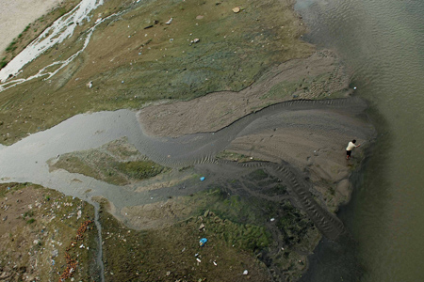A man fishes from an exposed mud flat on the Red River in Hanoi. Riparian communities have complained that the shrinking waterway has become increasingly shallow and polluted in recent years.

For thousands of years, poor subsistence-level communities have survived on the bounty of the Red River. In the past year or so, their way of life has changed dramatically.
Hong says that for the past year, she has been using well water to irrigate her vegetable garden, due to severe pollution in the Red River.
“After a few days of watering [with river water] my vegetables just wither and die, especially in the dry season,” said the farmer from Van Yen District in the northern mountainous province of Yen Bai.
Hong and her neighbors say they’re in a terrible predicament. They worry that chemicals in the river may have seeped into their ground wells – which they no longer use for washing and cooking.
“We order clean water from people living far away from the river bank,” she said. “These days, we always pull stinking black sludge out of the wells.”
About 80 kilometers downstream, in the provincial capitol, many small scale vegetable farmers say they’ve abandoned the trade.
Do Thi Nga has been farming in the town for nearly 50 years. This year is the first time she can recall seeing stinking black sludge.
“This river pollution may have killed off my vegetables, recently,” said Nga, who lives on Thanh Nien Street in the Bo Song (River Bank) Neighborhood.
In some ways, the situation is far worse for the community’s fishermen.
No more fish
The 1,150 kilometer Hong (Red) River begins in China’s mountainous Yunnan Province. The river stretches 556 kilometers into Vietnam, bisecting seven provinces and cities, including Hanoi, before emptying into the Gulf of Tonkin.
HEAVY METALS IN
YEN BAI PROVINCE
Heavy metals | Current quotients | Safe quotients for irrigation
Lead (Pb) | 0.74 mg/l | 0.05 mg/l
Cadmium (Cd) | 0.103 mg/l | 0.01 mg/l
Along with the Thai Binh River system, it has played a life sustaining role in irrigation and drainage for the region’s farmers in addition to providing an important transportation route and hydropower source.
Last week, riverfront residents told Thanh Nien that low water levels and severe pollution have threatened the area’s fragile fishing and agricultural economy.
Yen Bai Province’s Bo Song Neighborhood has counted on the Red River for generations.
Nearly all of the residents here say their families survived on fishing.
For the past year, many have taken to referring to the waterway as the “Dead” River, following a drastic decline in fish populations. Others are scrambling to find other means of support.
“It used to take one hour to catch enough for a meal,” said Nguyen Van Nghi, a local fisherman. “These days, it takes a whole afternoon, just to net a snack.”
To make matters worse, Nghi began pulling up noxious sludge in his nets. The ooze exuded fumes which gave him terrible headaches, he said.
Another fisherman, Nguyen Van Cuong, said his family has been fishing the river ever since his grandfather moved from Hanoi to Yen Bai.
Cuong recently quit the family trade and took a job transporting construction materials.
“Fish and shrimp have become scarce,” he said. “Many other families have also quit fishing.”
Nearby, the residents of Bao Dap Commune are also struggling with the challenges presented by the ailing river.
A young fisherman named Tien said that the practice of breeding fish in floating cages had become a thriving trade before widespread pollution lead to the death of many fish.
“There used to be abundant species, some of which weighed dozens of kilograms,” Tien said. “Today they only exist in the memories of old fishermen.”
Less water, less silt
Thanh Nien’s request to boat up towards the Chinese border
ORGANIC SUBSTANCES
IN LAO CAI PROVINCE
- Chemical oxygen demand: 1.25 times higher than the allowed level for irrigation water of 30 mg/l
- Biochemical oxygen demand: 2.7 times higher than the allowed level of 15 mg/l
- Total suspended solids: 20 times higher than the allowed level of 50 mg/l
(Source: Lao Cai Department of Natural Resources and Environment)
through Lao Cai Province was denied last week by provincial border guards, who cited low water levels.
“The river is too shallow even for small boats [to pass],” said Colonel Luong Van Son of Lao Cai Border Guard. “You would have to wade through thick mud flats.”
Hoang Thi Theo, a resident of Trinh Tuong Commune in the province’s Bat Xat District confirmed that the river has grown increasingly slight in recent years.
“It looks just like a small stream,” she said.
Hydrological statistics from November 2009 to April 2010 show that the river is experiencing unprecedented lows.
The data also reflect record lows in three Red River tributaries: Da, Thao and Lo.
The Lao Cai Department of Natural Resources and Environment said that poor rainfalls and the construction of upstream dams have seriously hurt the shrinking river.
The National Hydro-Meteorological Forecasting Center recently predicted that the river’s water levels running in the Hanoi area could fall as low as 10 centimeters, during the coming dry season.
The river’s low flow has alarmed a number of experts concerned with the fate of Northern Vietnam’s Red River Delta.
Pham Hong Giang, Chairman of the Vietnam National Committee on Large Dams and Water Resources Development, said there has been a “notable” change in the volume and quality of water in the Red River Delta, in recent years.
“Silt levels have fallen significantly and that is partly due to the upstream activities,” he said, adding that damming was certainly a contributing factor. “It was difficult to conduct inspections across the [Chinese] border; we’re only working with data on activities in Vietnam.”
Dams, mines and toxic waste
The Ministry of Public Security’s Environmental Police have instructed provincial authorities along the river to conduct a thorough sweep of all industrial facilities and coordinate with Chinese agencies in Yunnan Province to trace the cause of the pollution.
On Tuesday (March 15), police confirmed that pollution of the river in Lao Cai Province, which borders China, had been caused by the indiscriminate dumping of untreated wastewater in both countries.
Vietnamese inspectors charged that vegetable processing plants, mineral factories and riverfront hospitals in Lao Cai Town had all released toxic waste into the river.
Meanwhile, many residents in Lao Cai’s Bat Xat District say that Chinese Tapioca processing facilities have seriously contributed to the problem.
Mai Dinh Dinh, deputy director of the Lao Cai Department of Natural Resources and Environment, confirmed that the factories exist but declined to comment on the extent of their alleged pollution.
Another official from Dinh’s office told Thanh Nien that the construction of upstream hydropower dams, some of those in China, has significantly impeded nutrient-rich silt from washing down the river.
Dinh also claimed that the dams are responsible for lowering the water levels.
According to the Ministry of Natural Resources and Environment, China had planned 20 hydropower plants on the upstream Red River.
Eight are currently operating on the river with a peak load capacity of 1,700 megawatts. Together, the dams are capable of holding back two trillion liters of water.
Nevertheless, the exact cause of the pollution and low water levels remains a subject of speculation.
Nguyen Dinh Hoe of the Vietnam Association for Conservation of Nature and Environment blamed upstream mining activities for the pollution.
“Recent tests have shown high concentrations of heavy metals in the river,” he said. “This level of contamination could surely result in dangerous illnesses.”
Reported by Thanh Nien Staff

Last update 15/02/2011

Hanoi nearly ranks at the bottom of green city list
VietNamNet Bridge – According to the Asian Green City Index 2011 released on February 14, Hanoi is listed in the group of “under average” cities for the green.
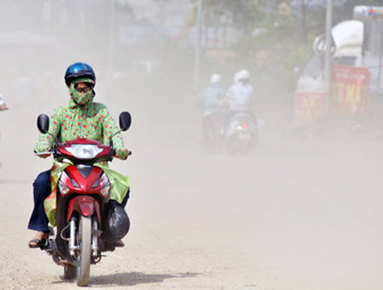
Of the 22 ranked cities, Hanoi, three cities in India (Bengaluru, Kolkata, Mumbai) and Manila of the Philippines are in this group. This group is only above Pakistan’s Karachi, the city at the bottom of the rankings.
Singapore is Asia’s greenest metropolis. This is the conclusion of the Asian Green City Index– a study commissioned by Siemens and performed by the independent Economist Intelligence Unit (EIU).
For the study, which was carried out over the past few months, the EIU analyzed the aims and achievements of 22 major Asian cities with respect to environmental and climate protection.
Singapore City stands out particularly for its ambitious environmental targets and its efficient approach to achieving them. In addition to Singapore City, in other Asian cities environmental awareness and climate protection guidelines are playing an increasingly important role.
The Asian Green City Index examines the environmental performance of 22 major Asian cities in eight categories: energy and CO2, land use and buildings, transport, waste, water, sanitation, air quality and environmental governance. The EIU developed the methodology in cooperation with leading urban experts around the world, including representatives of the OECD, the World Bank and Asia’s regional network of local authorities, CITYNET.
“The study of Asian cities shows one thing very clearly: higher income does not necessarily mean higher resource consumption. While resource consumption increases substantially up to an annual gross domestic product (GDP) of about €15,000 per capita, it drops again when income rises beyond this,” said Jan Friederich, research head of the EIU study.

Overall results:

Well above average: Singapore
Above average: Hong Kong, Osaka, Seoul, Taipei, Tokyo, Yokohama
Average: Bangkok, Beijing, Delhi, Ghuangzhou, Jakarta, Kuala Lumpur, Nanjing, Shanghai, Wuhan
Below average: Bengaluru, Hanoi, Kolkata, Manila, Mumbai
Well below average: Karachi
VN

Last update 20/03/2011
Saigon River in threat of sea water encroachment
VietNamNet Bridge – The encroachment of sea water into the Dong Nai-Saigon river system has soared, affecting the supply of freshwater for agriculture and daily life of millions of people in HCM City.
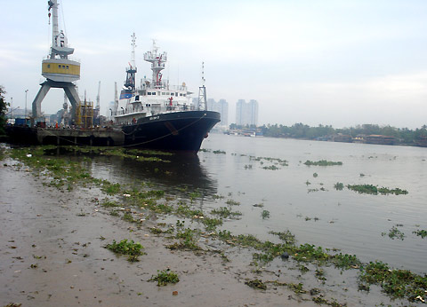
Nguyen Minh Giam, deputy director of the Southern Region Hydrometeorological Station, said that “the latest data collected at some rivers in the south shows that this year’s salty water encroachment occurred more early, and at higher level than previous years.”
Many rivers in the southern region are infected with salty water at very high levels, which are several times over the threshold. For example, the Nha Be River with 15 g/liter; Vam Co Dong River 4.6 g/liter; and the Vam Co Tay River 3.3 g/liter. The Vietnamese standard for salt in fresh water for daily life is under 0.25 g/liter.
Salty water has encroached deeply into canals inside HCM City. For instance, Doi, Te canals 3-4 g/liter, with An Ha and Xang canals at 1-2 g/liter.
The Saigon Water Supply Corporation said that “the encroachment of salt water has affected its operation.” To reduce the saltiness, Dau Tieng reservoir has to discharge water for the fourth time.
Bui Xuan Dai, Deputy Director of the Dau Tieng Irrigation Company, said “that on March 16, Dau Tieng reservoir discharged over 3.8 million cubic meters of water to reduce the saltiness in the downstream of the Saigon River, to save Tan Hiep Water Supply Factory (300,000 cu.m/day in capacity).”
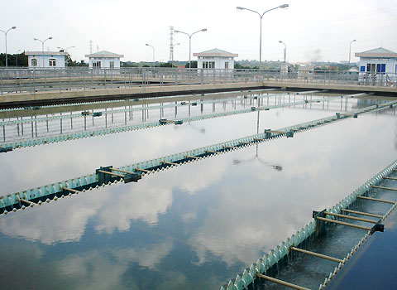

The Dau Tieng reservoir’s water level was 19.58m in the morning of March 17, only 2.58m over the dead level. The reservoir is getting dry due to drought, but it still has to discharge water to push back sea water and to supply water for Tay Ninh and HCM City.
Hydrometeorological experts said that “this year’s sea water comes early and encroaches more deeply into southern rivers because the water volume in the upstream is very modest. Moreover, upstream hydro-power plants have stored up more water to produce more electricity for the dry season, resulting in more serious salt water encroachment in the downstream.
March and April is the peak of the dry season. The saltiness in southern rivers is forecast to increase.

PV

Last update 10/03/2011
Time for Mekong Delta to redefine priorities: expert
VietNamNet Bridge - Sustainable development of the Cuu Long (Mekong) Delta and achievement of its growth potential depend on more sensible exploitation of its agricultural strengths, experts say.
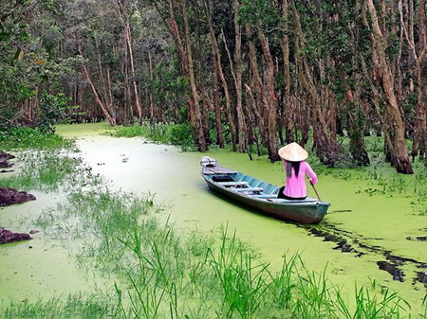
Professor Vo Tong Xuan, a rice scientist, said agriculture and aquaculture were fundamentally important for the delta's development, and any strategy excluding them would result in ruin for the region.
"Industry in the delta should be developed in the direction of supporting agricultural production and processing of agricultural and seafood products," Xuan said.
Xuan also said that fully exploiting the region's agricultural and aquaculture potential required the rezoning of cultivation areas.
"I have suggested a model to combine the cultivation of rice, fish, fruit trees and animal husbandry. Fish ponds would be adjacent to rice paddies, husbandry sheds and orchards and gardens," he said.
"Ponds would provide water for trees and gardens, and vegetables would feed cattle and pigs. Ponds would also provide irrigation for rice fields."
Xuan also felt earmarking separate cultivation areas for rice, fruit and fish or shrimp cultivation for the region as a whole would improve agricultural management and exploitation.
For instance, coastal areas with large amounts of brackish water would focus on aquaculture while areas further inland would mainly grow crops that need fresh water. This would reduce conflicts over the use of limited natural resources and ensure more balanced development.
With a combined area of 40,604sq.km that is crisscrossed by millions of inland canals and river systems, the delta accounts for half of the country's rice, 52 per cent of aquaculture and 90 per cent of its fruit production. It also accounts for 90 and 60 per cent of the country's rice and seafood exports respectively.
While local economists agree with scientists like Xuan that the region's agricultural potential has not been tapped well, they tend to differ on how it should be done.
Vo Hung Dung, director of the Viet Nam Chamber of Commerce and Industry (VCCI) in Can Tho City, considered the region's growth hub, told Viet Nam News that agricultural production had not reached its full capacity in the region.
While some localities' investments had paid off and improved production, many other areas had not spent enough on developing farming, aquaculture and fruit production, said Dung, an economist who specialises in the region.
"The delta did not have adequate industrial infrastructure for quick development of general industry," Dung said. "And a strategy and process for economic growth with a focus on agriculture was not implemented."
"Under the current system, farmers are not getting sufficient returns on their produce because investment has been too low", Dung said.
For example, star apples grown in Tien Giang Province under the Global GAP (Good Agricultural Practice) standards which require additional investment fetch higher prices than normally cultivated star apples.
The standards, which regulate the quality of soil preparation, cultivation methods, pest management, harvesting and storing methods, have helped raise farmers' incomes.
"It is obvious that farmers need to invest in production to produce GAP-standard fruits," he said, adding that both foreign and local buyers were interested in quality products.
"As you can see, the country's fruit imports are now higher than our exports, and we need to invest more. Industry can assist agriculture and aquaculture. For instance, it can offer modern processing technologies for storing agricultural produce."
Application of GAP standards also help fish breeders in the region meet import criteria set by European countries.
Because global GAP standards require quality packaging, the preservation and packaging industry should be developed in the delta, according to Dung.
"I agree that transforming the economic mechanism from agriculture to industry is a prerequisite for development of the Delta, but no one should forget investment for agriculture and aquaculture, which should serve as the base for industrial development," Dung said.
"That's the only way to have a sustainable economy for the delta," he emphasized.
Water management
Dr. Duong Van Ni of Can Tho University said the most crucial factor was to preserve and protect water for agriculture and aquaculture in the context of climate change.
"Each province is individually dredging its waterways, but they don't realise that this takes water from other places in the same river basin, causing a shortage elsewhere," Ni said.
Xuan, Ni and Dung praised the Government's initiative to formulate a masterplan for water resource management and land use in the delta.
They also said rice farmers needed policy help. "Only the Government can settle the problem of farmers suffering losses even when they have bumper crops," Dung said.
Several enterprise and industry associations have acknowledged that rice drying, husking and cleaning facilities should be physically closer to farmers, but the lack of roads are a big hindrance.
Dung said better roads leading to remote rice cultivation areas would help farmers meet rice exporters at convenient collection points, from where rice can also be transported to processing facilities more easily.
He also said farmers need credit assistance to meet production expenses to help them store harvested rice and sell at reasonable prices in the market. "Because of the credit shortage, farmers now sell all of their rice from their bumper crops, which then makes rice prices plummet."
Xuan mooted the idea of forming companies specialising in rice production management, processing and trading, saying they could work with other industrial sectors servicing the agricultural sector, and be based at collection points near the farmers' rice fields.
Meanwhile, the National Committee for the Southwestern Region, which is in charge of drafting policies to boost the development of the delta, has said it was working to create linkages between various sectors to boost development of the region as a whole.
According to Tran Huu Hiep, deputy head of the committee's office, a joint task force will be established for the purpose. The taskforce would comprise the committee, provinces, institutes and agencies, including the Southern Fruit Institute, the Cuu Long (Mekong) Delta Rice Research Institute, Cuu Long (Mekong) Delta Research and Development Institute, Can Tho University, the committee and the National Assembly.
"The linkage between provinces and sectors is expected to help the region meet its full potential and to set up a common base for sustainable development of 12 provinces and city (that comprise the Cuu Long (Mekong) Delta)," Hiep said.
Source: VNS

http://www.nytimes.com/2011/04/18/world/asia/18mekong.html

Decision Looms for Laos Dam, but Impact Is Unclear
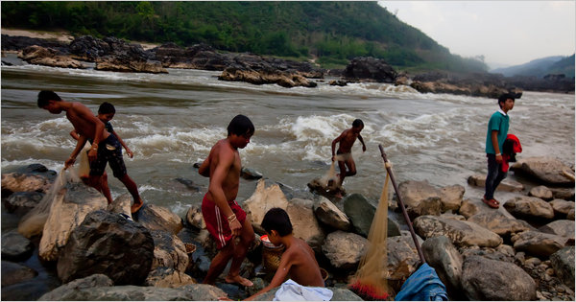
Justin Mott for the International Herald Tribune
The Mekong River, teeming with hundreds of species of fish, has for centuries been the lifeline of villages in Laos and Vietnam.

By THOMAS FULLER

Published: April 17, 2011
HOUAY SOUY, Laos — The Mekong River is so brown with silt as it passes this impoverished village, it could be called liquid dirt. For millions of people downstream this is the color of life: the Mekong, teeming with hundreds of species of fish and rich in minerals, has for centuries been the lifeline of villages and towns stretching from the rocky rapids of Tibet to the lazy meanderings of the river in the Vietnam delta.
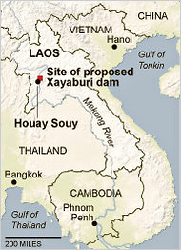

The New York Times
Farmers fear that the dam would affect water flow.
On Tuesday the four countries that share the lower reaches of the Mekong River will announce whether they agree to the construction of a controversial dam, a decision that could forever alter the character and natural diversity of one of the world’s longest and most bountiful rivers.
The proposed dam, known as the Xayaburi for the province in Laos where it is located, is a test case for a 1995 agreement signed by Laos, Thailand, Cambodia and Vietnam to share the river’s resources — its fish, water and the minerals carried by the silt that fertilize the soils of places like the Mekong Delta. The agreement, which called for a process of consultation on actions affecting the river, was seen as a major step toward greater cooperation for countries that a few decades ago, during the Vietnam War, were often at odds.
But Laos appears to be undermining the spirit of that cooperation. All four countries retained the right to build dams with or without agreement by neighboring countries. And here at the proposed site of the Xayaburi Dam, work has been under way since November. The area is teeming with trucks and hundreds of workers who have cleared an access road, built barges and set up concrete mixing facilities.
China, which was not part of the cooperation agreement, has already built four dams closer to the river’s source. Yet the dam in Laos is considered by many as pivotal because it could affect fish migration patterns and kick off the construction of at least five other dams already slated for the lower reaches of the Mekong.
Studies by experts on Xayaburi’s environmental impact are filled with apprehension and criticism, doubts that may be the seeds of future conflicts between countries sharing the river.
Senator Jim Webb, a Democrat from Virginia who heads the Senate’s Subcommittee on East Asian and Pacific Affairs, last week criticized the dam project for what he called a failure to meet international standards. He predicted that a lack of coordination between the countries that share the Mekong would have “devastating consequences.”
“The United States and the global community all have a strategic interest in averting regional conflict by preserving the health and well-being of the more than 60 million people who depend on the Mekong River,” he said in a statement.
The news media in Vietnam, which normally hew to the government’s line, have been unusually critical of the project. Farmers in the Mekong Delta fear that an accumulation of dams on the river could reduce the volume of water that reaches Vietnam, exacerbating the problem of saltwater seeping into farming areas from the sea.
A report published by the head office of the Mekong River Commission, the organization set up to coordinate dam projects on the river, described “fundamental gaps in knowledge” about how migratory fish would be affected by the dam. Experts hired by the commission estimated that the dam would curtail the migrations of anywhere from 23 to 100 species of fish. It described as “ineffective” a device proposed by the Thai construction company carrying out the project to allow fish to bypass the dam. And it said there was a “strong possibility” that one of the river’s most distinctive species, a giant catfish that can exceed the weights of several full-grown men, would become extinct.
But perhaps most striking is the commission’s estimate that the dam’s ability to produce electricity will be severely compromised within a few decades because the dam’s reservoir will fill up with silt. (The plan calls for a generating capacity of 1,285 megawatts, enough to power a small or medium-size city; most of the electricity will be sold to Thailand under an agreement already signed between the dam’s builder and a Thai utility company.)
“It is expected that under proposed operating conditions, the reservoir would effectively lose about 60 percent of its capacity due to sedimentation after 30 years,” the commission’s report says.
Thus, critics say, the dam will have permanent consequences for life in the river, including possible extinction of larger species, but may only produce several decades of electricity.
The Laotian government has responded to questions and criticisms about the dam with a stout defense of the project. The dam, which is situated between steep hills and will span a distance of about eight football fields, will have the same impact as a “natural waterfall,” the government said in response to the report by the Mekong River Commission.
Embracing hydropower will alleviate the need for “big power plants which cause a lot of pollution,” the government said. “Hydropower project development which is a green energy shall be strongly promoted and supported,” it concluded in its response.
Landlocked and sparsely populated, Laos is counting on revenues from hydropower to help lift the country out of poverty and finance government programs.
The government says it plans to become “the battery” of Asia with a total of 70 hydroelectric projects, 10 of which are already in operation. The Xayaburi Dam would take seven years to build.
CH. Karnchang, the Thai construction company carrying out the project, refused to allow a reporter to visit the proposed dam site. But it was possible to reach it by chartering a boat and walking several kilometers along the river bank.
In villages near the dam site people seem divided about the project. The government has proposed moving people who live in villages that will be flooded by the dam’s reservoir to a spot farther upstream and says it will provide electricity, which they currently do not have. But some villagers said they were told their new dwellings would not be along the riverbank.
“The government has already told us three times that we need to move out,” said Sripan Sukaew, a fisherman who lives in this village overlooking the dam site. “I’ve been fishing since I was born. This is better than working as a day laborer in Bangkok.”

A version of this article appeared in print on April 18, 2011, on page A4 of the New York edition.

Three Gorges lessons for Vietnam

Last updated: 6/3/2011 -- TNO
Damming the Mekong would lead to loss of fisheries, reduced agricultural productivity and erosion of river channels and coastline of the Mekong Delta
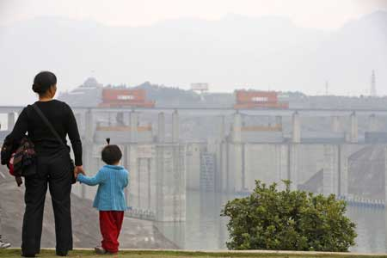
Visitors look at the shipping locks of the Three Gorges Dam near Yichang, Hubei Province, China. China will move at least four million people in the next decade to protect the ecology of the Three Gorges dam reservoir, Chinese media reported.
By Peter Bosshard (*)
The Three Gorges Dam on the Yangtze River is the world’s largest hydropower project. It has often been touted as a model for dam building around the world. Now the Chinese government has officially acknowledged that the project has serious social, environmental and geological problems. What are the lessons from the Three Gorges experience?
With a capacity of 18,200 megawatts – more than all proposed dams on the lower Mekong’s mainstream combined – the Three Gorges Dam is a masterpiece of engineering indeed. In spite of its daunting complexity, the government completed the project ahead of time in 2008. Its cost has been estimated at between US$27 billion and $88 billion.
The Three Gorges Dam generates two percent of China’s electricity and substitutes at least 30 million tons of coal per year. Yet it was neither the cheapest source of energy nor the best option for replacing coal. While the dam was under construction, the country’s economy actually became more wasteful in its use of energy. According to the Energy Foundation in the US, it would have been “cheaper, cleaner and more productive for China to have invested in energy efficiency” rather than new power plants.
Project impacts
The project’s social and environmental cost may be even more staggering than the financial price tag. The Three Gorges Dam has displaced more than 1.2 million people. Hundreds of local officials diverted compensation money into their own pockets, but protests against such abuses were oppressed. Because it no longer controls the economy and land is scarce, the government was not able to provide jobs and land to the resettlers as promised.
Damming the Three Gorges caused massive impacts on the ecosystem of the Yangtze, Asia’s longest river. The barrage stopped the migration of fish, and diminished the river’s capacity to clean itself. Pollution from dirty industries along the reservoir is causing frequent toxic algae blooms. Commercial fisheries have plummeted, the Yangtze River dolphin has become extinct, and other species are facing the same fate.
Due to dam building and pollution, rivers and lakes around the world have lost more species to extinction than any other major ecosystem.
While the social and environmental problems had been predicted, government officials were not prepared for the dam’s massive geological impacts. The water level in the Three Gorges reservoir fluctuates between 145 and 175 meters every year. This destabilizes the slopes of the Yangtze Valley, and triggers frequent landslides. According to Chinese experts, erosion affects half the reservoir area, and 178 kilometers of riverbanks are at risk of collapsing. More than 300,000 additional people will have to be relocated to stabilize the reservoir banks.
Since most of the Yangtze’s silt load is now deposited in the reservoir, the downstream regions are starved of sediment. As a consequence, up to four square kilometers of coastal wetlands are eroded every year. The Yangtze delta is subsiding, and seawater intrudes up the river, affecting agriculture and drinking water supplies. Because of a lack of nutrients, coastal fisheries have also suffered.
Hydropower projects have often been proposed as a response to global warming, yet the Three Gorges Dam illustrates how the vagaries of climate change create new risks for such projects. In a nutshell, past records can no longer be used to predict a river’s future streamflow. The dam operators planned to fill the Three Gorges reservoir for the first time in 2009, but were not able to do so due to insufficient rains. The current year has brought Central China the worst drought in 50 years, which has again sharply reduced the power generation of the Three Gorges and hundreds of other dams.
Change of course?
Scientists had warned of the Three Gorges Dam’s impacts throughout the 1980s and 1990s, but no one listened to them. On May 18, China’s highest government body for the first time acknowledged the dam’s serious problems. “The project is now greatly benefiting the society in the aspects of flood prevention, power generation, river transportation and water resource utilization,” the government maintained, but it has “caused some urgent problems in terms of environmental protection, the prevention of geological hazards and the welfare of the relocated communities.”
The Three Gorges Project has served as a model of dam building all around the world. The Son La Dam on the Da River has for example been called “Vietnam’s response to the Three Gorges Dam.” After the completion of the mega-dam on Yangtze River, the Three Gorges Power Corporation and its contractors started exporting the technology which they had acquired at the Three Gorges to other countries, including Laos, Cambodia and Vietnam.
Given the project’s global significance, it is important to draw lessons from the experience with the Yangtze dam. First and foremost, the Three Gorges Project shows that damming the mainstream of major rivers is particularly damaging, in that it will interrupt the migration of fish and the transport of sediments throughout a river’s ecosystems. As the World Commission on Dams recommended in its path-breaking report, Dams and Development, a river’s mainstream should not be dammed as long as there are other options.
Secondly, the Three Gorges experience demonstrates that large dams on major rivers are massive interventions into highly complex ecosystems. Their impacts can occur thousands of kilometers away and many years after construction has been completed. It is impossible to predict and mitigate all social and environmental impacts of such projects. As a team of international hydrologists coordinated by The Nature Conservancy found in a study in 2010, downstream impacts in particular are often neglected.
A Strategic Environmental Assessment prepared for the Mekong River Commission predicts that damming the lower Mekong mainstream would cause the loss of riverine and marine fisheries, reduce agricultural productivity in Mekong Delta and Cambodia’s floodplains, and erode the river channels and coastline of the Mekong Delta. All these impacts have been borne out by the Three Gorges Project. The recommendation by the Commission, and now by the Vietnamese government, not to dam the Mekong for the next 10 years reflects the experience of the Yangtze dam.
Finally, the Three Gorges Dam demonstrates that affected communities and other stakeholders should be involved in decision-making regarding large infrastructure projects from the beginning.
China has a strong state and spent tens of billions of dollars on resettlement programs for the Three Gorges Dam. But because the affected people were excluded from decision-making, the program often ignored their needs and desires, and resulted in wide-spread impoverishment and frustration.
The Chinese government recently started a comprehensive effort to pay pensions to the millions of people who were displaced by its dam projects. It would be cheaper and more effective to give affected people a say in decision-making from the beginning. The civil society consultations on the Xayaburi Dam which the Vietnamese government held earlier this year were a step in the right direction.
(*) Peter Bosshard is the Policy Director of US-based environment NGO International Rivers. The opinions expressed are his own.

Last update 04/03/2011
Lesson from Thailand with Mekong dams
VietNamNet Bridge – The World Wide Fund for Nature (WWF) on March 3 warned investors in dam construction projects in the Mekong River to learn the lesson from the dam on Mun River in Thailand, a failure in terms of economic, environmental and social impacts.
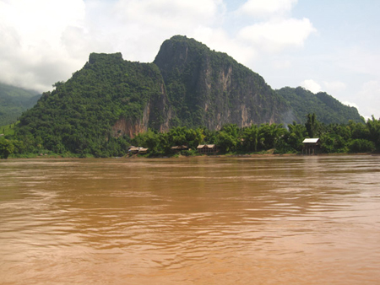
The Thai Government is considering permanently opening the doors of the Mun River dam in the hope to resume the ecological system in the Mun River, a branch of the Mekong River.
Mun River originates from the Khao Yai National Park, Thailand’s largest and oldest nature reserve. It meets the Mekong River in Ubon Ratthatchani province in northeastern Thailand.
The Mun River dam was built in the 1990s. The construction cost of the dam exceeded the scheduled budget while the dam caused a fall of seafood output from the river. Local people had to migrate while investors didn’t benefit from the project.
The above results may happen for Xayaburi, the dam that Laos wants to build in the major flow of the Mekong River. According to WWF, the lives of tens of millions of people in this region are being threatened.
“The Mekong is a unique and particularly complex ecosystem that hosts the most productive inland fisheries in the world and is second only to the Amazon in number of fish species. The lessons of Thailand’s Mun River dam are still fresh: Hasty environmental and social impact studies can lead to a bitter lose-lose situation for both fishermen and dam owners,” said Dr. Suphasuk Pradubsuk, National Policy Coordinator with WWF-Thailand.
At $233 million, the Mun River dam cost investors twice the original estimate, and energy production fell to a third of expected capacity during the dry season. Return on investment dropped from a projected 12 percent to 5 percent.
“All promoters of hydropower in the Mekong must learn the lessons of the Mun River dam. Current limited baseline studies do not sufficiently explain how the different parts of the ecosystem interact, so we can’t accurately predict the effects of any mainstream dam. The stakes are very high for people and nature, and therefore for investors as well,” said Dr. Suphasuk Pradubsuk.
The Xayaburi dam in Laos, the first to be proposed on the lower Mekong mainstream, is just ending the “consultation” phase stipulated under the procedures of the Mekong River Commission (MRC). This is meant to ensure a rigorous and transparent scientific assessment of the impact of the dam. However, the just-released Xayaburi feasibility study gives no indication that any of the Mun River dam lessons have been learned, WWF noted.
“The study blandly assures us that impacts of the Xayaburi dam would be low level without providing anything much to justify this optimism. Dam proponents were equally bland about impacts on the Mun River too, but there was economic and environmental disaster lurking in what was ignored and what was only superficially considered,” said Phansiri Winichagoon, WWF-Thailand Country Director.
WWF supports a 10-year delay in the approval of all lower Mekong mainstream dams to ensure a comprehensive understanding of all the impacts of their construction and operation.
Source: WWF

Last update 21/11/2010

Plutocracy controls the Mekong River?

VietNamNet Bridge – “Private power-holders and the wealthy elite have begun controlling the use of water resources of the Mekong River. Benefits will not go to the people of Laos, Vietnam or Thailand but to the pocket of the plutocracy,” Dr. Nguyen Ngoc Tran, former vice chair of the National Assembly’s Foreign Affairs Committee told VietNamNet.
Scarcity of fish in Mekong Delta’s flood season
Late flood sways farmers in Vietnam’s southwestern region
Chinese dams prevent flood in Vietnam’s southwestern region?
Dried Mekong River and countries’ responsibility
To have sufficient power, Vietnam needs 23 Mekong Rivers

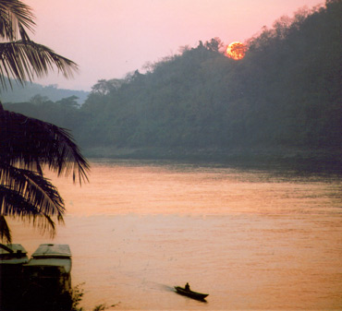

There is an urgent need for electric power for thedevelopment of Vietnam and the countries in the Mekong River downstream in general. Since 2007, there have been more and more construction projects for hydro-power plantsthe four downstream countries. There are at least 12 hydro power projects in Thailand, Laos and Cambodia at present.
But will these projects meet Vietnam’s demand for power or benefit Vietnam’s economy?

According to the Mekong River Commission’s research, hydro-power plants in the major flow of the Mekong River downstream can supply 11 percent of the shortage volume of power in the downstream from 2015 to 2025.

For Vietnam, by 2025, power projects in the Mekong River will provide 4.4 percent of the country’s demand for power. Therefore, to have enough power, Vietnam needs up to 23 Mekong Rivers.

These projects can satisfy part of the need for power, but they will have adverse impacts on societies, economies, ecological systems of many countries in the Mekong basin. Located in the downstream, Vietnam will suffer greater impacts from these projects, experts said.

So far, Vietnam has received large volumes of alluvial material from the Mekong River, which contributes to the existence of the Mekong Delta granary.

If power plants are built on the major current of the Mekong River, crude alluvial material will be deposited in reservoirs while the volume of smooth alluvial will fall by 75 percents, scientists said.

Seafood, which provides a significant benefit from the river, will drop by 42 percent for fish output and 17 percent for seafood output in general. In addition, some species of fish will disappear.

The biggest threat from hydro power plants is when reservoirs discharge water at the same time, which can cause earthquake in some areas.

It is clear that the benefit from the construction of hydro-power plants in the Mekong River are less impressive? in comparison to their impacts.

In addition, Vietnam can lose its source of? Control over? power once power selling countries stop selling electricity.

The plutocracy controls the river?

Laos will benefit the most from building hydro power plants in the Mekong River downstream. With a small population and small demand for power while its hydro power potential is large, Laos can become the major power supplier for Southeast Asia.

“If all 12 power projects are carried out, up to 70 percent of Laos’ annual revenue will come from exporting hydro power ($2.6 billion),” said Jeremy from the Mekong River Commission.

However, he said that Laos is incapable of building these plants itself. It needs private investors. Therefore, initially these projects will benefit private investors, not Laos. This will take at least 25 years, until these plants are handed over to the Lao government.

Dr. Nguyen Ngoc Tran, former vice chair of the National Assembly’s Foreign Affairs Committee, said that the plutocracy has begun controlling the use of water resources in the Mekong River. The benefit from the river will not go to the people of Laos, Thailand and Vietnam but to private groups.

National Assembly deputy Ky Quang Vinh from the Mekong Delta City of Can Tho questioned: “Should we place the lives of 20 million people in the Mekong Delta in the hands of some private groups?”

Vietnam should not be involved in Mekong power projects?

All attendants at the recent workshop titled “Developing hydro power dams in the Mekong River and challenges for Vietnam” agreed to delay these projects for at least ten years.

“Vietnam needs to be the first to make a strong statement about this? Be at the forefront of voicing its opinion? on this. the National Assembly will consider this issue and make decisions. During this time, Vietnamese companies should not invest in these projects,” Jeremy suggested.

If Vietnam doesn’t show a definitive attitude and take part in these projects, it will be very difficult for the country to raise its voice to defend its interest in the future, they said.

Vietnam has its advantage because Vietnam and Thailand are the major buyers of power in ASEAN. If the two countries don’t purchase power from these projects, which are designed to serve export, Laos will be unable to implement them.

hydro-power in the major flow of the Mekong River is the common concern of all relevant countries but China and Myanmar have not joined Vietnam, Laos, Cambodia and Thailand in the Mekong River Commission yet.

Dr. Tran called this situation as “same bed but different dream” because they share the river but each of them places their own interest above the common interest.

Experts suggested that Vietnam should convene with other countries to cooperate on shareddevelopment in the Mekong River to enjoy its full benefit.

Vietnam needs to seek the involvement of ASEAN and its partners and take advantage of the significance of the Mekong Delta granary to promote cooperation in the Mekong Delta.

Vietnam is a major rice exporter in the world. If its Mekong Delta is affected, so will the world’s food security

My Hoa

Last update 13/11/2010

Scarcity of fish in Mekong Delta’s flood season

VietNamNet Bridge – People in Vietnam’s Mekong Delta often say “as dirt-cheap as linh fish” but this statement is wrong now.
Late flood sways farmers in Vietnam’s southwestern region
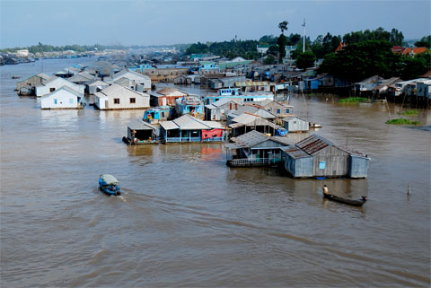

This is the flood season in this region but the price for linh fish at markets in Long Xuyen city, An Giang province is up to 180,000 dong (nearly $10) a kilo. Last year, the price for a kilo of linh fish was only several thousands of dong. Why has the fish become expensive?

VietNamNet reporters went in mid-October to Con Coc village, which is called the village of linh fish, in An Phu district, An Giang province, to find the answer.

Despite it being the flood season Con Coc was abnormally dry . Fishing equipment was placed along the road. Many fishing boats were not used.

“In previous years, if you went to our village, you would have to use a boat,” Nguyen Minh Chi, a local official told VietNamNet.

“The flood season is also the time to catch linh fish. This year flood doesn’t come so local people have to plant maize instead,” Chi said, pointing to a newly-grown maize field along the Hau river, a branch of the Mekong River.

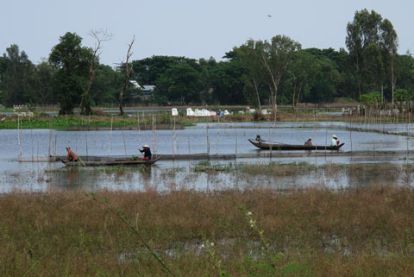

Nguyen Minh Huong, 70, who has earned his living by catching linh fish for several decades, said he used to catch hundreds of kilo of linh fish in previous flood seasons but this year flood doesn’t come so he had to plant maize.

Nguyen Van Tong, a fish creel maker, said last year he sold nearly 40,000 linh fish creels to local people and clients in Cambodia. This year even his clients in Cambodia didn’t buy creels because of the low water level in the Mekong river.

“Young people in our village went to Cambodia to catch fish but they had to return home and in the end went to Saigon and Binh Duong to seek jobs,” Tong added.

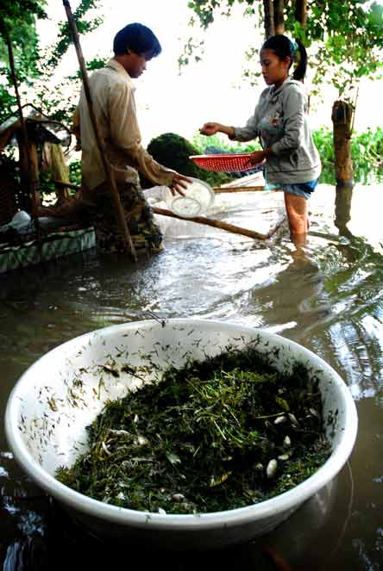 | 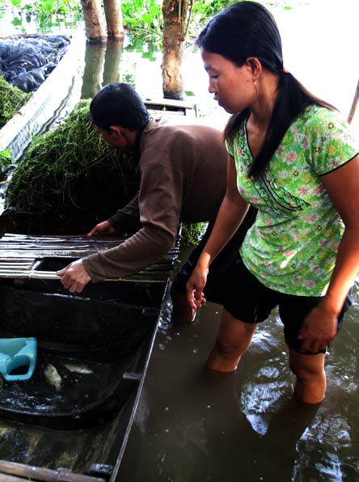
The fishing seasonBung Binh Thien in An Phu district, An Giang province, which is called the “God’s Fish Lake” because it used to be full of fish all the year round, is also poor this year.

“I have been drawing up nets from 4am but I until now (9am) I’ve caught less than a kilo of fish. I used to catch 30-40kg of fish a day,” Mrs. Lai Thi Hai said.

VietNamNet reporters called Huynh Quang Dau, director of Antesco company, which often purchase linh fish in An Giang during the flood season. Dau only said briefly: “Flood hasn’t come so we couldn’t buy linh fish this year”.

An Giang people said that in the past, linh fish was in plenty and it was dirty cheap. People used to buy linh fish to process animal feed. But now linh fish is very expensive.

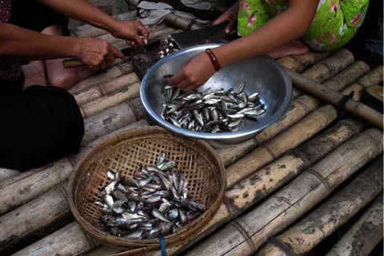

“Linh fish comes from Cambodia’s Tonle Sap Lake. During the flood season, the baby fish go to An Giang’s flooded fields. At the end of the flood season, they go to the Mekong River to go back to Cambodia to lay eggs. Linh fish has become An Giang’s specialty during the flood season,” explained Doan Ngoc Pha, deputy director of the Department of Agriculture and Rural Development of An Giang province.

Pha said that many people thought that flood in the southwestern region is the same one as the flood in the central Vietnam. But flood in the southwestern region is the good time for local people to earn money from breeding and catching fish and planting specialty vegetables like nhut, bong sung and dien dien. This year they have suffered losses as flood water doesn’t come.

He also said that without flood water, the next rice crop will be not good.

He said that flood water doesn’t come this year possibly because of the dams built by China in the upstream of the Mekong River and the drought in Laos and Cambodia.

According to the An Giang Hydrometeorology Centre, the flood peak in the Hau river (a branch of the Mekong River which runs through An Giang) this year was only 3.05m, over 1m lower than last year. This is the record low level in dozens of years, except for 1998.

Trung Thanh – An Bang

http://scientistatwork.blogs.nytimes.com/2013/05/28/hope-amid-the-dams-and-dangers/?src=recg
May 28, 2013,

Hope Amid the Dams and Dangers
By JEFF OPPERMAN
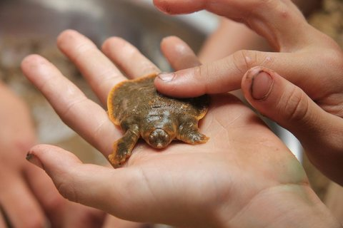Jeff Opperman A Cantor’s giant softshell turtle hatchling, hatched through a conservation program along the Mekong River in Cambodia.

Jeff Opperman, a senior freshwater scientist with the Nature Conservancy, took a once-in-a-lifetime trip down the Mekong River in Southeast Asia with his wife and two children, ages 8 and 10. This is his final post. Previous posts can be found here.
In my previous post I described how dozens of hydropower dams — planned and under construction — could lead to significant declines in the Mekong’s fisheries productivity, which feeds tens of millions of people, and its charismatic species like the Irrawaddy dolphin. But to work in conservation is to continually place new bets on optimism, so I’ll pause to reflect on a reason to keep playing the cards as they’ve been dealt, a reason to believe that a balanced solution — between a healthy river and an energy-producing river — can still be found.
Last year, Guy Ziv, Eric Baran and other researchers published a paper in Proceedings of the National Academy of Sciences on the trade-offs between Mekong hydropower and fish productivity. They focused on 26 dams proposed for Mekong tributaries throughout the basin, and their model assessed every possible permutation for those dams (e.g., building just one dam, various combinations of 2 dams, 3 dams, 10 dams, all the way to all 26 dams). The model then estimated the impact of each permutation on the production of migratory fish.
Full buildout of all 26 dams would reduce migratory fish biomass by nearly 20 percent across the whole Mekong basin (remember, this is just the tributary dams; the 11 proposed main-stem dams could have twice the impact). But here’s the reason for some optimism: Their results showed that 75 percent of the tributaries’ total energy could be generated by a combination of dams that would reduce fish biomass by just 4 percent. In other words, find an alternative for a quarter of the energy and lose only a fifth as many fish.
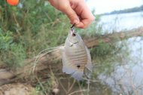Jeff Opperman A gourami caught in the Mekong River.
There are lots of caveats to this result, and obviously this first study doesn’t consider all relevant factors (e.g., the variable cost of energy from different dams, non-energy drivers for dam construction, the effect of main-stem dams), but the study shines a light on the possibility that some proportion, perhaps even a considerable portion, of the Mekong’s hydropower potential could be harnessed while retaining much of the river’s fish productivity.
But working in conservation also requires that optimism not interfere with clear-eyed assessments of reality. Just a month after we floated by the confluence of the Mekong and Sesan Rivers, the Cambodian government approved financing for Lower Sesan 2, a dam that Ziv’s study identified as the single most damaging of all they considered.
Lower Sesan 2’s impact on fisheries would be one to two orders of magnitude greater than that of any other tributary dam; on its own, Lower Sesan 2 is predicted to reduce migratory fish biomass by over 9 percent, half the total impact of building all 26.
The Sesan River contributes a quarter of the Mekong’s total flow and is its most important remaining source of sediment, badly needed to maintain the vitally important Mekong delta. Despite its singular importance for fish and sediment, the dam’s blueprints make no effort to allow either to pass by the structure.
The timing is terrible: Just as Ziv’s paper points toward the potential for a more balanced outcome, work begins on the one dam that, by itself, threatens to preclude such a solution. Conservation organizations and scientists are contesting the dam, or proposing less damaging alternatives, but the realistic window for altering Lower Sesan 2 is no doubt fairly short.
Jeff Opperman Wren and Luca fishing along the Mekong River in Cambodia.
Back on the Mekong, we woke for our final day on the river. My son, Luca, finally caught some fish, as he found a quiet patch of water around a tree stump where the fish were fighting to be the first on the hook.
While we were unloading the boat, Gordon Congdon’s cellphone rang. However many dolphins had been swimming in the Mekong on the day we met Gordon, WWF-Cambodia’s freshwater conservation specialist, there was one fewer on the day we said goodbye.
Gordon left to collect the dead dolphin for analysis, and we drove south to Kratie, where we showered and changed. Later, my daughter, Wren, and I went to the WWF office to see the dolphin.
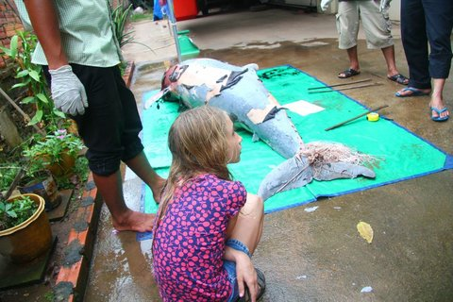Jeff Opperman Wren observing an Irrawaddy dolphin that drowned after getting its tail entangled in a fishing line.
It was a big animal — 7 feet long and more than 200 pounds. It hadn’t drowned in a net, but rather its tail had become entangled in a long line of baited hooks, and somehow the line had snagged on a log or other object and held the dolphin underwater.
Viewing the bloated corpse was a sobering bookend to the trip, a very tangible confrontation with rarity and finality.
While the tangled dolphin and Lower Sesan 2’s fumbled handoff between scientific potential and political reality paint a decidedly gloomy picture, I don’t believe that all is lost for the Mekong. So let me close this blog series with a thumbnail sketch of a conservation victory.
On our final day, eight hours before the call about the dolphin, Gordon received another call. After talking, he turned to us and said, “I just learned that there’s a new batch of giant softshell turtle hatchlings. We have a chance to see them, and the kids can release some into the river. It means a few extra hours in the boat. Are you O.K. with that?”
We were more than O.K. with that.
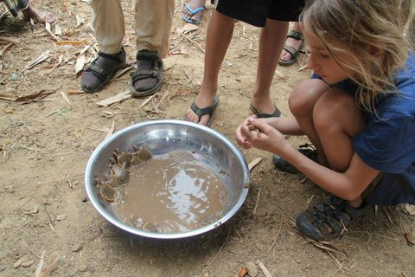Jeff Opperman Cantor’s giant softshell turtle hatchlings, hatched through a conservation program along the Mekong River in Cambodia.
In 2007, a survey team from Conservation International and WWF discovered a small population of Cantor’s giant softshell turtle, previously thought to be extinct in the Mekong. Conservation International initiated a program that paid people to find turtle nests, successfully hatch the eggs and then release the hatchlings into the river. Without this program, the nests are nearly always found by people and the eggs are collected for food.
In a small village, we found a crowd staring down at a stainless steel mixing bowl on the ground. We joined the villagers and crouched down to see tiny turtles nestled within watery sand at the bottom of the bowl. With their mottled brown coloring and round, soft bodies — thicker in the middle and tapering toward the edges — they looked like a batch of “silver dollar” pancakes.
The kids picked out two, gave them names (Stone and Lucky), and we took a boat out to the island in the middle of the river where the eggs had been laid 55 days ago. Lucky took some encouragement, but he eventually crawled into the river and then promptly buried himself in the sand, with just his eyes showing.
Every few minutes he stretched his long neck up and took a gulp of air. In contrast, Stone sprinted like a turtle version of Usain Bolt into the water and he, too, promptly buried himself.
This will be their life, as the adults spend 95 percent of it buried, ambushing fish. And they’ll grow to fulfill their name, reaching six feet and 100 pounds; their floppy carapaces will never harden.
This small moment on a sandy island obviously isn’t the conservation counterweight to approval of the wrong dam. But it reminds us that nature can be surprisingly resilient and that people can learn and adapt and try new solutions. Science, like Ziv’s paper, can illustrate the trade-offs of various alternatives and illuminate paths that aren’t quite so binary as the choice between dams and fish.
But not all opportunities for people to learn and adapt and try new solutions are equal. Those that come only after most alternative routes have already been closed are just a dim shadow of those that come when there’s still time to compare multiple paths. There’s still time for the Mekong. But not much.

http://scientistatwork.blogs.nytimes.com/2013/05/06/casting-for-fish-in-the-mekong/

May 6, 2013,

Empty Nets on the Mekong
By JEFF OPPERMAN
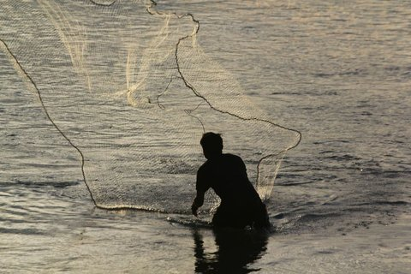Jeff Opperman Fishermen along the Mekong River capture their dinner by unfurling large nets.
Jeff Opperman, a senior freshwater scientist with the Nature Conservancy, is taking a once-in-a-lifetime trip down the Mekong River in Southeast Asia with his wife and two children, ages 8 and 10. Previous posts can be found here.
In my last post, I described how our attempts at fishing in the Mekong River had produced meager results, which was somewhat puzzling because the Mekong produces the largest harvest of freshwater fish in the world, by far.
As a father, this was frustrating; catching fish was the top priority of my 10-year old son, Luca, and I was determined that he fulfill that goal. But as a river ecologist, our low success rate had me curious about the status of fish populations in this river.
And it wasn’t just that I’m an inexperienced angler trying to catch fish in a big, complicated river (and using a rod and reel in a place where people generally use nets and traps). We’d spent one afternoon with experienced fishers — using the right equipment — and we’d hauled in a pretty small catch for the effort. Were Mekong fisheries in decline?
We had reached the southern border of Laos, an area called Si Phan Don, or “Four Thousand Islands.” Here the Mekong, which for thousands of miles has flowed as a single, muscular channel, abruptly shatters into a twisting labyrinth of land and water. The eighth biggest river in the world, it becomes a tapestry of lesser rivers and streams — here a channel the size of the Potomac, over there the Hudson, and flowing between them and across a rocky island is something the size of my backyard creek. Hundreds of these channels weave between and across thousands of islands that range in size from a minivan to Manhattan.
We stayed on Don Khon, an idyllic island of rice paddies, palm trees and small hotels with restaurants that cantilever over the river. Our “floating bungalow” bobbed gently with passing boats. I had arranged to spend the afternoon with a pair of experienced fishermen, hoping to address both my personal fishing frustration and professional curiosity.
We boarded the fishermen’s narrow wooden boat and motored upriver through the maze of islands.
We stopped on a tiny island, more like a sand bar with some patches of thick shrubs. One of the fishermen began to throw a cast net while the other, a man named Bewm who was acting as the guide, showed us how to throw a cast net.
To prepare for a throw, the net is rolled up and distributed across various body parts. The proper position for casting requires both hands, one elbow, a shoulder and a few teeth (to grip the retrieval line).

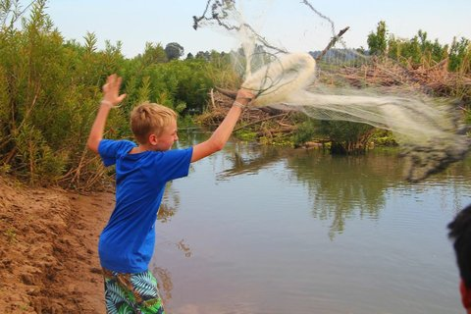Jeff Opperman Luca casting a net.

To cast, you wind up your body and then explosively open up, somewhat like a discus thrower. Ideally, the net unfurls into space to form a perfect circle just before hitting the water’s surface. The outer edge of the circle is weighted, causing the net to rapidly sink to the bottom, trapping anything in the water or on the river bed within its circumference.
After a few casts, Bewm pointed to the net and then back and forth between me and himself and said, “Same same?” I was on deck.
My attempts were not quite as comical as I’d feared, but I certainly wouldn’t want to depend on me to catch dinner without a lot more practice. Luca went next and, like most fishing-related activities, he seemed to have more innate skill than I do.

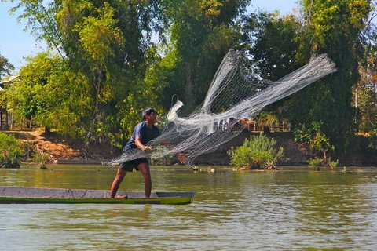Jeff Opperman Our guide, Bewm, demonstrates the proper way to cast a net.

Our semi-attempts, along with continuous casting from the other fishermen, had netted a grand total of one fish, so we climbed back in the boat and continued upriver. We pulled alongside and tied up to a huge chunk of concrete in the middle of the channel – a French colonial-era navigation marker that a flood had pushed onto its side.
Bewm rigged up his rod, which featured thick line and a massive reel. He looked at Luca’s rod, good for bass and sunfish, and said something as he shook his head smiling. My wife, Paola, who speaks Lao, translated, “He says you’ll be in trouble if you hook something big.”
Bewm opened a jar, filling the air with a putrid smell. From the jar, he molded lumps of a white pasty substance onto the hooks. Paola asked him what it was and then said, “I’m not really sure, but I think he’s describing some kind of fermented fish product.”
Luca began with the serious rod while I fished with his. Right away I felt a hit. I set the hook and, filled with far more enthusiasm than skill, began reeling in hard. Too hard. The line snapped. Luca looked at me with thinly veiled disapproval.

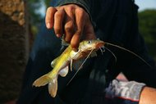Jeff Opperman A catfish, snagged in a river that seems to be yielding fewer fish.

Then Luca’s line tugged and he set the hook and began reeling, with far greater patience. But then the line snagged. Bewm jumped in to take over and eventually reeled in a very modest catfish. He held it up for me to photograph and then he cupped it in his hands. We heard three sharp cracks, like the sound made by snapping dry branches for kindling. He dropped the fish to the bottom of the boat and we saw the he’d broken off its spiny dorsal fin and both pectoral fins. The catfish wriggled under the boards like a snake.
Luca looked at me aghast. He was fine with eating what we caught, but to him this seemed excessive suffering. I tried to explain how people approach fishing from very different perspectives.
“You love looking at fish and think a lot about how they’re treated, but he’s just pulling in food. Those fins are really sharp and he’s probably received some bad cuts before. He’s probably trying to protect us and he knows that the fish is gonna end up being eaten, so why risk getting a cut? You get cut on your hands, and it’s pretty hard to fish like these guys do.”
It wasn’t cruel, it was just life in a place where food comes straight from the river.
After a few hours we headed back to the hotel, and we still only had the two fish. My disappointment in the meager catch — and the fact that Luca still officially hadn’t reeled in a fish — was tempered by the golden afternoon light that painted in rich colors the world of water and island, trees and temples.
We sat on the hotel deck over the Mekong and ordered some Beer Lao and mango milkshakes. Bewm slipped into the river just below us and continued to work his cast net in a steady repetition: throw, retrieve, repack, throw again. After a few hours of fishing side by side, we had reverted to our real roles — we were just visitors, now watching the sunset and sipping our drinks as we watched the fisherman work long into the evening. He wanted us to have enough fish for dinner.

Jeff Opperman Dinner, fresh from the river.

Eventually he had enough for all of us to eat dinner. The fish was bony, but otherwise delicate and delicious.
After dinner Paola interviewed Bewm about fishing and I took notes. Bewm related how it was harder to fish now, that there were more people fishing and they were pulling in smaller hauls and smaller fish. He noted that the tourists liked to eat fish and wondered if that demand was what was driving the decline. He said that most of the fish that people catch here — from small fish up to the increasingly rare big ones — are all coming from Tonle Sap, the huge Cambodian floodplain lake hundreds of miles downstream from here.
Through Paola, I asked him what he thought about the proposed dams, including Xayaboury, which had just started construction a few months earlier. He replied that a lot of people supported the dams but he was worried about whether the fish could continue moving up and down river past the dams.
“Did you know that there are two or three proposed dams between here and Tonle Sap?” I asked.
“No, I didn’t. I’d be really worried about dams that would block us from Tonle Sap.”
This conversation and my other fishing experiences had given me just a few anecdotal data points. In a week, I had an appointment with Eric Baran, one of the leading experts on Mekong fish and fisheries, who works for the World Fish Centre in Phnom Penh. I hoped that Eric could give me a fuller perspective.
There was no question the river was still capable of great productivity. For most of its thousands of miles south of China, the Mekong was undammed, and the annual flood pulse still inundated vast floodplains, which are the engines of productivity in a river system.

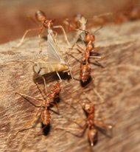Jeff Opperman Ants converged on the caddisflies, ripping their wings and carrying the pieces away.

We said goodnight to Bewm. As if to illustrate the river’s productivity, the lights outside the restaurant were enveloped by a cloud of thousands of caddisflies; there must have been a mass emergence of the winged adults from larvae that live and grow in the river. The caddisflies coated various surfaces near the lights. An ant colony had discovered the bounty, and a column of red ants was ripping apart the delicate winged insects and methodically hauling them away.
It wasn’t cruel, it was just life in a place where food comes straight from the river.

http://scientistatwork.blogs.nytimes.com/2013/05/23/mekong-mystery-dwindling-fish/?src=recg
May 23, 2013,

Mekong Mystery: Dwindling Fish
By JEFF OPPERMAN
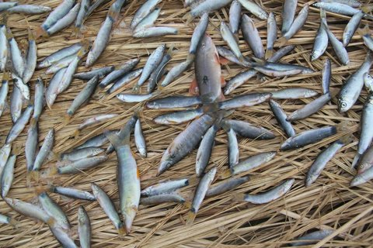Jeff Opperman The fish harvest from the Mekong is increasingly dominated by small fish, like these drying in the sun at a fishing camp at the border of Laos and Cambodia.
Jeff Opperman, a senior freshwater scientist with the Nature Conservancy, is taking a once-in-a-lifetime trip down the Mekong River in Southeast Asia with his wife and two children, ages 8 and 10. Previous posts can be found here.
As we traveled down the Mekong River, I kept hearing variations of the same story: “There are fewer fish.”
Our guide in the Four Thousand Island region of Laos relayed that fishermen now work longer hours and catch fewer fish. At a fishing camp just below Khone Falls, at the border of Laos and Cambodia, a boat captain described how in his youth (three decades ago) they would regularly catch 30-pound fish at the base of the falls — a rare occurrence today.
He shared this story as we surveyed the days’ catch drying in the sun, consisting entirely of fish that would fit in just fine in my son’s aquarium back home. It’s not a big aquarium.
I also always asked the fishermen where the fish were coming from, and always heard the same answer: “They’re coming from Tonle Sap.”
Tonle Sap, Khmer for “great lake,” is a huge body of water in mid-Cambodia. Fringed by dense forest, during the dry season it contracts to the shape of a skinny, blue violin that has been laid down on a green cloth, with its neck, the Tonle Sap River, pointing southeast toward Phnom Penh.
For half the year, the Tonle Sap River is a tributary that discharges water from the lake into the Mekong. But in the monsoon season, the Mekong rises into a wall of water that initially rebuffs the tributary and, as the Mekong continues to rise, the Tonle Sap turns and flows in the direction formerly known as “upstream” to refill the lake with Mekong water.
The lake swells to three to five times its size in surface area and quadruples in depth to 25 feet from 6 feet. The violin becomes a cello.

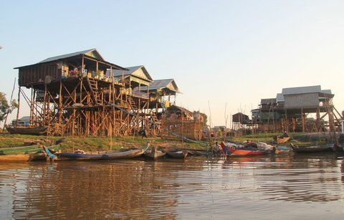Jeff Opperman Stilt houses on the edge of Tonle Sap, or great lake, in Cambodia. During the rainy season, the lake rises to nearly the bottom of these houses.

The geographical transformation of the Tonle Sap is obvious and dramatic. Even more dramatic, though not obvious from the surface, is the biological transformation that takes place. The lake becomes a factory for fish.
As the lake swells, the raw materials for fish production flow in: water, nutrients, adult female fish ready to spawn, and larval or juvenile fish that were spawned upstream and have been riding the rising tide downstream. The rising lake engulfs the fringing forest and the assembly line of fish production readily incorporates the organic material of the forest: leaves, fruits, beetles and ants.
On an annual cycle, the factory assimilates these raw materials and then pumps out vast quantities of fish. Fishermen take their positions in the Tonle Sap River as the lake drains and their huge nets harvest up to 30 tons of fish per hour. That’s 120,000 fish dinners in an hour, three million in a day, just from this lake.
But I couldn’t square these current statistics with what I had been hearing from the fishermen. So, as our trip approached its end, I met with Eric Baran, a leading fish expert for the Mekong who works for the World Fish Centre, at a French cafe in Phnom Penh.

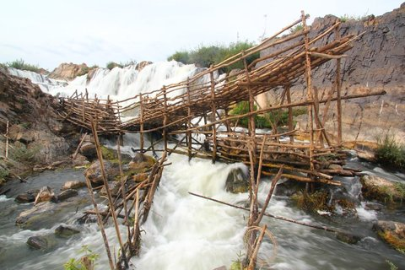Jeff Opperman A fish trap in one of the hundreds of channels of the Mekong River that flow through the Khone Falls region at the border of Laos and Cambodia.

I asked him if the fish harvest was dropping in the Mekong, relaying our own limited success with fishing and all the anecdotal stories I had heard.
“It is hard to answer because there is no scientifically underpinned baseline,” he said. “With an ocean fishery, one can measure what’s coming off the boats at a dock,” but in the Mekong there are so many people fishing and catching fish in so many ways — more than 1.5 million people using 102 fishing methods in Cambodia — “it’s been hard to get a good estimate of the yield. In fact, the estimates of basin-wide fish harvest have been increasing over time, from less than one million tons to more than two million tons, but this is because assessment methods have varied and improved over time; 2.1 million tons of fish is the most solid and accepted estimate.”
By best estimates, he said, the harvest from Tonle Sap had almost doubled from 1940 to 1995, while the number of people fishing has quadrupled during that period, cutting the catch per-fisher in half.

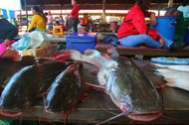Jeff Opperman Big fish, like this 4-foot catfish in a market in Pakse, Laos, are becoming increasingly rare in the harvest from the Mekong.

That explains the consistent refrain I had been hearing about fishermen working harder and catching less. At a large scale (country or river basin) the catch may not have declined, but from the perspective of a fisherman, it certainly had.
Mr. Baran continued and confirmed another story I had heard about the decline of the big fish: “While the trend in overall harvest is arguable, it is clear that the average size of the fish being caught is declining, with now more small fish” — small species and small individuals — “and fewer big fish. And that affects the value of the harvest. In terms of economic value, a 10-pound catfish is more valuable than 10 pounds of small fish – even though 10 pounds of small, bony fishes are more nutritious than 10 pounds of a big meaty catfish.”
A steady fish harvest also masks the decline in terms of fish biodiversity. While millions of tons of fish are still being harvested, the Mekong’s giants — the Mekong giant catfish, the giant barb — are slipping away.

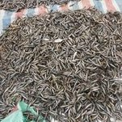Jeff Opperman A harvest of “trey riel,” a small fish used for fish sauces and pastes, from the Mekong River in Laos.

In much of the world, fishing pressure eases when the harvest becomes dominated by small fish — that’s because they’re not desirable, and that gives large species a chance to recover. But in Southeast Asia, fish sauces and pastes are a staple of the cuisine, and because these can be made from the processing, or fermenting, of small fish, the fishing pressure continues even as the nets haul up mostly tiny fish.
The fish of the Mekong, particularly the larger species, face an uncertain future even before we consider the impacts of the dozens of dams now under construction or planned. However, fisheries can be managed and fish populations can recover. The challenge with big dams is that many of their impacts are essentially permanent.
And science is scrambling to catch up. When overharvest was the main challenge confronting fish in the Mekong, scientists focused on Mekong fisheries (the economics and management of fishing). Now that the most urgent challenge is dams, scientists realize they know much less about Mekong fish and their behavior.
“Dams are being developed,” Mr. Baran said, “and in some cases, such as the Xayaburi dam in Laos, fish ladders are proposed, but you cannot expect fish ladders to work without knowing your target species, their swimming capabilities or the water current that will attract these fishes toward the entrance of the fish pass. Ecological and even ethological research is still very much needed for mitigation to be more effective.”
Further, very little is known about where the long-distance migratory fish are spawning, a huge gap when trying to understand the impacts of proposed dams at various locations on the Mekong main-stem or on major tributaries.
To address all these knowledge gaps, the Mekong River Commission had proposed a 10-year moratorium on main-stem dams, though Laos is now going ahead with the main-stem Xayaburi dam, and dams on major tributaries are also going forward.
The window for a balanced solution on the Mekong — energy and fisheries — is starting to close.

http://businesstimes.com.vn/the-end-of-the-small-scale-hydropower-plants/?utm_source=feedburner&utm_medium=email&utm_campaign=Feed%3A+VietnamBusinessWeek+%28Vietnam+Business+News%29
May 23rd, 2013
Energy / HEADLINES | By BTimes

The end of the small scale hydropower plants
The Ministry of Industry and Trade (MOIT) plans to exclude 338 projects from the list of hydropower plant projects to be developed nationwide.
Do Duc Quan, Director of MOIT’s Hydropower Department, said the ministry has decided to propose the government to remove the projects after checking the power plant development program and the implementation of the projects. In fact, even if the government does not stop the projects, investors may still decide not to invest in the projects themselves, because this is no more a lucrative business field.
Quan affirmed that if the government approves the proposal to remove the 338 projects, or 1/3 of the programmed projects, this would in no way affect the power generation and supply to the national economy, because these are all small scale projects.
Economists have pointed out that Vietnam would have more losses than gains when developing small scaled hydropower plants, because the electricity output to be churned out is modest, while the plants would cause the environment pollution.
Meanwhile, the expenses on small scale plants would be very high, because of the high expenses on the transmission line system which collects electricity from the small plants to transmit electricity in the national grid.
Tran Viet Ngai, Chair of the Vietnam Energy Association has noted that in fact, investors had stopped pouring money into small scale hydropower plant projects before the ministry decided to cut down the number of projects shown in the power plant development program.
A forecast says Vietnam may lack 50 billion kwh of power by 2030. However, it does not lack electricity now. 90 percent of electricity has been provided to serve the industrial production, while only several percent of electricity output serves the household daily use. Meanwhile, the production has been stagnant in the economic crisis.
“Why should the Electricity of Vietnam (EVN) buy electricity from small scale hydropower plants if it does not lack electricity?” Ngai said.
Before deciding to pour money into hydropower projects, one should consider if it can sell electricity to EVN, the only wholesale buyer. Meanwhile, EVN itself is also big power generator which has 14,000-15,000 MW of hydropower.
“It’s now the end of small scale hydropower plants. No one would be foolish enough to invest in small scale hydropower projects nowadays,” Ngai said.
Also according to Ngai, in the future, coal run and gas run power plants would be the main sources of power supply.
Vu Ngoc Cu, Deputy Chair of the Lao Cai provincial Entrepreneurs’ Association, also thinks that it’s very risky to make investment in hydropower projects nowadays.
It always requires big investment rates for hydropower projects and long time to take back the investment capital. Most of the hydropower plants are located in remote areas where the transport infrastructure conditions remain very poor, which makes it very difficult and costly to carry equipments and materials to the sites to serve the construction works.
Meanwhile, the investors also face a lot of other high risks, from the spiraling prices due to the economic recession, the changeable credit policy, the flood, drought or natural calamities.
According to Cu, the investment rate for small scale hydropower projects in Lao Cai is VND25-30 billion per 1 MW in Lao Cai province. This does not include the expenses to be spent to connect the power plants with the national grid.
Source Vietnamnet.

http://vietnamnews.vn/environment/237394/mekong-residents-waste-groundwater.html
March, 28 2013
Mekong residents waste groundwater
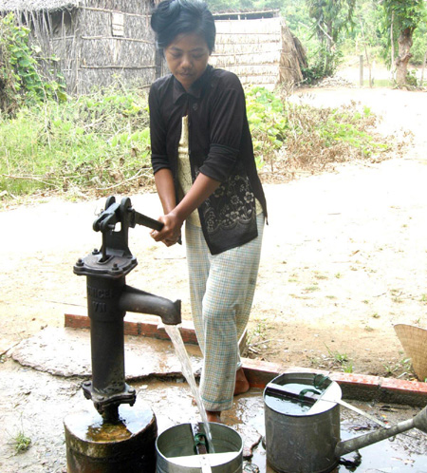
A woman pumps water from a well in Tham Don Commune, Soc Trang Province. The Cuu Long (Mekong) Delta's groundwater quality and quantity have declined due to over exploitation for daily life and business use. — VNA/VNS Hoang Hai

CUU LONG DELTA (VNS)— The Mekong Delta groundwater's quality and quantity have declined due to local residents' over exploitation for daily life and business use.
There are more than 400,000 household bore wells besides hundreds of water-supply stations that draw groundwater in the region. The water is also used for agricultural production and aquatic cultivation.
Tran Van Ho in Soc Trang Province's Vinh Chau Town said he used water from his family's 110-meter deep bore well to irrigate vegetables and watermelons.
"Without this bore well, my family could not produce anything," he said.
Duong Quoc Viet, head of the Soc Trang Sub-department of Irrigation and Flood and Storm Prevention and Control, said groundwater was being used wastefully.
Of the used groundwater, only 20 per cent irrigates crops and the rest just flows away.
The province has told people to use a drip irrigation method, but local residents ignore the method.
Because there is not enough water for household use and production, the province has found it difficult to ban bore well use.
Soc Trang has more than 78,000 household bore wells, according to the province's Department of Natural Resources and Environment.
In Bac Lieu Province's rural areas, groundwater is being used extensively, said the province's Centre for Clean Water and Rural Environmental Sanitation for Rural Areas. Bac Lieu has nearly 6,200 bore wells.
Dr. Le Anh Tuan of Can Tho University's Research Institute for Climate Change said the exploitation of groundwater in the Delta on a large scale could lead to land depression.
Sea water levels are already rising, according to Nguyen Ngoc Tran, director of the Cuu Long Delta Development Research Institute.
The Bac Lieu Centre for Clean Water and Rural Environmental Sanitation for Rural Areas said groundwater contains alum and salt. Bac Lieu water quality has declined in general.
The water level of many bore wells in Bac Lieu has fallen by 10-12 metres over the last few years, according to the National Observation Centre.
In Soc Trang Province, the groundwater level has also fallen by 0.5-1 metres a year.
Tran Van Thanh, deputy director of the Soc Trang Province Department of Natural Resources and Environment, said the province's groundwater contained too much alum and iron.
The department has issued warnings to the public, asking them to not use groundwater for irrigation.
Because many abandoned bore wells had not been filled properly, the water has become polluted. — VNS

END OF CHAPTER SIX

