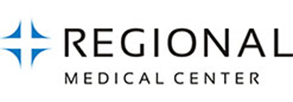
Welcome to Regional Medical Center at San Jose.
As you work at our facilities, please complete your orientation and competency information.

2017 DOCUMENTS REVIEW

Name _ _____¾ ID# ____________________

School____________________________________________

Instructor ________ Department ________

Date_____________

I have read and understood this material. ______________
(Student Signature)
225 North Jackson Avenue
San Jose, CA 95116

Education Department
(408)729-2823

After completion of these documents, please return them to the Education Department, located at 225 North Jackson Avenue, 1st Floor. If you have any question, please call the Student Placement Program Coordinator, Karla Manfut, at (408) 729-2823, or from any internal line at extension *42823.

ORIENTATION ACKNOWLEDGEMENT FORM
I have fully read and comprehend the contents of the Orientation booklet, which included:

- Mission and Vision
- Ethics and Compliance
- General Information
- HIPAA (Health Insurance Portability and Accountability Act)
- Risk Management
- Disaster Preparedness
- Emergency Codes
- Rapid Response
- Falls
- Equipment and Electrical Safety
- Ergonomics
- Hazardous Materials (SDS)
- Bloodborne Pathogens
- Infection Control
- Hand Hygiene
- Personal Protective Equipment (PPE)
- Isolation Precautions
- BioMedical Waste
- National Patient Safety Goals and EMTALA
- Patient Rights
- Social Media Guidelines
- Abuse Reporting
- Violence in the Workplace
- Patient Experience
- Sexual Harassment
- Substance Use in the Workplace
- Customer Service Standards

Printed Name:

Signature:

Date:

Code of Conduct Acknowledgment Card

I certify that I have reviewed the HCA Code of Conduct and understand it represents mandatory policies of the organization. I agree to abide by the Code.

Signature

Printed Name

School

Date

HIPAA Privacy Policies

I have been educated by a self-study version on the HIPAA Privacy Policies HIM.PRI.001 through ADM G-2.

Print Name:

Signature:

Date:

Confidentiality and Security Agreement Acknowledgement Form

By signing this document, I acknowledge that I have read the Confidentiality and Security Agreement and I agree to comply with all the terms and conditions.

STUDENT SIGNATURE | FACILITY NAME/COID  Regional Medical Center/08385 | DATE
STUDENT PRINTED NAME

Infant Security Policy

I hereby acknowledge receipt of Regional Medical Center Hospital’s Infant Security policy. I understand that I am responsible for reading this policy and complying with all of its conditions. I further understand that any questions regarding this policy should immediately be directed to my preceptor or department manager/director.

Print Name:

Signature:

Date:

Hand Hygiene Guidelines

Cleansing of the hands is the foundation of our Infection Prevention and Control Program at Regional Medical Center. Our guidelines are based on the World Health Organization (WHO) and Center for Disease Control (CDC) recommendations. Compliance with these guidelines is mandatory for all healthcare providers providing care in the hospital. This includes the medical staff, all employees, volunteers, and contract workers. Good band hygiene is encouraged for all patients and visitors.

The practices included in this process are well researched and are proven to save lives. Please review the guidelines provided below and make a commitment to protecting the health of our patients, colleagues, and community as well as yourself by following these recommendations carefully.

Regional Medical Center leadership is committed to placing sinks and/or alcohol based hand cleansers in locations that make them readily accessible when they are needed. Lotion will be provided in locations convenient for staff to maintain the integrity of their skin when doing frequent hand hygiene.

The two methods of hand hygiene include washing for a minimum of 20 seconds with soap and water then rinsing well and patting dry with a paper towel or use of an alcohol based hand rub that is at least 60% alcohol. Soap and water should be used if moisture or debris can be felt on the hands. Alcohol based hand sanitizer is effective for killing germs and should be applied in an amount necessary to moisten the hands '\o the wrist" and then rubbing until dry. This should take about 15 seconds. An alcohol based product should NOT be used if a patient has undiagnosed diarrhea or a diagnosis of Clostridium difficile. Those patients should be placed in Contact with Enteric Isolation until the stool is formed and hands should be washed with soap and water for a minimum of 20 seconds.

Hands should be always be cleansed:
- When entering the hospital
- When entering a patient room. Remember that the patient or family should be able to see you cleanse your hands.
- Before touching a patient. If you have been touching items in the room you should cleanse hands again before touching a patient.
- Before donning and doffing gloves.
- Before leaving a patient room or immediately after leaving the room. Make sure you touch nothing before hand washing if going to sink outside the room.
- Any time you are going to touch anything "more clean" than the last thing you touched.
- Before eating
- After using the restroom

Artificial nails or nail enhancements are not allowed for any person who has direct patient contact or a person who handles food or medications. Nails should be short and only natural color nail polish is allowed for any person with direct patient contact, food handlers or persons who handle medications. Short is defined as nails that are not visible over the tip of the finger when the hand is held up palm facing the person with the tips of the fingers at eye level.
Surgical scrubs are required in specified areas and must comply with the AORN guidelines.

Printed Name:

Signature:

Date:

ACKNOWLEDGMENT OF TUBERCULOSIS TRAINING

Student Name: --------------------­
(Print)

Department: ----------- Date:

Please circle the correct answer.

True False
1. T F The organism that causes Tuberculosis is called Mycobacterium tuberculosis.
- T F Tuberculosis can be transmitted from person to person by airborne nuclei in contaminated air.
- T F The Tuberculosis Exposure Control Plan is located in your Infection Control Manual on the Heart Beat.
4. T F Healthcare Workers will wear a NEGATIVE pressure N-95 respirator when entering airborne isolation room.
- T F Someone with latent TB infection is capable of passing TB germs to others.
- T F Airborne Precaution Sign is posted outside the door of a TB patient.
- T F I wear a positive pressure respirator during a high hazard procedure (procedures that generate aerosol)
- T F It is the responsibility of every employee to adhere to the Tuberculosis Exposure Control Plan Aerosol Transmissible Disease Standard (ATD)
- T F As a healthcare worker, I am required to have annual TB screening.
- T F All healthcare workers with documented or confirmed exposure to Tuberculosis should have a TB screening and report to Employee Health.

I have attended orientation and understand the Tuberculosis Exposure Control Plan.
I have completed and passed the comprehensive quiz at the conclusion of the orientation. I have had any questions regarding the Tuberculosis Exposure Control Program answered.

Student Signature Date

16

ACKNOWLEDGMENTOF BLOODBORNE PATHOGEN TRAI NING

Please circle the correct answer.

True False
T F Hepatitis B vaccine may protect you from Hepatitis B disease. T F HIV and HBV may be present in body fluids other than blood.
T F The eye is potential route of entry into the body for blood borne pathogens. T F Each employee decides whether to use safety devices or not.
T F To consult a copy of the Hospitals Exposure Control Plan, check in your Infection Control Manual located on the Heart Beat.
T F Standard Precautions means treating all patient's body fluids as infectious
T F Every time you remove your gloves you must wash your hands with soap and water of use the alcohol hand rinse/gel.
T F You may store food next to blood in the refrigerator, if it is housed in a
secondary container.

T F The hospital could receive an OSHA citation/fine if an employee does not use appropriate personal protective equipment (PPE)
T F You do not have to wear personal protective equipment (PPE) if it is annoying or uncomfortable.
T F All healthcare workers with possible exposure to blood and body fluids are offered Hepatitis B vaccine.
T F Eating in patient care area is allowed when you do not have time to take a break.

I have attending Hospital Orientation and understand the Exposure Control Program.
I have completed and passed the comprehensive quiz at the conclusion of the orientation and have had any question regarding Exposure Control Program answered.

Student Signature Date

Student Name (printed)

Please remember that compliance with these guidelines is mandatory for providing careand not open to personal preference. See back:

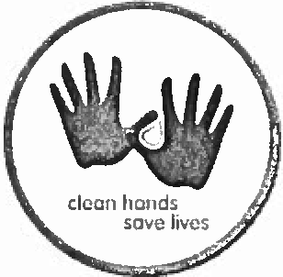

Washing your hands with Soap and Water

- Assure access to paper towels without touching a handle
- Wet hands. Keeping the water temperature low will decrease irritation of the hands.
- Apply soap
- Rub all hand surfaces well. Make sure you include between fingers, knuckles and around nails.
- Wash for 20 seconds
- Rinse hands well
- Pat hands to dry. Do not rub with paper towels
- Use lotion to keep hands soft and supple.

Cleansing hands with an Alcohol Based Hand Rub

- Apply enough product to moisten hands completely up to the wrist
- Rub until dry
- This should take about 20-30 seconds
- It is helpful to use this as an opportunity to teach patients and families that a hand rub is effective for killing germs as long as the hands are not soiled with visible debris

When i s Soap and Water cleansing required?

- If hands are visibly soiled
- If you can feel debris on the hands
- If the patient has undiagnosed diarrhea or confirmed Clostridium difficile. I have read and understand this Hand Hygiene guideline.

Student Signature Date

Student Name

STUDENT RIGHTS

To all Students/Travelers:

Regional Medical Center San Jose recognizes the ethical responsibility to ensure appropriate patient care while providing a mechanism to address caregiver’s requests to refrain from participation in aspects of patient care or treatment. Such requests to refrain are based on an individual’s reasons related to cultural values, personal ethics or religious beliefs.

In order to honor requests, it is imperative that open communication exists between students and instructors throughout the externship/internship process. Students will have the opportunity or may use their initiative to discuss the functions of the position with the instructor, including any functions, which may conflict with cultural values, personal ethics, or religious beliefs.

I understand that my instructor will document discussions regarding requests to refrain from participation in aspects of patient care or treatment and the outcome from those requests.

I, also, understand that although all requests to refrain are fully considered, Regional Medical Center San Jose makes the final determination as to what, if any, accommodations will be provided and how aspects of patient care will be performed. Individual accommodations may include revised procedure or job restructuring which permit the individual to perform the essential functions of the job and which do not negatively affect patient care or treatment or cause undo hardship to Regional Medical Center San Jose.

My signature below indicates that I have read the above information and am aware of the outlets available to me should I encounter a conflict with my personal ethics, religious beliefs, or cultural values while on the job.

STUDENT SIGNATURE DATE

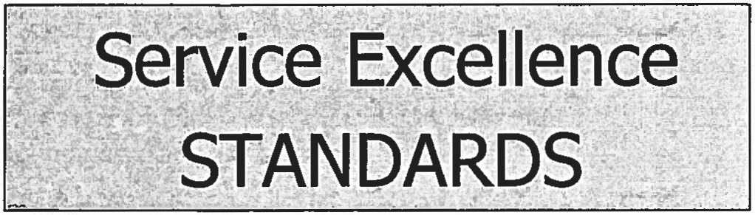

AIDET
- Acknowledge
- Introduce
- Duration
- Explanation
- Thank you
First Impression
- Recognize customers: stop what you
are doing, make eye contact and say hello with a smile
Respect & Sensitivity
  - Be the solution; stay connected and follow up
  - Be tolerant, open and accepting
  - Remember why you arc here; to care for patients or support those who do
  - Be totally present with people you arc caring for and helping

Service Recovery
r. <,• l Anticipate and correct problems before they become customer complaints
Supportive Team
  - Be organized, efficient and timely in work efforts
  - Anticipate needs of others and assist them; be clear & concise with requests
  - Foster a blameless environment
  - Collaborate & cooperate with others:
be flexible, keep commitments
- Be on time for meetings

- Introduce yourself, listen carefully
- Use customer's name and identify your role
- Address needs with immediate response, "Is there anything else I can do for you?'
- Offer services before they are
requested

•
•

•

Acknowledge mistakes when they occur without placing blame Apologize for the mistake even if you arc not at fault
Make amends for mistakes
Calm, Professional, & Caring
- Speak softly and calmly
- Show concern about patients' and families' discomfort
- Do not use cell phones for personal use while on duty
- Be sensitive to noise level
- Dispose of litter & ensure spills arc

- Wear your name badge, visible to customers & above your waist
- Follow the dress code policy }

Recognition & Appreciation
Telephone/E-mail Etiquette
- Answer phone by speaking clearly, calmly, and at a moderate pace
- Answer with a smile and give your name, department and appropriate
addressed for safety & esthetics

Follow Up
- Provide customer with updates in a timely manner

- Command u team member and a f
team when they demonstrate \
standards and behaviors
- Create ways to celebrate service excellence
- Acknowledge someone's extra work, patience with a difficult situation, and compassion for all customers
greeting
- ' Make ·communications purposeful and concise
- Recognize where privacy is. warranted; do n use e-mail for confidential information
- Stay calm, cool and collected in all ' communications
  - Communicate with co-worker when accepting task/responsibility
  - Keep your promises

Cultural Awareness
  - Be respectful and non-judgmental in regard to age, religion, socio­ economic standing, ethnicity, size,
sexual orientation or illness

Positive Communication
- Establish rapport by listening attentively, clarifying, addressing concerns or questions
- Use "onstage" behavior: always be a professional and caring healthcare provider
- Be mindful of Chose around you and avoid talking "over" visitors in elevators and public areas
- Take time to show common courtesy; Say please and 1ha11k you
Above & Beyond
I am committing to the Service Excellence Standards and I am willing to demonstrate these in my daily work.
Print Name
Department _
- Take the extra step co help ochers
- Offer assistance without being asked
- Be willing to step out of your official work role to help others
- Create efficient & pleasant environments; smile
- When giving directions, don’t point personally direct the visitors to their destination.
- Speak English in all patient and service areas while on duty, i.e., nursing station, patient's room, hallway,,cafeteria service line
- Utilize the Cyracom Interpreter phones when a patient cannot speak English
- Be willing to modify your care to meet the culturc1I needs of your customers

