DE ANZA COLLEGE
BUSINESS, COMPUTER SCIENCE & APPLIED TECHNOLOGIES DIVISION
BUSINESS 90 – PRINCIPLES OF MARKETING - Online
Summer 2017
INSTRUCTOR: Emily Garbe PhD

Welcome to Principles of Marketing! This is a completely online class where we will have online readings, assignments and mini-simulations. We will cover the fundamentals of marketing and play mini-simulations which emulate decisions needed in development of a marketing plan. So get ready for a fun and exciting quarter.

Since this is a summer class, we are moving at twice the normal speed in order to complete the course in 6 weeks rather than the typical 12 weeks quarter. Therefore, it is essential to keep up with all the readings and assignments. No late assignments will be accepted. If you plan on taking time off from this class for vacation, work, family, personal matters, etc., please consider taking the course in the fall quarter instead. Please do not ask for extensions beyond what is listed.
This course relies on Canvas and Pearson MyLab; as such, please make sure you start your assignments and readings early in case you have computer, software, or network issues. Instructor will not make allowance for technical problems for late assignments. Please make sure you complete a system check for Canvas and Pearson MyLab and update all browsers and settings according to instructions by Canvas and Pearson. Please DO NOT contact the instructor for tech support. There are help desk staff much more qualified to help you.

The assignments and deadlines are subject to change based on the course progress during the quarter. Please refer to Canvas for updates.

NUMBER OF UNITS: 5

REQUISITES:

Advisory: English Writing 211 and Reading 211 (or Language Arts 211), or English as a Second Language 272 and 273.

COURSE OBJECTIVES:

By the end of the course students are expected to:
- Determine appropriate market segments and target markets and describe the major components of a fundamental model of consumer behavior.
- Analyze the effectiveness of the marketing mix (product, price, promotion and distribution) for a particular organization.
- Identify global forces external to the organization that affect marketing strategies.
Emphasis in the course is on key terminologies, critical analysis, strategic concepts and managerial decision-making in marketing as it is conducted today in world-class business firms.

CONTACT INFORMATION:

Class location: This class is completely online via Canvas. No face-to-face meeting.
Office hours: No office hours during the summer quarter.
Canvas Messaging for non-course questions: Go to Canvas home page and click on “Inbox”. Do not email the instructor. Please, do not ask for assignment extensions or extra credits please. The instructor will try to answer the messages within 2 business days or highly likely much sooner. All course content questions (about the chapters or simulations) must be in Class Q&A Forum, not private message to the instructor.

COURSE MATERIALS (Required as of first day of class):

- Marketing – Real People, Real Choices, 9/e, by Solomon, Marshall & Stuart
- Pearson MyLab
The e-text is bundled with MyLab and accessed via Canvas.
- Pearson MyLab with eText, access card ISBN 9780134293189
- Optional only if you want a paper copy:
- MyLab with eText & loose-leaf textbook ISBN 9780134640112
- Traditional textbook ISBN 9780134292663

You may purchase either directly from Pearson MyLab (via a link from Canvas) for a special negotiated price of $69 once Canvas is available for the quarter (the weekend before start of school), or from the De Anza book store (will be at higher bookstore price). Do not go to Pearson website directly on your own as your Pearson account would not link to your Canvas account. The first time you click on MyLab from Canvas, you will be prompted to purchase the etext/MyLab. After which you will have integrated link to MyLab and your etext.

If you are on financial aids or using a book voucher, you must purchase from the De Anza Bookstore. Please follow the appropriate process via the DA bookstore directly who are better equipped to help you. Since it takes time to go through the bookstore, please purchase the textbook BEFORE start of the quarter to ensure you complete the first assignment by Wednesday of Week 1. No extensions on assignments.

COURSE REQUIREMENTS:
This is a five-unit course on an accelerated summer schedule where 2 weeks worth of materials are covered in one week timeframe with 3 chapters per week plus assignments. Make sure you allocate sufficient time per week studying the course materials and doing the homework assignments. All assignments must be submitted on time (see due dates for each assignment listed at the end of the syllabus). You may turn in your assignments up to 2 weeks early, but not late. You will need to access the websites listed below.
- All registered students must use De Anza’s courseware Canvas to access the course homepage where access to all the course materials reside https://deanza.instructure.com
- Read the lecture slides for the assigned chapters. You may want to print out the lecture slides, and use them as the study guide for the chapters.
- Read the etext by clicking on the MyLab tab at Canvas course homepage.
- Watch the videos for the assigned chapters and take the video quizzes. Make sure you enable pop-up in your browser.
- Complete the mini-sim(s) for the assigned chapters. Make sure you enable Java and cookies in your browser.
- Take the open-book online chapter quizzes only after you have studied the chapters.
- Complete the class forums and writing assignments.
Please note: if a link listed in this syllabus does not work please copy and paste the URL to your browser directly. Sometimes a browser may not link to an URL from Word doc so please no need to contact the instructor, just copy/paste to your browser.

Getting help:

Please click on the help button on the lower left of your Canvas screen for tech support, or upper right hand corner “?” for Pearson MyLab help desk. Please do not ask the instructor for tech support since the Pearson and Canvas are much better positioned to help you.

Please post course content questions to the “Class Q&A forum” about the assignments or the chapters in the book. This is an interactive class, so students are strongly encouraged to post and respond to your classmates’ postings. Private message (not email) instructor only for course administration issues. Any course content questions will be re-posted to the Class Q&A forum since if you have a question, it is highly likely others also have the same question. Let’s make this a fun, collaborative, and supportive learning environment.

Class Attendance and Participation:

The instructor will drop the students who fail to complete all required assignments during Week 1. Those who failed to purchase the textbook by end of Week 1 will also be dropped since the assignments must be completed in MyLab in addition to Canvas. Trial account will not be counted as purchasing the textbook/assignment access. If a student uses the trial access during Week 1, the account needs to be converted to paid account by Week 1 to ensure that your assignment access will continue throughout the quarter since trial account access would be cut off by the publisher upon the expiration of the trial period. Instructor will drop all students who do not have a purchased account by 4:00pm 7/10. Note that should you withdraw from the course later in the quarter and have purchased the ebook, you can reactivate your account in the fall quarter if you take the course with a De Anza instructor who is using the same ebook.

The instructor may drop the students who fail to participate by completing all assignments for 2 or more weeks during the quarter unless the students contact the instructor prior to the assignment due date with valid reasons and proofs (National Guard, jury duty, major illness) to request an “I” (Incomplete) for the course. Based on the De Anza Student Handbook, to request an incomplete on the transcript, a student must have completed at least 75% of the course assignments and tests.

However, if a student needs or wants to drop the class, the student is solely responsible for dropping the course on time. Travelling, work, vacation, family, forgetting the assignments, or computer/network problems are not valid excuses. Please see De Anza’s attendance policies and deadline for drop/add at http://www.deanza.edu/policies/attendance.html and http://deanza.edu/calendar/.

Participation in class and timely completion of assignments are essential as learning in this class is built on top of the previous chapters. As such, for those students who add the class with an add code, the record of assignment submissions and participation maintained by the instructor begins with the day the students are given the add code by the instructor. However, it is the sole responsibility of the students to add the course officially on De Anza MyPortal.

The key dates for this class are:
Last Day for Refund | July 05, 2017
Last Day for Adds | July 09, 2017
First instructor drop date for failure to complete all Week 1 assignments or have not purchased (not trial access) etext/assignment access by 7/10 4:00pm | July 10, 2017
Last Day for Drops w/o “W” | July 10, 2017
Second Instructor drop date for missing 2 or more weeks of assignments | By July 30, 2017
Last Day for Drops w “W” | August 01, 2017

SYSTEMS AND NETWORK REQUIREMENTS:

Access to a computer and the internet:
This is an online class, which means all of the coursework will be conducted online, including online assignments, Canvas forum discussions, and online chapter videos, simulations, and quizzes. All assignments are posted on Canvas at https://deanza.intructure.com.

A computer is required for submitting your assignments. You may use your own computer for Internet access; or, if you prefer, you can use the computers in either the De Anza library or the Library West Computer Lab. Not having time to go to the library to use the computers or forgetting to do the assignments are not valid excuses for incomplete assignments. No late submissions will be accepted.

Canvas:
Canvas supports the current and first previous major releases of the following browsers:
- Internet Explorer 11 and Edge (Windows only—please make sure your operating system is also current as noted in the computer specifications lesson; you may need to download the Windows 10 Anniversary Update to submit Canvas assignments)
- Safari 8 and 9 (Macintosh only)
- Chrome 52 and 53
- Firefox 47 and 48 (Extended Releases (Links to an external site.) are not supported)
- Flash 22 and 23 (used for recording or viewing audio/video and uploading files)
- Respondus Lockdown Browser (supporting the latest system requirements (Links to an external site.))

We highly recommend updating to the most current version of your preferred browser. Your browser will notify you if there is a new version available.
Run the readiness test by clicking on this link or copy/paste the link https://apps.3cmediasolutions.org/oei/tools/computer-readiness.html so that you can test your browser and see what plug-ins you might need.

Pearson Mylab/etext:

Popup, Java and cookies need to be enabled to view the videos and run the simulations. For Google Chrome, go to “setting”, “advance setting”, “privacy”, “content setting”, “pop ups”, “allow”. For more details or for other browsers, please follow this link to make sure your computer support Pearson MyLab http://www.pearsonmylabandmastering.com/northamerica/mymarketinglab/system-requirements/index.html. You MUST also enable cookies. Follow the instructions listed in this link very carefully and do exactly what was recommended for popups and cookies. You must enable both. For cookies, include “pearson.com”, “pearsoned.com” and “mathxl.com” in “Manage exceptions” of cookies settings. The Pearson link above has detail instructions and screen shots to guide you. For instructor’s own experience, Safari on Apple and Firefox on Windows seem to run better. However, some students thought IE or Chrome are better. Please try different browsers to see which runs best on your own system.

Not able to run videos or not able to see the etext or sims are not valid reasons for missing assignments. Again, please contact Pearson help desk if you have any technical issues, not the instructor. The instructor will email and also post on Canvas information about Pearson and Canvas help desk.

CLASS ACTIVITIES

- Chapter reading.
- Chapter videos and video quizzes (15 min for each quiz. Est. time: 5-8 min per video)
- Chapter mini-sims (no time limit. Est. time: 5-10 min per sim)
- Chapter quizzes (40 min per quiz)
- Discussion forums (no time limit. Est. time: 30-45 min).
- Marketing plan

COURSE HOME PAGE
Log into Canvas at https://deanza.instructure.com with your De Anza ID. You can access your Canvas course home page starting the weekend before start of the quarter till Friday of the last week of the quarter.

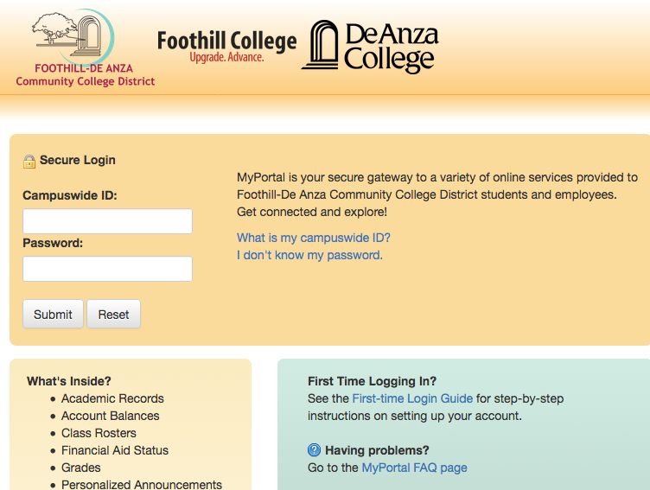

Once you log in to Canvas, you will see a list of courses you have registered that has a Canvas component. Click on BUS90 to go to our course home page.

Click “MyLab and Mastering” to go to Pearson site for purchase/access to etextbook.

Click on the appropriate week button for each week’s assignment module.
Click on “Grades” to keep track of your own progress.

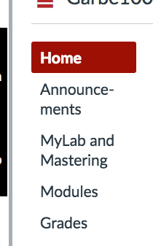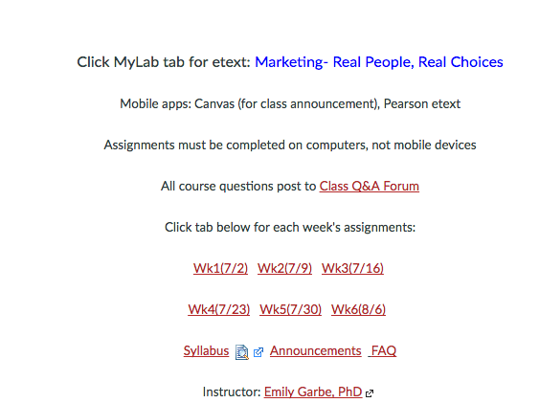

Within each week’s module, there are two sections: Resources and Assignments. Follow the list under Resources for chapter readings, lecture slides, and any additional videos or weblinks. Chapter readings for our main textbook resides on Pearson MyLab. You can click on “MyLab” then “etext” to access the textbook. You can also download the Pearson etext app onto a mobile device and read your chapters on the mobile device. However, you need to complete and submit the assignments on a computer, not a mobile device.
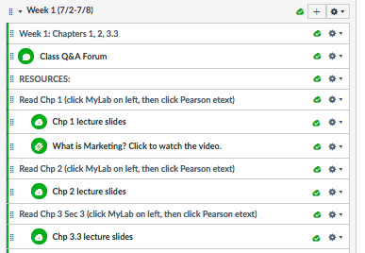

Under “Assignments”, there are two due dates: assignments due Wednesday, and assignments due Saturday. Complete each assignment by clicking on each link. Mini-sims, video quizzes and chapter quizzes will lead you seamlessly to Pearson MyLab, where upon completion of the assignment, will bring you back to Canvas. Discussion forums (Week 2 and 3) and marketing plan (Week 5) are local to Canvas and you need to complete the assignments based on the grading rubrics and project descriptions.

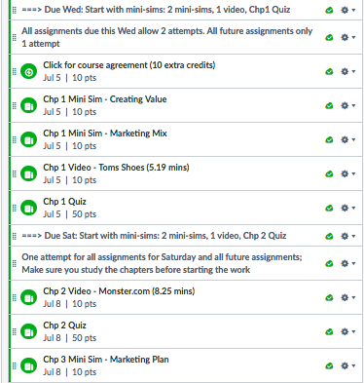

ACCOMODATIONS

Students with learning disabilities are encouraged to make arrangements with the De Anza Disabled Student Services if you need extra time on the quizzes. Students who are unsure whether they have a learning disability are encouraged to contact the Disability Programs and Support Services as soon as possible to determine eligibility. Please submit your DSS form to the instructor if you need accommodations. Instructor cannot make accommodations without instructions from DSS.

Pearson MyLab and Canvas provides accessibility accommodations for all etextbook, sims, videos. Please follow the instructions as indicated by Pearson and Canvas.

GRADING POLICY

The grades will be based on the following distributions. Note that one lowest grade video quizzes, three mini-sims and two lowest chapter quizzes are dropped. So if you did not do well in one or two assignments, had systems issues, or forgot/missed them, do not panic and NEVER ask the instructor to extend or restart just for you as it would not be fair to others in the class.

Activities | Canvas Points
Video quizzes | 100 (10 points per case, 11 videos, 1 lowest grade dropped)
Mini sims | 150 (10 points per sim, 18 sims, 3 lowest grades dropped)
Chapter quizzes | 550 (50 points per quiz, 13 quizzes, 2 lowest grades dropped)
Discussion forums | 120 (60 points for Segmentation and Gamification forums)
Marketing plan | 80

Letter grades will be assigned to students based on their total points, which is calculated as a sum of the grading components, as described above, divided by 1,000 points. The letter grade assignment table below will be used as the guideline.

Total Canvas points | Letter grade
970 or above | A+
930-969 | A
900-929 | A-
870-899 | B+
830-869 | B
800-829 | B-
770-799 | C+
700-769 | C
670-699 | D+
630-669 | D
600-629 | D-
599 or below | F

Academic Integrity Policy:

Students are expected to abide by the Student Conduct Rules as described in the Student Handbook at http://www.deanza.edu/studenthandbook/academic-integrity.html. Students who cheat on the tests, or help another person to cheat will receive a failing grade in this course and be reported to the Dean of EOPS & Student Development.

Business 90 – Summer 2017
Weeks | Reading assignments | Quizzes & Assignments (due 11:59pm)*
Week 1  (due Wed 7/5) | Chapter 1 – World of Marketing | Video – Toms Shoes  Mini Sim – Creating Value  Mini Sim – Marketing Mix  Chapter quiz
Week 1  (due Sat 7/8) | Chapter 2– Global Marketing | Video – Monster.com  Mini Sim – Global Marketing  Chapter quiz
Week 1  (due Sat 7/8) | Chapter 3.3 – Marketing Plan | Mini Sim – Marketing Plan
Week 2  (due Wed 7/12) | Chapter 4 – Market Research | Mini Sim – Market research  Chapter quiz
Week 2  (due Sat 7/15) | Chapter 5 – Market Analytic | Mini Sim – Big data  Chapter quiz
Week 2  (due Sat 7/15) | Chapter 6 – Understand Markets | Video – Eaton  Mini Sim – Buyer decision process  Chapter quiz  Discussion Forum: Gamification
Week 3  (due Wed 7/19) | Chapter 7 – Segmentation | Video – NutriSystem  Mini Sim – Segmentation  Chapter quiz
Week 3 (due Sat 7/22) | Chapter 7 (cont’d) | Discussion Forum: Facebook vs. Twitter
Week 3  (due Sat 7/22) | Chapter 8 – New Product Development | Video – Honest Tea  Chapter quiz
Week 3  (due Sat 7/22) | Chapter 9 – Product Strategy and Branding | Video – Fiber One  Mini Sim – Product Life Cycle  Chapter quiz
Week 4  (due Wed 7/26) | Chapter 10 – Pricing | Video – General Electric  Mini Sim – Pricing  Mini Sim – Pricing Strategies  Chapter quiz
Week 4  (due Sat 7/29) | Chapter 13 – Advertising and Sales Promotion | Video – Zappos  Mini Sim – Advertising  Mini Sim – IMC  Chapter quiz
Week 4  (due Sat 7/29) | Chapter 14 – Social Media Marketing, Selling and PR | Video – Principal Financial Group  Mini Sim – Online Marketing  Mini Sim – Personal Selling  Chapter quiz
Week 5  (due Wed 8/2) | Chapter 11 – Distribution Strategy | Chapter quiz  Video – Dunkin Donuts  Mini Sim – Supply Chain
Week 5  (due Sat 8/5) | Chapter 3.3 revisited - Marketing Plan | Assignment: Marketing Plan
Week 6  (due Wed 8/9) | Chapter 12 – Bricks and Clicks | Chapter quiz  Video – Umpqua Bank  Mini Sim – Service Marketing  Mini Sim – Retailing
*See course page in Canvas for details on the assignments.

