Work and Energy
Newton’s Laws of motion, along with our definitions of displacement, velocity, and acceleration have allowed us to solve a wide variety of problems. However, in many different types of problems it is difficult or impossible to apply Newton’s Laws. A much more convenient and easier approach is to use the concept of work and energy. This is our next topic of study.

SCALAR (DOT) PRODUCT
Before we define work in physics we need to first define the scalar (dot) product between two vectors. The reason for this is because we will define work in terms of the scalar (dot) product between the force vector and displacement vector.

Note that the scalar product is a scalar quantity and not a vector quantity!

Dot Product Between Unit Vectors

WORK DONE BY A CONSTANT FORCE

Def: The work done on an object by a constant force F is equal to the product of the component of force in the direction of displacement and the magnitude of the displacement of the point of application of the force.

Work Done By A Constant Force

*You can think of work as a measure of the effectiveness of a force to cause an object to be displaced.

Note that work is a scalar quantity and not a vector quantity. Work does not have any direction in space.

Units of Work

System | F | S | W
SI | N | m | 1 Joule(J)=1 N.m
cgs | dyne | cm | 1 erg = 1 dyne.cm
British Eng. | lb | ft | 1ft.lb = 1 foot.pound

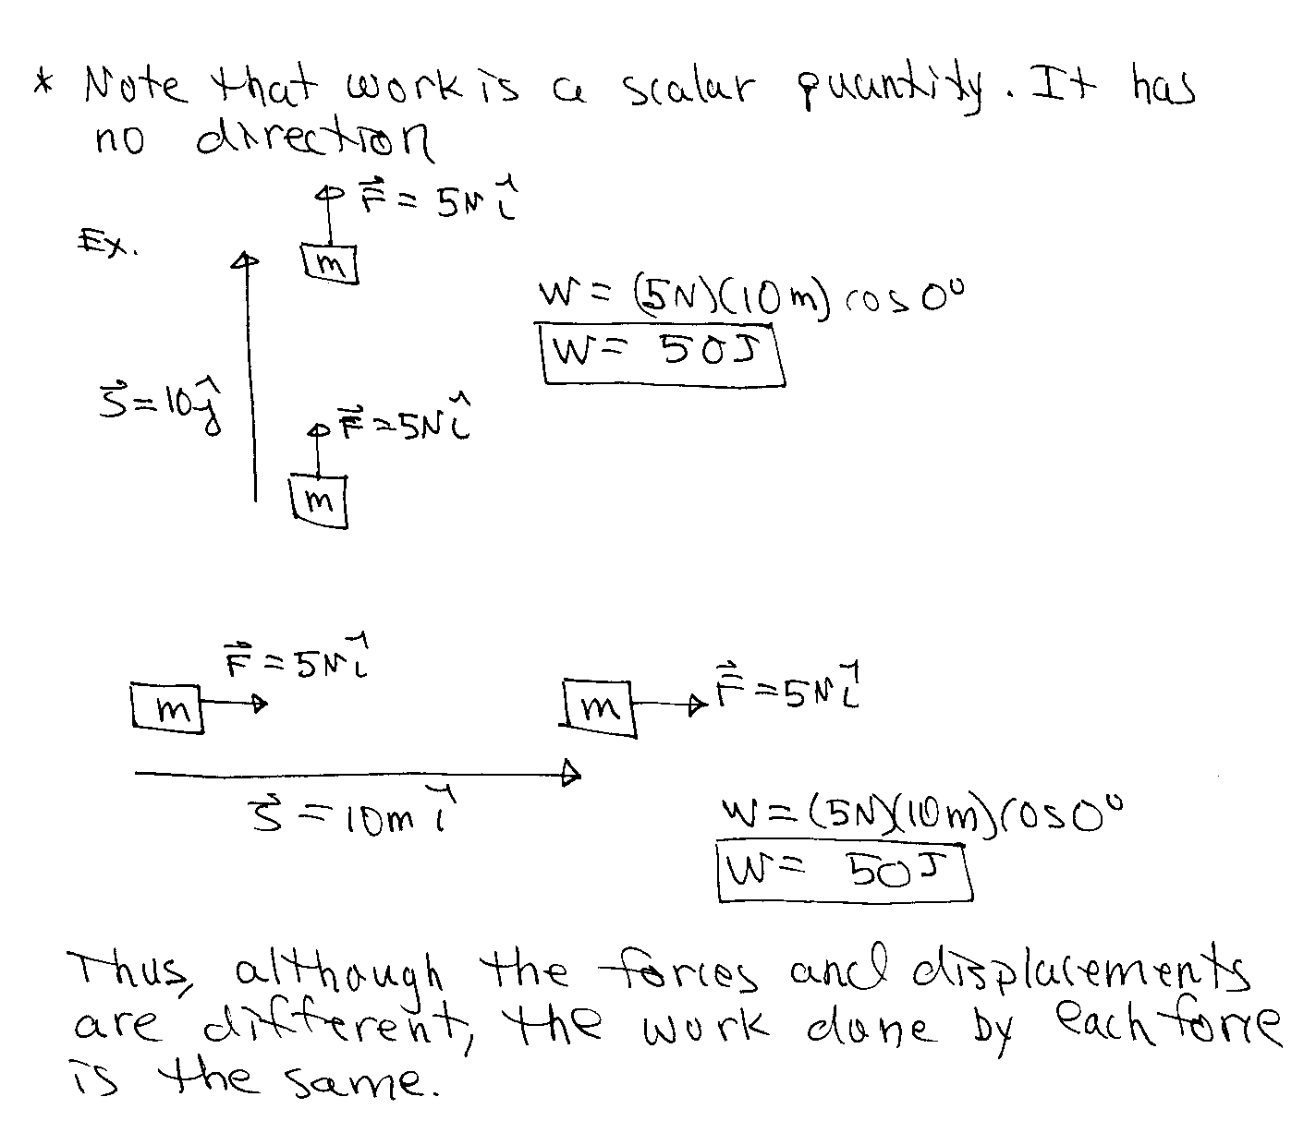
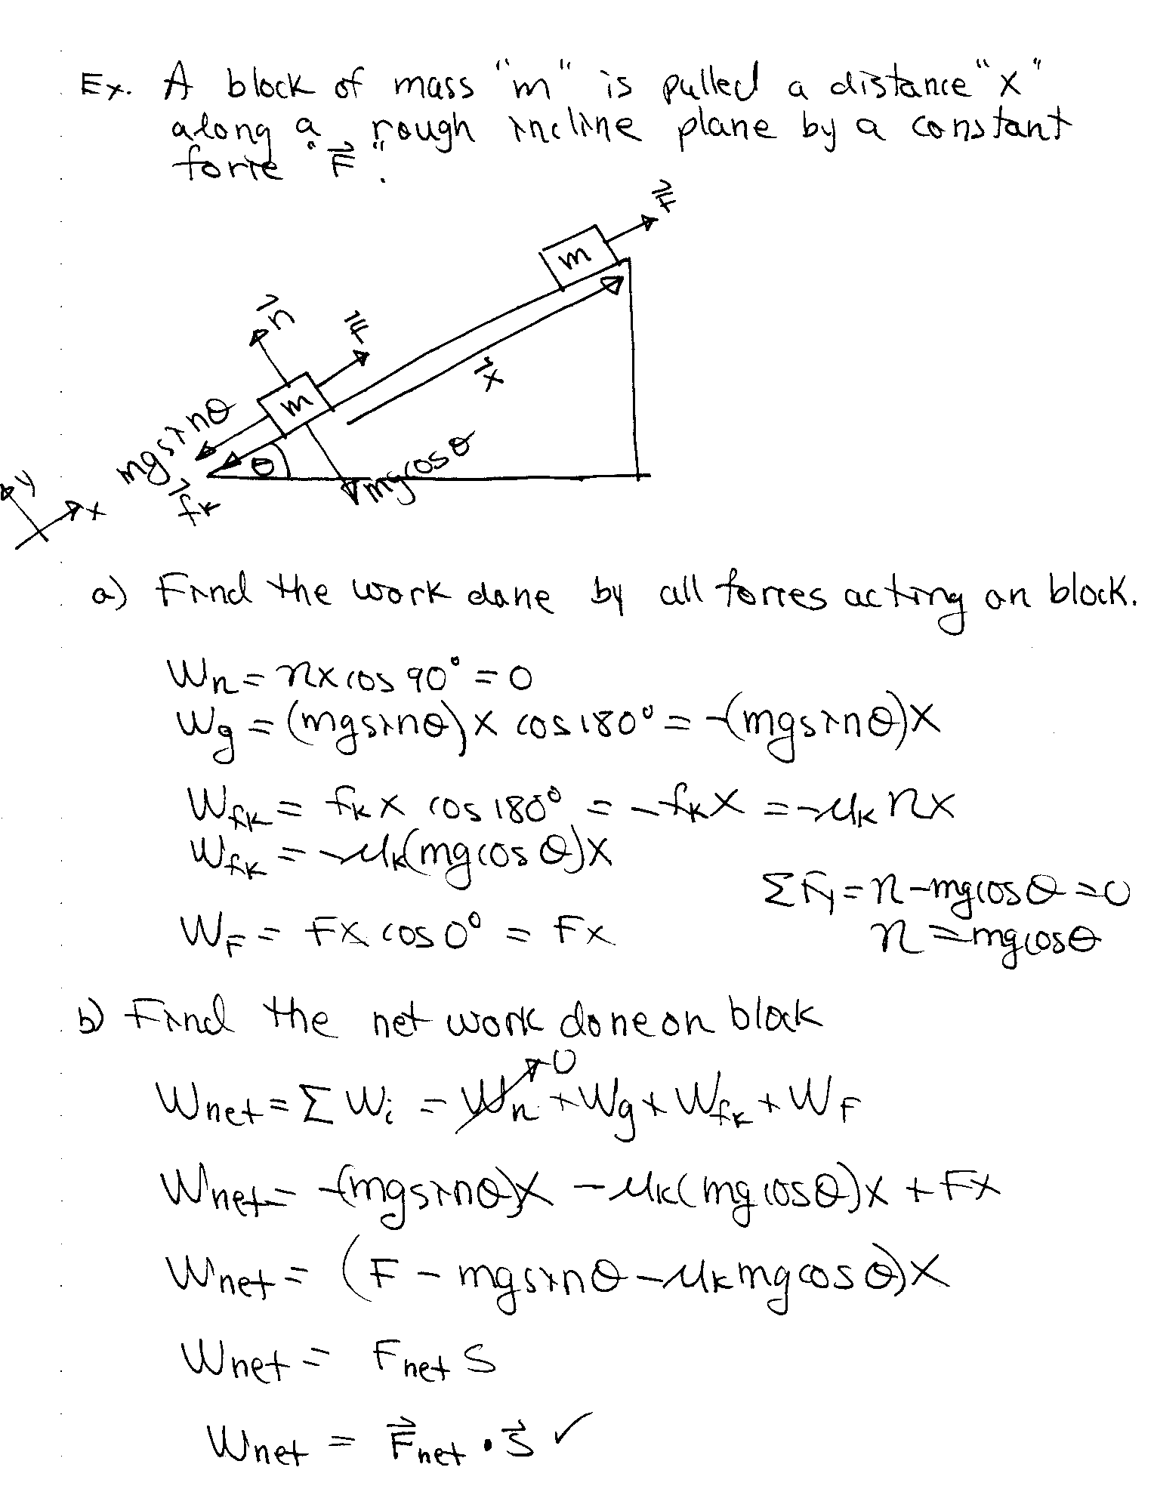

Spring Force

How do we calculate the work done by a non-constant force? Before we answer the question let’s consider the spring force which is an example of a non-constant force.

Consider the following Spring-Mass System.

- Note that the spring force F_{s} is always in the opposite direction of the displacement of the mass.
- The larger the displacement from equilibrium, the larger the spring force.

These two properties of the spring force can be summarized by the following equation called Hooke’s Law:

Hooke’s Law

F_{s} = spring force (N)
k = spring constant (N/m)
x = displacement of block (spring) from equilibrium position (m)

The value of the spring constant K is a measure of the stiffness of the spring.

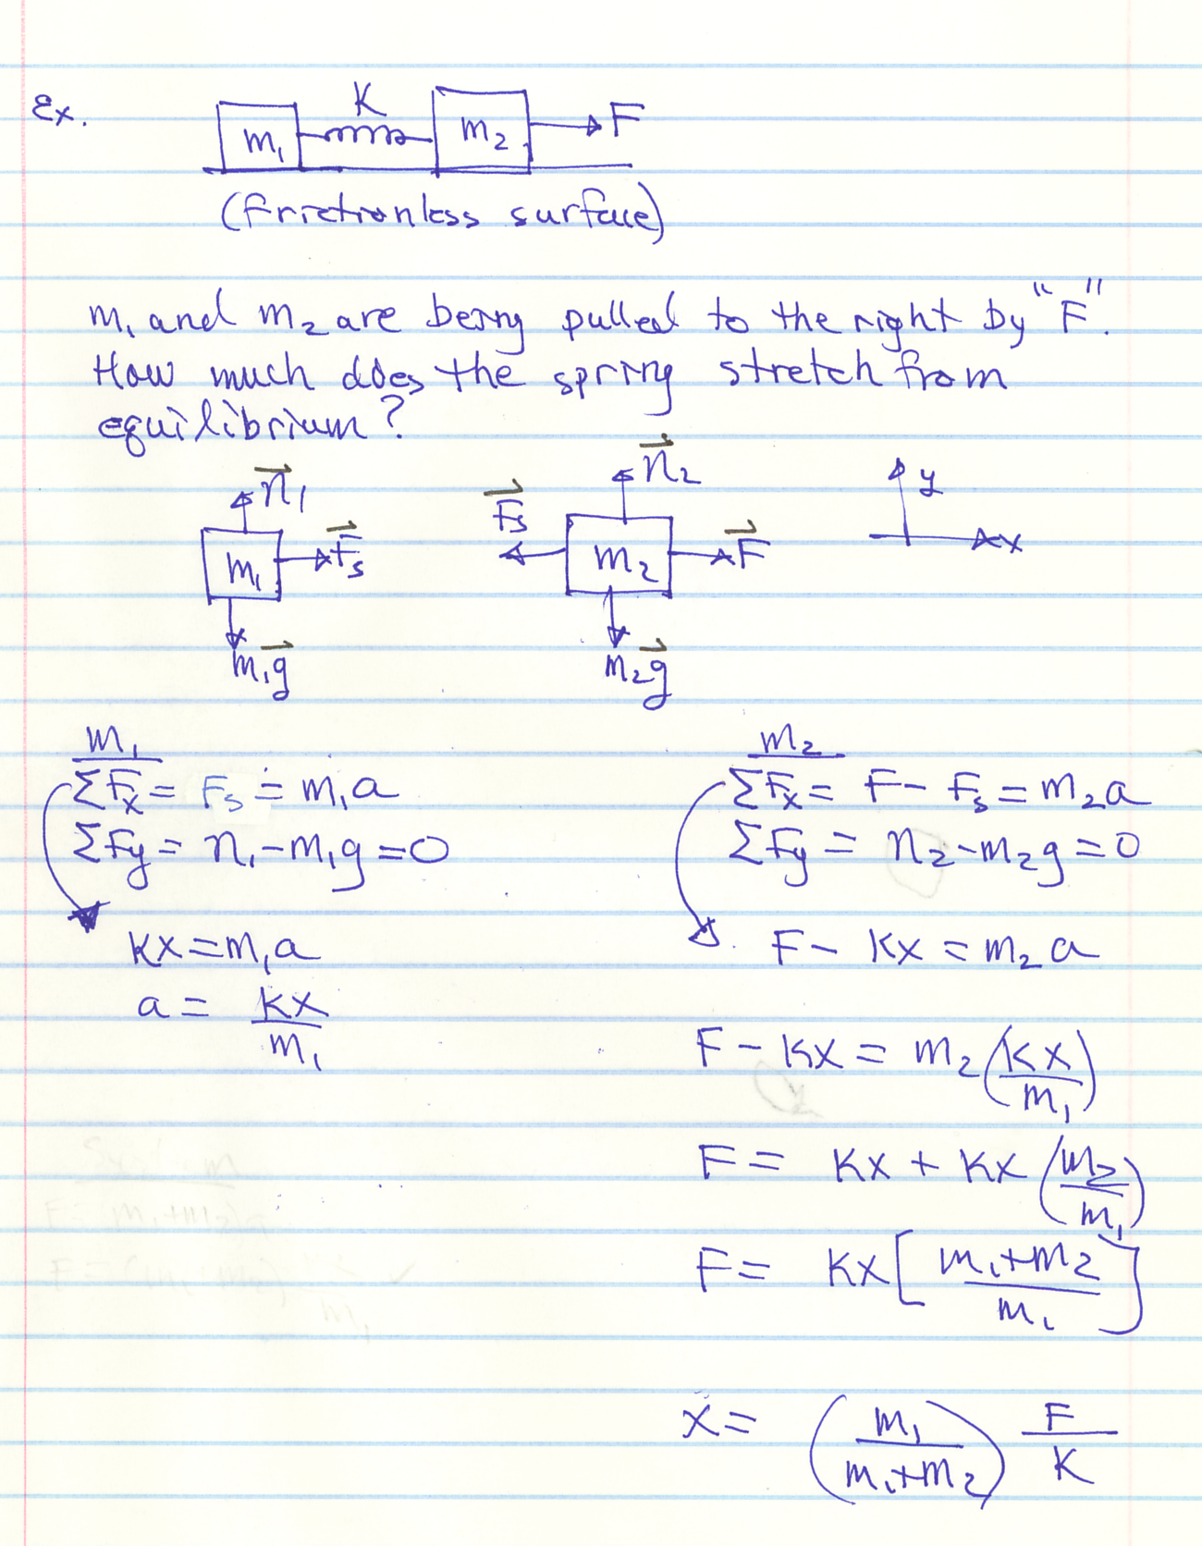

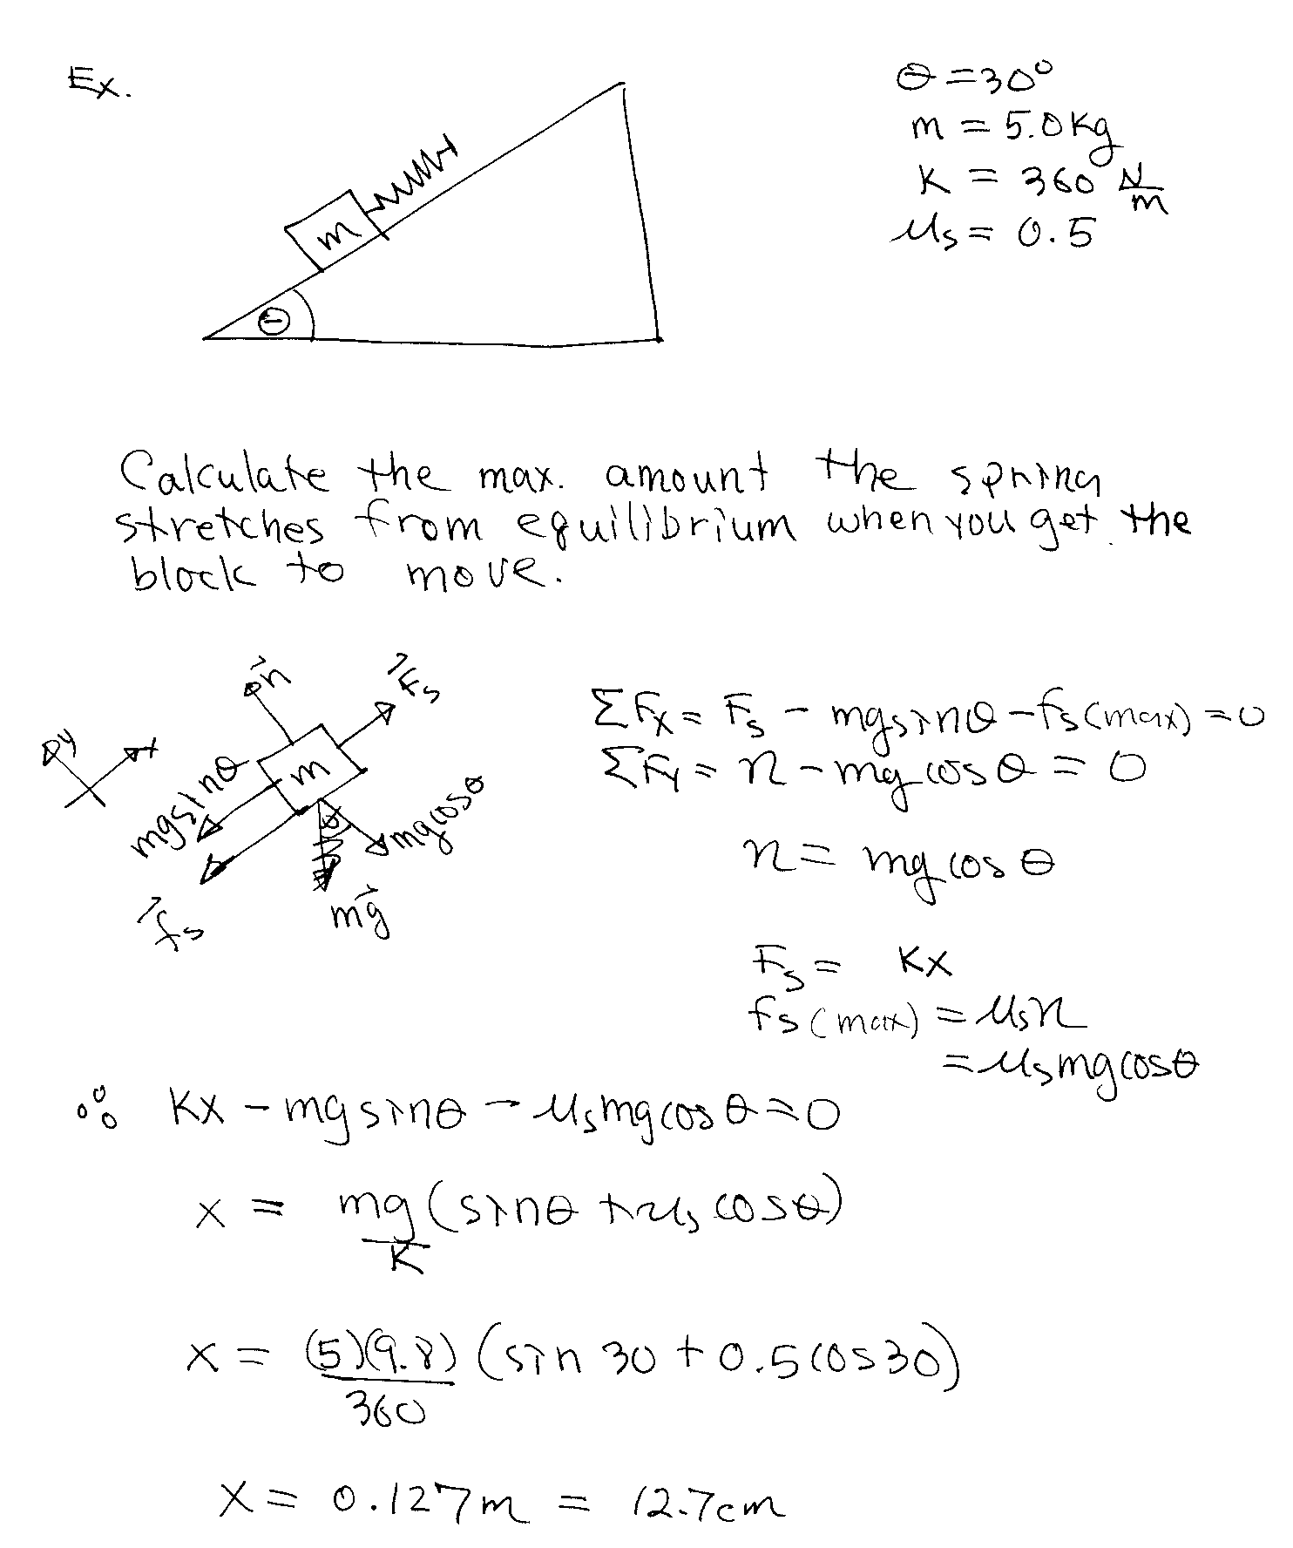

WORK DONE BY A NON-CONSTANT FORCE IN 1-D

Consider a particle being displaced along the x-axis under the influence of a non-constant force F(x) also directed along the x-axis. We would like to determine the work done by F(x) for a displacement from x_{i} to x_{f}.

Since the force is not constant we cannot use . However, for a very small displacement Δx, the forceF_{x} is approximately constant and thus we can use .

(for a small displacement Δx)

To obtain the work done by F(x) from x_{i} to x_{f} we divide the curve into a large number of intervals and then add the results:

Work Done By A Non-Constant Force in 1D

The geometric interpretation for work is the following:

In a F vs. x graph the area between the curve and the x-axis equals the work done by the force during the corresponding displacement interval.

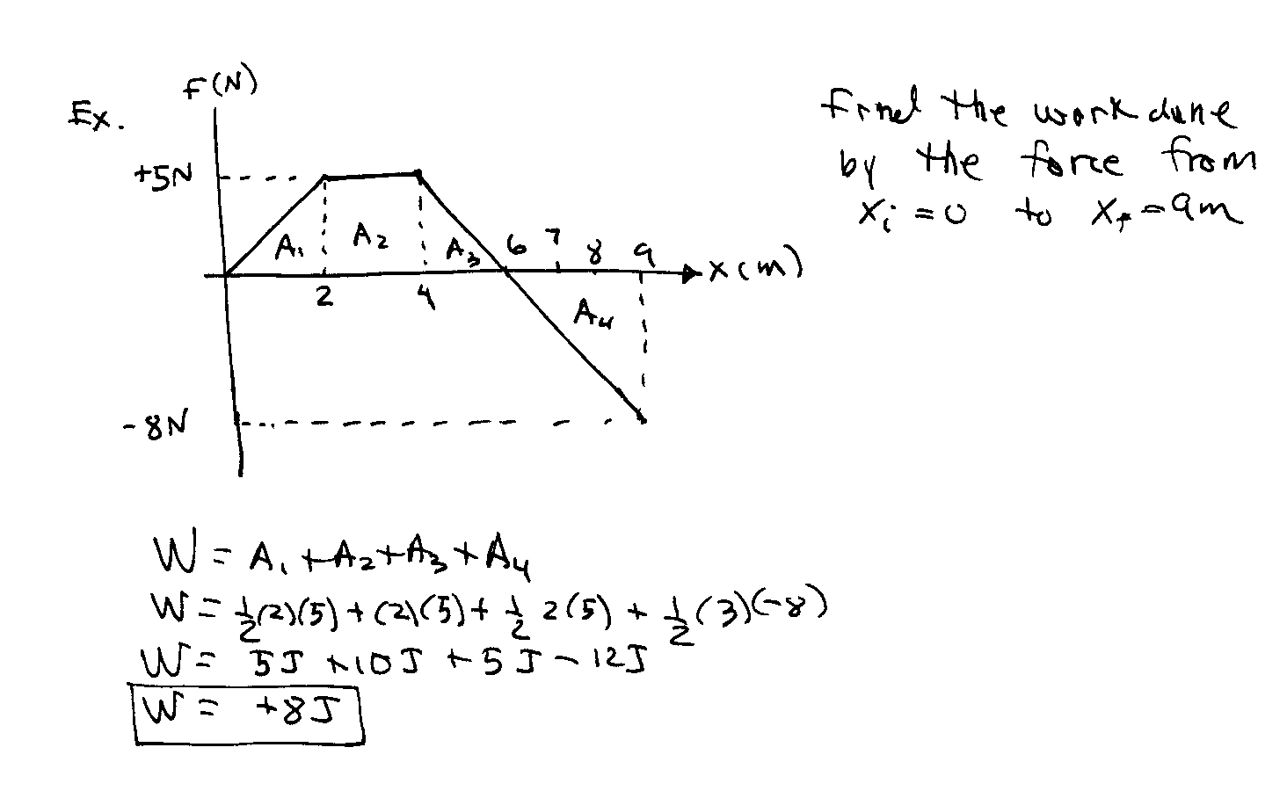

Work Done By The Spring Force

Consider a spring-mass system. The mass is displaced by an applied force F_{app} between x_{i} and x_{f}.

Find the work done by the spring force F_{s} in displacing the block from x_{i} and x_{f}.

Work Done By Spring Force

Find the work done by the applied force F_{app} in displacing the block from x_{i} and x_{f} if the block is displace very slowly so that F_{app} = - F_{s}.

Work Done By Applied Force

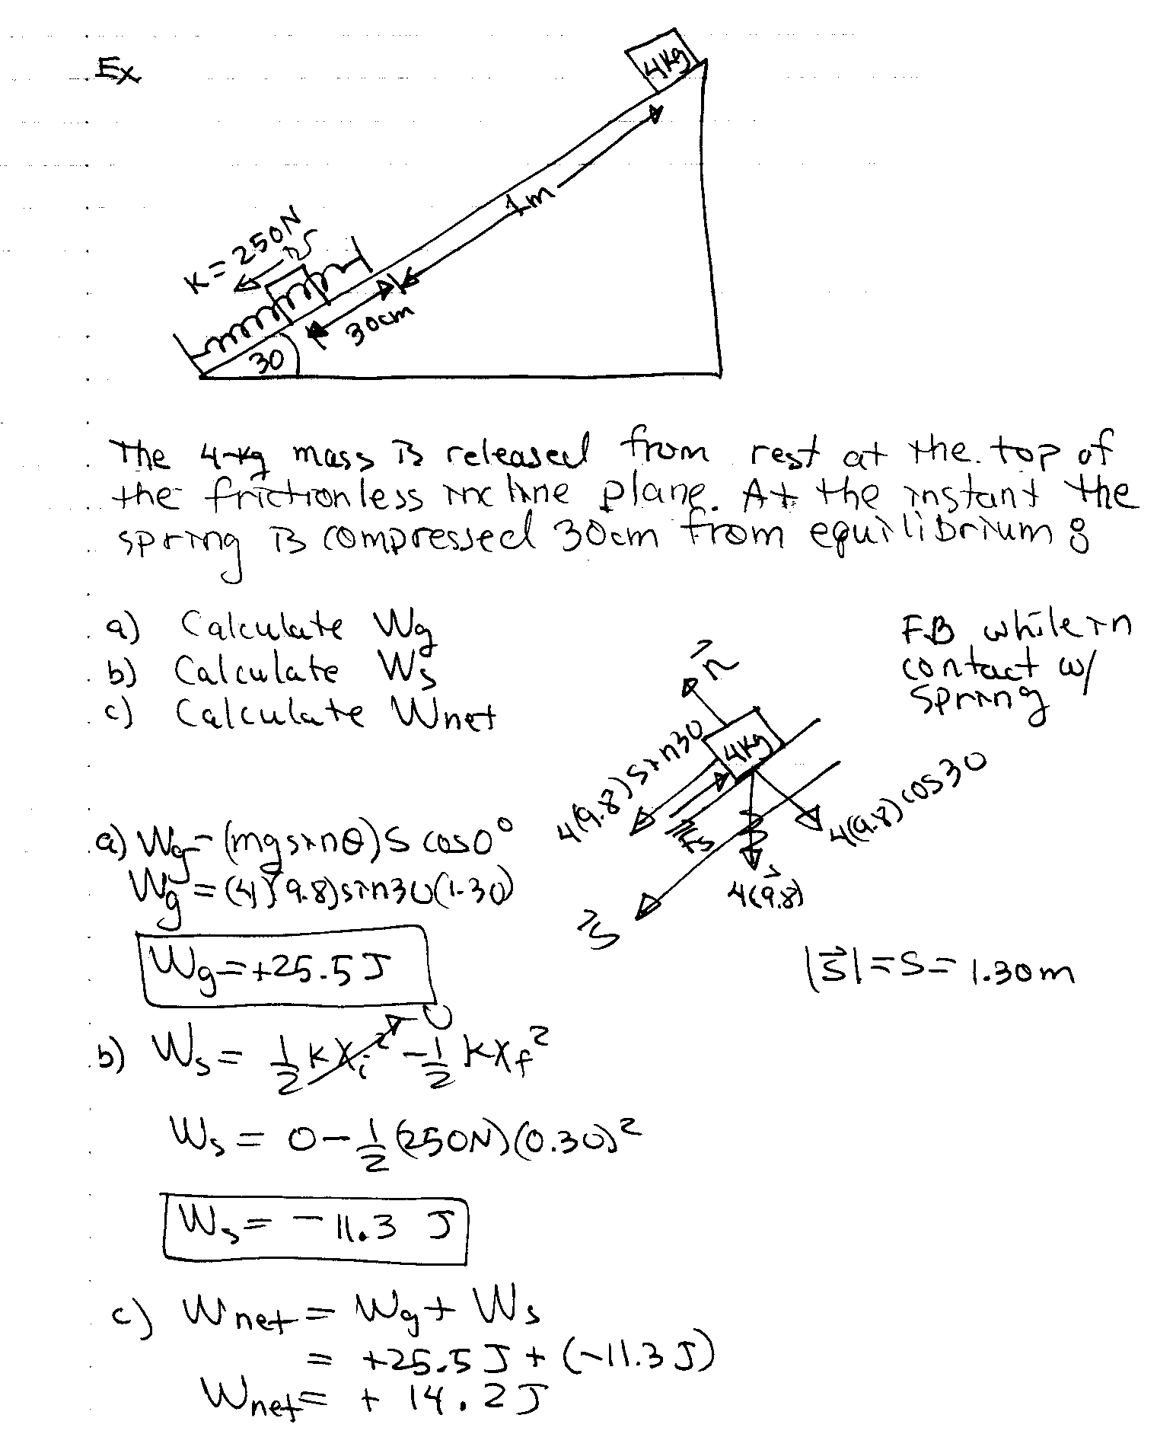

Work-Energy Theorem
We have seen that work is related to displacement as shown by the equation:
However, can we also say that it is related to the speed or the change of speed? From the above equation, if a particle experiences a net force F(x) , then this force will do some W_{net} on the particle. Thus, if the particles experiences a net force F(x), then it will have an acceleration and thus a corresponding change in velocity (speed). How is the change in speed related to work?

The Work-Energy Theorem is a very important theory that will allow us to solve problems much easier than using Newton’s Laws. Consider an object that is moving along the x-axis under the influence of a non-constant net force ΣF_{x} also directed along the x-axis. We would like to determine the work done by the net force for a displacement from x_{i} to x_{f}.

Kinetic Energy

Work-Energy Theorem

Notes on Kinetic Energy and Work-Energy Theorem

- Kinetic energy is energy associated with the motion of a particle.
- The SI unit of KE is the joule (J).
- The Work-Energy Theorem is valid even when the net force is not constant!
- The Work-Energy Theorem is valid only for particle-like objects.
- If work is done on a system and the only change in the system is in its speed, the work done by the net force equals the change in KE of the system!
- Work and Energy are equivalent concepts:
- Work is a method of transferring energy to or from a system due to a force acting on the system.
- If W_{net} > 0, then ΔK > 0 and the speed of the particle has increased. Energy had been transferred into system.
- If W_{net} < 0, then ΔK < 0 and the speed of the particle has decreased. Energy had been transferred out of system.
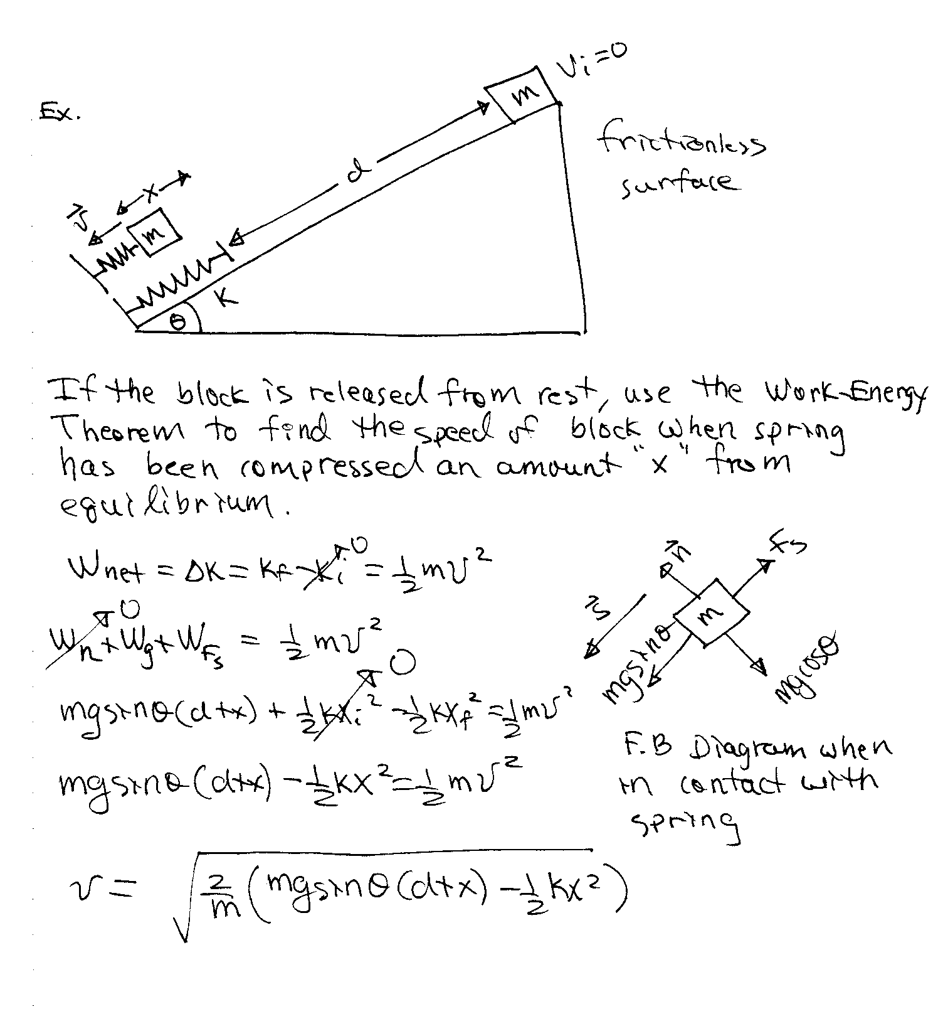

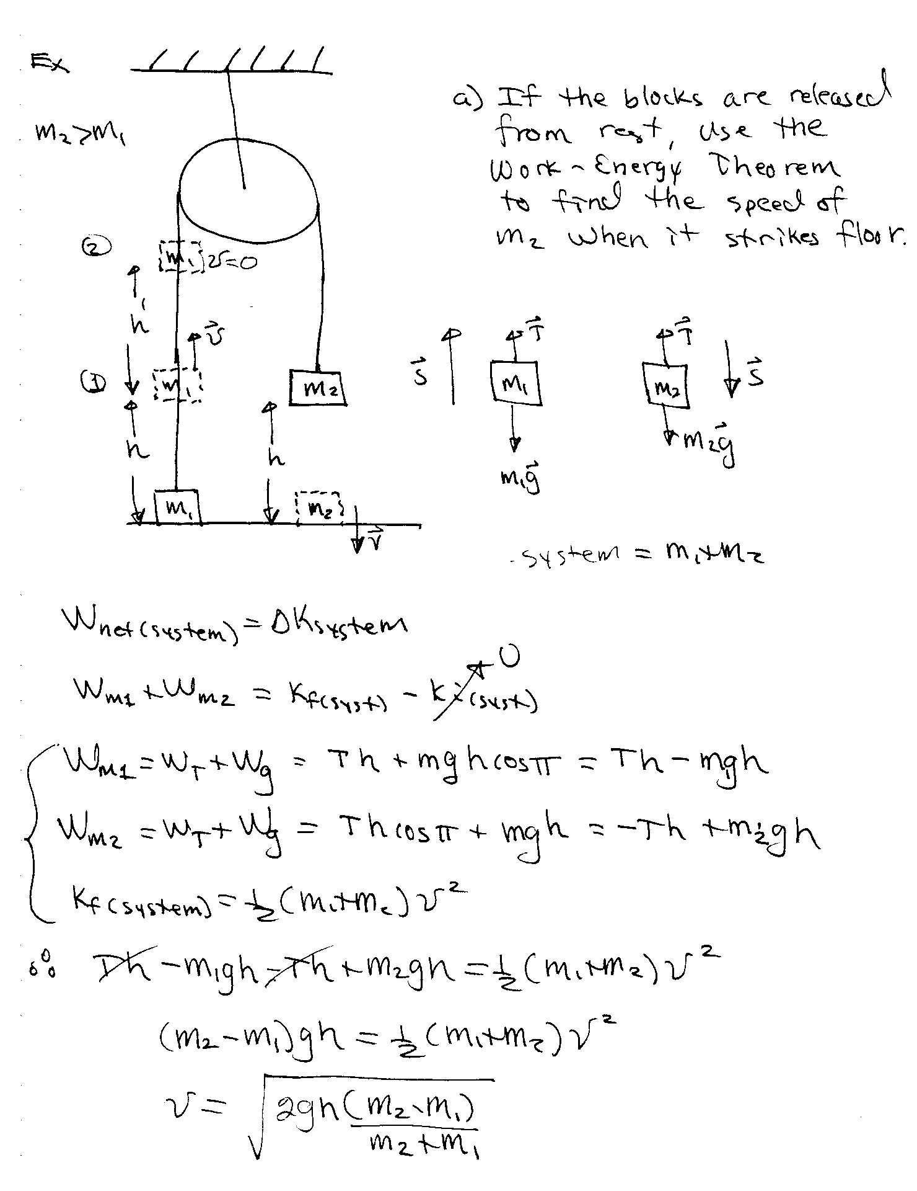
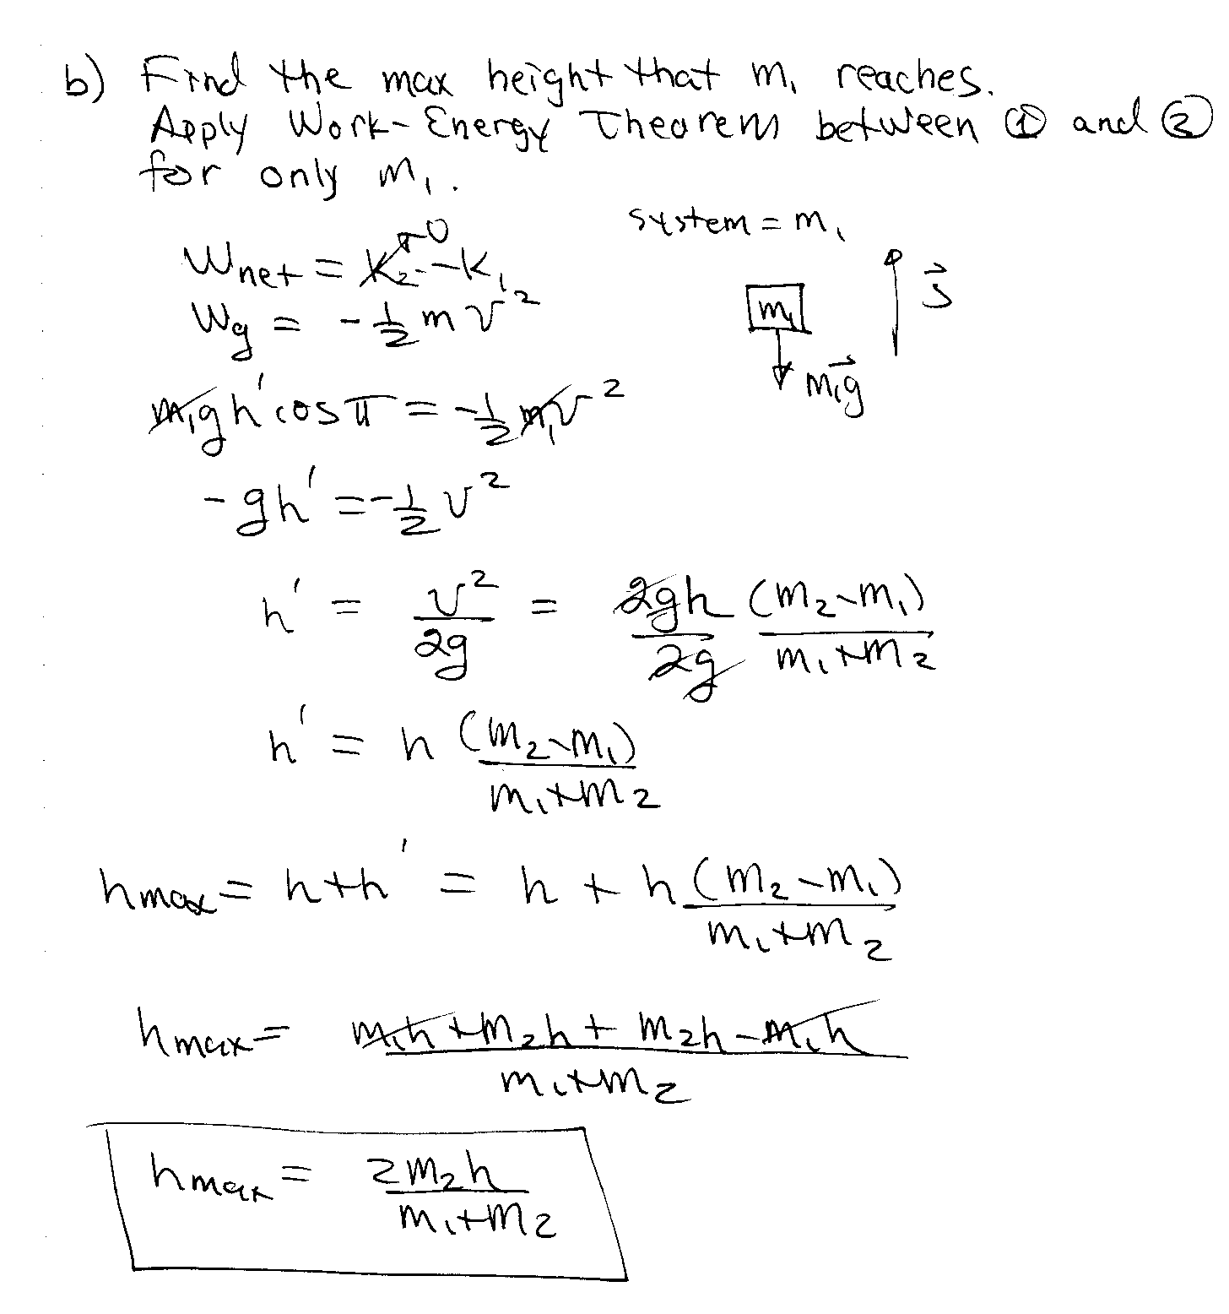

Work-Energy Theorem Involving Friction
Consider a block that that is given an initial velocity V_{o} on a surface where μ = μ_{k}.

Note that –f_{k}s is not the work done by f_{k} on the block.

- s is the displacement of the block not the displacement of f_{k}.
- f_{k} is not localized at a single point but distributed over the contact surface
- Since f_{k} is not localized on a single point, the block cannot be treated as a particle-like object and thus the Work-Energy Theorem does not apply in this case.

However, the equation still describes the decrease in KE due to the friction force. If there are other forces besides friction acting on the object, the change in KE is the sum of that due to friction plus the other forces acting on the object (from the Work-Energy Theorem).

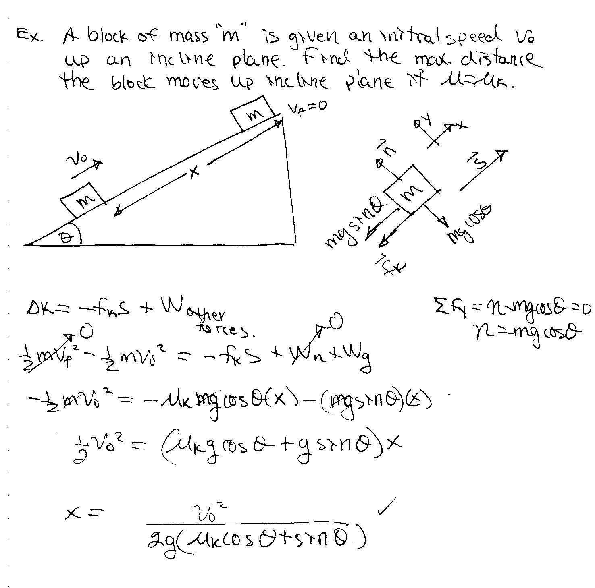

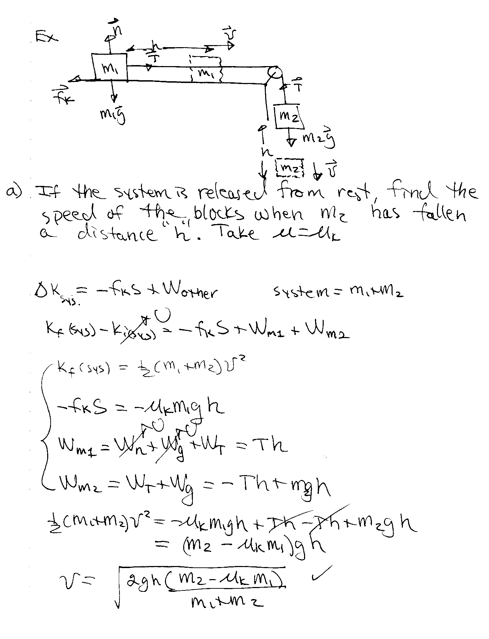
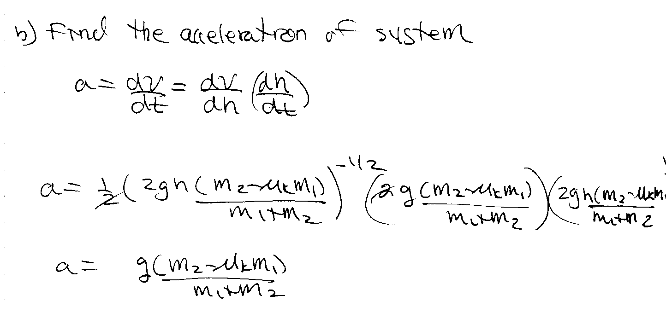

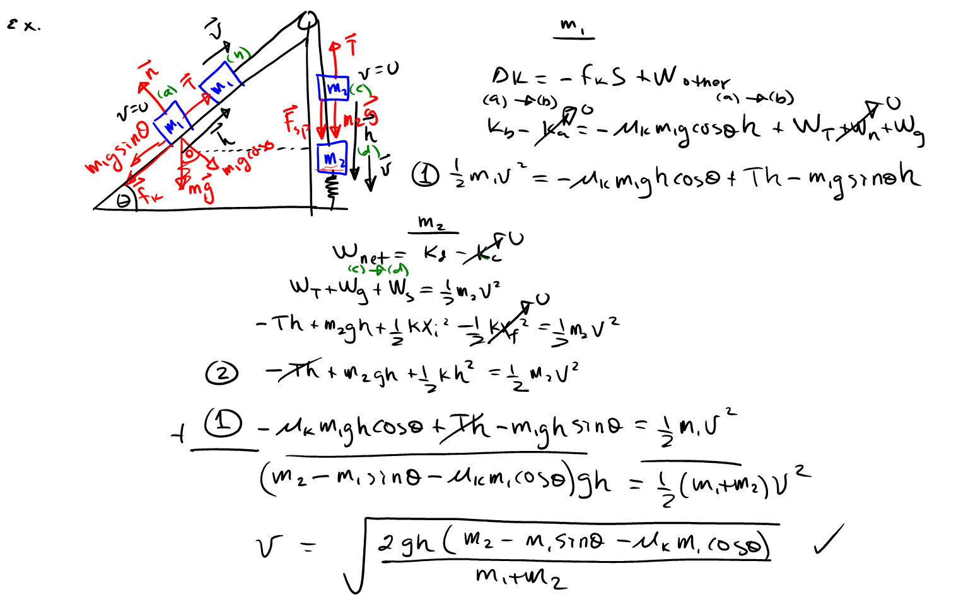

POWER
From a practical viewpoint, not only are we interested in the work done on an object, but also at the rate at which work is being done on the object.

Def: If an amount of work ΔW is done on an object in a time interval Δt by a force F, then the average power delivered to the object by the force F is given by:

Average Power

Often the rate at which work is done on an object varies with time and thus we speak about instantaneous power.

Instantaneous Power

Consider a force F acting on a particle over a very small displacement ds. The work done by F is given by:

Instantaneous (instantaneous rate at which F does work on particle)

Instantaneous Power

In general power is the time-rate of energy transfer to a system by any method:

Power

However, for our purpose we will consider work to be the method of energy transfer.

Units
The SI unit of power is the watt(W)
1W=1J/s
A common unit of power used in the U.S is the horsepower (hp):
1 hp = 746 W = 0.75 KW

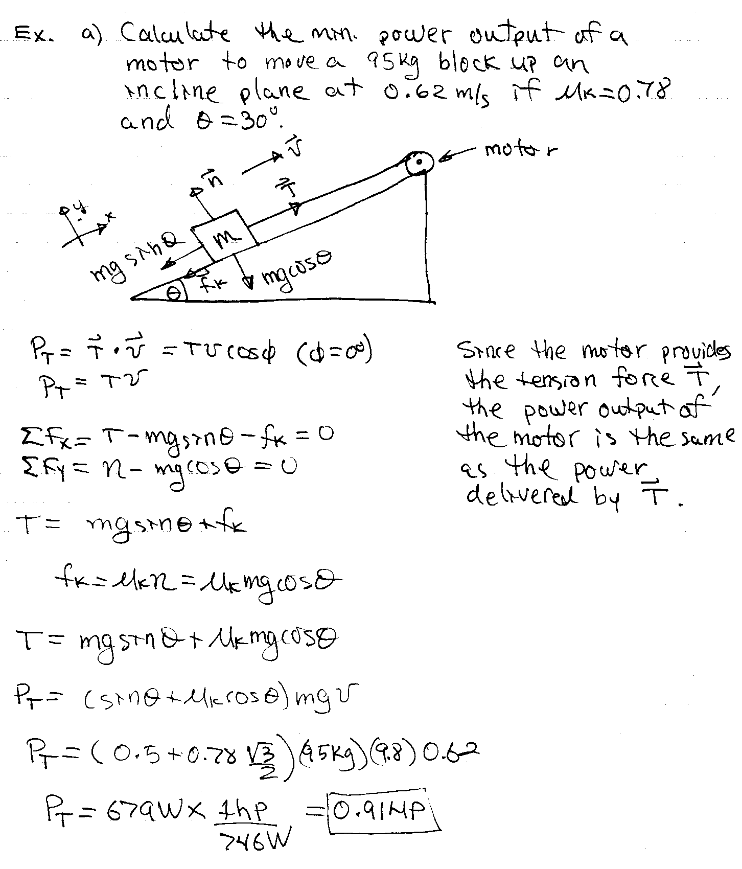

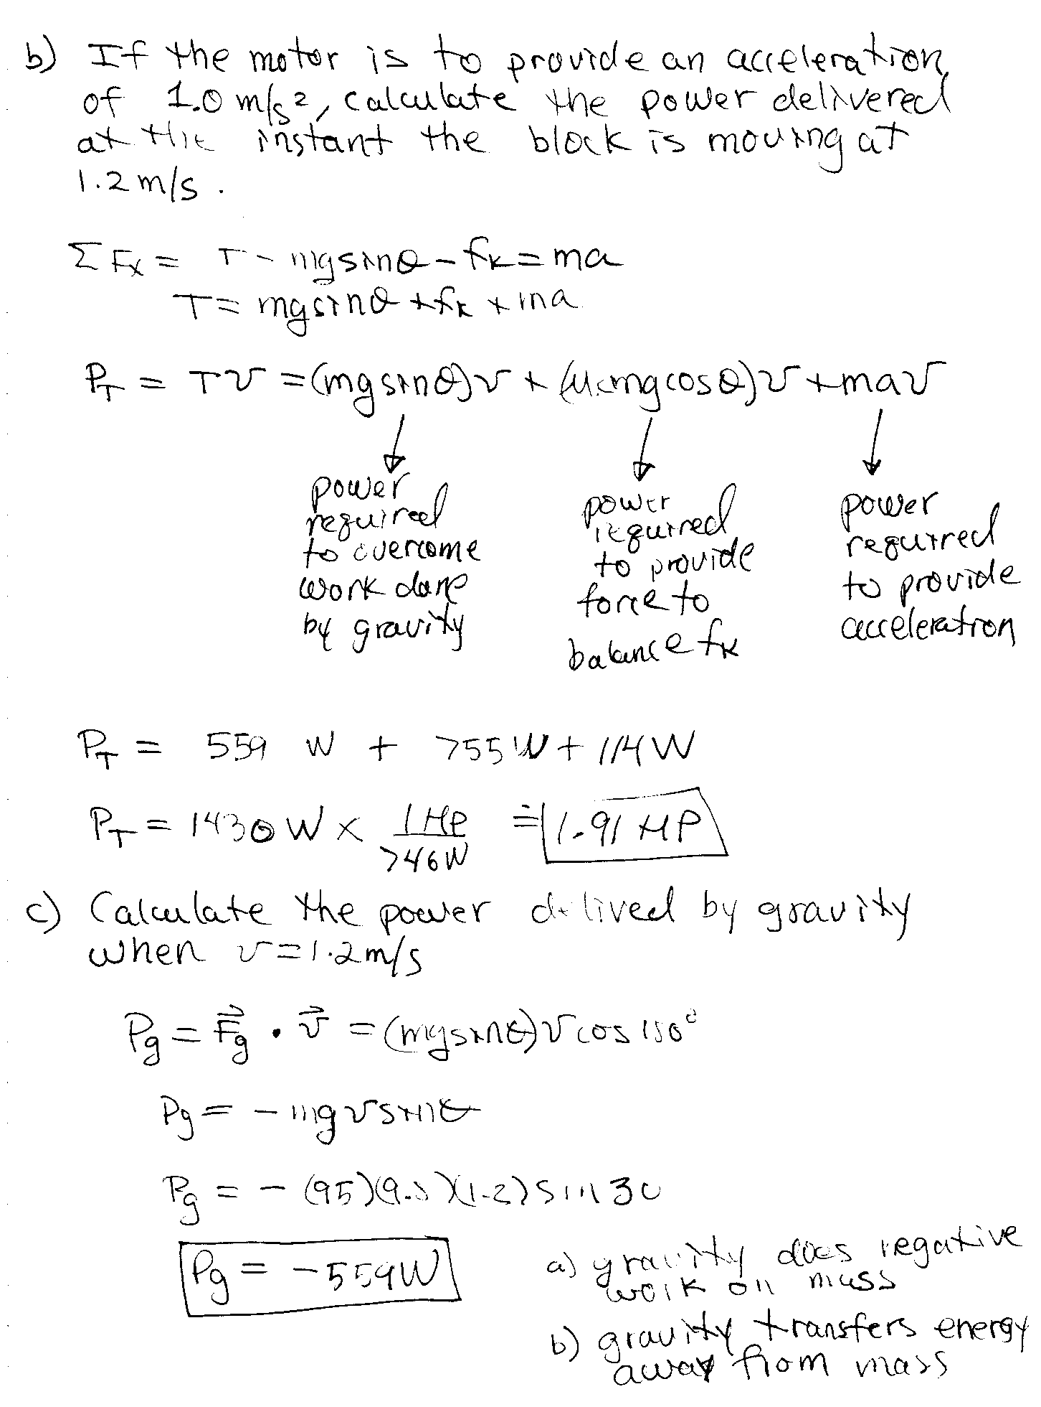
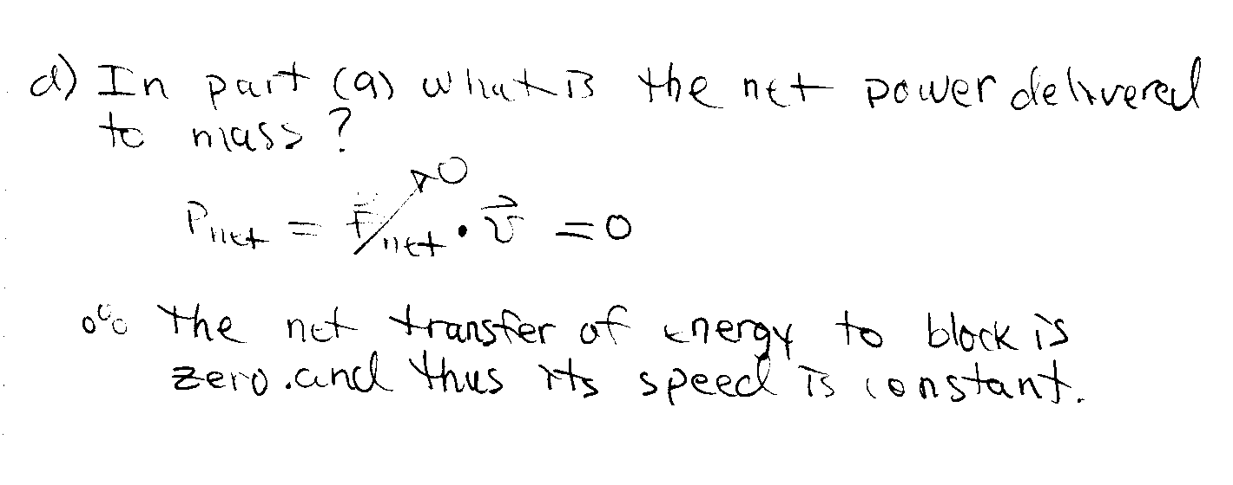

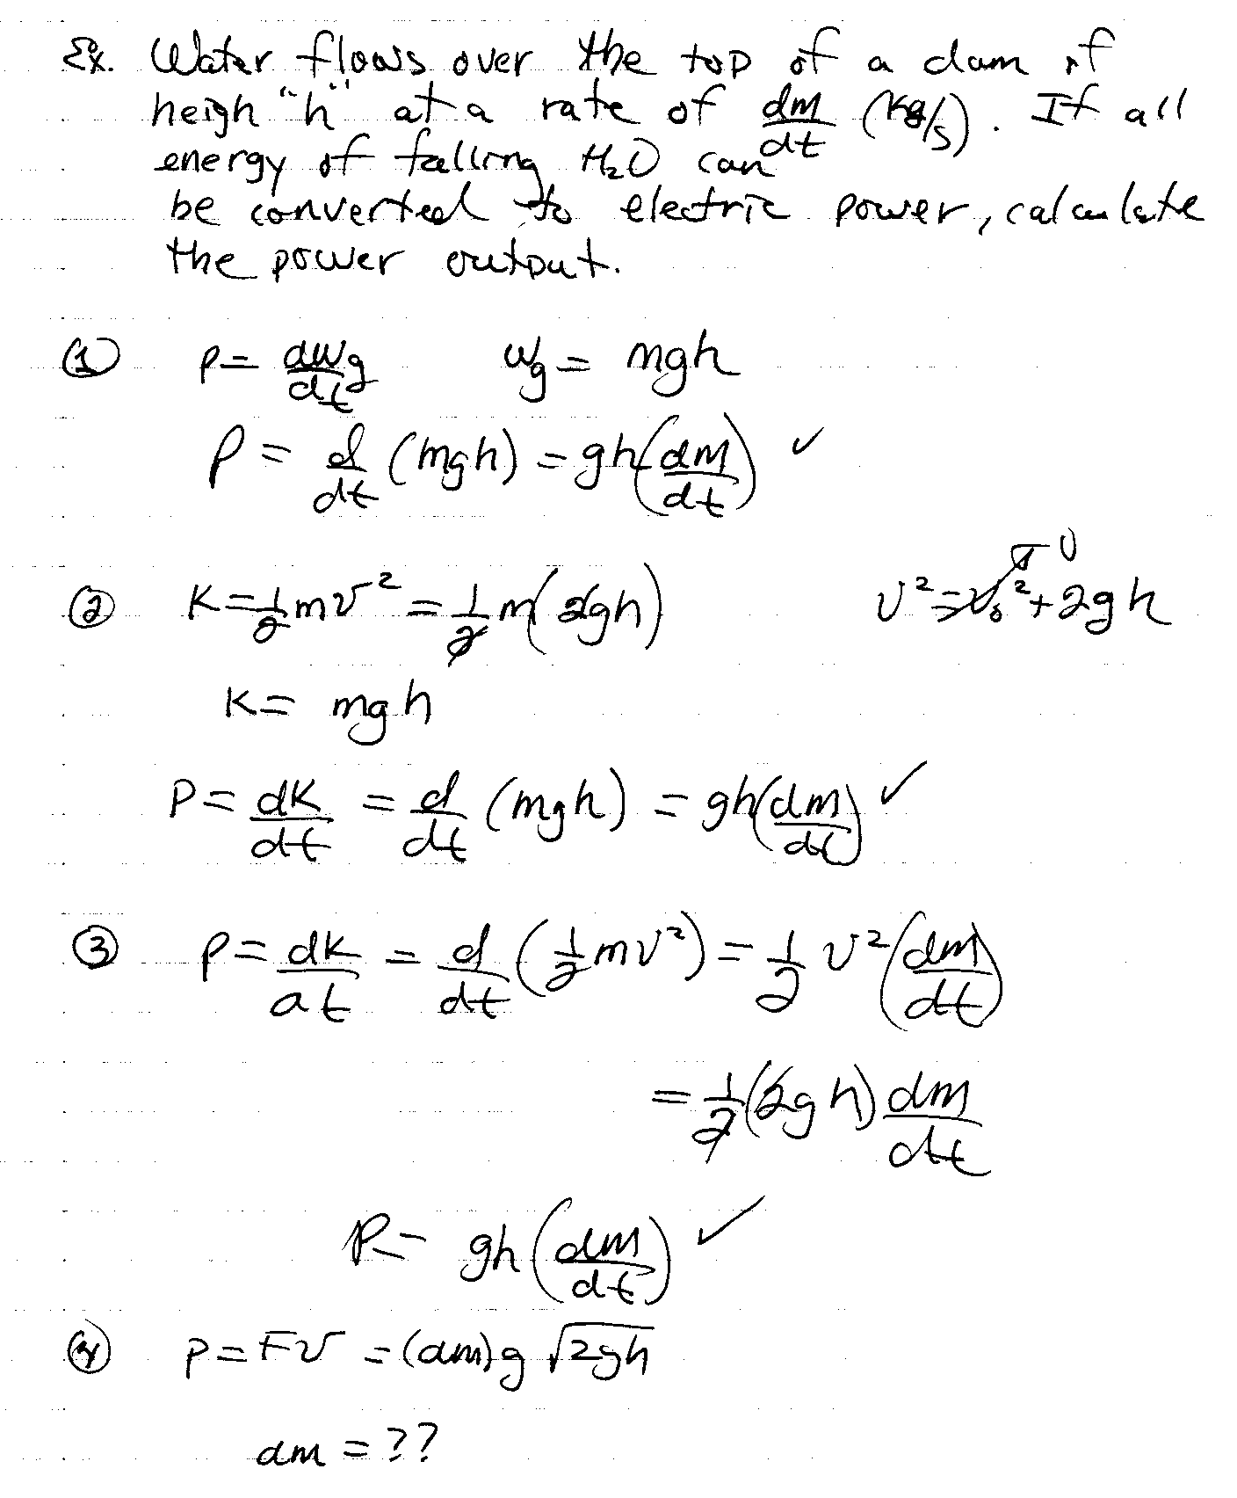
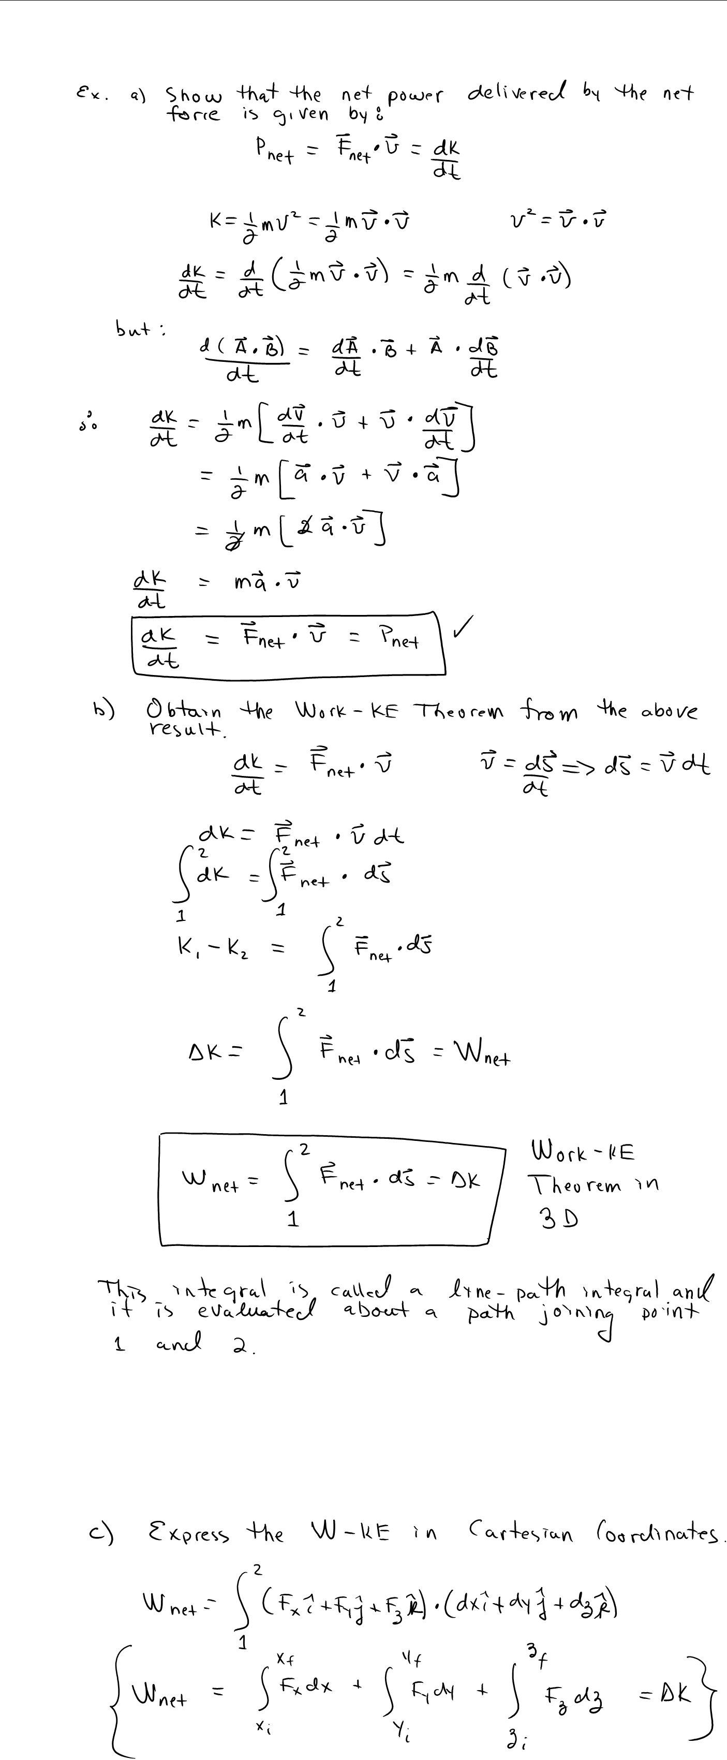
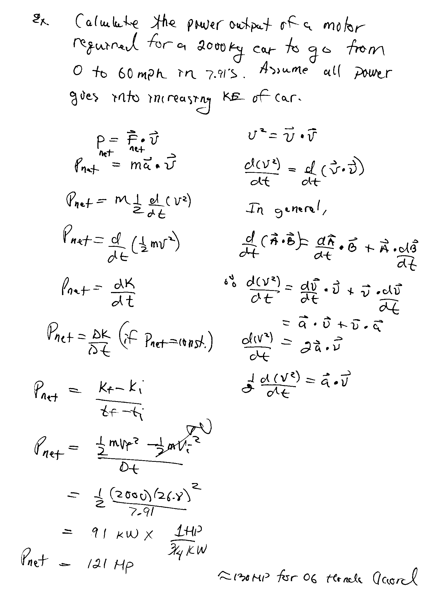
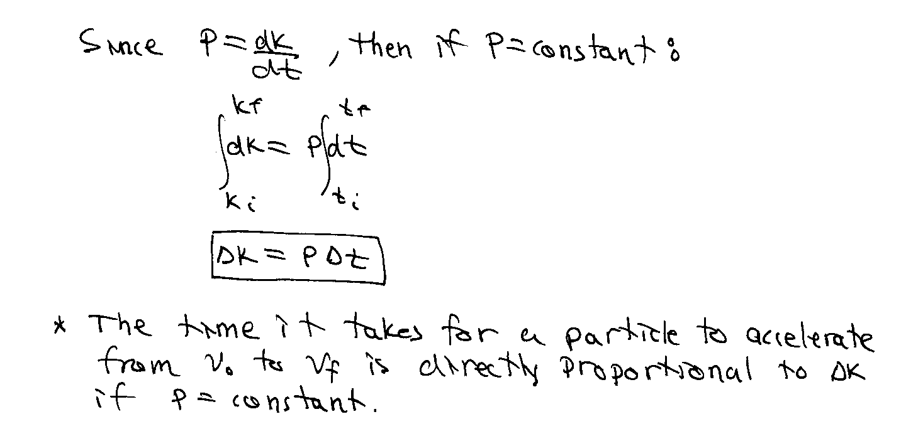
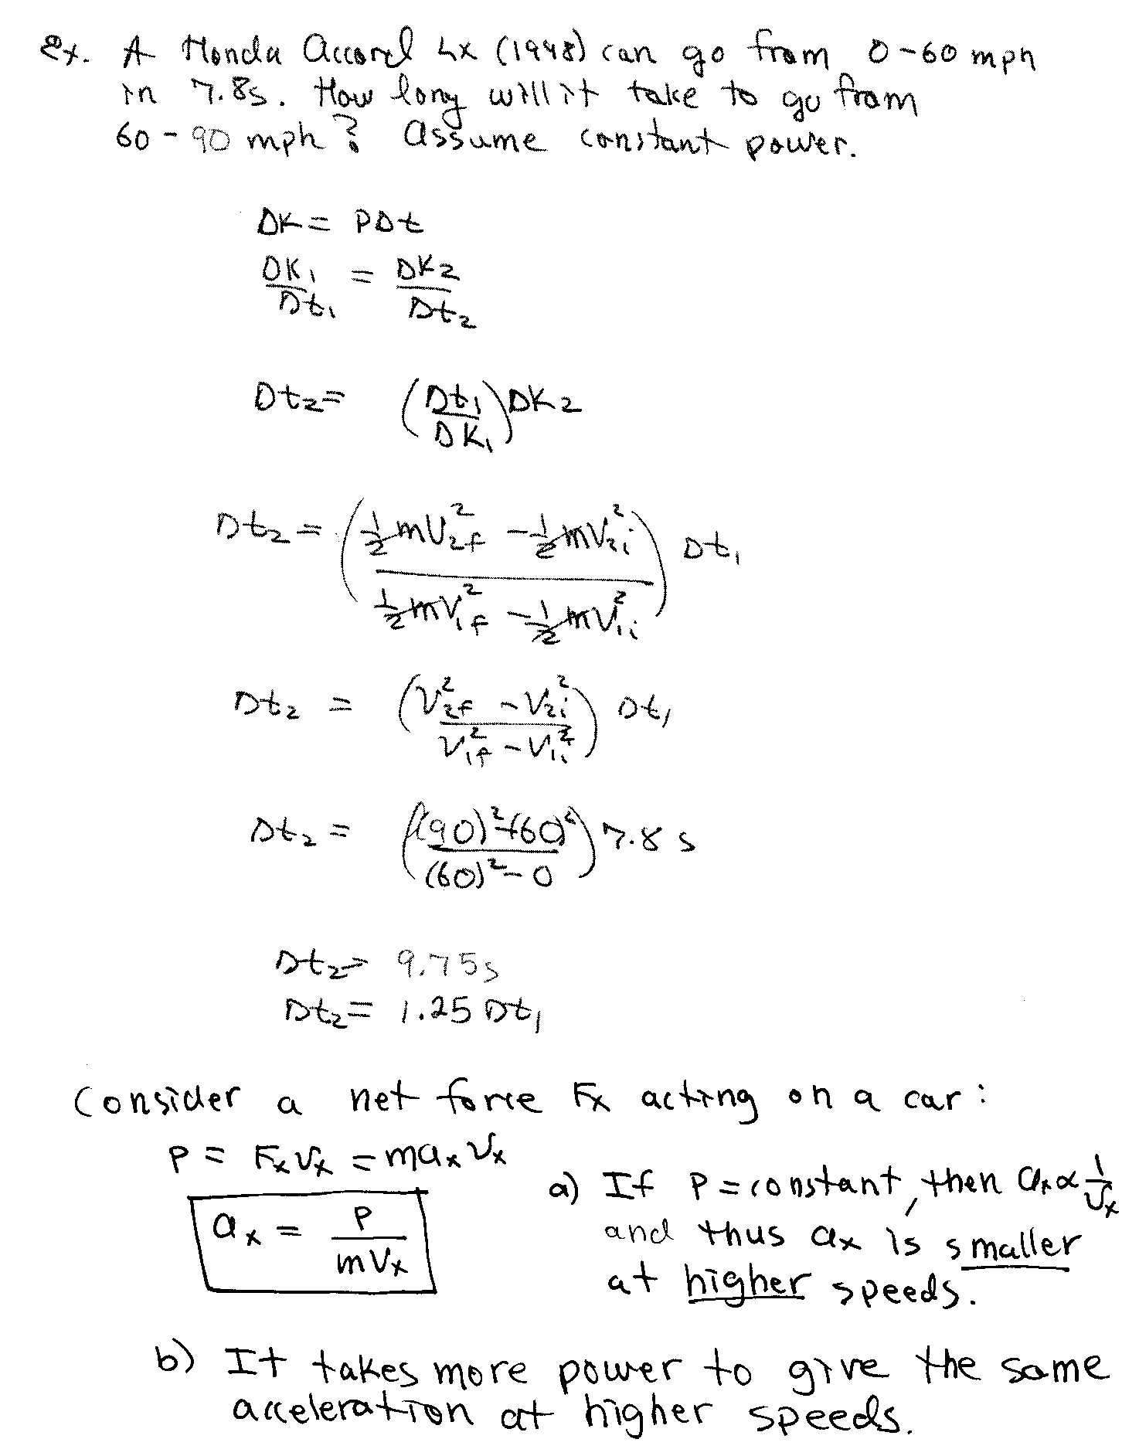
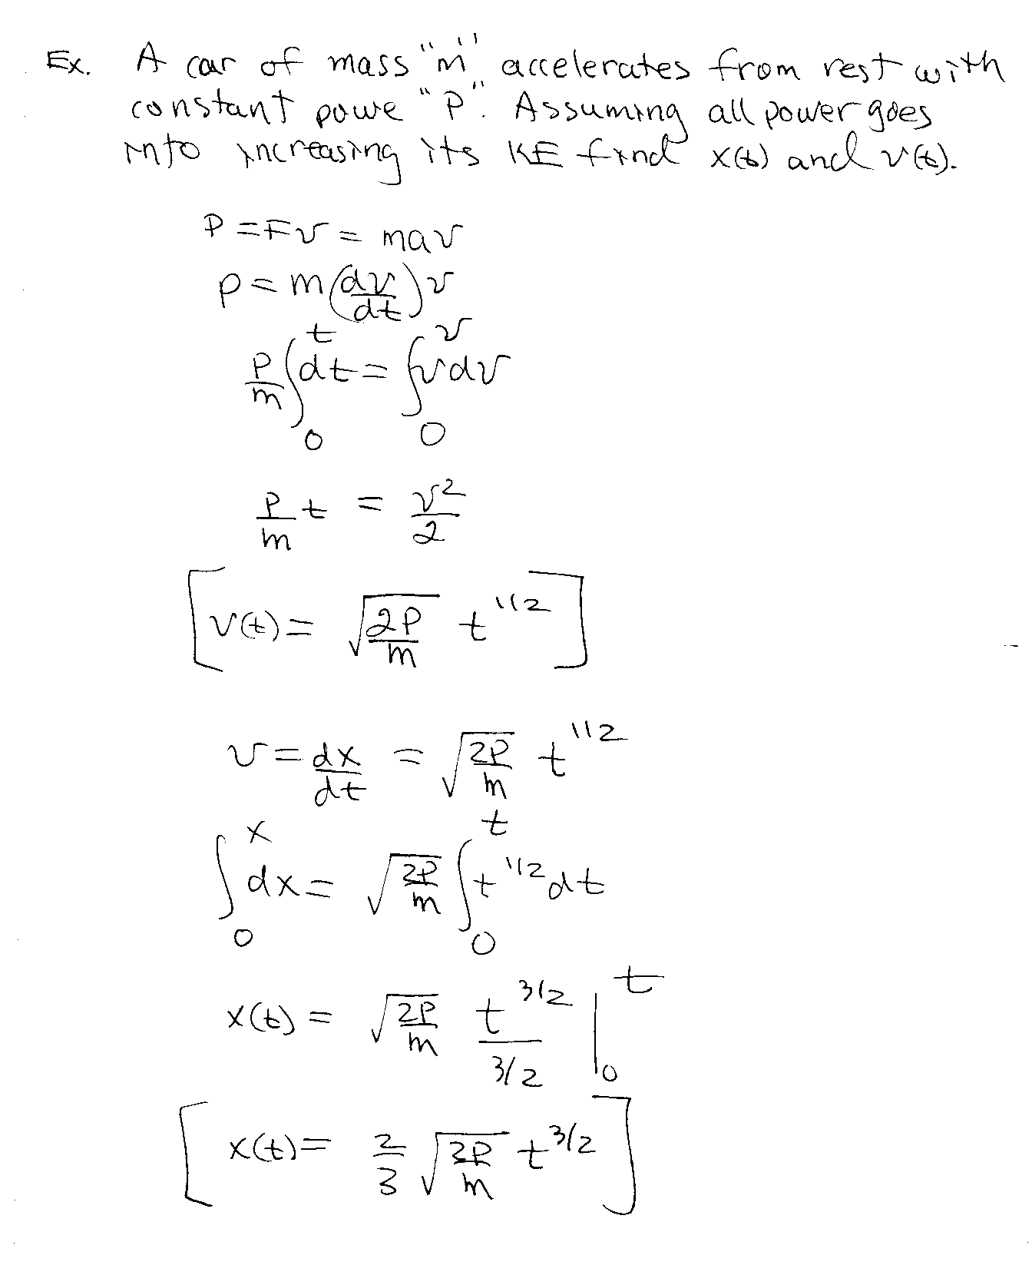

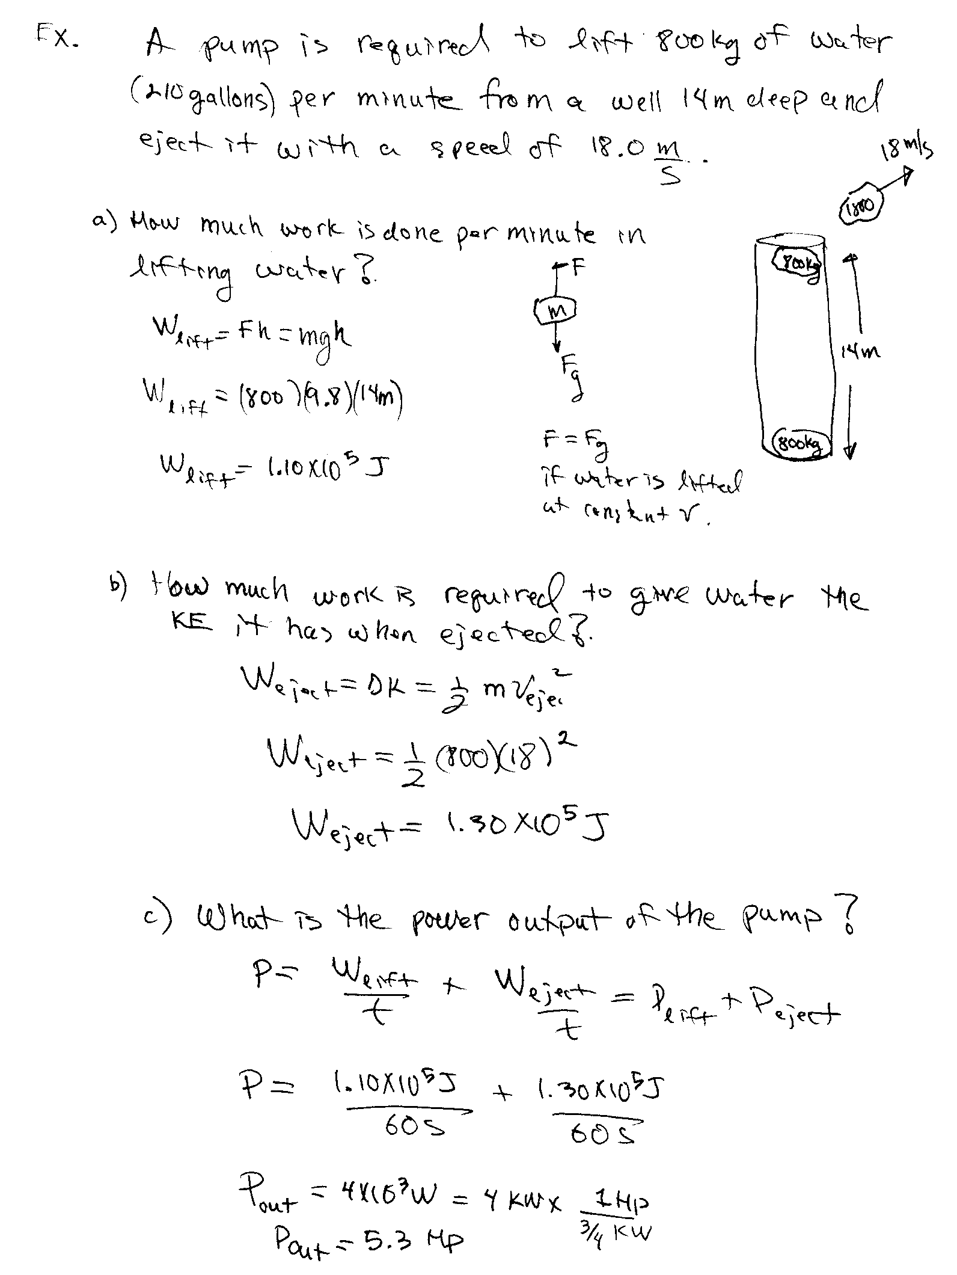
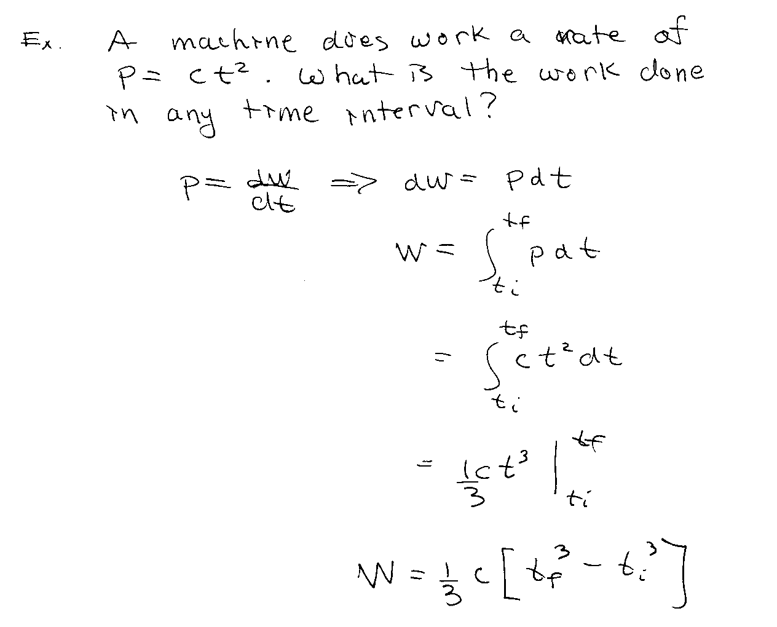
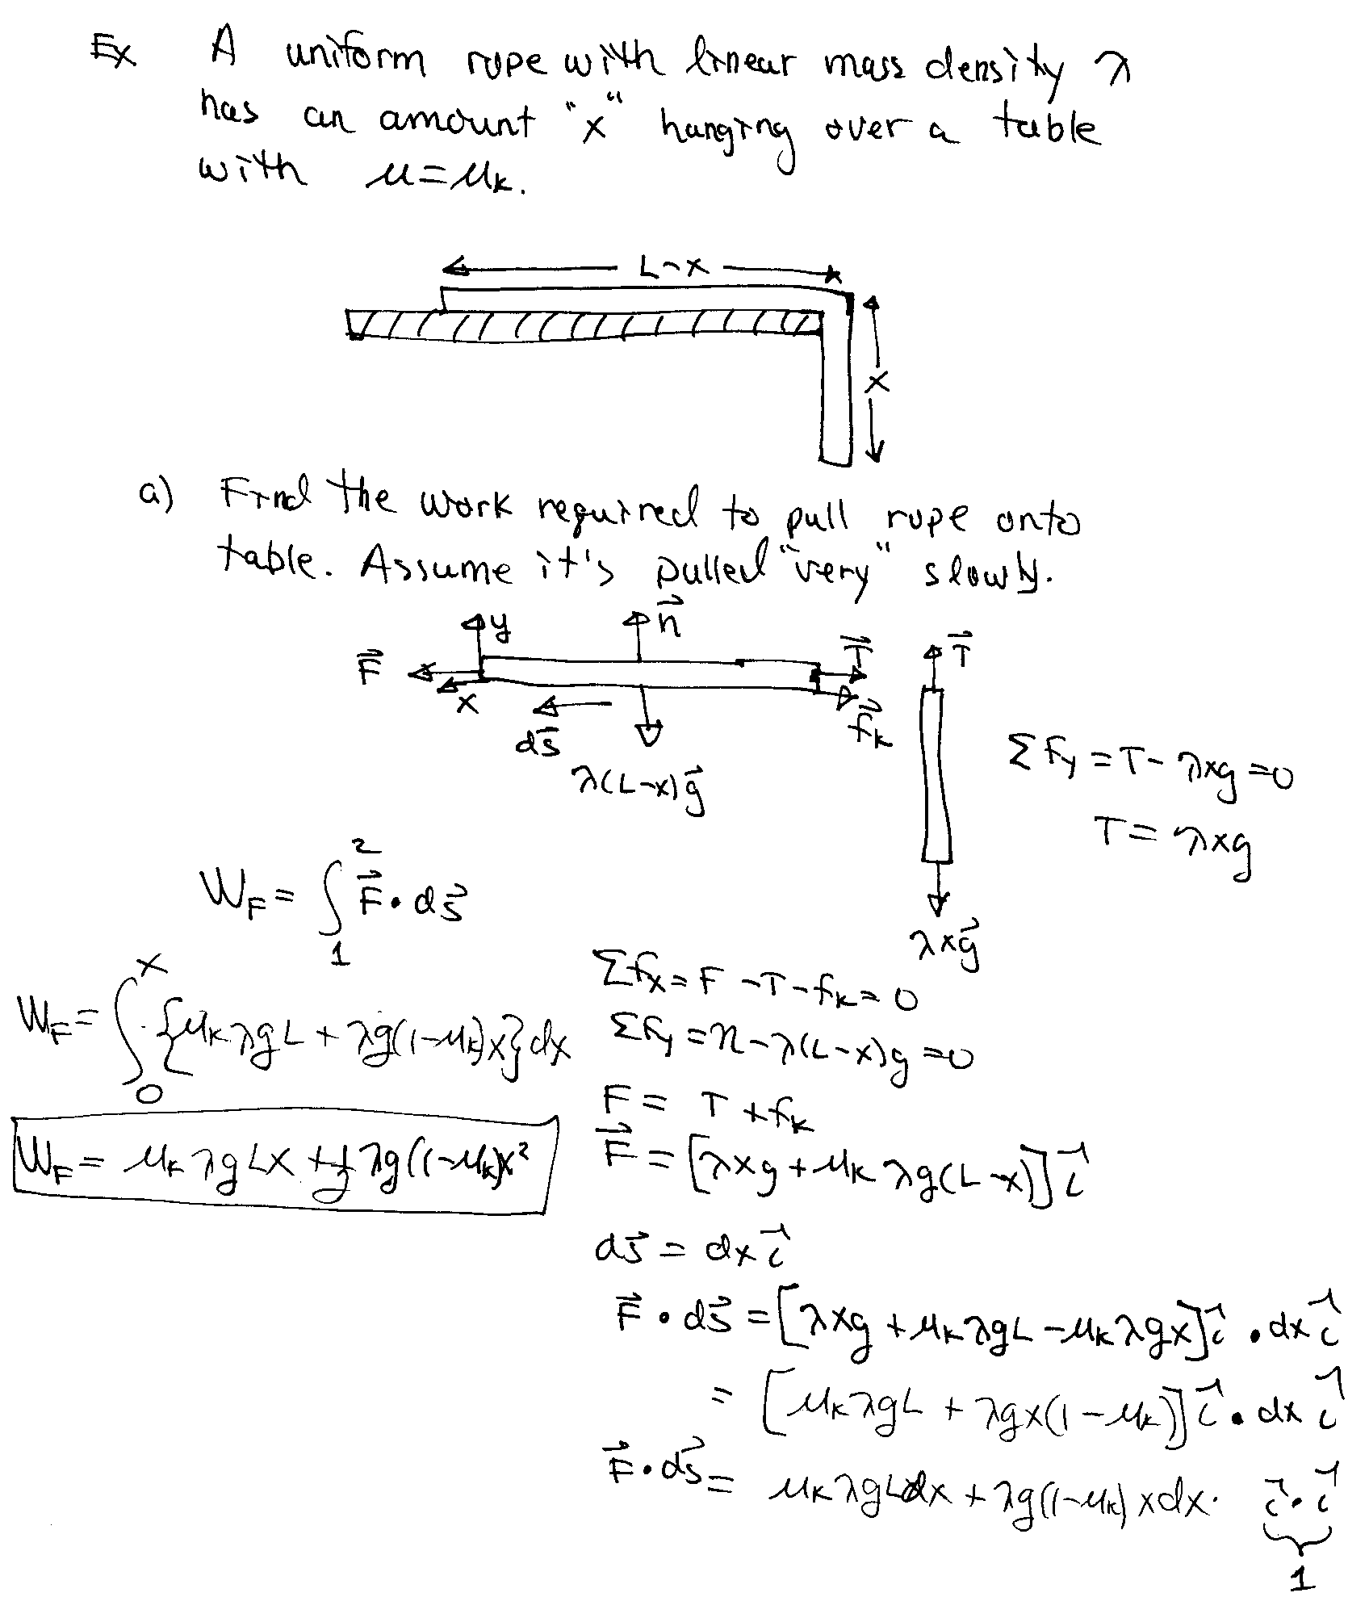
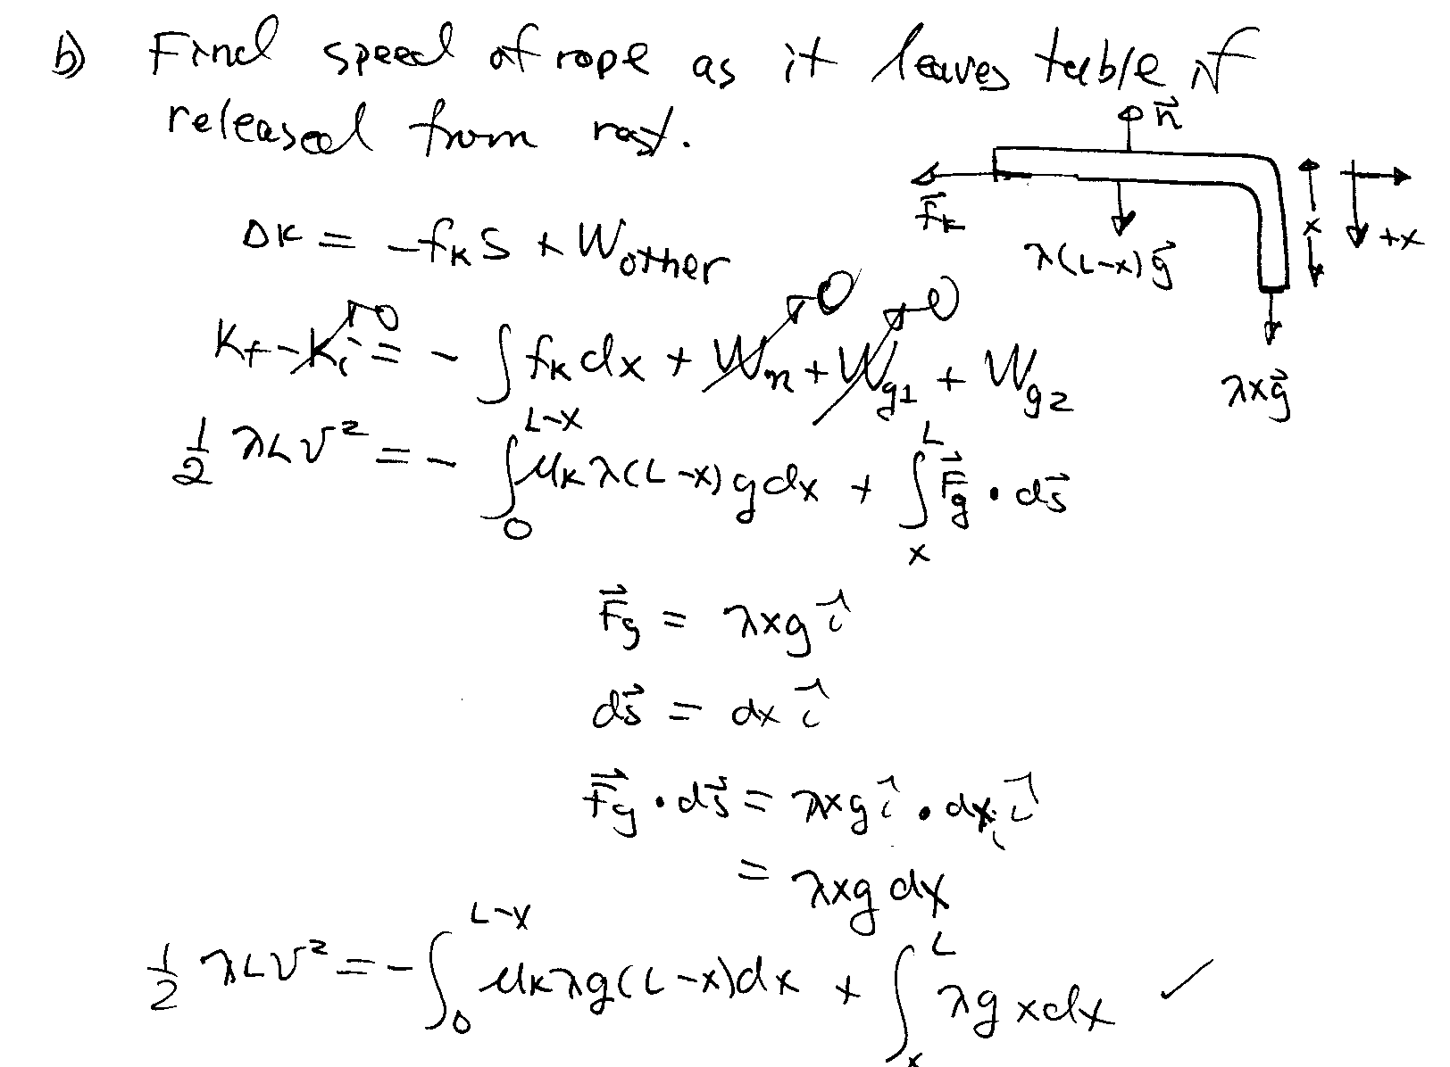
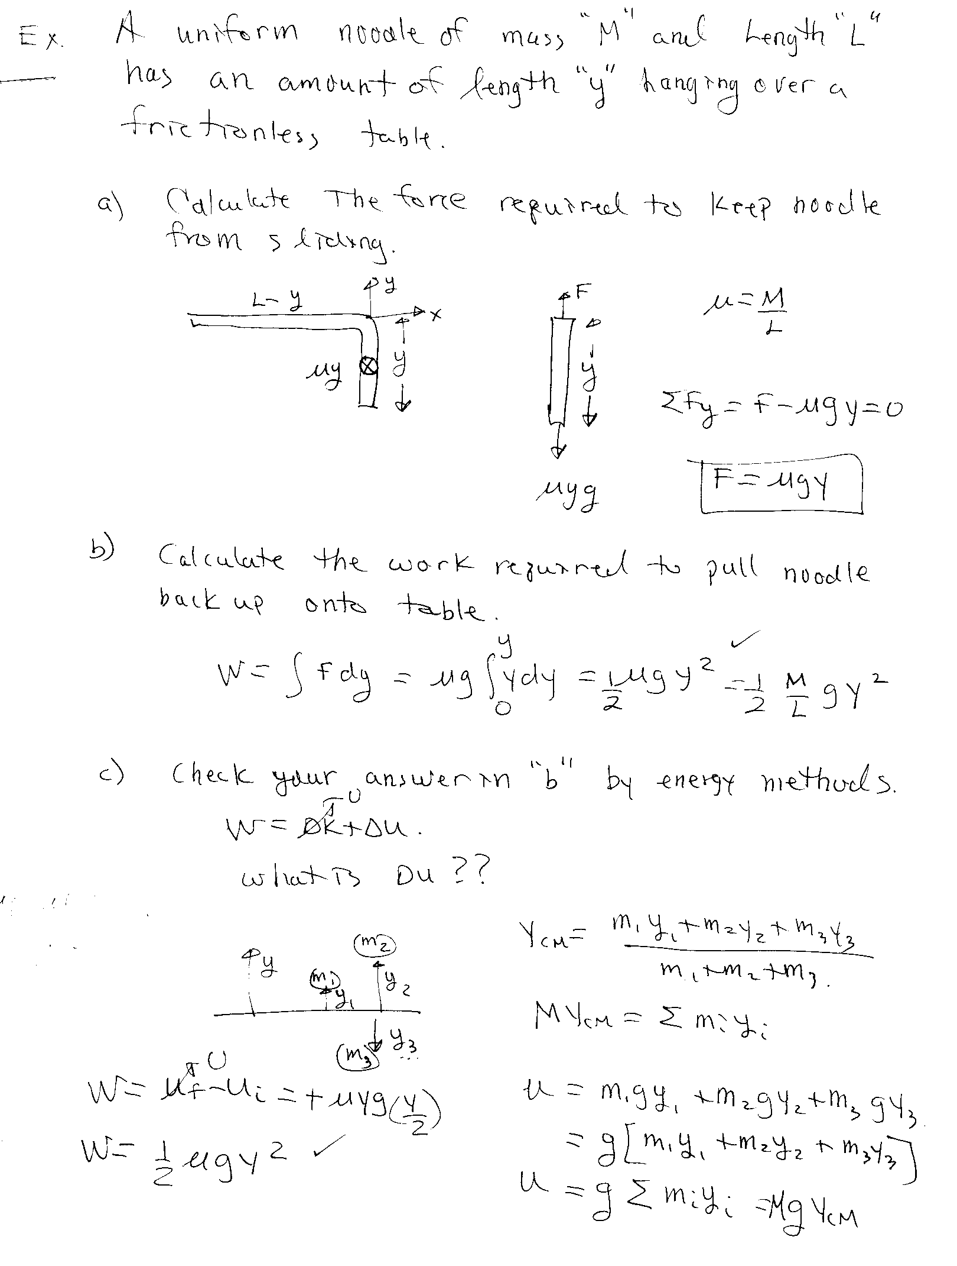
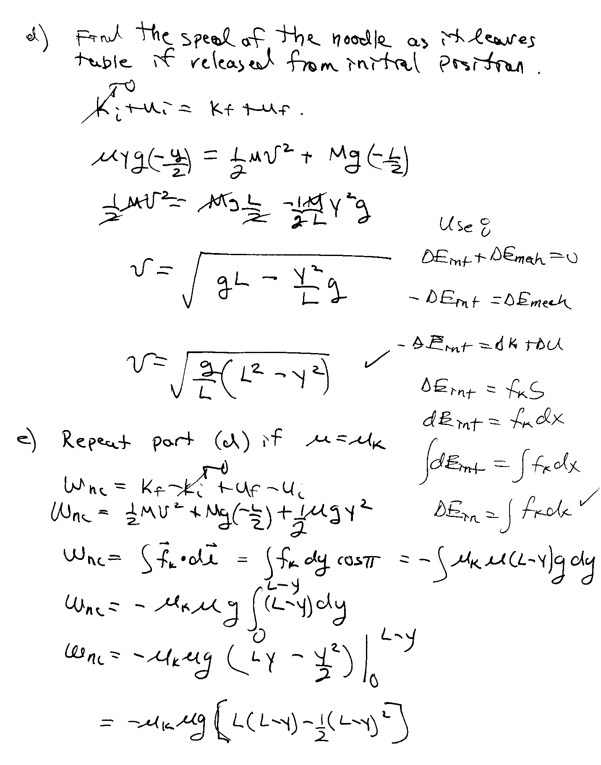
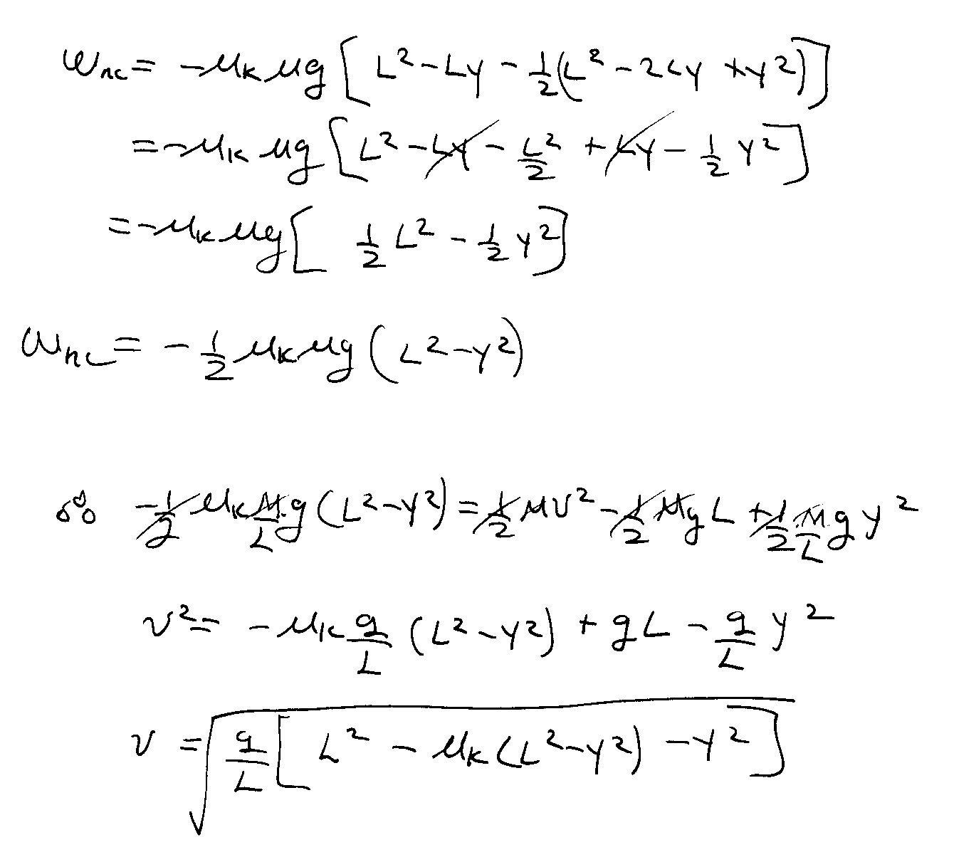
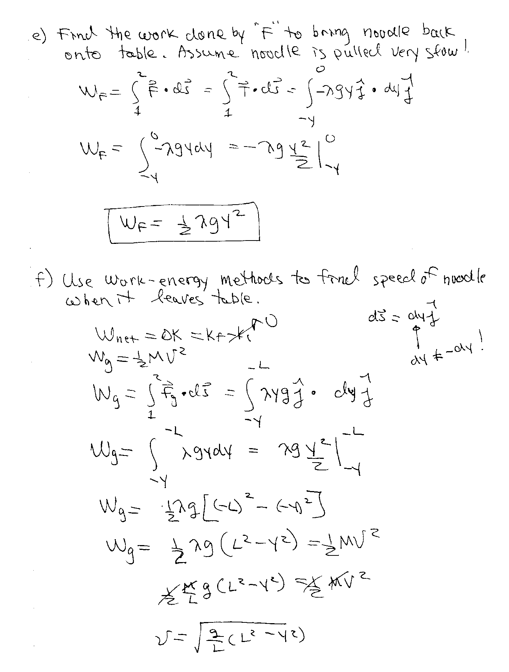

Work In 3-D
We will now consider the more general definition of work for which the force acting on the particle can change in magnitude and direction. Consider a particle moving between two points 1 and 2 along a given path. Suppose the particle is acted on by a force F at a given point.

The work done by F over a very small displacement ds is:

The total work done by F between two points is given by:

Work Done in 3-D

In Cartesian coordinates:

Work-Energy Theorem in 3-D

This is valid for any net force along any given path!

