TIME DILATION

The following problem shows the fact that different observers in different reference frames will measure different time intervals for a two events. Consider a trainbox moving with constant speed v as shown below. One observer is at point O’ inside the trainbox holding a laser and a second observer is at point O fixed on the ground. At some instant in time the laser emits a light pulse (event1) and travels toward a fixed mirror on top. The light pulse is reflected and then arrives at the laser (event 2). We would like to measure the time interval between these two events as measured relative to both observers.

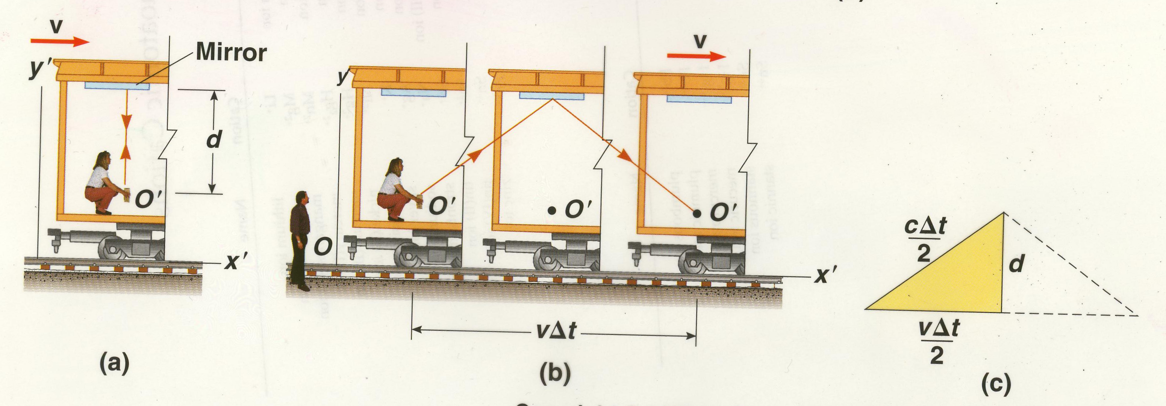

Time Measure in O’

Time measured in O
Relative to observer in O by the time the light pulse reaches the mirror and then back to the laser, the trainbox and mirror will have moved a distance vΔt. The path observed by the observer in O is shown in figure (b). Thus, the light pulse will travel further relative to the observer in O and the time interval Δt measured in O will be longer. From the right triangle shown we have:

Time Dilation Equation

Where,

Note that since v < c, then .

- Δt’ = proper time (the time measured by an observer moving along with a clock and sees the events occurring at the same point in space.

- This result shows that the time interval Δt measured by an observer moving with respect to a clock is longer than the time interval Δt’ measured by an observer at rest with respect to the clock.

- Because the time between ticks of a moving clock Δt is observed to be longer that the time Δt’ between ticks of an identical clock at rest, we say that:

A moving clock runs slower than a clock at rest by a factor of γ.

4. In general all physical processes (including chemical and biological) slow
down when observed in a reference frame in which they are moving.

- As v → c , then Δt → ά and if v > c then Δt becomes imaginary, thus v must always be less than c.

