**Chem 30A Experiment 1: Measurements**

**Learning Outcomes**

Upon completion of this lab, the student will be able to:

1. Use various common laboratory measurement tools such as graduated cylinders, volumetric flask, burettes, electronic balance, and thermometer.
2. Differentiate between precision and accuracy.
3. Construct graphical representations of data.

**Introduction**

All laboratory work involves some form of measurement- volume, mass, temperature, pressure etc. Every measurement has some degree of uncertainty due to inherent limitations of the instruments used for the measurements. It is therefore important to understand the significance of each digit in the measured value. Multiple measurements are often necessary in order to improve the chances of obtaining accurate measurements.

*Accuracy* refers to the closeness of the measured value to the true or accepted value of the measurement. The term *precision* is used to refer to the closeness of multiple measurements to each other. The best set of data will ideally be both accurate as well as precise. If the true value of a particular measurement is known, then an estimate of the accuracy of the data can be obtained by calculating the percent error in the data.

Percent Error = 

Percent error may be positive or negative. A positive value of percent error implies that the experimental value is larger than the true value. Likewise, a negative value of percent error implies that the experimental value is smaller than the true value. Alternately, it is also acceptable to simply indicate the absolute value of percent error, in which case the value is an indication of the deviation from the true value. In all cases a smaller percent error signifies a more accurate data set.

A common example of precision and accuracy is given below:

Examples of Accuracy and Precision

○ 

○





○ 

○ 

Not Precise and Not Accurate Precise but Not Accurate

                                                               

                                          

Accurate but Note Precise Precise and Accurate

Errors in measurement are broadly ascribed to two categories: systematic and random errors. *Systematic error* is the result of improper handling of the instrument or a defective instrument. *Random error* is a result of varied factors that are difficult to isolate (changes in environmental conditions in the laboratory, voltage fluctuations, parallax etc). While it is possible to minimize or even eliminate systematic error through instrument calibration and thorough review of the instrument’s operations manual, it is impossible to eliminate random error.

*Uncertainty* is the term associated with the margin of error in any measurement. Each instrument (e.g., ruler, beaker, thermometer, balance, etc.) used in the laboratory has a precision that determines the uncertainty of measurements, due to random error, taken with that instrument. The precision of a measuring device is usually expressed in terms of a ± value indicating the limitation of the device. The common instruments used in General Chemistry can be divided into two types: those that have a graduated scale and can make measurements over a range of values (e.g., ruler, thermometer, balance, graduated cylinder, graduated pipette, beaker) and those that measure a single, fixed volume of a liquid (e.g., volumetric flask, volumetric pipette).

The distance between graduation marks on a ruler, thermometer, burette or other glassware may be subdivided into ones, tenths, hundreds or other divisions depending on the precision of the device. A 50-mL graduated cylinder, for example, has graduation marks at each 1 mL. Since the experimenter can estimate between the graduation marks, the volume can be measured and recorded to the one-tenth of a mL (0.1 mL, Figure 1a). A burette, on the other hand, has graduation marks at each one-tenth mL (0.1 mL, Figure 1b) or the hundredth place (0.01 mL, Figure 1c). Therefore, an extra digit to the right is gained when the burette is used, making the burette more precise. In each instance, the last digit (underlined and in italics) is an estimate.

4.0

5.0

40

50

4.0

4.1

Figure 1a Figure 1b Figure 1c

Reading: 44.*5* units 4.4*5* units 4.04*5* units

As can be seen from figures 1a, 1b, and 1c, uncertainty in the data is related to the number of significant digits in the data. The number of significant digits depends on the instrument used for measurement. The instrument providing the most number of significant digits (figure 1c) is also the instrument with the smallest uncertainty. Two other devices are commonly used in the laboratory: digital thermometer and electronic balance. In both of these cases, all the digits displayed are to be recorded and the uncertainty is assumed to be in the last digit of the display.

**Digital Thermometer**

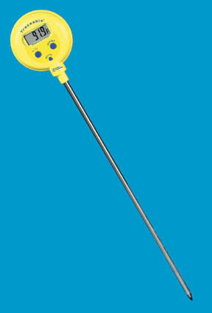

Reading: 91.*9*°F

**Electronic Balance**

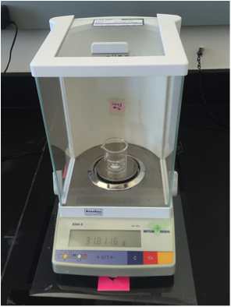

Reading: 31.811*6* g

**Statistical Tools**

The most common statistical tools needed for data analysis are mean (or average) and standard deviation.

View the short video in the link to learn how to calculate the mean or average for your data:

<http://www.virtualnerd.com/middle-math/probability-statistics/mean-median-mode-range/mean-data-set>

In statistics a measure of the deviation of each value in a data set from the mean value of that data set is given by the standard deviation. The standard deviation (S.D.) is calculated using the following formula:



In the above formula:  is the standard deviation, *xi* is a data point,  is the mean (or average), and n is the number of data points.

See this short video to learn how to calculate standard deviation: <https://www.youtube.com/watch?v=arzaMpDxYSQ>

[If you want to use Excel, follow these directions: *These statistical values can also be computed by entering the data in a spreadsheet and using an appropriate formula. For instance, when using Microsoft Excel, the formula to calculate the mean is: “=AVERAGE(select data)” and the formula to calculate the standard deviation is: “=STDEV(select data)”. ]*

**Graphical Representation of Data**

Often times one might encounter a data set where the measured quantities may be directly proportional to each other. For instance, in this experiment, the two measured quantities- mass and volume are directly proportional to each other and the ratio of mass to volume is defined as the density of that substance. If data “x” is proportional to data “y”, then we can say that:

y α x

or y = mx or y = mx + b

In such instances, the value of the slope, m, provides useful information. In the example of the mass-volume relationship, the slope would be the density of the substance when mass is plotted on the y-axis and volume is plotted on the x-axis. A simple method to obtain the slope is to plot of a graph of volume vs. mass. View this video to learn how to determine the linear regression for your data using Excel: <https://www.youtube.com/watch?v=ExfknNCvBYg&feature=youtu.be>

**Calculation of Percent Error**

For the calculation of Percent Error, view this video. The actual value can be the average value for your trials. Here is a link to the video for calculating error and percent error: <https://www.youtube.com/watch?v=h--PfS3E9Ao> **Experimental Design**

In order to understand the differences between the various common laboratory tools, in this experiment, you will measure the density of water. Density is defined as the mass of a substance per unit volume. Density is calculated using the formula:



Density of liquids is commonly expressed in units of grams/ml. The true value or the accepted value for the density of water at room temperature is 1.00 gram/ml.

Here is a link to a short video about calculating densities: <https://www.youtube.com/watch?v=7tVebi3TSsg>

**Reagents and Supplies**

From the Stock Room: 10-ml and 100-ml graduated cylinders, burette, 25-ml volumetric flask, two 50-mL beakers

From the Lab: deionized water

**Procedure**

Part 1: Measure the density of water using a 10-ml graduated cylinder

1. Measure the mass of an empty 10-ml graduated cylinder.
2. Add some tap water into the graduated cylinder to anywhere below the 10-ml mark.
3. Record the volume of the water.
4. Measure of the mass of the graduated cylinder with water.
5. Empty the water in the sink.
6. Repeat the steps two more times.
7. Calculate the density of water for each trial, the average density, the standard deviation, and the percent error.

Part 2: Measure the density of water using a 100-ml graduated cylinder

1. Measure the mass of an empty 100-ml graduated cylinder.
2. Add some tap water into the graduated cylinder to anywhere below the 100-ml mark.
3. Record the volume of the water.
4. Measure of the mass of the graduated cylinder with water.
5. Empty the water in the sink.
6. Repeat the steps two more times.
7. Calculate the density of water for each trial, the average density, the standard deviation, and the percent error.

Part 3: Measure the density of water using a volumetric flask

1. Measure the mass of an empty 25-ml volumetric flask.
2. Fill the volumetric flask with water till the mark.
3. Record the volume of the water.
4. Measure of the mass of the volumetric flask with water.
5. Empty the water in the sink.
6. Repeat the steps two more times.
7. Calculate the density of water for each trial, the average density, the standard deviation, and the percent error.

Part 4: Measure the density of water using a burette

1. Measure the mass of an empty beaker (Any small beaker is acceptable. You will measure the mass of the empty beaker only once).
2. Obtain a burette stand, a burette clamp, and a burette, and clamp the burette to the stand (you may use a micro-burette or a 25-ml burette as per the discretion of your instructor).
3. Fill the burette with water to some level less than the maximum possible.
4. Record the “Initial Burette Reading”.
5. Dispense a small volume of water into the beaker (from step 1); approximately 0.2 ml if you are using a microburette or 2 ml if you are using a larger burette.
6. Record the “Final Burette Reading”.
7. Measure the mass of the beaker containing the water.
8. Do not empty the beaker. You will be keeping an increasing mass and volume for your graph. Dispense an additional amount of water into the beaker (approximately the same volume as before).
9. Record the new “Final Burette Reading”.
10. Measure the mass of the beaker containing the additional water.
11. Repeat steps 8-10 four more times.
12. Plot of graph of this data and obtain the density of water from the slope of the best-fit linear regression line. Calculate the percent error in the density of water.

Instructions for Plotting a Graph and Obtaining the Regression Equation

Consult this short video for determining the linear regression equation: <https://www.youtube.com/watch?v=ExfknNCvBYg&feature=youtu.be>

Or you can follow these instructions

1. *Enter the data in two columns, the x-data first and then the y-data.*
2. *Select the data set (x and y).*
3. *Click the “Gallery” tab or “Insert Chart”.*
4. *Select the XY-scatter plot.*
5. *Choose the plot type where the data points are not already connected.*
6. *The graph will now be displayed.*
7. *Click on any of the data points on the graph.*
8. *Click on the “Chart Layout” tab and select “Add trendline” under analysis.*
9. *Click on the trendline options.*
10. *Check the boxes: “Display equation” and “Display r-squared value” (may be under options).*
11. *If the intercept is supposed to be zero, be sure to also check the box that says: “set intercept = 0”.*
12. *Click OK. The equation of the line, and the correlation coefficient will be displayed on the graph.*

**Data Table**

Part 1: Measure the density of water using a 10-ml graduated cylinder

|  |  |  |  |
| --- | --- | --- | --- |
|  | Trial 1 | Trial 2 | Trial 3 |
| Mass of empty graduated cylinder (grams) |  |  |  |
| Volume of water (ml) |  |  |  |
| Mass of graduated cylinder + water (grams) |  |  |  |
| Mass of water (grams) |  |  |  |
| Density of water (grams/ml) |  |  |  |

Average density of water = _________________________________

Standard Deviation of density of water = _________________________________

Percent error in density of water = _________________________________

Part 2: Measure the density of water using a 100-ml graduated cylinder

|  |  |  |  |
| --- | --- | --- | --- |
|  | Trial 1 | Trial 2 | Trial 3 |
| Mass of empty graduated cylinder (grams) |  |  |  |
| Volume of water (ml) |  |  |  |
| Mass of graduated cylinder + water (grams) |  |  |  |
| Mass of water (grams) |  |  |  |
| Density of water (grams/ml) |  |  |  |

Average density of water = _________________________________

Standard Deviation of density of water = _________________________________

Percent error in density of water = _________________________________

Part 3: Measure the density of water using a volumetric flask

|  |  |  |  |
| --- | --- | --- | --- |
|  | Trial 1 | Trial 2 | Trial 3 |
| Mass of volumetric flask (grams) |  |  |  |
| Volume of water (ml) |  |  |  |
| Mass of volumetric flask + water (grams) |  |  |  |
| Mass of water (grams) |  |  |  |
| Density of water (grams/ml) |  |  |  |

Average density of water = _________________________________

Standard Deviation of density of water = _________________________________

Percent error in density of water = _________________________________

Part 4: Measure the density of water using a burette

MASS

|  |  |  |  |
| --- | --- | --- | --- |
| Mass of Empty Beaker (grams) |  |  |  |
| 1. Mass of beaker + water (grams) |  | 1. Mass of water (grams) |  |
| 2. Mass of beaker + water (grams) |  | 2. Mass of water (grams) |  |
| 3. Mass of beaker + water (grams) |  | 3. Mass of water (grams) |  |
| 4. Mass of beaker + water (grams) |  | 4. Mass of water (grams) |  |
| 5. Mass of beaker + water (grams) |  | 5. Mass of water (grams) |  |

VOLUME

|  |  |  |  |
| --- | --- | --- | --- |
| Initial Burette Reading (ml) |  |  |  |
| 1. Final Burette Reading (ml) |  | 1. Volume of water (ml) |  |
| 2. Final Burette Reading (ml) |  | 2. Volume of water (ml) |  |
| 3. Final Burette Reading (ml) |  | 3. Volume of water (ml) |  |
| 4. Final Burette Reading (ml) |  | 4. Volume of water (ml) |  |
| 5. Final Burette Reading (ml) |  | 5. Volume of water (ml) |  |

Graph of Volume (x-axis) vs. Mass (y-axis), see example below

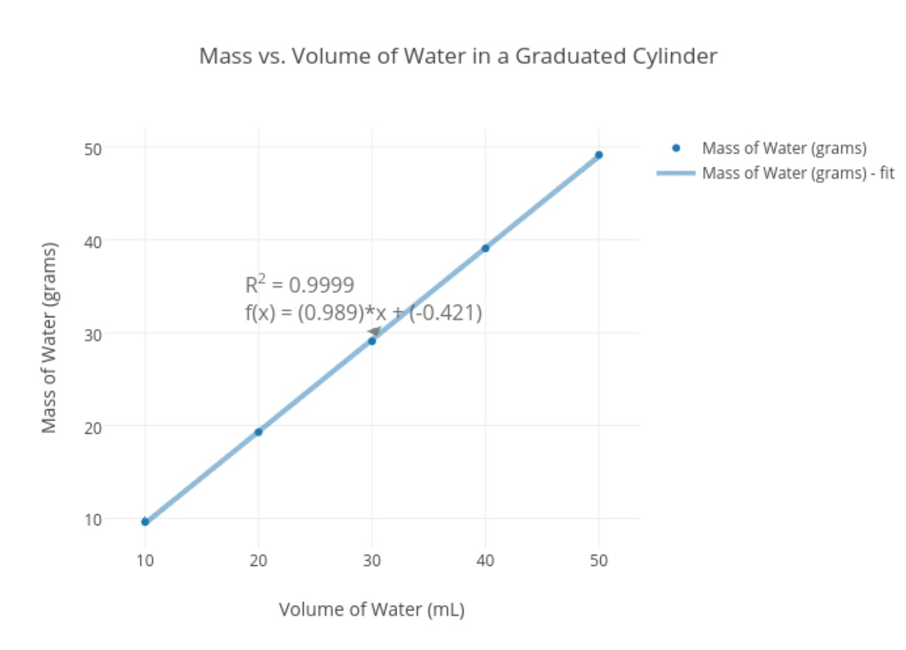

|  |  |
| --- | --- |
| Volume (ml) | Mass (grams) |
| **0** | **0** |
|  |  |
|  |  |
|  |  |
|  |  |
|  |  |

Equation of regression line: _________________________________________

Density of water (slope of the line = _________________________________________

Percent Error in Density (use average density as the true value) = _________________________________________