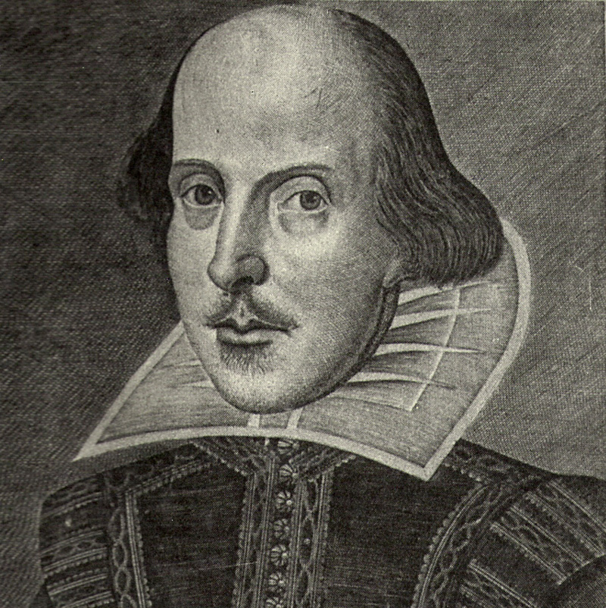 ELIT 17 Introduction to Shakespeare
Will Power! The plot thickens around religion, sex, royalty, and mystery in the great works of Shakespeare

Instructor: Julie Pesano
Phone/ E-mail: (408) 864-8653 E-mail: pesanojulie@fhda.edu
Web Page: http://faculty.deanza.edu/pesanojulie/
Class Time/ Location: Tues/Thurs 1:30-3:15 Admin 103
Office Location: F61L (Near the Turtle Sculpture)
Office Hours: Monday/Wednesday – 12:30-1:30 (please let me know if you plan to stop by)
Or By Appointment

Required Texts: William Shakespeare, Hamlet
William Shakespeare, Romeo and Juliet
William Shakespeare, Much Ado About Nothing
William Shakespeare, A Midsummer Night’s Dream
William Shakespeare, Taming of the Shrew
(I prefer the Folgers Edition of the Previous texts, but you may use any edition you like)
Other Supplemental Texts: These are texts I’ll bring to class often. You may borrow for short-term loan.
The Friendly Shakespeare by Norrie Epstein (approachable and fun)
Shakespeare After All by Marjorie Garber (insightful lectures from Harvard and Yale)
Shakespeare’s World by D.L Johanyak (helpful resource about Elizabethan culture)
The Bedford Companion to Shakespeare by Russ McDonald (another solid source for presentation information
Shakespeare’s Words: A Glossary and Language Companion by David Crystal and Ben Crystal (Very thorough dictionary of Shakespeare’s language)

Objectives: ELIT 17 is a four unit course in which students will analyze a survey of Shakespearean sonnets, tragedies and comedies. Specifically students will:
- Interpret Shakespeare’s writings in relationship to their social and intellectual context.
- Analyze Shakespeare’s writings in their literary context, using the techniques of the discipline of literary study.
- Apply generic expectations of dramatic performance, comedy, tragedy, history, and sonnet to Shakespeare’s writings.
- Examine the social and cultural stereotypes in Shakespeare’s writings.
- Recognize the contemporary relevance and historical specificity of Shakespeare’s writings through examination of modern dramatic interpretations, rewritings, and adaptations.
- Compare the dilemmas faced by Shakespeare’s characters to those presented by the modern world.
- Develop and compare alternative interpretations of and approaches to the texts.

Grading:
Scale: 97-100%=A+, 93-96%=A, 90-92%=A-, 87-89%=B+, 83-86%=B, 80-82%=B-, 77-79%=C+, 70-76%=C, 67-69%=D+, 63-66%=D, 60-62%=D-, 59% and below=F

A final grade for the course will be assigned on the basis of performance in the following areas:
Formal Essay 20%
Scene Performance: 10%
Historical Presentation: 10%
Quizzes: 10% (unannounced, no make-ups)
Attendance and Class Participation: 10% (see below for details)
Midterm 20%, Final Exam: 20%
Extra Credit Options: 1 extra credit maximum (added into quiz section of grade)
- Local Shakespeare Performance (turn in proof of attendance and 1 page critique) – 10 points
- Modern movie adaptation of one of our class plays (turn in 1 page critique) – 5 points
- Read one of the Modern Perspective Critiques at end of Folgers Edition (turn in 1 page critique) – 5 points

Late Work: Essays are due at the beginning of the class period on the due date. Late essays will be penalized; the later the paper, the greater the penalty (5 points for half a week late, 10 points a week late, and 10 more for every additional week – in other words, turn you papers in on time!). Absence and technology problems are no excuse. A late paper submission may be returned to you late.

Attendance: Students must attend the first week of class to secure their enrollment. Regular class attendance is necessary for successful completion of this course. Each student will be allowed 2 absences with no penalty. For each absence thereafter, the attendance grade will be reduced by one letter grade. An excess of 4 absences may result in a withdrawal from the course. 3 lates will result in 1 absence. Students who are absent are responsible for all announcements made, assignments given, and material covered.
Participation: : Collaborative learning requires your participation in group and class discussion; your class “presence” will be public and is graded regularly. Plan on being prepared and involved in class. Remember that your 10% Attendance and Participation grade is not only attendance – half of that is actually contributing to class discussion. (Texting, sleeping, not bringing the play to class all negatively affect your ability to participate.)

Plagiarism: Plagiarism is the use of ideas, facts, opinions, illustrative material, data, direct or indirect wording of another scholar and/or writer – professional or student – without giving proper credit. If a student is found guilty of plagiarism, he/she will receive a zero for the assignment and an “F” for the course.

Need Money?
De Anza’s Financial Aid Office, on the bottom floor of the Hinson Center (near Campus Police) gives out many scholarships and often has textbook grants of up to $100!The website is http:www.deanza.fhda.edu/financialaid/scholist.htm or contact Cindy Castillo (408)864-8403 or castillocindy@fhda.edu.
Need Special Accommodations?
Bring me the appropriate forms ahead of time, and allow a few minutes to discuss, and your needs will be met.

Important Dates: (see http://www.deanza.edu/calendar/)
Last day to drop for a refund for out of state or foreign students April 9
Last day to drop for a refund for in state students April 16
Last day to drop a class with no record of grade April 23
Last day to request P/NP grade April 29
Last day to drop with a "W" May 27
Memorial Day Weekend May 28-30

Welcome to the class! Please let me know if you have any questions. I encourage you to throw your heart into the learning, and the grade will follow. I look forward to working with and learning from all of you. JP

ELIT 17 Tentative Schedule Spring 2011

Week 1 4/5-4/7 Introduction to the course
Background of Shakespeare, Renaissance, and Elizabethan Culture
Reading Assignment: Sonnets (Handout)
Sample Quiz on Reading

Week 2 4/12 Intro to Comedies Read Midsummer Night’s Dream Acts 1-2, {Presentation #1}

4/14 Read Midsummer Night’s Dream Acts 3-4

Week 3 4/19 Finish discussion of Midsummer Night’s Dream {Presentation #2}

4/21 Read Much Ado About Nothing Acts 1-2 (Happy Birthday 4/23 Will!)

Week 4 4/26 Read Much Ado About Nothing Acts 3-4 {Presentation #3}

4/28 Read Much Ado About Nothing Act 5

Week 5 5/3 Read Taming of the Shrew Acts 1-2 {Presentation #4}

5/5 Read Taming of the Shrew Acts 3-4

Week 6 5/10 Read Taming of the Shrew Act 5 {Presentation #5}

5/12 Midterm Exam (Comedies)

Week 7 5/17 Introduction to Tragedies {Presentation #6}
Read Romeo and Juliet Acts 1-2

5/19 Read Romeo and Juliet Act 3-4

Week 8 5/24 Read Romeo and Juliet Act 5{Presentation #7}

5/26 Read Hamlet Acts 1-2

Week 9 5/31 Bring Outline/Play Proposal for Essay/Screenplay – peer review{Presentation #8}

6/2 Read Hamlet Acts 3-4

Week 10 6/7 Essay Due Peer Review (Bring 2 Copies!) {Presentation #9}

6/9 Read Hamlet Act 5

Week 11 6/14 Scene Enactments

6/16 Scene Enactments

Week 12

Wednesday 6/22 Final Exam 1:45-3:45

