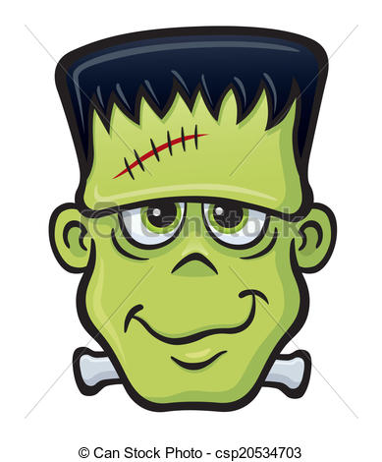Frankenstein Schedule and Questions

3/7 Video about Mary Shelley and critic’s views of Frankenstein

*** The pages here reflect the Penguin Edition of the text. If you have a different edition, double check the pages you need to complete.

3/9 Letters - Volume 1 Chapter 5 (pp. 13-61)

Discuss Questions 1-4

3/14 Volume 1 Chapter 6 – Volume 2 Chapter 2 (pp. 62-98)

Discuss Questions 5-8
Volume 2 Chapter 3 – Volume 3 Chapter 3 (pp. 99-168)

Discuss Questions 9-12

3/16 Volume 3 Chapter 4 – End (169-215)

Discuss Questions 13-16

- Each group is responsible for being the resident expert and leading class discussion for the questions assigned. Also, each student must turn in written answers to only the questions he/she is assigned but must have knowledge of the others to participate in class discussion. (The final exam will be based on our discussion and the themes from our text.)

Questions

- What are Walton’s motives for traveling to the North? What do Frankenstein and Walton have in common?

- What is Frankenstein’s childhood like? Many critics have likened it to Paradise (Garden of Eden). Where do you find evidence of this? How does this anticipate the rest of the story?
(Allison, Antonio, Evan)

- What does Frankenstein say are his earliest interests and goals? What are his motives for pursuing scientific studies and discoveries? How and why are these contrasted to Clervel’s?

- Examine the creation of the Creature (51-56); many critics have claimed that this scene shows a usurping of women’s power? How? Why does he reject the Creature? What does the dream about Elizabeth represent?
(Stephanie, Steven, Eric)

- How does Frankenstein know that the Creature killed William? What is symbolic in Justine being falsely accused?

- Explore Victor Frankenstein’s reaction to the natural setting (Mont Blanc, etc)? Why do you think nature makes him feel this way?
(Dana, Parker, Brenden)

- Characterize the tone and style of the Creature’s first words to Frankenstein, contrasting them with Frankenstein’s speech to the Creature. Which of the two sounds more moderate, learned, and reasonable? (Vol. 2, Chapt.2)

- How is the reader supposed to react to the Creature’s tale? What is the purpose of telling the tale of the De Lacey Family?
(Lorena, Travis, Vala)

- What is significant about the creature’s reading Paradise Lost?

- How does Frankenstein feel about himself and his situation? Does he feel as the victim or the criminal? Do you think of him as a victim or criminal?
(Mahad, Hector, Alex)

- Analyze the argument that “the love of another will destroy the cause of my crimes” (142). What is the Creature’s evidence and how does he support his conclusion? Do you see evidence to support this notion anywhere else in the text?

- Examine Frankenstein’s considerations and reasons for not choosing to create a mate for the creature (160-161), and compare them with his reasons for creating the monster in the first place. Has Frankenstein learned his lesson? If so, then how do you account for the disasters that follow? If not, explain what moral feelings he exhibits here.
(Yesenia, Bryan, Cynthia, Jasmine S.)

- What is significant about Frankenstein’s experience in Ireland?

- Explain the sources of interdependence between Frankenstein and the Creature during the chase in the final chapters. Why for example does the Creature leave clues and perhaps even food behind for his enemy? What is the significance of the landscape?
(Kierra, Katrina, Jasmine T. Veronica)

- How does Frankenstein convince Walton’s crew to move forward? Does this suggest if he is heeding his own words to Walton, “learn my miseries, and do not seek to increase your own”(203)?

16. Explore what happens to the creature when Victor dies. What meaning is behind the ending?
(Cristian, Kee, Rebecca)

