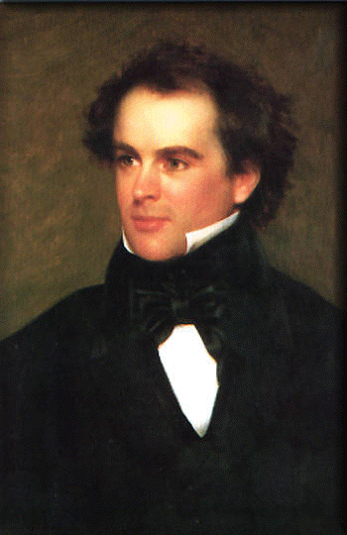Nathaniel Hawthorne Discussion Questions
Unlike many of the writers of his day, Hawthorne was not interested in social and worldly matters; instead, he burrowed “into the depths o four common nature,” as he said. What he found there often saddened and even shocked him. Hawthorne did for sin and guilt what Poe did for death and gore, Thoreau did for nature, and Melville did for the sea. He was the first great American writer of psychological fiction.

“Young Goodman Brown”

- Examine “Young Goodman Brown” as an allegory. What are its possible symbolic meanings in the names, the pink ribbons, the forest or the old man in the woods?

- How and why does the story use ambiguity?

- What are the characteristics of Romanticism? How can we apply them to this short story?

“ The Minister’s Black Veil”

- What is the symbol of the black veil?

- How and why is the story a parable (a short story designed to illustrate or teach some truth, religious principle, or moral lesson)?

- What is the purpose of all the supernatural elements?

