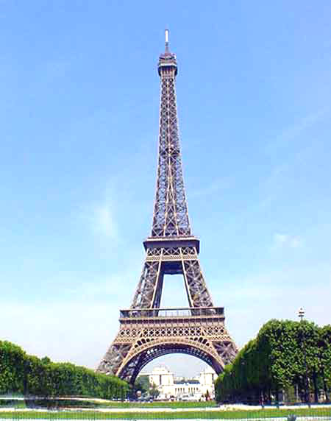
Introduction to Poetry
Wine, Women and Song: A Study in French Poets and Poetry

Instructor: Julie Pesano
Voice Mail at De Anza: (408) 864-8653
E-mail Address: pesanojulie@fhda.edu
Web Page: www.faculty.deanza.fhda.edu/pesanojulie/
Time: 11:30-1:00 Tuesdays and Thursdays

Course Description: When Charles Baudelaire states “Be drunk, always. Nothing else matters; this is our sole concern. To ease the pain of Time’s dread burden…” (Be Drunk), I prefer to believe he is drunk, not on wine but on poetry. This is the enthusiasm I hope to inspire in students of an introduction to French poetry course. Poets like Gerard Nerval, Stephane Mallarme, Charles Baudelaire, Jules Laforgue, and Paul Valery are some of the great French poets I would use to springboard into 19th and 20th century Romantic to Surrealist French poetry.

Required Texts: The Penguin Book of French Poetry 1820-1950 William Rees
An Introduction to Poetry by Jeff Knorr

Objectives: Introduction to Poetry is a 4 unit course in which students will read, discuss, and analyze structure and meaning of French poetry. Specifically students will:
1. Examine multiple poets styles and contributions to French poetry.
2. Analyze the structure and content of poets from different genres (Romanticism, Cubism, Surrealism, etc).
3. Apply the standard critical discourse for poetry (metaphor, imagery, symbolism, theme, etc.)
4. Write poetry in order to explore the medium in an applicable way.

Grading: You are required to complete all assignments. Assignments are due at the beginning of the class period on the due date. Late assignments will be penalized. A final grade for the course will be assigned on the basis of performance in the following areas:
Midterm Exam: 30%
Final Exam: 30%
Written Poems 10%
Presentations 10%
Quizzes: 10%
Attendance and Class Participation: 10%

Attendance: Regular class attendance is necessary for successful completion of this course – even in Paris! Students who are absent are responsible for all announcements made, assignments given, and material covered. Students will be allowed 2 absences. For every absence thereafter, the attendance grade will go down one letter grade. Students with 4 absences may be dropped. In addition, 3 tardies will constitute one absence.

Participation: Collaborative learning requires your participation in group and class discussion; your class “presence” will be public and is graded regularly. Plan on being prepared and involved in class. If you remain passive, you will do poorly.

Plagiarism: Plagiarism is the use of ideas, facts, opinions, illustrative material, data, direct or indirect wording of another scholar and/or writer, professional or student, without giving proper credit. If a student is found guilty of plagiarism, he/she will receive a zero for the assignment and an “F” for the course.

Bien Venue a la classe!. Please let me know if you have any questions. I look forward to working with and learning from all of you in this amazing journey we are going on. JP

Tentative Schedule (Dates and Assignments are Subject to Change)

Week 1 4/10-4/12 4/10 Introduction to Class
4/12 Read: “Romanticism in France” 1-4
Victor Hugo 40-42, “Ecstasy” 43, “Since Flowering” 44, “Memory of the Night …” 45-
Introduction to Poetry Chapter 1
Sample Quiz

Week 2 4/17-4/19 4/17 Read: Gerard de Nerval 75-76 “Dream Memory”77 “Guilded Verses” 78
Introduction to Poetry Chapter 2
Presentation #1
4/19 Read: Charles Baudelaire 133-135 “Connections” 136 “The Albatross” 137
Presentation #2

Week 3 4/24-4/26 4/23 – We arrive in Paris! Bien Venue!!! (Recover from Jet lag 4/24 – no class)
4/26 Read: “The Parnassian Movement 170-171
Stephane Mallarme 190-192 “The Windows” 193, “Sea Wind”
Introduction to Poetry Chapter 3
Presentation #3
4/28 Saturday Excursion to Chartres

Week 4 5/1-5/3 5/1 Paris Holiday – Accent Center Closed
Independent Project (Write Poem, Visit Victor Hugo House, Visit Art Museum)
5/3 Read: Paul Verlaine 224-226 “My Intimate Dream,” “Night Impression”
Introduction to Poetry Chapter 4
Presentation #4

Week 5 5/8-5/10 5/8 Paris Holiday – Accent Center Closed
Independent Project
5/10 Midterm Exam

Week 6 5/15-5/17 5/15 Read: “Cubism, Cosmopolitism, and Modernism” 511-512
Guillaume Appolinaire 537-539 “Zone” 540-550 “The Pont Mirabeau” 551-553
Introduction to Poetry Chapter 5
Presentation #5
5/17 Paris Holiday – Accent Center Closed
Independent Project
5/19 Saturday Excursion to Versaille

Week 7 5/22-5/24 5/22 Read: Leon-Paul Fargue 513 “On the Pavement” 514 “The Railway Station” 518
Introduction to Poetry Chapter 6
Presentation #6
5/24 Read: Catherine Pozzi “Ave” “Nyx” 621
Presentation #7

Week 8 5/29-5/31 5/29 : “Surrealism” 673-674
Andre Breton 675-677 “Sunflower” 678, “Watchfullness” 680
Introduction to Poetry Chapter 7
Presentation #8
5/31 Read: Louise Aragon 725-727 “Poem to Shout in the Ruins” “Elsa at Her Mirror”
Presentation #9
6/1-6/3 Friday-Sunday Excursion to Normany and Brittaney

Week 9 6/5- 6/7 6/5 Read “Negritude” 801
Leopold Sedar Senghor 802 “Black Woman” “Camp 1940”
Introduction to Poetry Chapter 8
Presentation #10
6/7 Read: Rene Char 829 “Artine” 831
Presentation #11

Week 10 6/12-6/14 6/12 Poetry Slam! Bring Your Best Poems in Paris!
6/14: Final Exam - Le Fin!

