**ELIT 46B, Major British Writers (Neoclassical to Romantic 1660-1830)**

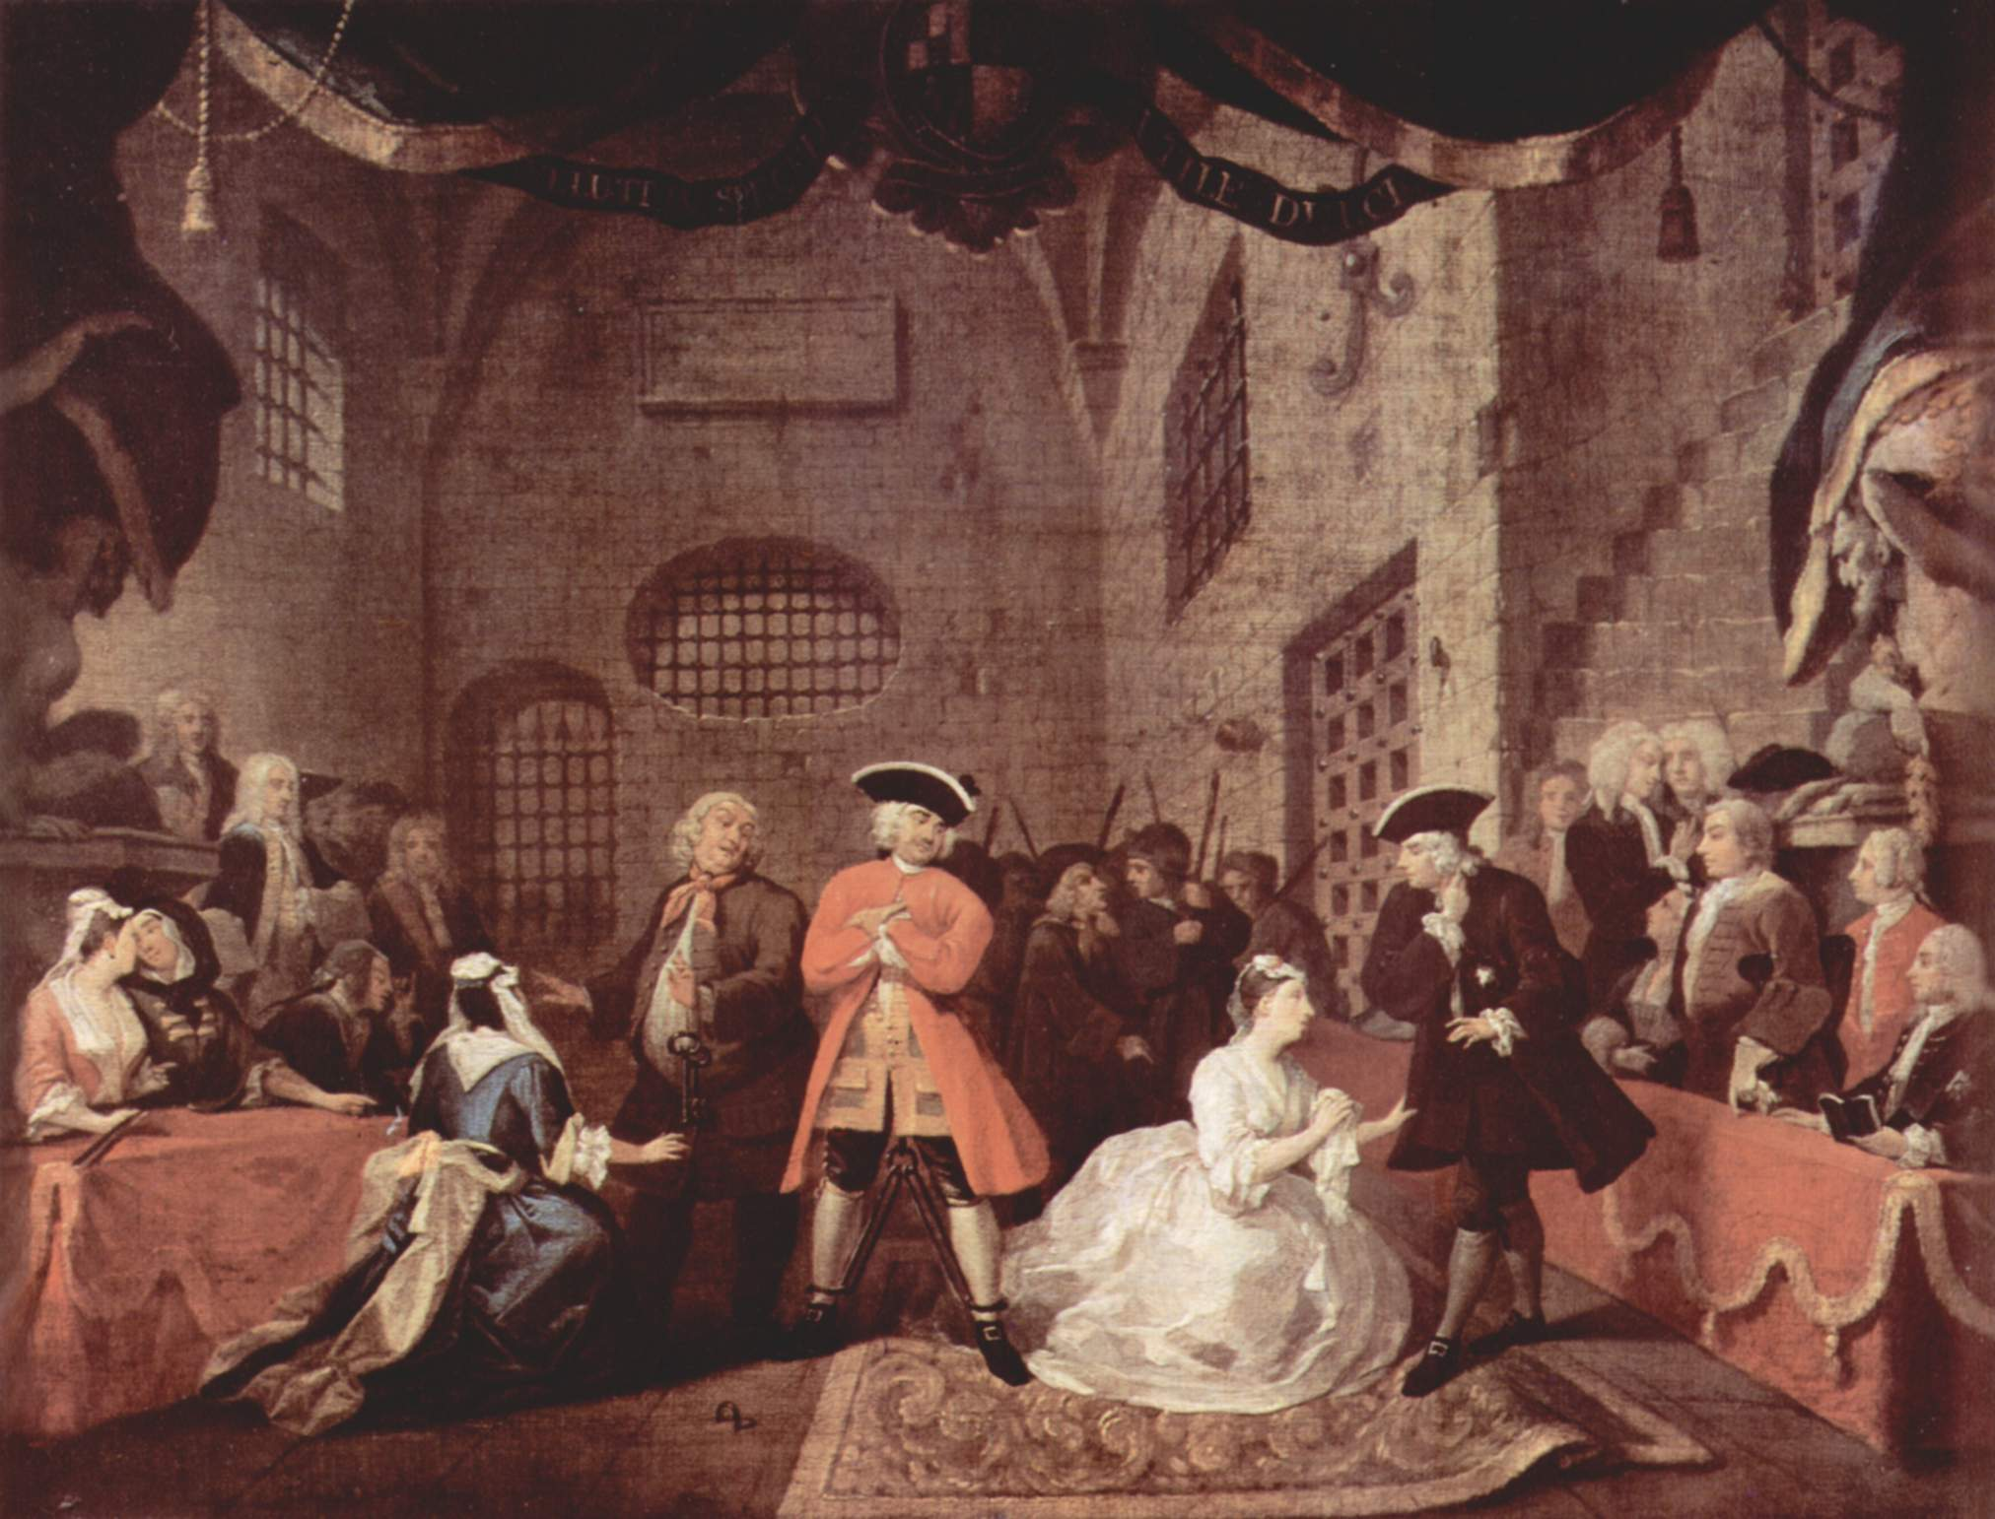 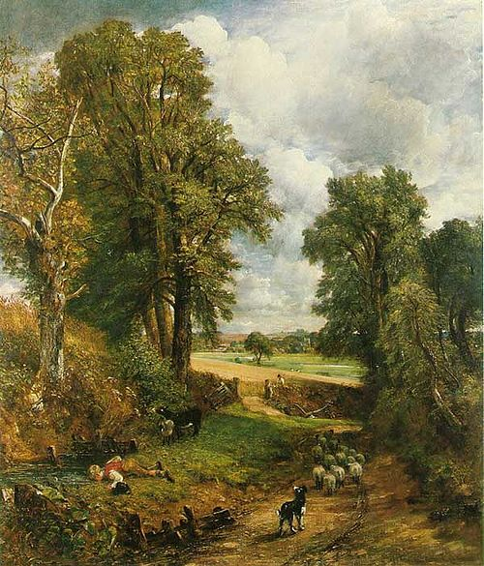

**Instructor:** Julie Pesano

**Phone/ E-mail:**  (408) 864-8653 E-mail: [pesanojulie@fhda.edu](mailto:pesanojulie@fhda.edu) or jpesano@gmail.com

**Website:** www.faculty.deanza.fhda.edu/pesanojulie

**Class Time/ Location:** Monday-Thursday 12:30-1:20 L36

**Office Location:** F61L

**Office Hours:** Tuesdays/Thursdays 1:30-2:30

Or By Appointment (Please let me know when you plan to stop by – thanks!)

**Course Advisory:** Eligibility for EWRT 1B *or* ESL 6.

**Required Texts:** 1. Greenblatt, et. al. *The Norton Anthology of English Literature: 8th Ed.*Volumes C and D

(Those who plan to enroll in Elit 46C may wish to purchase Vol. 2 in its entirety).

2. Mary Shelley *Frankenstein*: *Or the Modern Prometheus*

(Please get the 1831 edition not the 1818, and if you can, try to get the Penguin Classics ISBN 978-0140433623 at bookstore or online.

http://www.amazon.com/Frankenstein-Modern-Prometheus-Penguin-Classics/dp/0140433627

**Course Description**

This course covers British literature from 1660 to 1830. It is customary to call the period from 1660 to 1785 the *Neoclassical Era* and the period from 1785 to 1830 the *Romantic Era*. For convenience, we will further divide the two eras as follows. As you might expect, the years 1740 to 1798 are a period of transition. It is good to remember, moreover, that the following dates are arbitrary. Certain Romantic traits can be seen as early as the Renaissance era which precedes the Neoclassical, and Neoclassical traits may be found well into the Romantic era.

|  |  |
| --- | --- |
|  | *The Restoration Period, 1660 to 1700* |
|  | *The Augustan Age, 1700 to 1740* |
|  | *The Waning of the Neoclassicism and the Rise of Romanticism, 1740 to 1798* |
|  | *Romanticism, 1798 to 1830* |

**Grading:** You are required to complete all assignments. Assignments and readings are due at the beginning of the class period on the due date. Late assignments will be penalized; the later the paper, the greater the penalty. ***Absence or technology problems are no excuse***. A final grade for the course will be assigned on the basis of performance in the following areas:

Analytical Literary Responses: 20% (2 responses = 10% each)

Presentation: 20%

Quizzes: 10% (unannounced, **no make-ups**)

Attendance and Class Participation: 10%

Midterm 20%, Final Exam: 20%

Scale: 97-100%=A+, 93-96%=A, 90-92%=A-, 87-89%=B+, 83-86%=B, 80-82%=B-, 77-79%=C+, 70-76%=C, 67-69%=D+, 63-66%=D, 60-62%=D-, 59% and below=F

*** Extra credit: (Optional) – Get creative! Write a poem, essay, brief short story in the style of one of our authors. For example, write a satirical poem in the style of the Rochester slamming someone or something you want to mock (celebrity, your parents, the De Anza registration process!) Maximum 1-2 pages, typed, double space, on 8.5x11 white paper. This is worth 1% of your total grade (or the equivalent to 5 points in your quiz section). You may do a maximum of 1 and turn it in any time before the end of the quarter.

**Attendance: *Students must attend the first week of class to secure their enrollment****.* If you do not come on any day of the first week, I will drop you and give your seat to a waitlisted student.Regular class attendance is necessary for successful completion of this course. Each student will be allowed 2 absences with no penalty. For each absence thereafter, the attendance grade will be reduced by one letter grade. An excess of 4 absences will result in a withdrawal from the course. 3 lates will result in 1 absence. Students who are absent are responsible for all announcements made, assignments given, and material covered.

**Participation**:

ELIT 46B is a discussion-based course. Your class “presence” will be public and you will be asked to express your ideas about the texts regularly. Students are expected to do the assigned readings before each session and to come prepared to discuss the readings in both small groups and class discussions. If you attend every class but participate minimally, you will not receive a high grade for attendance and participation (10% of grade). You must be prepared, engaged, and involved in the classroom community in order to succeed.

**The Classroom:**Please, come to class on time! Turn all electronic devices (cell phones, Ipads, etc.) off or to vibrate before class starts and please avoid texting, video games, or any other distractions not related to course content. During the quarter, you will frequently encounter values and beliefs, which differ from your own. Show respect for the ideas of others and others will do the same for yours.

**Honesty**: (Plagiarism) I am interested in your ideas as well as how clearly you can discuss the ideas of others. If you use the ideas of anyone else (printed, friends, on-line), acknowledge your source immediately in parentheses (MLA style). If you use the words of a source, use quotation marks **and** acknowledge the source. Plagiarism automatically results in a zero for the assignment with no opportunity for makeup. If you are uncertain about the rules for using a source, come see me before you turn in the assignment.

**About Course Content**:

This is an adult level course; therefore, the subject matter of readings and discussions will contain adult material and will not be censored.

**The Reading Load:**

This class is a literature class, so the reading load is high! Do the best you can, and if you fall behind, it is your job to catch up, not the course’s job to slow down. Also, the texts we read can and will be challenging, so please make sure to take good notes and come up with questions as you read so that you can be prepared to participate in class.

**Need Money?**

De Anza’s Financial Aid Office, on the bottom floor of the Hinson Center (near Campus Police) gives out many scholarships!The website is http:www.deanza.fhda.edu/financialaid/scholist.htm or contact Cindy Castillo (408)864-8403 or castillocindy@fhda.edu. 

**Need Special Accommodations?**

If you have any special circumstances that you feel may influence your performance in this class (a diagnosed learning disability, physical disability, or anything at all that might interfere with your learning), please come chat with me so that we can create a learning environment that works for you.

**Important Dates:** (see <http://www.deanza.edu/calendar/>)

Last day to add Winter Quarter classes (Add date is enforced) Saturday, April 18

Last day to drop a class with no record of grade and full refund (Drop date is enforced) Monday, April 20

Last day to drop with a "W" (Withdraw date is enforced) Friday, May 29

Memorial Day Holiday (no class) Monday, May 25

ELIT 46B Tentative Schedule Spring 2015

* All readings below come from *The Norton Anthology* or *Frankenstein*
* Complete Readings **before** the week meeting and be reading for unannounced quizzes.

# Week 1 **The Restoration**

# 4/6-4/9 Introduction to the course

*Reading Assignment:* “The Restoration and the Eighteenth Century 1660-1785” 2057-2082

John Wilmot, Second Earl of Rochester 2167 “Satyr on Charles II” http://andromeda.rutgers.edu/~jlynch/Texts/charles2.html

Sample Quiz on Reading

Assign Presentations

Week 2  **Satire**

4/13-4/16 {Presentation #1 – 4/13}

*Reading Assignment:*  John Dryden 2083-2084 “MacFlecknoe” 2111-2117

“Wit as ‘Propriety’” 2131, “The Art of Satire” 2131-2132

Week 3 **Political Allegory**

4/20-4/23 {Presentation #2 4/20}

*Reading Assignment:* Jonathan Swift 2301-2303 “A Modest Proposal” 2462-2468, *Gulliver’s Travels*  Part 1 (2323-2365)

*Analytical Response #1 due 4/23*

Week 4 **Height of Neoclassicism**

4/27-4/30 {Presentation #3 – 4/27}

*Reading Assignment:* Alexander Pope 2493-2496, “The Rape of the Lock” 2514-2532

Week 5 **Rise of the Novel**

5/4-5/7 {Presentation #4 – 5/4}

*Reading Assignment:* Aphra Behn 2178-2180 *Oroonoko, or The Royal Slave* 2183-2226

Week 6

5/11-5/14 Review for Midterm **Midterm Exam** 5/13-5/14

Week 7 **Early Romanticism**

5/18-5/21 {Presentation #5- 5/18}

*Reading Assignment*: Switch to Volume D of the *Norton Anthology* “The Romantic Period 1785-1830” 1-22

William Blake 76-79 *Songs of Innocence and Experience* 81-97

Week 8  **Romantic Movement Continued (The Lake Poets)**

5/25-5/28 Memorial Day Holiday – No Class 5/25

{Presentation #6 – 5/25}

*Reading Assignment:* William Wordsworth 243-245, *Lyrical Ballads* 245-274 Samuel Taylor Coleridge 424-426 “The Rime of the Ancient Mariner” 430-446

Week 9 **Later Romanticism**

6/1-6/4 {Presentation #7 – 6/1}

*Reading Assignment:* George Gordon, Lord Byron 607-611, “She walks in beauty” 612, “When we two parted” 613, *Don Juan* Canto 1 669-697

Percy Bysshe Shelley 741-744 “Mont Blanc” 762-766

*Analytical Response #2 due 6/4*

Week 10  **The Gothic Novel**

6/8-6/11 {Presentation #8 – 6/8}

*Reading Assignment*: “The Gothic and the Development of Mass Readership” 577-579

*Frankenstein* by Mary Shelley

Letters - Volume 2 Chapter 2 (Chapt 10) (p. 13-98 in Penguin Edition)

Week 11

6/15-6/18  *Reading Assignment: Frankenstein* by Mary Shelley

Volume 2 Chapter 3 (chapt. 11) – end (pages 99-215 in Penguin Edition)

Week 12

6/22 Review for Final on Monday 3/24

**Final Exam** Tuesday 6/23 11:30-1:30