Transcendentalism - Background
By the nineteenth century, many Americans were more radical in their commitment to individualism. A growing concern over the people left out of the American dream fueled reform movements designed to extend individual rights to the historically disenfranchised and oppressed. Calls for the abolition of slavery, Native American rights, women's rights, prison reform, and help for the impoverished challenged American society to make good on its proclamation that all people are created equal. The industrialism that was transforming the American workplace became increasingly troubling to reformers, who felt that factories were stifling individual creativity and self-expression. As social critic Albert Brisbane put it in 1840, "Monotony, uniformity, intellectual inaction, and torpor reign . . . society is spiritually a desert." Ralph Waldo Emerson agreed, warning that "society everywhere is in conspiracy against the manhood of every one of its members ... the virtue in most request is conformity."

Emerson's remedy for this stifling conformity was a radical call for self-reliance. His essay on this subject, "Self-Reliance," is a manifesto of what has come to be called Romantic Individualism. More radical and more mystical than Enlightenment ideas about individualism, Romantic Individualism asserts that every individual is endowed with not only reason but also an intuition that allows him to receive and interpret spiritual truths. Individuals thus have a responsibility to throw off the shackles of traditions and inherited conventions in order to live creatively according to their unique perception of truth. Emerson's intoxicating ideas about the power of the individual captivated many of his contemporaries, giving rise to the Transcendentalist movement (the group believed that only by transcending the limits of rationalism and received tradition could the individual fully realize his or her potential). Writers and thinkers like Margaret Fuller, Bronson Alcott, Theodore Parker, and Henry David Thoreau heeded Emerson's call and built on his ideas. Fuller pushed Romantic Individualism in the direction of women's rights, while Thoreau embarked on a personal project to practice self-reliance by living alone in the woods at Walden Pond, free from the suffocating influences of modern commercial and industrial life.

Transcendentalism 101
1. There’s a direct connection or “correspondence” between the universe and the individual soul. As a result, Nature is where it’s at. Nature is the gospel of the new faith.
2. By contemplating objects in nature, people can transcend the world and discover union with the Over-Soul (also known as the Ideal or Supreme Mind) that unites us all.
3. Follow your own intuition and own beliefs, however divergent from the social norm they may be. Since all people are inherently good, the mantra ran, the individual’s intuitive response to any given situation will be the right thing to do. Here’s where we get our robust strain of self-reliance.

Discussion Questions

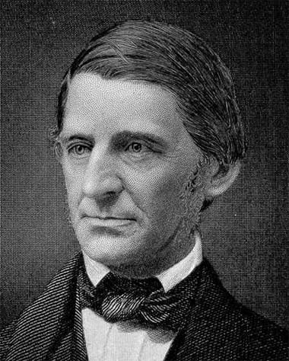Ralph Waldo Emerson and 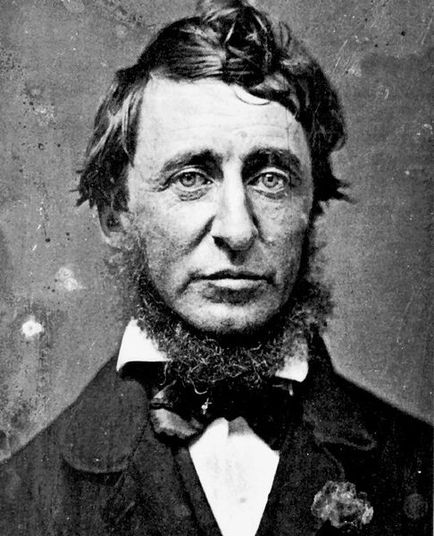 Henry David Thoreau

Both of these authors present potentially difficult texts to understand. One strategy I would recommend is to focus more on understanding the general feel/meaning of the text rather than on comprehending the meaning of each and every sentence and paragraph. Underline or take note on which “sound bite” sentences or passages seem meaningful or significant to you. Why are they meaningful?

Examine and explain each quote. To what aspect of Transcendentalism does each quote allude? How do these ideas transcend time and apply today?

“Self Reliance” Quotes

- “To believe in your own thought, to believe that what is true for you in your heart, is true for all men, - that is genius” (Emerson 533)

- “There is a time in every man’s education when he arrives at the conviction that envy is ignorance; that imitation is suicide; that he must take himself for better, for worse, as his potion; that though the wide universe is full of good, no kernel of nourishing corn can come to him but through his toil bestowed on that plot of ground which is given to him to till” (Emerson 533).

- “What pretty oracles nature yields us on this text in the face and behavior of children, babes, and even brutes” (Emerson 534).

- “Whoso would be a man must be a nonconformist” (Emerson 535).

- “It is easy in the world to live after the world’s opinion; it is easy in solitude to live after our own; but the great man is he who in the midst of the crowd keeps with perfect sweetness the independence of solitude” (Emerson 536).

- “A foolish consistency is the hobgoblin of little minds, adored by little statesmen and philosophers divine. With consistency a great soul has simply nothing to do” (Emerson 537).

- “To be great is to be misunderstood” (Emerson 538).

- “ The relations of the soul to the divine spirit are so pure that it is profane to seek to interpose helps” (Emerson 541).

- “Man is timid and apologetic. He is no longer upright. He dares not say ‘I think,’ ‘I am,” but quotes some saint or sage. He is ashamed before the blade of grass or blowing rose. These roses under my window make no reference to former roses or to better ones; they are for what they are; they exist with God to-day. There is no time with them” (Emerson 541).

- “It is easy to see that a greater self-reliance , - a new respect for the divinity in man, - must work a revolution in all the offices and relations of men; in their religion; in their education; in their pursuits; their modes of living; their associations; in their property; in their speculative views” (Emerson 545).

- “Welcome evermore to gods and men is the self-helping man” (Emerson 545).

- “As our Religion, our Education, our Art look abroad, so does our spirit of society” (Emerson 547).

- “[Men] measure their esteem of each other, by what each has, and not by what each is. But a cultivated man becomes ashamed of his property, ashamed of what he has, out of new respect for his being” (Emerson 549).

“Where I Lived, and What I Lived For” Quotes
What Emerson laid out in theory, Thoreau put into practice. Examine the following quotes and give concrete examples that demonstrate these quotes.

- “Man is rich in proportion to the number of things which he can afford to let alone” (Thoreau 887).

- “But I would say to my fellows, once and for all, As long as possible live free and uncommitted”(Thoreau 888).

- “We must learn to reawaken and keep ourselves awake, not by mechanical aids, but by an infinite expectation of the dawn, which does not forsake us in our soundest sleep” (Thoreau 891). (getting up in the morning – always changing)

- “ I went into the woods because I wished to live deliberately, to front only the essential facts of life, and see if I could not learn what it had to teach, and not when, when I came to die, discover that I had not lived…. I wanted to live deep and such out all the marrow of life…” (Thoreau 892).

- “When we are unhurried and wise, we perceive that only great and worthy things have any permanent and absolute existence – that petty fears and petty pleasures are but the shadow of reality” (Thoreau 895).

- “Men say that a stitch in time saves nine, and so they take a thousand stitches to-day to save nine to-morrow” (Thoreau 893).

- “Simplicity, simplicity, simplicity! I say, let your affairs be as two or three, and not a hundred or a thousand” (Thoreau 892).

8. “Time is but a stream I go a-fishing in. I drink at it; but while I drink I see the sandy bottom and detect how shallow it is” (Thoreau 896).

Final Thought:
Jefferson provides us with a declaration of political independence; Franklin affirms our independence from any single dogma or body of systematic thought, exhorting us to make our own systems—preferably on the model of his own. If we try reading Emerson and Thoreau as declarations of complete intellectual independence, then in what spirit should we read Emerson and Thoreau—or anybody else who offers wisdom or values? In other words, is rebellion against Emerson/Thoreau himself, moment to moment or overall, a supremely Emersonian/Thoreauian act?

