Skyline Ridge Preserve Field Trip make up
Art session #4
The assignment is a landscape drawing of a natural scene, showing distance using detail, contrast and size of objects. You must draw this plein aire (outside and on site, no photos. Photos can only be used as a reference to finish at a later time if not completed in the field) Rancho San Antonio Open Space preserve is a beautiful and convenient place to go to complete this assignment, but of course you can go to any natural place to complete this assignment.
Process:
page 1 = planning sketches
draw 2 - 3 very simple thumbnail sketches of different views like those we did in class the other day for the composition assignment. See below for examples:

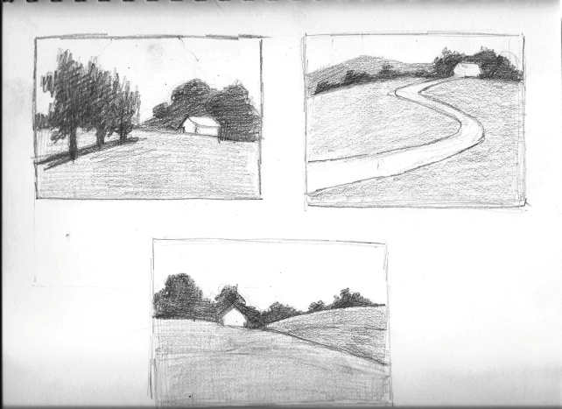

Choose the view you like the most. Consider the information we discussed in class last week about composition. Where is the focal point? Does it follow the rule of thirds?
On bottom of page practice your pencil strokes that best represent the textures of the grass, trees and shrubs in your scene etc. See examples below

Page 2 =
On the next clean page in your sketchbook, draw a landscape based on the one view you chose from the 2 -3 thumbnail sketches that you drew. This drawing needs to show distance, shading and texture.
Remember:
- include a foreground, middle ground and background
- include a sense of distance using:
detail- more in the foreground, less and you move back
contrast- deeper shadows and lighter lights in foreground with less as you move back
size of objects (trees and plants) objects get smaller as you move back.
- consider the rules of composition we discussed in class last week
Is there a focal point or center of focus ex. large tree in foreground etc.
rule of thirds- don't place focal point or center of interest directly in the middle, move it to the right or left 3rd of the page.
- You can draw a 1" to 2" inch border in from the edge of your paper to make it a more manageable size.

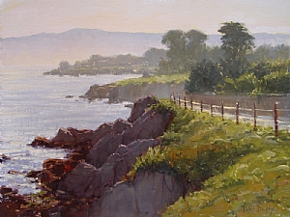

Making up the field trip portion of the project: 35pts.
After drawing your final sketch, write a full page in your sketchbooks, analyzing how you showed distance in your drawing. What elements did you use ie. detail, contrast and/or size of objects. Describe the scene and the process that you went through. Was it difficult to find a scene that you were inspired to draw? Was it overwhelming? What about your drawing, was it successful? What was challenging? Did you follow the rules of composition? How? What was your focal point if there was one. Turn this in with your sketchbooks during week 11!!
THEN: go to www.artspan.com type in "natural landscapes" in the keyword search box at the top of the page. Choose 1 artist whose work you like and do a write up on one piece in particular, analyzing it's organization and composition and whether it gives a sense of distance.. how does it do this? Use the above questions as a guide ...

