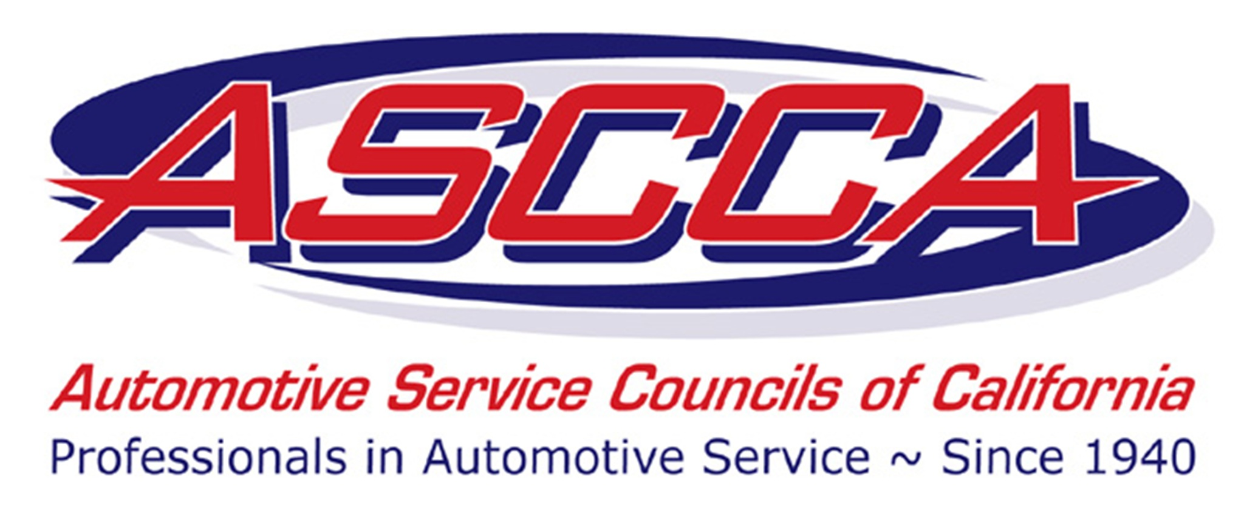
Automotive Service Councils
San Jose • Chapter 42
266 Hillsdale Avenue, San Jose, CA 95136
408-266-9658
Fax 408-266-7940

AUTOMOTIVE TECHNICIAN
SCHOLARSHIP APPLICATION

ASCCA AWARDS - ASCCA will award a total of $2000.00 to selected De Anza College Automotive Technology students, with $1000.00 going to the top selection and $500.00 each to the 2nd and 3rd selections.

Overall Qualifications: - Open to students enrolled in the De Anza College Automotive Technology Program. Students who meet the criteria listed below should submit completed applications to Pete Vernazza, ASCCA Chapter 42 Scholarship Chair.

  - 2.0 overall grade point average
  - 3.0 grade point average in Automotive major courses
  - Submit a college transcript verifying grades and current course work. Unofficial transcript printed from De Anza Portal is acceptable.
  - Instructor’s letter of recommendation
  - A brief narrative stating “Why this scholarship is important to me”. (250 words maximum)

Application dates

- Deadline for Scholarship applications to be received by the Scholarship Chair is April 22, 2011.
- The Chapter will notify the scholarship winners by May 6, 2011.
- The Chapter will award the scholarship winners at the monthly dinner meeting on May 11, 2011. Scholarship winners should plan on attending this meeting.

Instructions: Failure to complete entire application may disqualify the applicant from consideration.

Mail application, letter of recommendation, narrative and transcript to:

De Anza College Automotive Technology Dept.
Attn: Pete Vernazza
21250 Stevens Creek Blvd.
Cupertino, CA 95014
Automotive Service Council
San Jose • Chapter 42
PO Box 36255, San Jose, CA 95158-6255
408-266-9658
Fax 877-426-8501

AUTOMOTIVE TECHNICIAN
SCHOLARSHIP APPLICATION

Name:
Last First MI

Address:
Street City ZIP

Cell phone ( ) Home phone ( )

Check One:
College status: Freshman Continuing Student

College units completed ______

Check One:
Immediate goal: Certificate Associate or Bachelor degree

Automotive major service area ________________________________________

Educational Background
Please list the high school from which you graduated and all post-secondary or vocational schools attended or in which currently enrolled.

NAME OF SCHOOL | CITY/STATE | GRADUATION DATE | DEGREE

REMINDERS! The following are required for application submissions:
- College transcript for verification of grades and current course work
- Instructor’s letter of recommendation
- Brief narrative stating “Why this scholarship is important to me” (250 words)
- Mail application, letter of recommendation, narrative and transcript to:

De Anza College Automotive Technology Dept.
Attn: Pete Vernazza
21250 Stevens Creek Blvd.
Cupertino, CA 95014
*(Applications not properly submitted will not be considered for a scholarship award.)

