DIRECTIONS FOR ACCESSING LMS AND COMPLETING THE TWO MANDATORIES

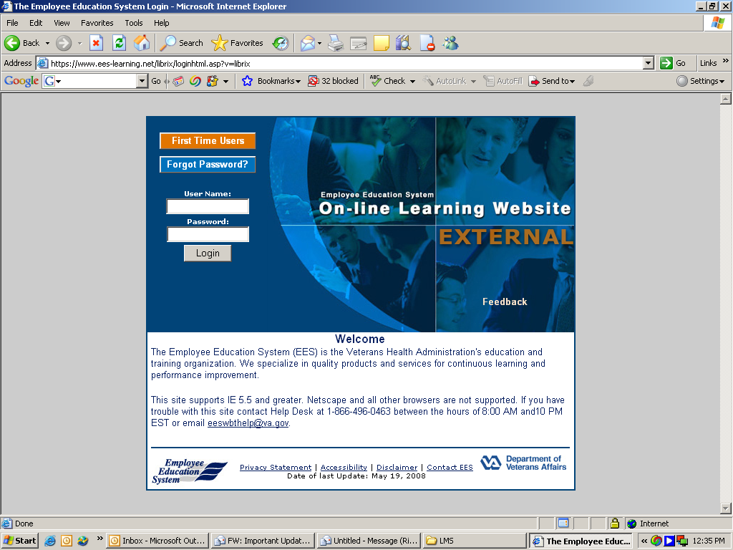

Log onto the website:
https://www.ees-learning.net/librix/loginhtml.asp?v=librix

Click on “First Time User.”
DIRECTIONS FOR ACCESSING LMS AND COMPLETING THE TWO MANDATORIES
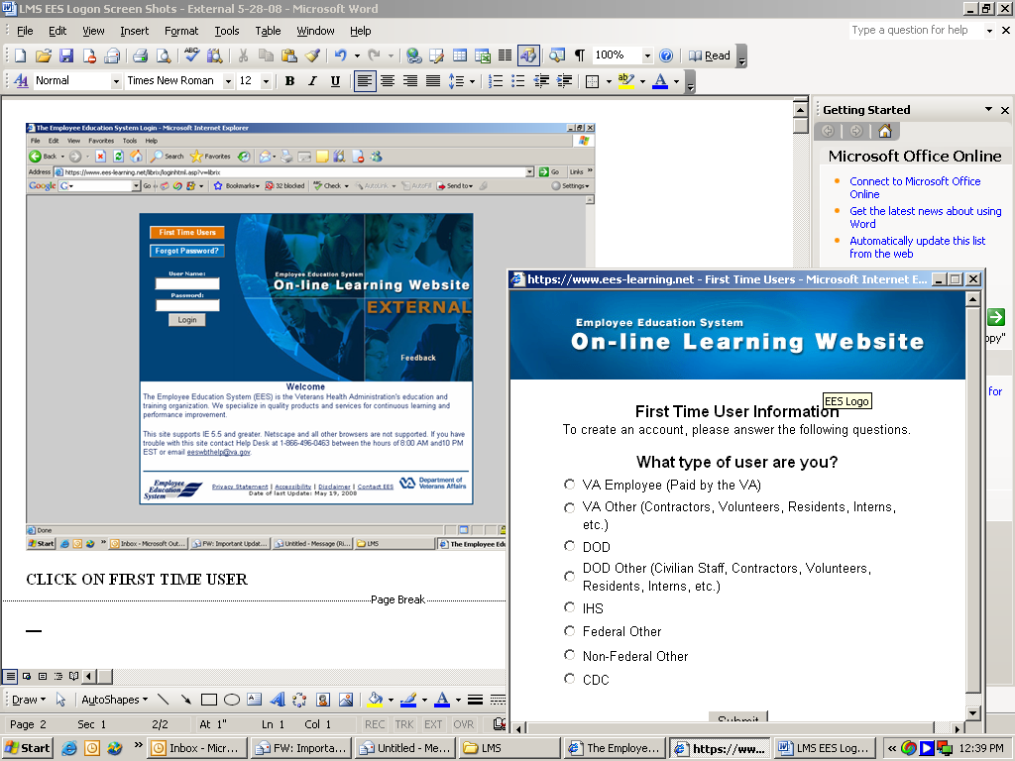

Check the category of VA user you will be: VA Other

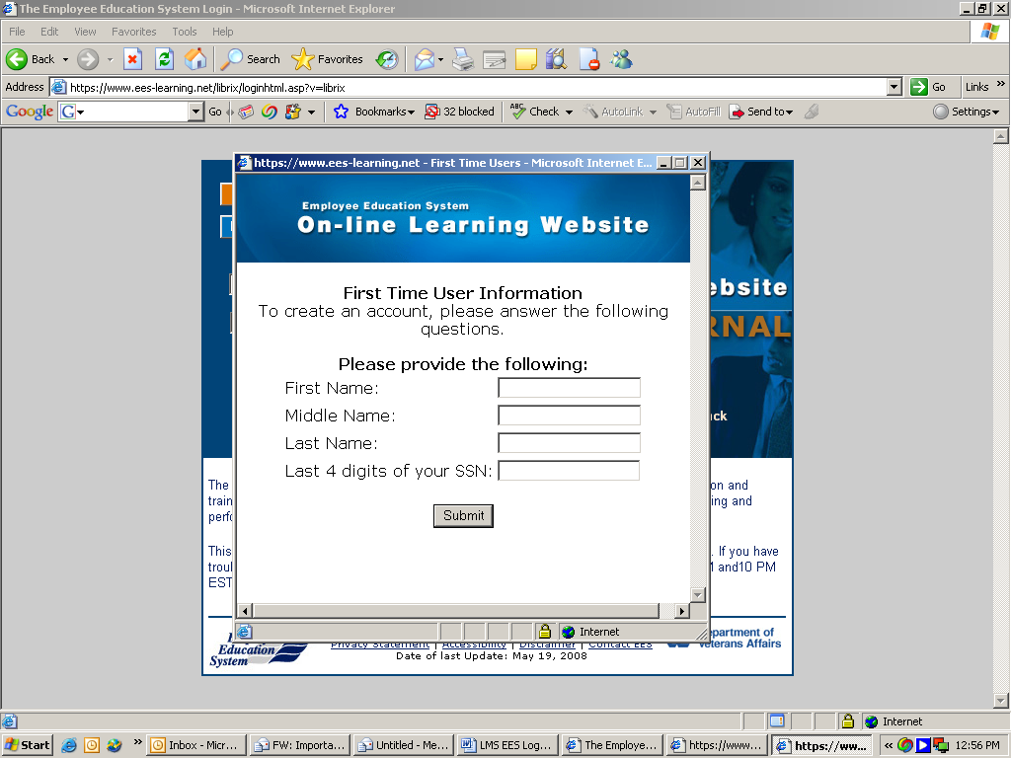

Enter your full (legal) first name, middle name, and last name.
Enter the last four numbers of your Social Security Number (SSN).
Click on the “Submit” button.

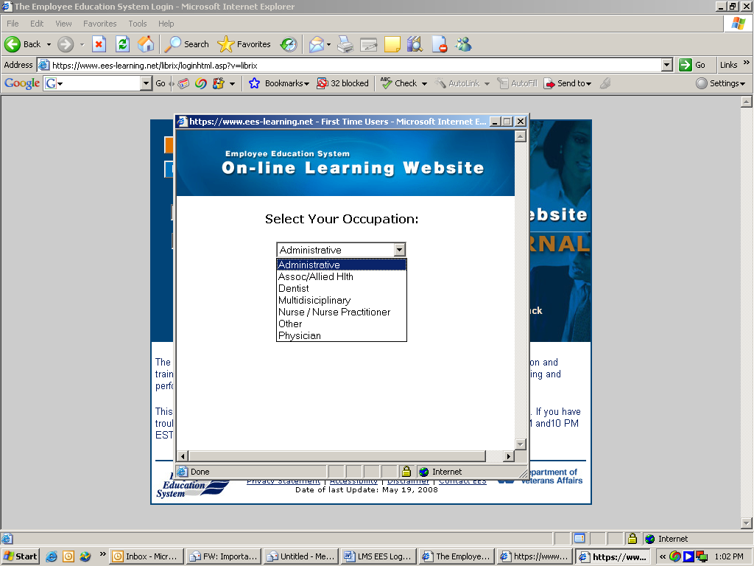

From the drop-down menu, select one entry. Then click on the “Submit” button.

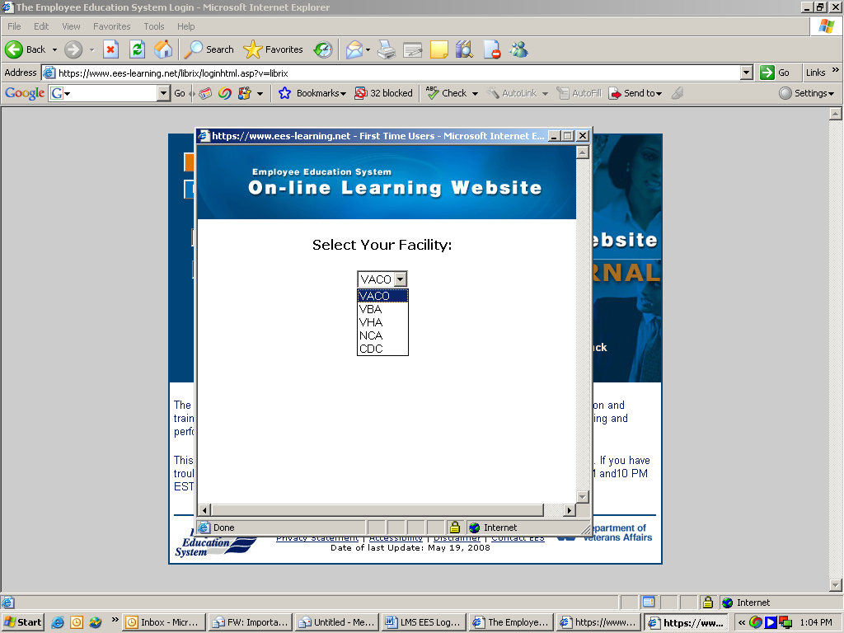

From the drop down menu, select “VHA.”
Click on the “Submit” button.

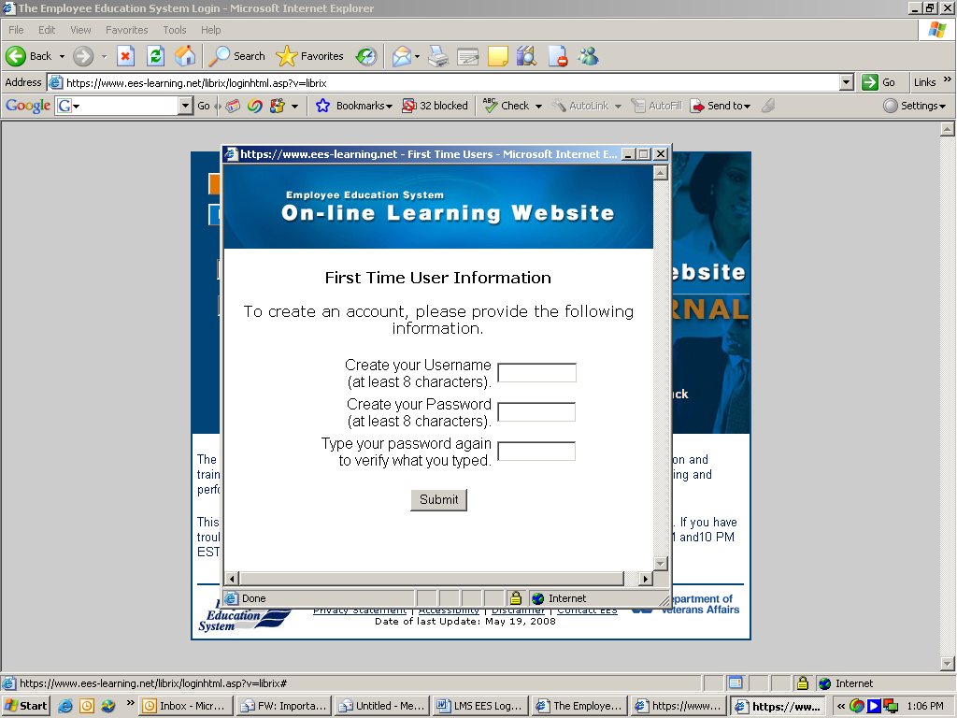

Create a special username that you will use.
Create a special password – one that you are not already using on any VA networked computer.
Type your new password in again.
Click on the “Submit” button.

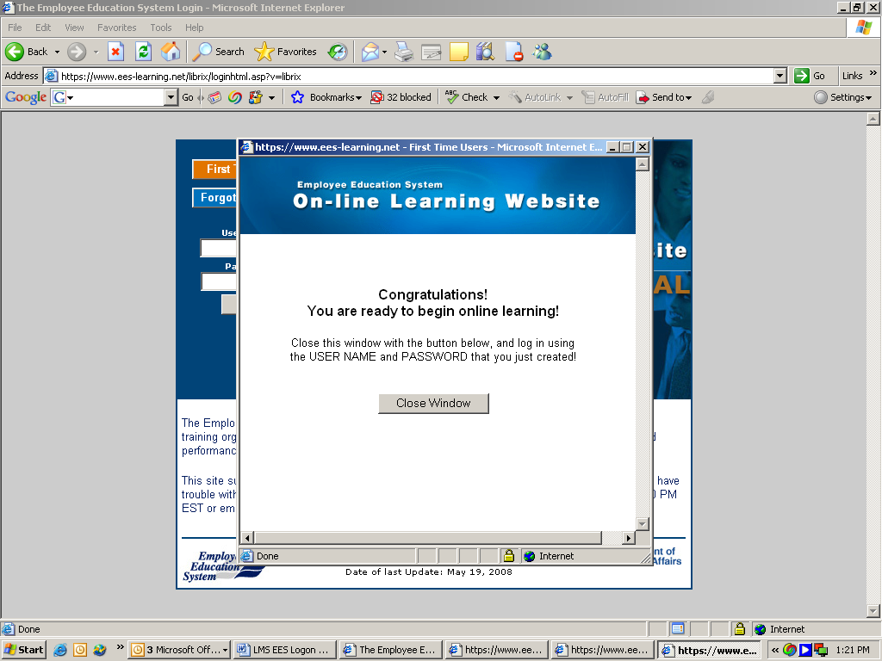

Follow the instructions.
Close the Window.

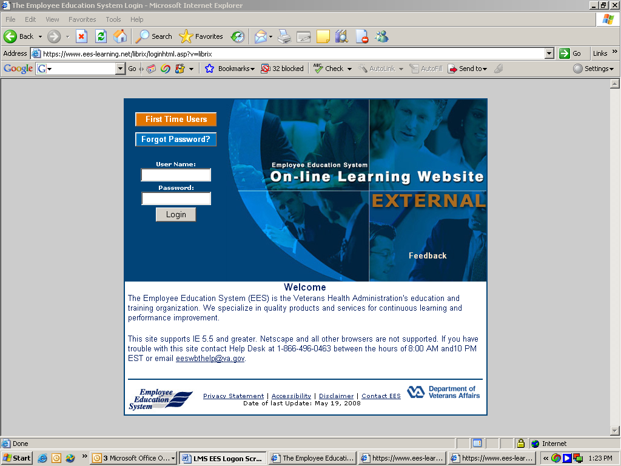

Enter the User Name and Password that you just created.
Click the “Login” button.

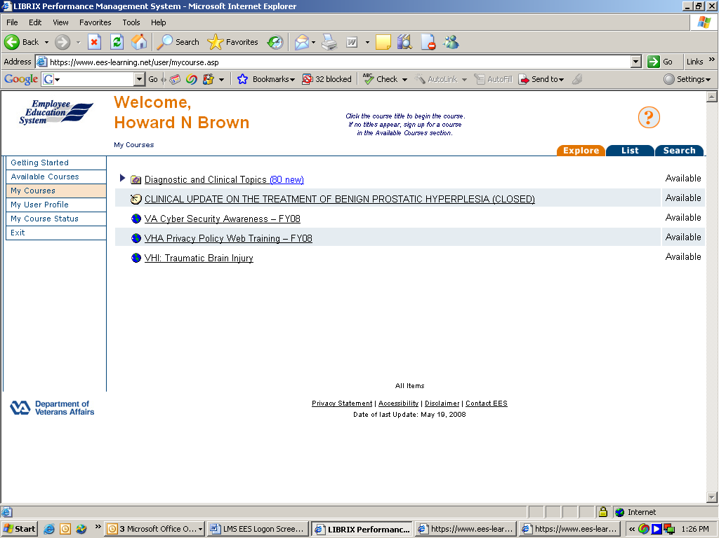

The screen will show a Welcome to you.
You will see the two required classes you have to complete. These are:
1) VA Cyber Security Awareness – FY08
2) VHA Privacy Policy Web Training – FY08.

Click on the course title to begin taking the course. Example: Click on VA Cyber Security Awareness – FY08
Complete the course, and any and all online tests and certification statements for this course. Print out your certification of completion and save it. Before you begin work, you will be asked to provide a copy of the certificate to a designated official at VA Palo Alto Health Care System.

Click on the course title for VHA Privacy Policy Web Training – FY-08. Complete the course and any and all online tests and certification statements for this course. Print out your certification of completion and save it. Before you begin work, you will be asked to provide a copy of the certificate to a designated official at VA Palo Alto Health Care System.

