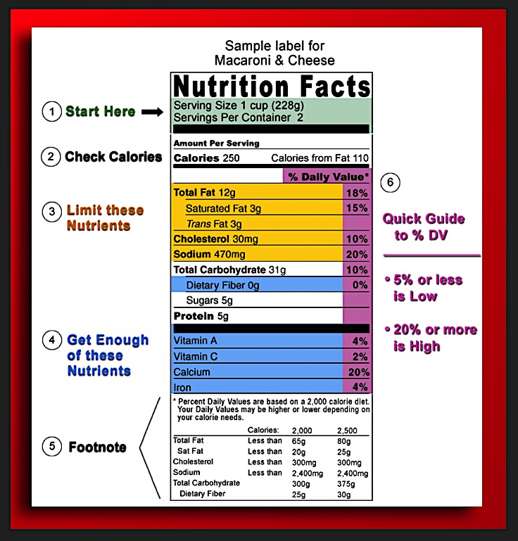

* Nutrition content is listed as % Daily Value (%DV) based on a 2000-calorie diet.
* Start with serving size: If you double your serving, then double all nutrients and calories!
* Ignore ALL claims on packaging. They are vague, poorly regulated and mostly marketing.
* Find the fat: Daily goal 20-35% of calories from fat, < 7-10% saturated fat. no trans fat.
* Scope out sodium: Daily goal <2300 mg; ~ amount in fast-food burger or tsp. of salt!
* Focus on fiber: Daily goal 25g for women, 38g for men; Fiber is only in plant foods!
* Survey the sugar: Daily goal ≤6 tsp. for women, ≤9 tsp. for men. Calculate tsp. by dividing grams of sugar listed in the label by 4
* Inventory the ingredients: Short ingredient list of recognizable foods is your best bet.