- What strategies do you have to try to diversify your applicant pool as much as possible, especially for student groups for which there is an equity gap? For instance, is the Dept. aware of, or has done research on, training/graduate programs and organizations for their disciplines and fields that are known to be welcoming/advocates for diversifying their disciplines and fields?
  - In both departments, English and Communications Studies, we depend primarily on local (Bay Area and California) applicants because the cost of living is prohibitive to people from outside the region. We have extended searches on multiple occasions in the past in order to seek a more diverse pool.
  - English: We have in the past relied on District HR to help us advertise and generate a diverse applicant pool. We also recruit from SFSU, which offers an MA in Composition that heavily emphasizes composition and reading and includes a program learning outcome that embodies educational values of ethics, social justice, diversity, and globalization. Our faculty are members of numerous organizations and attend a variety of conferences that provide opportunities to diversify the discipline, including the Conference on College Composition and Communication, and NCORE
  - COMM: We have a diverse faculty in Communication Studies, and we rely to an extent on referrals of candidates from the SJSU master’s program, which shares many of our diversity and pedagogical values. Our connection to SJSU has helped us many times find new PT faculty members when there was no one left on the applicant pool that we had not already interviewed or hired. Our faculty in Communications Studies are also members of numerous organizations and attend a variety of conferences that provide opportunities to diversify the discipline, including the Western States Communication Association, and NCORE
- How challenging is it to find part time instructors to open up new sections when you have waitlists. How often do you have large waitlists, but no ability to open new sections due to lack of faculty (FT or PT)?
  - English: We have a growing demand for seats in some classes, notably in EWRT1A/LART250 corequisite courses, and we regularly find ourselves making multiple calls to our existing faculty to staff these classes.
  - Communications Studies: We regularly have all classes filled to capacity and full waitlists by the third week of registration, and we add classes almost every quarter when we have available teachers. We hire new part-time faculty almost every year and screen or interview every new application in the system.
- Where relevant, supporting data for justifications they have written (for example, growing demand, number of students who could not take their classes each quarter, number of students who are delayed because of lack of these classes, etc)
  - Communications Studies classes fill in the first two to three weeks of registration. And the wait lists also fill. Our program review data does not capture wait list information at point in time, so like many other deans, I download the full enrollment data for my departments regularly during registration. This spreadsheet of enrollment data for Communications Studies for August 6, 2020 is an example of the information I review throughout registration and when building schedules. You can see that every seat is taken and the wait lists are full only two weeks into the registration period. This is included as an example and is typical of other quarters. Whenever possible, we add classes but we often run out of teachers, and we have not been able to add enough sections to meet the demand.
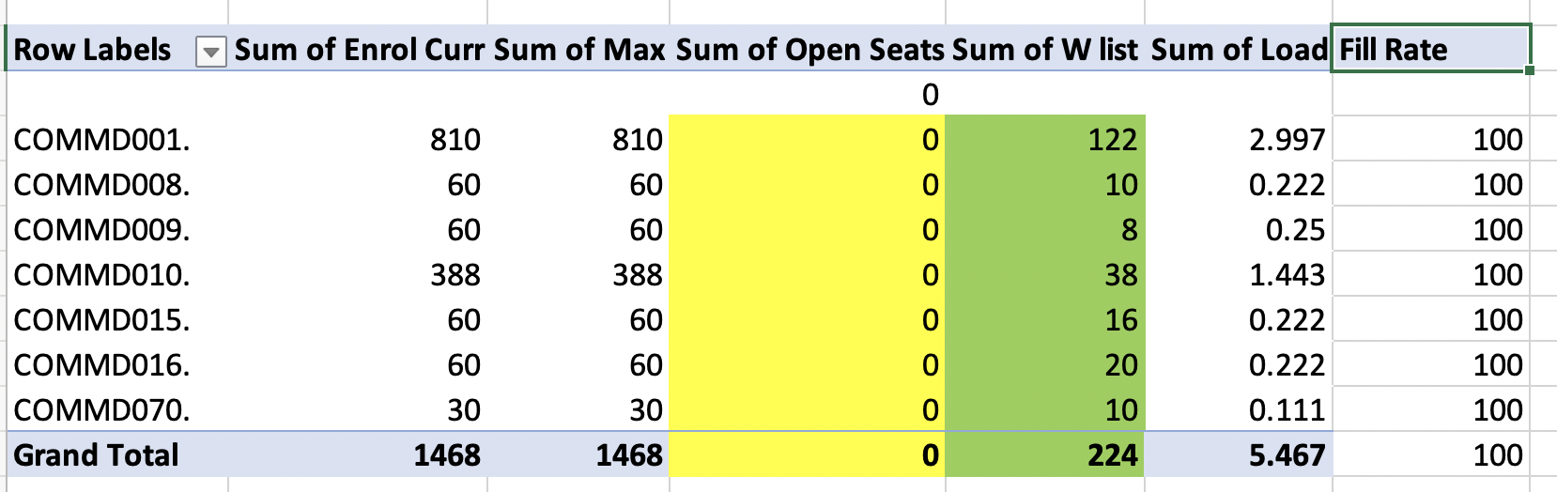
- Confirmation that the data on FT and PT is updated and accurate
  - Yes, the percentage of FT, PT, and overload appears correct. It is more difficult to assess the ethnicity data as it is self-reported at the time of hire.
  - What departments have lab technicians?
  - We have a technician in our Language Arts Division lab, which primarily supports English and ESL.

- Why are African Americans, Latinx, and Filipinx students grouped together? Who decided on this, and is this up for reconsideration?
  - This question falls outside the purview of Language Arts, and would be better answered by Institutional Research.
Communications Studies
- Supporting data, especially on justification #5
  - There are two aspects to this bullet. 1) We asserted that disproportionately impacted students benefit from having greater access when we offer courses in multiple modalities. Our program review data demonstrates the demand from disproportionately impacted students. As we increased our fully online offerings in Communications Studies prior to the pandemic, we saw a significant increase in demand from our disproportionately impacted groups. Over the three-year period prior to the pandemic, African American, Filipinx, Latinx and Native American student enrollments in purely online classes grew from 88 in 2017-18, to 173 in 2019-20, a 97% increase in demand.
  - 2) Prior to the pandemic, our department had made a concerted effort to develop hybrid and fully online course offering in Comm Studies in order to meet student demand and interest. We were very thoughtful and intentional about how these courses would be developed pedagogically as we were one of the first departments across the state to offer communication courses in hybrid and fully online modalities. We required that faculty who would develop and teach these courses have training, expertise, and experience in teaching online in order to ensure a quality experience for students taking these courses. Demand for these hybrid and fully online course sections was steady and increasing prior to the pandemic and since then has increased greatly. If we want to meet our student demand, we will need to increase our department offerings in fully online and hybrid courses in the future (even as we phase back to on-campus classes). We want to be able to hire faculty who have the expertise and experience in online pedagogy to meet student needs.

English
- Please speak more on the structural reform they're working on:
  - Prior to the passing of AB 705 and the subsequent procedural guidance from the Chancellor’s Office, we offered four pre-transfer level courses for students who placed into them. In response to AB 705, we transformed our curriculum and those courses, two in reading and two in writing, are no longer offered, meaning all students enter directly into EWRT1A.
The intent of the law is to increase the number of students who complete college-level writing and math in their first year. The curriculum reform left the students who would have previously entered in pretransfer level writing in need of other support to succeed in college level writing.
Since the elimination of pre-transfer level courses, we have been working on building structural support, including dedicated counselors, targeted tutoring, and support courses so that students can be successful in their college-level writing. The English Performance Success Program is designed to provide students with the support they need and is modeled on other successful cohort programs. Students can now take EWRT1A in any of three options, each with different types and levels of support. As we move forward, we want to ensure that the necessary interventions that English Performance Success provides is able to reach any eligible student.
- What is a shared portfolio process?
  - The English Department has implemented a portfolio process so that all students, regardless of who their teacher is, complete a set of common essay assignments. The portfolios are then read by teams of teachers at the end of the quarter so that students are assured that their work meets a common standard.

- As compared to other large departments, English has many faculty and many classes, but a big number of those classes are not full. What's the cause of this inefficiency?
  - The program review data sheets indicates that we have a 96% fill rate in English. I’m not certain where any other data may have come from. The number of drops this year has been higher than in the past, but that is a consequence of the sudden transition to online-only offerings and not unique to English.
- Is faculty needed for, and therefore hiring efforts would be concentrated toward, certain classes (Women in Literature, African American Literature, Asian Pacific American Literature)
  - Although we offer a great variety of literature classes, we are seeking to hire a faculty member who specializes in college-level reading and writing instruction.
- What factors contribute to the low success rates?
  - Although we always seek to improve our success, as is demonstrated by the structural reforms we have made and are making, I do not agree with the characterization that the success rates are low. We have significantly higher success rates in college writing than other colleges and are among the highest in the state.
Nonetheless, we want to improve our success and are trying to address a number of factors. It’s important to note that all students are required to take writing, regardless of their ability or interest, including many students who don’t like writing or are openly fearful of the subject and that has an impact on our overall success. There are a wide array of factors that lead to students’ dislike or fear of writing, factors ranging from prior education and economic disparity to reading skills and study habits. The EPS program is designed to discover and address those factors to the extent possible.

