

Hello everyone,

With this letter, I am providing you with information on new / requested projects along with evaluation data for you to use in prioritizing projects at the college and Central Services level. Lessons learned on our first cycle through this process last term indicated that the timelines to implement three cycles of review in a year may be too aggressive given all of the other activities we have going on. Accordingly, I have modified the calendar to provide only two cycles of review annually. Please note the revised calendar in Table 4 below.

For this next cycle of review, what I will need from you by **April 6th** is to:

1. Recommend priorities for all new, requested projects (see Table 2) based on the information in the above documents and any additional information that you collect.
2. Recommend changes in priorities of current, requested projects identified as **critical** to keep the total number of critical projects to ten or under (if necessary). (See Table 3)
3. Recommend changes in priorities to other current projects as needed.

Appendix A of this document contains a worksheet you can use to report results. Note that only the first two tasks listed above are necessary to complete. The third task is optional.

Table 1 (below) shows the priority codes to be used in evaluating projects

Table : Priority Codes To Use in Evaluating Projects

|  |  |  |
| --- | --- | --- |
| **Code** | **Title** | **Explanation** |
| **C** | Critical | These are the most important projects for the district. Currently ETS has enough staff to only work on a subset of these at a time. |
| **I** | Important | These projects are next in line to be worked on as critical projects are completed. |
| **N** | Nice to have | These projects may add some value but are much less in priority and will probably not be worked on for the foreseeable future. |
| **X** | Canceled | These projects are canceled. They may be brought back at a later date. |

Table : List of New, Requested Projects

|  |  |  |  |
| --- | --- | --- | --- |
| **Project Name** | **Description** | **For College or CS** | **Evaluated?** |
| CalPERS Benefits Transition Project | Switch from current benefit providers to PERS – **very important** | Central Services but affects everyone | **Yes** |
| iPad Pilot | Set up environment to test iPads for student – classroom use | Foothill College only | **Yes** |
| DA Flea Market | Enable network/phone connectivity to parking lot for admin support | De Anza College only | **Yes** |
| BDMS for Purchasing | Convert over to electronic document storage for purchasing | Central Services but affects everyone | **Yes** |
| International Students Application | Modify the student application form and process currently in Banner | De Anza College only – could also support Foothill College | No |

Some projects may not have been evaluated due to the date that the paperwork was received or availability of key personnel. ETS will endeavor to conduct the evaluations and provide the information to you; however, ETS may not have time to evaluate some projects this cycle.

When prioritizing, we would like you to return a final list of no more than **ten** total ***Critical*** projects, including those already identified as *Critical* on the previous list. Any more than this makes this prioritization process meaningless, because at some point everything becomes critical. Our current prioritization list of critical projects is listed in the table below. You may recommend changes to the priorities of these projects if they have not already started.

Table : List of Current Projects Identified as Critical

|  | **Project Name** | **Has Project Started?** |
| --- | --- | --- |
| 1 | Automation for Meetings | Yes |
| 2 | ParSystem - ScanTron | Yes |
| 3 | SLO Database | Yes |
| 4 | Banner Waitlist Stop – FA Contract | Yes |
| 5 | Unified messaging (email calendar replacement) | Yes |
| 6 | Universal ID (capture card replacement) | Yes |
| 7 | Banner Student Installment Plan | **No** |
| 8 | District Web CMS | **No** |

Shaded projects may not be reprioritized. (However, they may be canceled if desired.)

Listed below in Table 4 are the key dates for review and prioritization of projects by committees involved in prioritization.

Table : Key dates for Project Prioritization Process FY2011-2012

|  |  |  |
| --- | --- | --- |
| **Task** | **Summer - Fall  Quarters 2011** | **Winter-Spring  Quarters 2012** |
| Technology Task Force (TTF) meeting dates | Refer to TTF | **Refer to TTF** |
| ETS directors finish new project evaluations |  | **By March 6** |
| ETS provides evaluations to TTF & ETAC Committees | By October 2 | **By March 7** |
| TTF committees submit prioritized lists to VC Technology | By November 2 | **By April 6** |
| ETAC Committee Review | November 9 | **April 11[1]** |
| Meetings of District Technology Project Committee[2] | Nov 15 to Dec 6 | **April 15 to May 15** |
| Chancellor’s Cabinet Approval | December 13 | **May 22** |
| Project Status updated with new priorities | January 3 | **June 4** |

Please send all suggestions for improvement to me so we can make the process better.

Thank you for your support.

Fred

# Appendix A: Submission Form for TTF Recommended Priorities

### Task Force (De Anza, or Foothill, Central Services) _____________________________

*Complete the boxes under titles in* ***red font*** *(also designated by an asterisk*) below, as appropriate.*

Table : TTF Recommended Priorities for New, Requested Projects

|  |  |
| --- | --- |
| **Project Name** | **Priority\*** |
| CalPERS Benefits Transition Project |  |
| iPad Pilot |  |
| DA Flea Market |  |
| BDMS for Purchasing |  |
| International Students Application |  |

Table : TTF Recommended Changes for Current Critical Projects (if any)

| **Project Name** | **Change to …\*** |
| --- | --- |
| Banner Student Installment Plan |  |
| District Web CMS |  |

Table : TTF Recommended Changes for Current, Non-Critical Projects (if any)

|  |  |  |
| --- | --- | --- |
| **Project Name\*** | **Current Priority\*** | **Change to …\*** |
|  |  |  |
|  |  |  |
|  |  |  |
|  |  |  |

Please submit this completed form to the Vice Chancellor of Technology by the due date.

# Appendix B: Project Information

* **IT Project Evaluation Tool - New Projects.xlsx**: This spreadsheet contains an evaluation of several new / requested projects. The graph depicts the results on two axes measuring impact and effort. The blue dotted line represents the region of the graph where the previously prioritized *Critical* projects were located.

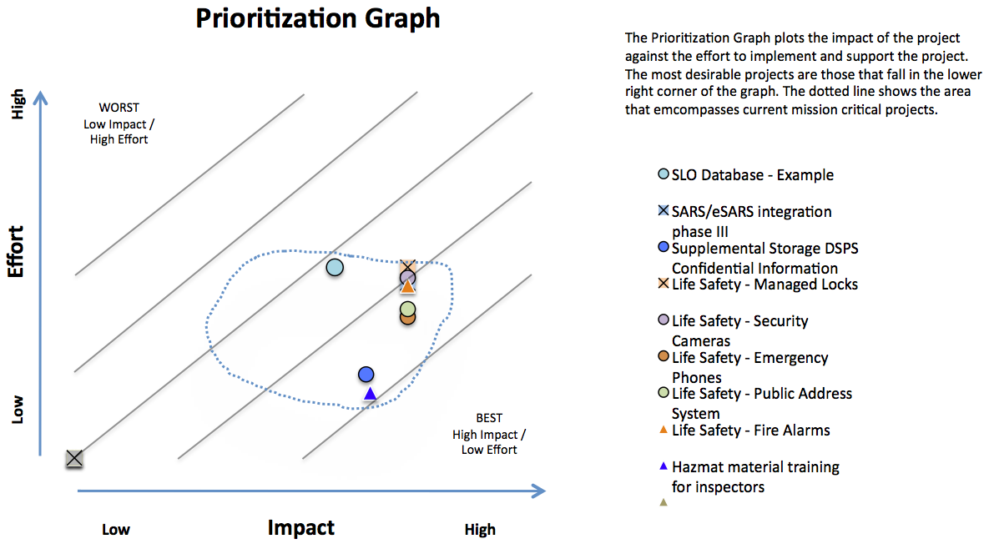

The detailed results of each evaluated project are included on the subsequent sheets (which are numbered). Note that many of the evaluation criteria have pull down menus that standardize the input from the ETS director and project requester. You can see these by clicking in the light blue boxes (in Section 2 as an example) and then clicking on the small double arrow icon in the lower right hand corner of the box.

A team of one ETS director and the project requestor evaluated each of these projects. Accordingly, these teams are different from project to project so some variations in ratings have naturally occurred. Also, we noticed a tendency for project requestors to inflate the ratings so that their projects would be evaluated higher.

It is important when prioritizing projects that factors other than these evaluation scores are considered; gaining a familiarity with each project is also important for understanding its value to the district.

Also included in the Excel document is a report that includes the following fields:

Title Project title

Description Project description

ETS Lead: ETS technical lead responsible for project completion

User Lead: Local person who represents all users on this project

Supports: Describes the college / Central Services goals that this project meets

Enhancement: Describes how the critical the project is

* **U.pdf**: This document contains a list of **already** prioritized user-requested projects and their status. An up-to-date list can always be viewed at <http://fhdafiles.fhda.edu/downloads/etsfhda/U.pdf>.

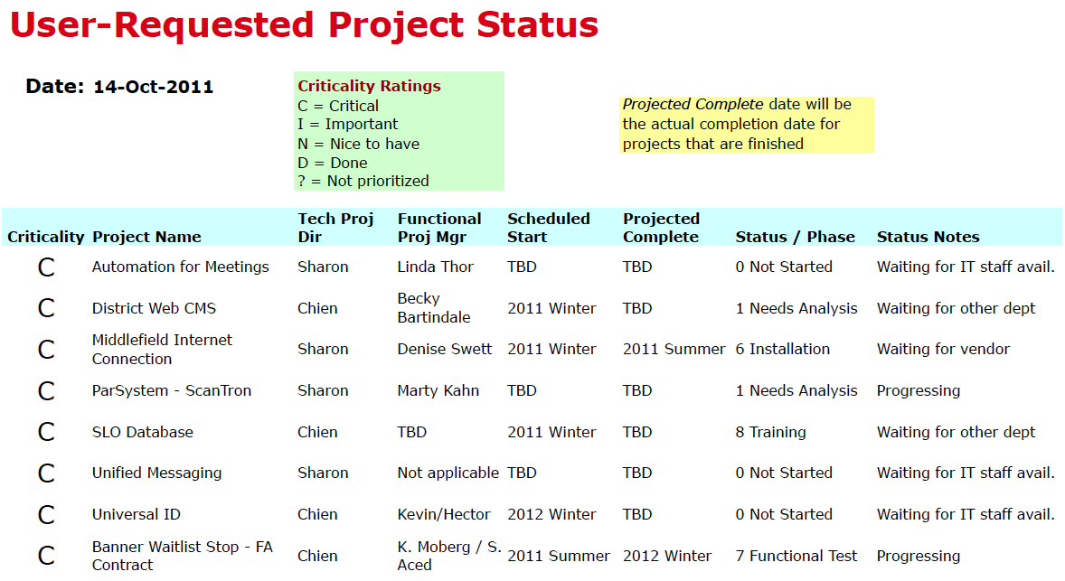

(Sample, not current: only one of several pages shown)

1. Special two hour meeting
2. Specific meeting dates to be designated later