

De Anza College Health Services

Student Flu Clinic

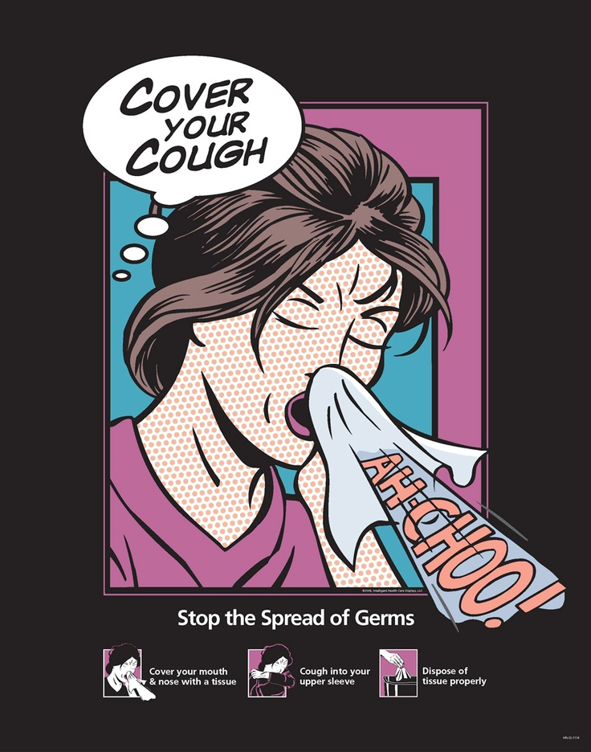

Free For All Students:

Bring Student ID

Be prepared to answer:

Allergies to chicken, eggs, or egg products?

Pregnant? Or Maybe?

Sick today with fever > 100.4?

Been sick in the past 2 weeks?

Ever had Guillain-Barre syndrome?

Students < 18 years old  
Need parental consent

Fall Flu Clinic

October 14th & 15th

October 21st & 22nd

9 am – 3 pm

In front of the Health Services Building

Hinson Campus Center