California Academic Library Report 2002-03 for Foothill College

August 5, 2003
Andrew LaManque

Produced for Beverly Shead

Data Elements (see definitions attached)
Student Count, Student FTE, Faculty Plus Staff Count, Faculty Plus Staff FTE

All data is for Fall 2002, from the state chancellor’s office data mart:

http://www.cccco.edu/divisions/tris/mis/reports.htm

1) Student Headcount By Enrollment Status , For Foothill For 2002 Fall Quarter
= 20,282

2) Full Time Equivalent Students(FTES), Foothill College For 2002 Fall Quarter
5,431 credit plus 60 noncredit time 3 (to annualize) = 16,473

3) Fall Staffing Report 2002, Employee Category Headcount Distribution
= 839

4) Fall Staffing Report 2002, Employee Category FTE Distribution
= 582

c:\lamamque\misc\California Academic Library Report 2002.doc

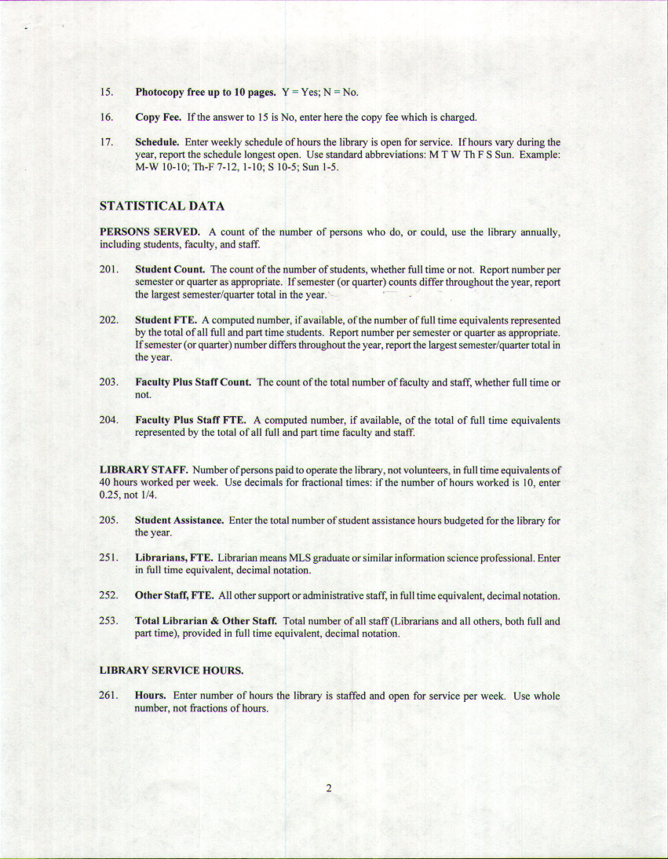
This is to notify you that a data request has been made.
Request Date: 2003-07-29
Request Number: 74
Requester's Name: Beverly Shead
Requester's Position: Executive Assistant
Department: Library
Division: Learning Resource Center
Requester's email address:sheadbeverly@fhda.edu
Campus: Foothill
Requester's Telephone: 650/949-7390
Other
Other description : This data is required for the California Academic
Library Report 2002-03.
Description: Faculty/Staff Count
Faculty/Staff FTE
Student Count
Student FTE
How is the data going to be used: The information is collected by the
California State Librray Foundation and put into a yearly report to be
distributeds to all California Libraries.
What question does the data answer?:
Impact on current practices:
Financial Impact: No
Late Consequences: August 20, 2003

Student Demographics

Student Headcount By Enrollment Status
For Foothill For 2002 Fall Quarter
Data Current As Of August 05, 2003 08:11:54
Download The Result In Comma Delimited Format
Enrollment Status | Headcount
Continuing Student | 10,994
First-time Student | 1,674
First-time Transfer | 3,132
Not Applicable | 946
Returning Student | 3,286
Uncollected /Unreported | 250
Grand Total | 20,282

Full Time Equivalent Students(FTES)

Foothill College For 2002 Fall Quarter
District | College | Credit FTES | Non-Credit FTES
Foothill CCD | Foothill | 5,431.21 | 60.31

