
The Computer Technical Support Program

CompTechS is both an internship program for students studying toward a career in information technology; and a recycling program. CompTechS’ mission is to assist disadvantaged students to make it through college and help students facing obstacles to employment transition from college to work, while providing local employers with well trained computer technical support staff and an environmentally safe means of recycling their e-waste.
Phase I: Preparation & Application
- Successfully complete the following courses at Foothill or De Anza College or equivalent classes elsewhere, or gain the equivalent experience:
- Basic English
- Basic Math
- Computer Literacy
- Course that covers Microsoft Windows 2000 Professional or XP Professional
- Course in one of the following: PC Construction, Networking, or Programming
- Submit a signed and completed Application Packet
- Visit OTI Website (http://oti.fhda.edu/comptechs.html) and download
  - Application,
  - Skills Evaluation
  - Faculty Reference forms.
- Submit the Faculty Reference form to your chosen faculty reference with instructions to return the form directly to OTI.
- Mail or deliver the Application, Skills Evaluation form, and your Resume to:
OTI-Computer Technical Support Program
Seminar Building, Rooms 1B or 7E
De Anza College
21250 Stevens Creek Blvd
Cupertino CA 95014
- You will be contacted for a one hour interview and program overview. The interview includes a short quiz on hardware that is used to determine how much supervision you will need in the refurb lab. Once accepted into the program you will be asked to:
- Complete hiring paperwork.
- Maintain enrollment of at least 6 units at Foothill College OR at least 6 units at De Anza College.
Phase II: CompTechS Internship
If you are selected for a paid Computer Technical Support Program Internship you will start working in our on-campus Refurb Lab making $8 per hour. A maximum of six students work up to three 3.5 hour shifts per week. Students can only work up to 144 hours total in the lab.
Phase III: Industry Internship
Qualified students may have an opportunity to compete for paid industry-based internships. Currently student interns are working in the IT departments at Roche Pharmaceuticals, Synopsys Inc., Fujitsu Computer Systems, Fujitsu America, Flextronics, Photon Dynamics and VMWare. Intern duties can include:
  - Correcting hardware problems with supported desktops, laptops and peripherals by coordinating support with OEM vendors (in warranty)
  - Managing returns on warranted parts and systems
  - Packing and shipping replacement parts to customers
  - Maintaining standard software configurations, including troubleshooting, loading and configuring software images, supported applications and drivers
  - Installing, supporting and troubleshooting approved desktop software
  - Performing planned maintenance, moves, adds and changes
  - Troubleshooting and resolving basic network connectivity incidents
  - Maintaining and updating Loadsets (images) for standard systems
  - Recommending hardware and software solutions, including new acquisitions and upgrades
  - Consulting with the helpdesk on helpdesk calls
  - Providing phone support and diagnostics to remote customers
  - Documenting activities, processes and procedures
  - Participating in training programs designed to educate customers about basic and specialized applications
  - Answer Helpline
  - Log calls in Remedy
  - Escalate help calls as necessary
  - Solve routine calls as able
  - Interact with rest of team in resolving helpdesk calls
  - Use Remote tools (Remote Assistance, Remote Desktop)
A student who meets the qualifications specified by one of our employers and is hired, can work up to 25 hours per week while school is in session and 40 hours per week during breaks. Interns start at $10 per hour and can move to $12 per hour after a successful probation period. Students need to commit to a minimum of 3 months if they work for an outside employer.

For more information contact Susan Malmgren at 408-864-5713, malmgrensusan@fhda.edu or stop by our lab in the Seminar Building in Room 1B on the De Anza campus.

This is a great way to get some real world work experience, update your resume with a recognizable company or, in some cases, even get a job.

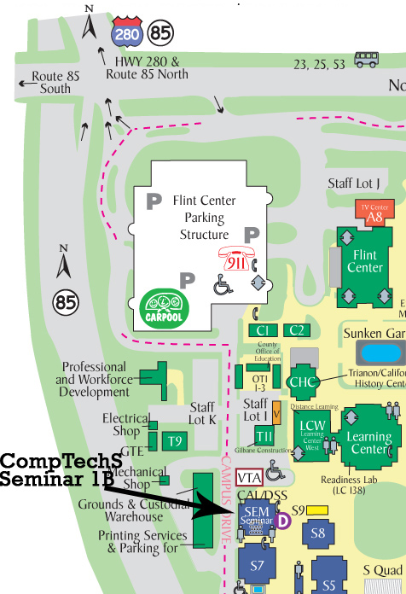
Drop by our Refurb Lab in the Seminar Building, Room 1B to see what the program is all about.

