

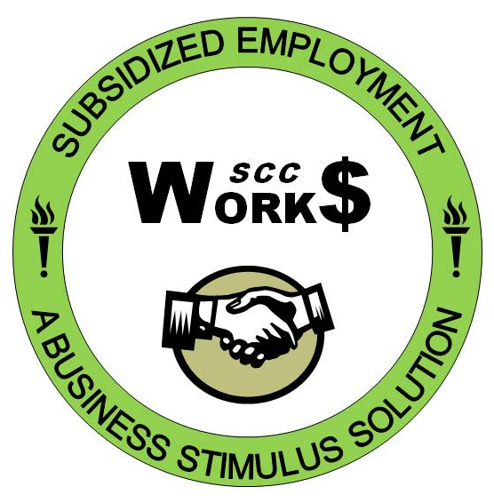
The Occupational Training Institute (OTI) is a resource for employers seeking low-cost hiring solutions. OTI offers this valuable service to both employers and eligible applicants through the OTI-SCCWORKS program.

How OTI-SCC Works Benefits Business
 OTI subsidizes wages up to 80%; businesses contribute 20%.
 Employers benefit from career-focused candidates who have the knowledge and abilities to match their company's job requirements.
 Employers augment staffing, while increasing their recruitment pool of potential employees.
 Employers are directly involved in the training of their future workforce.

Contact:

Phone - 408-864-5772
Fax - 408-864-8462
Email - dammai@fhda.edu

SCC Works Coalition
County of Santa Clara Social Services Agency and
Occupational Training Institute
Foothill – De Anza Community College District
Subsidized Employees
For Silicon Valley Businesses
Offers Staff Support Employees
Funded through the American Reinvestment and Recovery Act
OTI-SCC Works Subsidized Employment positions are funded through the American Reinvestment and Recovery Act


 Career Focused Candidates
 80% Reimbursement
 Full Time Employees
OTI – SCC Works
The Occupational Training Institute (OTI) serves as a staffing resource for employers, offering low-cost candidates to fill open vacancies. In exchange, the business agrees to hire an eligible candidate and provide them an opportunity to develop job skills and gain work experience.

Subsidized Employees for Silicon Valley Businesses
 Low-cost Candidates
 Wide Range of Skills
 Augment Staffing Needs
- County of Santa Clara Social Services Agency

- Foothill – De Anza Community College District

- Occupational Training Institute – 30 years Serving Silicon Valley

- Funded through the American Reinvestment Recovery Act

How it works:
 An open position/job description is submitted to an OTI representative. Please include a description of the job duties and the minimum qualifications. Multiple openings may be submitted by a business.
 The OTI representative will work individually with each business and refer potential candidates to the business representative. The business representative and work-site supervisor will interview and select the best candidate.

OTI-Santa Clara County (SCC) WORKS offers businesses in Silicon Valley 80% reimbursement for wages of each employee!

All employee's wages are subsidized through the American Reinvestment and Recovery Act of 2009, economic stimulus funding.

WORK EXPERIENCE!
OTI-SCC Works reimburses businesses for 80% of the wages for each candidate assigned to a subsidized employment position.

A subsidized position must be full-time and pays up to $15.00/hr.

Call (408) 864-5772 today to learn how to become a participating business, and access low-cost candidates to help augment your staffing needs.

OTI-SCC Works Program Trainees
Program candidates possess a wide range of skills and job experience. They are career-focused individuals who will benefit from working in your business and learning how to meet your company’s long-term employment requirements.
Your company will benefit today by utilizing the workforce of tomorrow, through President Obama's initiative to get the country back to work!

