Welcome from the Student Learning Outcome Coordinators

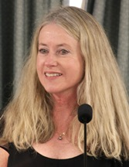SLO/SSLO/AUO



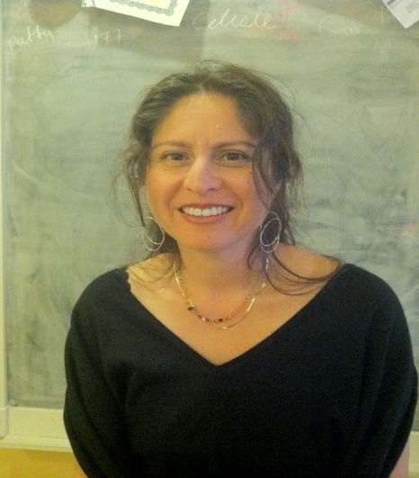

Toño Ramirez

Mary Pape

Amy Leonard

Veronica Acevedo Avila

***Student Learning Outcome Assessments have initiated improvements to the curriculum, to departments, and to the institution.***



Here are some examples we would like to share with you.

**Institutional Learning Outcome:** The 2013 Convocation began the process of assessing our ICC then titled “Global, Cultural, Social and Environmental Awareness”. This assessment cycle directly led to a reframing of the ICC itself--an improvement to the institution which in turn shapes any curriculum that is tied to it. A narrative of the process may be found at [Civic Capacity Assessment Cycle #1](http://deanza.edu/slo/icc_assessment/civic_capacity_assessment/cycle_1_narrative.html) .

**Student Services Learning Outcomes: Health Services** conducted assessments and enhancements for the years 2011-14 triggering significant changes to the structure of the [Tobacco Cessation Program](http://www.deanza.edu/slo/accreditation_2017/Tobacco_Cessation_Program.pdf).

**Student Learning Outcome PHIL07: Assessment Driving Change in Curriculum:** [The assessment summary of SLO 4](http://www.deanza.edu/slo/accreditation_2017/PHIL07_Assessment_Driving_Change.pdf) is directly tied to changes that will be submitted this year for the Course Outline of Record.

[AUO assessment for Vasconcellos Institute for Democracy in Action – VIDA](http://www.deanza.edu/slo/accreditation_2017/AUO--VIDA.pdf)(formerly the Institute for Community and Civic Engagement) is conducted every other year via a survey instrument that helps the center to identify opportunities to strengthen its presence in 'service courses'. One outstanding example is found in the 2016 Convocation presentation [“Healthy News habits”](http://www.deanza.edu/slo/accreditation_2017/Healthy%20News%20Habits.pptx) by Cynthia Kaufman illustrating how the survey reveals the 'news habits' of De Anza students. This information initiated a vigorous dialogue concerning how more conscientious news habits can be fostered by the College.

[Program Level Outcome Assessment](http://www.deanza.edu/slo/accreditation_2017/Philosophy_PLO_Assessment.pdf) **precipitates departmental change**: This example shows how an assessment cycle directly led to the revival of "Women in Philosophy", a course that was on the brink of being dropped from the catalog. Philosophy faculty agreed to revise/reinstate the course, and as of Fall 2017 it has been successfully offered for a third consecutive year. The course is scheduled for SLO assessment 2017-18.

**Chemistry CHEM 25 Course: Assessment driving resource request/allocation:**

The [enhancement documented at the end of this example](http://www.deanza.edu/slo/accreditation_2017/Chemistry_SLOAC_Example.pdf) shows how course-level assessment can easily shape the approach that a department takes toward the annual Program Review process, using data to call attention to resource needs.

**Computer Information Systems Program Level Outcome:** [Assessing the Program Level Outcome addressing programming language certificates and degrees](http://www.deanza.edu/slo/accreditation_2017/CIS%20Program%20Level%20Outcomes.pdf), it was noted that more support was needed for beginning students in the C++ course. For Winter 2018, LinC the course with EWRT 1A will offer students a sense of community as well as facilitating natural study groups.

**Psychological Services Learning Outcome:** The [assessment for the Psychological Services](http://www.deanza.edu/slo/accreditation_2017/Psych%20Services.pdf) student services level outcome was conducted in 2014-15.  This is a *desperately* needed service for our campus community, and has been fervently advocated from a variety of shared governance groups such as our Harm Reduction Team, the Student Disciplinary Hearing Board, and Veterans Services. As evidenced in the assessment report, this service unit is taking assessment seriously, and developing an instrument that will eventually be used to systematically evaluate the services it provides. Thus, the 2014-15 assessment effectively lead to enhancement to the assessment *method*.

[SLO Assessments for Massage Therapy:](http://www.deanza.edu/slo/accreditation_2017/Massage_Therapy_50A_50B.pdf) Method of assessment chosen was a focus group of students. The assessment led to improvements to the learning experience of the students as outlined in the [department minutes](http://www.deanza.edu/slo/accreditation_2017/Massage%20Retreat%20notes%203_25_16.pdf).

**Learning Outcomes Assessment Cycle Award:** The College offers an annual grant of $500 to support the implementation of an enhancement resulting from a course- or program-level assessment. For 2016-17 the award was to business instructor Byron Lily. He presented his report [“What I Won My $500 LOAC Award For”](http://www.deanza.edu/slo/accreditation_2017/What%20I%20Won%20My%20500%20dollars%20LOAC%20Award%20For%20by%20Byron%20Lilly.pdf) to faculty and staff at the 2017 Convocation and, by popular demand, to the Business, Computer Science, & Applied Technologies division. For 2017-18 the award was to Communications Studies to support their efforts in [Information Literacy Assessment](http://www.deanza.edu/slo/accreditation_2017/2017-18%20LOAC%20Speech%20Application.pdf).

**Humanities Department:** [Assessment of HUMI 16](http://www.deanza.edu/slo/accreditation_2017/HUMI%2016.pdf)This examples illustrates the impact that the SLO/PLO process regularly has on classroom teaching, helping faculty of the Humanities department see where they are most or least effective. The assessments documented here led to changes that are not so much changes in curriculum as changes in emphasis, awareness, and engagement.

The SLO/SSLO/AUO process is comprehensively supported by the college administration. The SLO process at the course and program levels is 100% faculty designed and implemented.

The reflection and enhancement documented alongside outcome assessments serves as evidence of internal department dialogue. This dialogue ultimately precipitates changes to broader campus processes, such as what has occurred with Program Review and its relationship to resource allocation. The dialogue-to-change connection is increasingly found across instructional, student service, and administrative areas.

***Course SLOs are listed for all departments in all Divisions*** [***here***](http://www.deanza.edu/slo/#CLO)

Faculty typically turn to this page to identify the outcomes to include on their syllabi. ***These may be different from the outcomes included in the Course Outlines of Record for pedagogical and practical reasons. We encourage faculty to update outcome statements when assessment work indicates that such updates will drive better pedagogy. These updates will not necessarily be in sync with the five-year review process. To mandate immediate change in the Course Outline of Record would overburden the curriculum committee and articulation office.***

* Some individual departments have chosen to have instructors upload syllabi to an online site. For example: <http://www.deanza.edu/buscs/greensheets/gsarchive.html>
* Other departments host copies in the division office.
* Online education has faculty upload syllabi well before start of quarter: <http://syl.deanza.edu/>
* Beginning with release of new website design, the tool found at <http://syl.deanza.edu/> will be used for all classes.

It is the responsibility of the Division to make sure syllabi are uploaded. The SLO team randomly samples those available online to verify compliance with listing SLOs.

***Our progress in disaggregating data to assist the Institution in Closing the Gap***

A report on the disaggregation of data collected on the Institutional Core Competencies (ICCs) may be found at: <http://deanza.edu/accreditation/2017/pdf/StudentAccreditationICCs_2016.pdf>

Further disaggregated data concerning Institutional Core Competencies may be found at: <http://deanza.edu/ir/deanza-research-projects/2013-14/Disaggregated%20ICCs.pdf>

The disaggregation of data regarding the college survey of student engagement may be found at <http://deanza.edu/ir/deanza-research-projects/2012_13/Institutional%20Core%20Competencies.pdf>

Faculty members now have access to a data tool which provides disaggregation by College, division, department, or course. An addition to this tool now allows an individual faculty member to disaggregate their student success data for their own students and for their own eyes. It is done by “Managing Cohorts”.

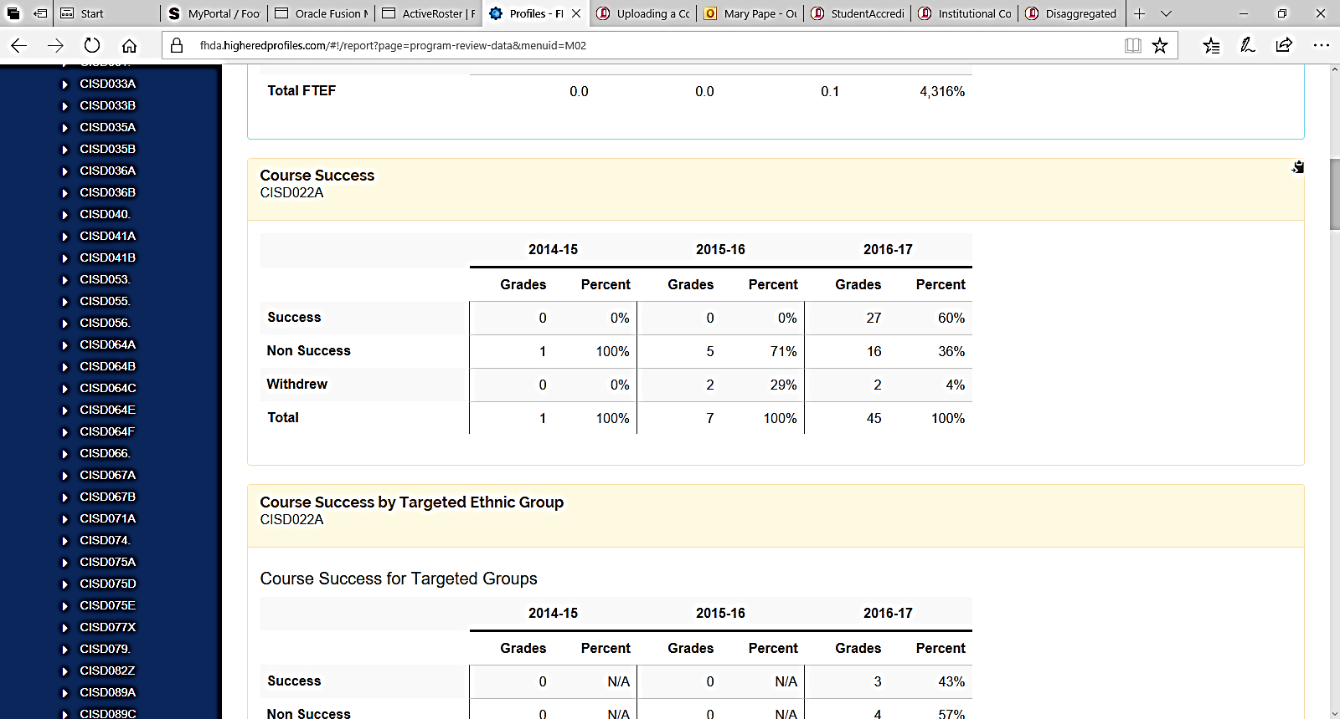

Planning for further disaggregation of assessment data for student learning outcomes at the course level has centered around the following:

* The Data Tools feature in TracDat has been analyzed. Use of this feature would necessitate clerical data entry. More importantly, because it requires faculty to make many tedious mouse clicks ("Above Expectations", "At Expectations", "Below Expectations") for each student, we suspect that it would jeopardize the reflection, enhancement, and dialogue pieces. Hence, we will not choose this method to disaggregate data.
* Canvas (our online course management system) allows for the integration of SLO statements with specific assignments. The assessment becomes part of the regular feedback process and interaction between instructor and student. The data collected is used to back the reflection, enhancement, and departmental dialogue pieces of assessment; unlike the Data Tools in TracDat, it is not likely to replace them. This set of tools will be demonstrated in the SLO Newsletter with reference to materials and workshops that will be provided through Online Education. Fall 2017 is the first quarter where Canvas is the one and only LMS being used by all faculty who teach hybrid or online classes. Considering that Canvas is very new to all, this integration will be postponed until Winter or Spring 2018.