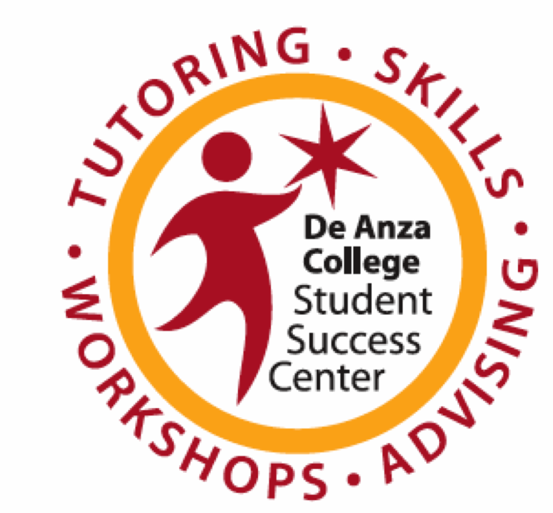
Preparing for and Taking Tests

You can improve the way you study for tests!
Tests are meant to measure what you know and what you’ve learned, but many people don’t do well on tests because they don’t use effective strategies. Test taking tips can help, but the key to doing well is good preparation. With time, you can develop routines that will help you decide what, when, and how to study, understand what strategies work for you, and know how to prepare for different formats and types of tests.

Goal of this workshop:
Improving study skills takes commitment, time and practice. One workshop won’t change your life or make you into an expert, but we hope that by thinking about what you do and talking to others, you’ll discover ways to improve. At the end of the workshop, we’ll ask you to identify just one new strategy that you will try that will help you prepare and do your best on your next test.

What are your test-taking practices? Check the sentences that best describe what you do. Discuss your results with a partner.

1. |  | I often don’t know exactly what or how to study for a test.
2. |  | I make a detailed list of what I need to study.
3. |  | I often put off studying for a difficult test until the last minute.
4. |  | I break my study list into chunks and make a plan for when I will study each section.
5. |  | Negative thoughts interfere with my concentration during the test.
6. |  | I arrive a few minutes early to the test to gather my thoughts before a test.
7. |  | I tend to doubt myself during the test and change my answers a lot.
8. |  | I know the total time for the test and keep track of time during the test to be sure I do not go too fast or too slow.
9. |  | Usually I am not satisfied with my grade, but don’t know why I got that grade.
10. |  | I analyze my errors on tests to see how I can improve for next time.
Write, then discuss with group or partner:

What is your biggest challenge with preparing for and taking tests?

What is one strategy or approach you do that helps you do well?

Taking Tests: Before, During and After

BEFORE: Prepare

When? Make a schedule for when you’ll study. Prepare over time.
- Daily review
- Weekly review
- Exam review (countdown from one week before)

What? Make a detailed list of what you need to study.
- Use study guides, lecture notes, reading notes, chapter summaries, handouts, quizzes, assignments, previous tests etc. to create a list of topics and subtopics that will be tested.
- Decide what information should be reviewed for understanding, and what needs to be memorized.
- Prioritize the list, and study the hardest and most important topics first.

How? Use a study system.
- Make study tools such as summary pages, charts, mind maps, note cards, practice tests, and “cheat sheets” that condense lots of information into concise notes.
- Use visuals and color to highlight and organize information.
- Use mneumonic (memory) tricks to help you memorize.
- Consider studying with a partner or group to compare notes and quiz each other.

DURING: Use Smart Strategies

Before you begin…

- Arrive on time, well rested and well fed but not too full.
- Use relaxation techniques and positive self-talk.
- Survey they test. How many sections? How many points each?
- Plan your time. How many minutes should you spend on each section?
- Read the directions.
- Ask questions.

Multiple Choice

- If you know the material well, answer the question in your head before looking at the answers, then choose the closest choice.
- If you sort of know it, read all the options and eliminate any you know are not right, then choose the best of the rest.
- If you have no idea, use “educated guessing.”
  - Eliminate 100% modifiers such as all, always, never
  - Choose one or the other of “look-alikes”
  - Choose “all of the above” or “none of the above.”
  - Choose mid-range numbers
  - Choose “C” (this is a last resort.)

True/False
    - Answers containing 100% modifiers or absolute word are often false.
    - If any part of the answer is false, the answer is false.

Fill in the blank
- Determine what kind of word it should be (name, date, place, term)
- Look at the grammar of the sentence. Do you need a noun, verb, phrase?
- Use information in the question for hints.

Essay tests

- Read question carefully to identify instruction words and topic.
- Make quick outline of information to cover
- Restate question and give concise answer in first sentence
- For longer answers, use a new paragraph for each topic.
- Leave time to proofread.

AFTER: Reflect and Improve

Review correct and incorrect answers.

For correct answers, how well did you know it? Did you guess?

For incorrect answers, why did you miss it?
- Didn’t study that information
- Studied it but forgot
- Misunderstood question
- Ran out of time

Where was the information for the questions you missed? In your notes? Textbook? Homework?
Spend time to understand the material you missed.

Talk to the instructor during office hours, or ask another student. Instructors are impressed with students speak to them about how they are doing!

Ask:
- How did you feel during the test? Were you anxious, distracted, or focusing well?
- How did you prepare for the test?
- How many hours did you spend preparing?
- How did you decide what to study?
- What study tools did you use?

What will you do the same next time? What will you do differently?
Pretest Planner

Course: Instructor:

Date, time, and place of test:

Type of test (quiz, midterm, final): Points Value/Percent of grade:

1. List everything you know about the content format of test from a study guide, what the instructor has said in class, the syllabus, website, etc. What types of questions? How long? Will questions be from textbook, lecture, homework?

2. What do you need to find out before the test (ask instructor via email or in class)?

3. What materials do you need to bring to the test (e.g., textbook, paper, autoscore, calculator, notes):

4. What chapters/topics to be covered on the test?

5. Set up a detailed test preparation schedule: list the topics/subtopics you need to review, strategies you will use (flashcards, practice problems, review questions, rewrite notes, make graphic organizers, make summary sheets, etc.) Estimate how long each task will take, and decide when you will do it.

Topic | Source(s) | How will I learn it? | How long will it take? | When will I do it?

6. What support will you use to prepare (ie rearrange work schedule, travel to study location, arrange study group meetings, instructor office hours, use tutoring)?

7. What other steps will you take to make sure you prepare well for this test (ie rearrange work schedule, transportation, study location, etc.)?

