
Time Management Strategies For Success

Do know where your time goes? You may be working very hard, but don’t ever feel the satisfaction of getting everything done. You may feel overwhelmed, or a bit out of control. You might be way too busy, or you may have too much free time. Regardless, managing your time not only helps you do better in school, it reduces stress and lets you enjoy life.

Goal of this workshop:
Improving study skills takes commitment, time and practice. One workshop won’t change your life or make you into an expert, but we hope that by thinking about what you do and talking to others, you’ll discover ways to improve. At the end of the workshop, we’ll ask you to identify just one new strategy that you will try that will help you prepare and do your best on your next test.

What are your time management? Check the sentences that best describe what you do. Discuss your results with a partner.

1. |  | I use a planner to write down all my assignments and deadlines for the quarter.
2. |  | I leave extra time so I can arrive on time or early to classes, practices and work.
3. |  | I study where I can avoid distractions such as phone, web, games, social media.
4. |  | I study when I am most awake.
5. |  | I break down big tasks or assignments into smaller manageable pieces.
6. |  | I motivate myself without the pressure of last-minute cramming.
7. |  | I keep track of how long it takes to read or do homework for a class so I can estimate accurately.
8. |  | I make detailed written To Do lists and cross things off as I do them.
9. |  | I use travel time and wait time between activities to get things done.
10. |  | I get at least 7-9 hours of sleep each night.
Write, then discuss with group or partner:

Describe your two biggest challenges you have with managing your time.

Describe two strategies or approaches you use that help you stay on track and be productive.

Planning Your Time—Write it Down!

Fill in your calendar for the quarter (monthly)
(This is the big picture, don't include too much detail.)
- Gather all the sources of information--Anything that has dates, deadlines. Use course syllabi, school calendars, calendars for work, sports/exercise, recreation, social, family, religious events, etc.
- Write down all school deadines: add/drop dates, holidays, etc.
- Write down all the dates for your classes: Homework, tests, papers, projects, readings, mid-term and final exams, etc.
- Write down all the dates for your other activities.Look for potential conflicts (i.e. scheduled to work late the night before big test) and change or plan how to manage.

Fill in your “Master” weekly schedule
(For activities that happen at the same time each week)
- Account for all waking hours.
- Add classes, regular work hours, regular sports/exercise, recurring social activities.
- Add transportation, meals, household obligations, sleep, recreation/relaxation. Be realistic.
- Look for good blocks of time for study. Decide when and where you will study most productively. Try to use time just before and after class to review. Schedule breaks.
- Look for “hidden time,” small blocks of time when you can complete easier/smaller tasks (i.e. reviewing flashcards or reading on the bus or during wait time.) Keep “pocket tasks” handy for these times.

Fill in your calendar for each week
(Include more detail here.)
- Transfer items from monthly calendar.
- Add detail, break down big tasks.
- Add study time—work backwards from deadlines, schedule when you’ll complete homework, prepare for tests, research, pre-write, draft and revise papers, etc. Plan to do your hardest tasks when you are most alert.
- Write in exercise/sports, social/family/religious events etc.
- Look ahead to predict potentially stressful or busy times, plan a reward or relaxing activity for after that.

Make a To Do list each day
(Include lots of detail here)
- Categorize your tasks—by class, type
- Prioritize—circle or highlight most important and urgent (i.e. big consequences if you don’t do them.)
- Predict how long you think each task should take—learn to be realistic, but if something is taking too long, figure out why (too many distractions?) and solve the problem.
- Cross off items after you complete them (this feels so good ☺.)
- Transfer things you didn’t get done to the next day’s To Do list.
- Look at your To Do list each day, or several times, to keep yourself on track.

Refer to your calendars and To Do list often.
Figure out what helps you be productive and stay on track, and take action!
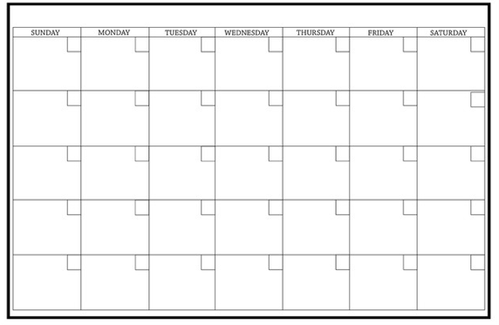
Monthly…
Weekly…

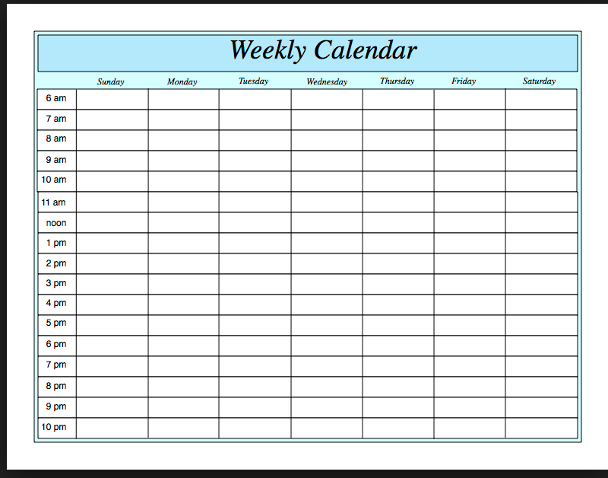
Daily!
