Justice, Nature and the Geography of Identities

**Spring Class ICS 19**

**Wed. 6:30-10:20 Cassie Blume**

Learn about the history of Silicon Valley through the lens of social justice. Explore the development of our region as it pertains to the communities living in and impacted by local politics, natural environment, cultural shifts and the tech-driven economy.  Students will learn about efforts to promote equity thorough first-hand experience, field trips and opportunities to explore careers in social change.

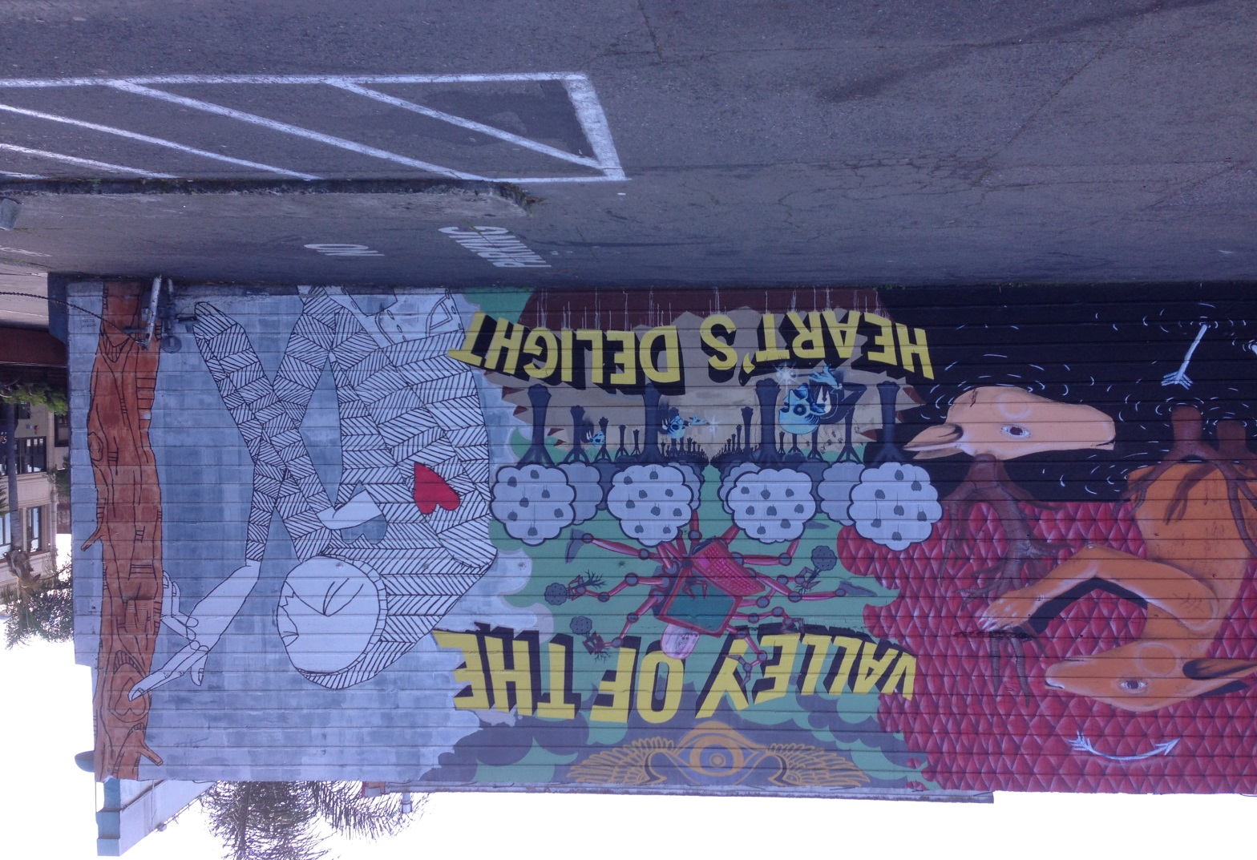

Cassie Blume serves as Coordinator for the LGBTQ Youth Space, a drop-in center and counseling program for lesbian, gay, bisexual, transgender, queer and questioning youth and young adults.

**For more information about the class, contact** [**blumecassie@deanza.edu**](mailto:blumecassie@deanza.edu)

Counts for the Certificate in Leadership and Social Change

For more information about the certificate go to: <http://deanza.edu/communityengagement/LeadershipandSocialChange.html>

Or contact Cynthia Kaufman [kaufmancynthia@deanza.edu](mailto:kaufmancynthia@deanza.edu)