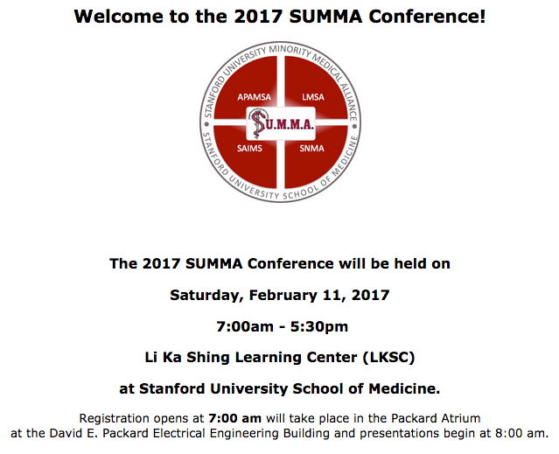

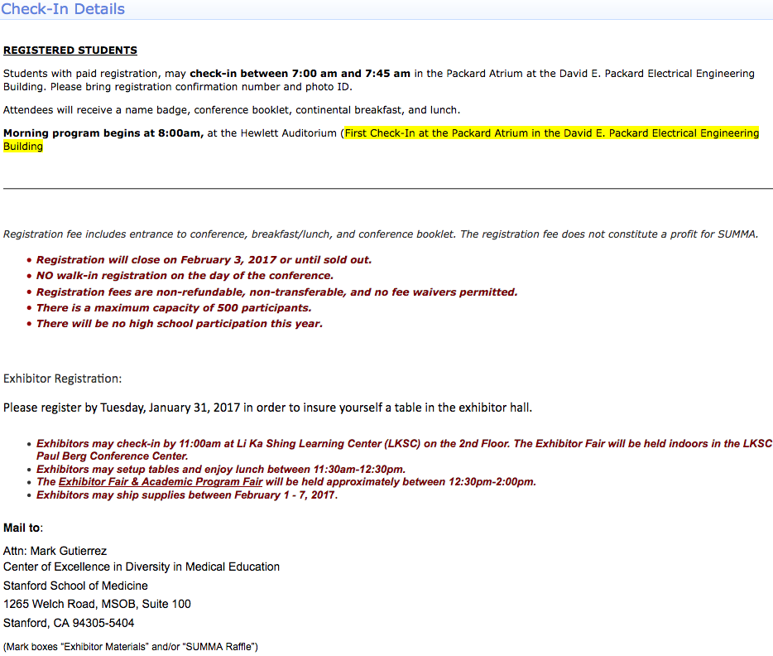

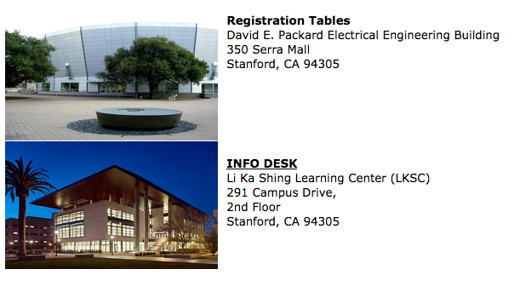**PARKING**

Participants may park in the parking structures located at the corner of Campus drive and Roth Way (Structure 1). Or between Oak Road and Stockfarm Road (Structure 5).

Parking is free in 'A', 'C', 'E' or visitor spaces on Saturday unless otherwise posted.

**Public Transportation-** Reaching Stanford via public transportation is somewhat difficult on the weekends due to limited service and availability.  
[CalTrain](http://www.caltrain.com/) (Palo Alto Station/University Ave) - Weekend Schedule (limited)  
[Stanford Marguerite Shuttle](http://transportation.stanford.edu/marguerite/) (Campus Only Shuttle) - Weekend Schedule (limited)  
[Stanford Yellow Taxi Cab](http://stanfordtaxicab.com) - (650) 321-3535  [Yellow Cab Palo Alto](http://www.yellowcabairportride.com/taxi-palo-alto.html) - (650) 384-5555

|  |  |
| --- | --- |
|  | |
|  |

|  |  |  |
| --- | --- | --- |
| Dear Melecia Navarro:    Thank you for registering for 2017 SUMMA Conference. We look forward to your attendance. Please find the details of your registration below.    Registration Code: 64813-13993533-6384  Date Completed:    2017-01-12 08:53:58  Please bring registration confirmation and photo ID day of conference. | | |
|  | | |
| Attendee Type | | |
| **Advisor - Registering student(s) only** | |  |
|  | | |
| Registrant Details | | |
| **Title** | | Ms. |
| **First name** | | Melecia |
| **Last name** | | Navarro |
| [vlmoreno@stanford.edu](mailto:vlmoreno@stanford.edu) | | [navarromelecia@fhda.edu](mailto:navarromelecia@fhda.edu) |
| **Organization/School Name** | | De Anza College-EOPS |
| **Address** | | 21250 Stevens Creek Blvd |
| **City** | | Cupertino |
| **State/Province** | | CA |
| **Zip Code** | | 94564 |
| **Phone Number** | | 408-864-8829 |
|  | | |
| Transaction Detail | | |
| |  |  |  |  |  | | --- | --- | --- | --- | --- | | **Description** | | **Quantity** | **Amount** | **Total** | | Additional Registration Ticket | | 25 | $30.00 | $750.00 | | Advisor - Registering student(s) only | | 1 | $0.00 | $0.00 | | Exhibitor Registration Fee | | 1 | $450.00 | $450.00 | | Offsetting transaction - Additional Registration Ticket | | -1 | $30.00 | $(30.00) | | Offsetting transaction - Advisor - Registering student(s) only | | -1 | $0.00 | $0.00 | | Offsetting transaction - Exhibitor Registration Fee | | -1 | $450.00 | $(450.00) | | **Total:** | | | | **$720.00** | | **Date** | **Payments** | **Received** |  |  | | 17-Jan-17 | George Robles (Visa 2380) | Yes | $720.00 | $720.00 | | **Total:** | | | | **$720.00** | | Balance due: | | | $0.00 | | | |
|  | | |
| **\*No walk-in registration on the day of the conference. *Registration fees are non-refundable, non-transferable, and no fee waivers are permitted. *There is a maximum capacity of 500 participants. *There will be NO high school participation this year.** | | |
|  | | |
| Other Registrations on this Order | | |
| |  |  |  | | --- | --- | --- | | 1) | Ravi Aacharya | [raviaacharya@yahoo.com](mailto:raviaacharya@yahoo.com) | | 2) | Jessica Carrizales | [jessica_cpulido@yahoo.com](mailto:jessica_cpulido@yahoo.com) | | 3) | Christine Chon | [mochi4981@hotmail.com](mailto:mochi4981@hotmail.com) | | 4) | Alondra Garcia | [Alondragarcia_95@yahoo.com](mailto:Alondragarcia_95@yahoo.com) | | 5) | QiaoXing Li | [xingdeanza@gmail.com](mailto:xingdeanza@gmail.com) | | 6) | Laureal Lovinsky | [Laureal.lovinsky@gmail.com](mailto:Laureal.lovinsky@gmail.com) | | 7) | Stacey Ma | [stacey831102@gmail.com](mailto:stacey831102@gmail.com) | | 8) | Yesenia Mejia | [Yeseniamejia2407@gmail.com](mailto:Yeseniamejia2407@gmail.com) | | 9) | Cindy Nguyen | [cindycindy12311@gmail.com](mailto:cindycindy12311@gmail.com) | | 10) | Phat Nguyen | [nphat346@gmail.com](mailto:nphat346@gmail.com) | | 11) | Uyen Nguyen | [nguyenngocthanhuyen@gmail.com](mailto:nguyenngocthanhuyen@gmail.com) | | 12) | Anh Phan | [phanthuytuyetanh@gmail.com](mailto:phanthuytuyetanh@gmail.com) | | 13) | Guowei Mou | [mouguowei1994@gmail.com](mailto:mouguowei1994@gmail.com) | | 14) | Shuo Qiu | [qiushuoo@hotmail.com](mailto:qiushuoo@hotmail.com) | | 15) | Aimee Serrano Vasquez | [Vasquezaimee11@gmail.com](mailto:Vasquezaimee11@gmail.com) | | 16) | Olga Smelik | [geriaich@gmail.com](mailto:geriaich@gmail.com) | | 17) | Armani Thompson | [Alasalle.ssccpp@gmail.com](mailto:Alasalle.ssccpp@gmail.com) | | 18) | Linh Tran | [linhtran180195@gmail.com](mailto:linhtran180195@gmail.com) | | 19) | Thelma Villanueva | [thelma862@gmail.com](mailto:thelma862@gmail.com) | | 20) | Milat Worku | [milatworku@yahoo.com](mailto:milatworku@yahoo.com) | | 21) | Melinda Hughes | [hughesmelinda@fhda.edu](mailto:hughesmelinda@fhda.edu) | | 22) | Lily Greene | [greenelily@fhda.edu](mailto:greenelily@fhda.edu) | | 23) | Lydia Chen | [navarromelecia@fhda.edu](mailto:navarromelecia@fhda.edu) | | 24) | Stevie Walsh | [walshstevie@fhda.edu](mailto:walshstevie@fhda.edu) | |
| Thank you for your registration. | | |



|  |
| --- |
|  |
|  | |