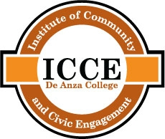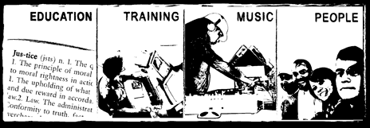

**Calling students who want to make positive changes in their community!**

De Anza College’s Institute of Community and Civic Engagement is hosting the 6th annual Youth Voices United for Change Student Leadership conference. The conference will empower, educate, and engage students to make positive changes for themselves and their communities while connecting them to existing community organizations.

* note to Counselors: 11th and 12th graders preferred. We will provide transportation from your school to and from De Anza College! *

**For more information or to RSVP for the event contact:**

Jorge Morales ♦ 408.864.5803 ♦ moralesjorge@deanza.edu or

LaQuisha Beckum ♦ [BeckumLaQuisha@DeAnza.edu](mailto:BeckumLaQuisha@DeAnza.edu)

|  |  |
| --- | --- |
|  |  |

* **Admission**
* **Breakfast & Lunch**
* **T-shirt & Raffle**
* **Transportation**

**Friday, November 18,2011**

**9:00 -2:00 p.m.**

**De Anza College ♦ Campus Center**

**Mission:** *The Institute of Community and Civic Engagement advances education for democracy with full participation for all of our communities as its core value.* [www.deanza.edu/communityengagement](http://www.deanza.edu/communityengagement)

Annual Student Leadership Conference