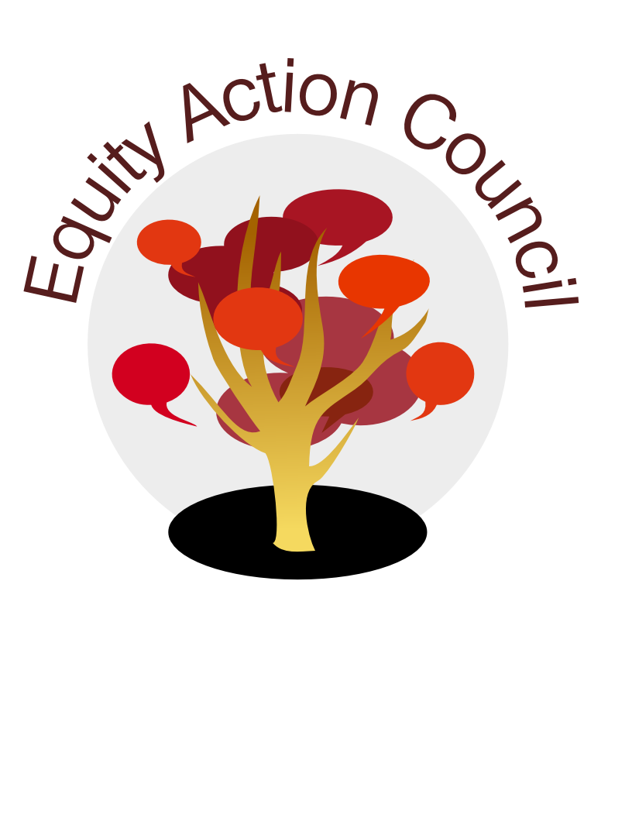
Time | Topic | Process | Facilitator(s)
1:30 pm | Introduction  Conocimiento | Welcome and New Year Check In Activity | Alicia Cortez
1:40 pm | Organization | Review Agreements and Mission of EAC | Alicia Cortez
1:50pm | Organization | Integrated Plan 2017-19 Update :(I)- Informational Item | Alicia Cortez
2:00pm | Organization | Update on EAC Structure: (I,D)- Informational Item + Discussion | Alicia Cortez
2:15pm | Discussion | Hate and White Supremacy (I and D)-Informational Item + Discussion  Propaganda across College Campuses -Upcoming Workshop Series: | Alicia Cortez
2:30pm | Discussion | Equity Practices Share (I)-Informational Item  E and E Division: Student Employee Equity Training  Intro to Equity Core Teams Workshop: | Alicia Cortez
2:45pm | Closure | Appreciations, Sharing, Announcements | All

EAC Community Agreements
Show up, and choose to be present
Pay attention to what has heart and meaning
Tell the truth without blame or judgment
Be open to outcome, not attached to outcome
From The Four-Fold Way® by Angeles Arrien, Ph.D

