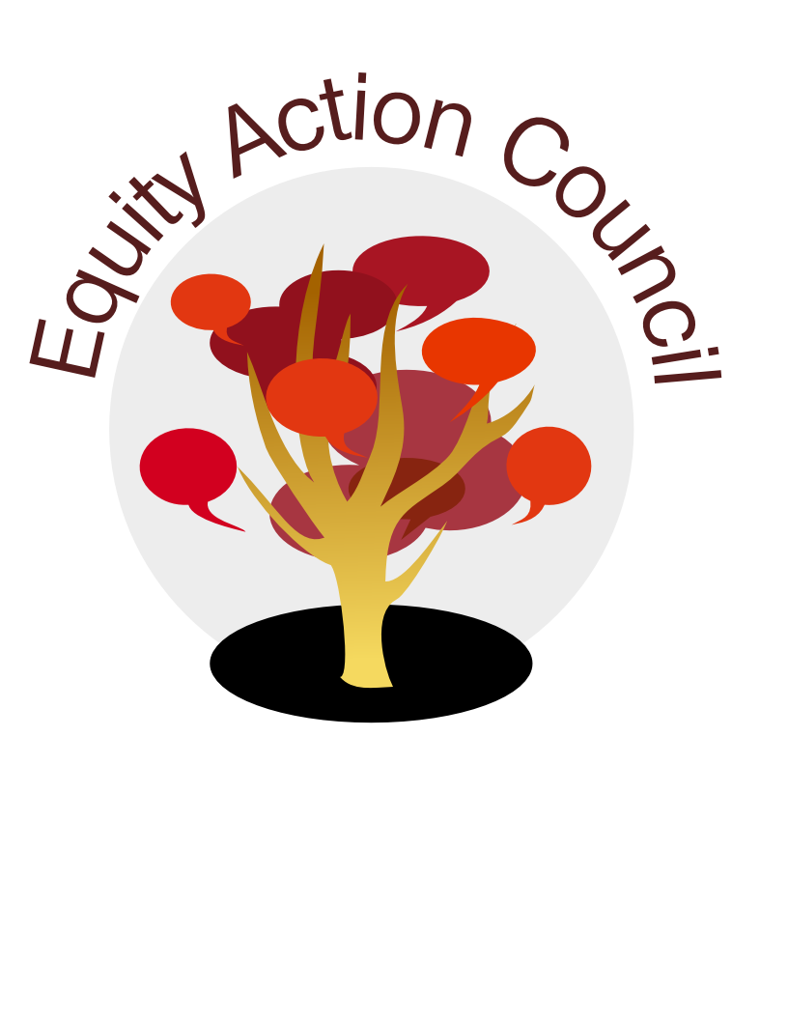
Time | Topic | Process | Facilitator(s)
2:30pm | Welcome | -Introduction | Veronica
2:45pm | Guest Speakers | Mallory Newell: Introduced by Veronica Neal | Veronica
STRETCH BREAK
3:30pm | Guest Speakers | Phil Winn: Introduced by Andrew Phelps | Andrew Phelps
4:00pm | Closing | EAC Next Steps | Veronica
EAC Community Agreements
Show up, and choose to be present
Pay attention to what has heart and meaning
Tell the truth without blame or judgment
Be open to outcome, not attached to outcome
From The Four-Fold Way® by Angeles Arrien, Ph.D.

Save the Date
Tuesday, June 20th, 2017
3-5pm

