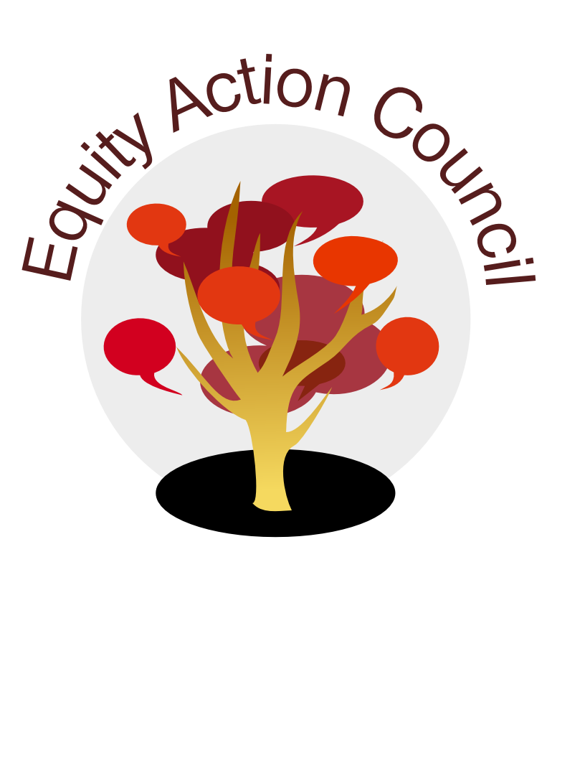
Equity Action Council Agenda: 10/14/15
Time | Topic | Process | Facilitator(s)
2:30 | Welcome/Agenda Review and  Check-in | Whip Around  Pair-share: EAC Hopes and Expectations for the Year | Veronica
3:00 | Academic Year Goals/Commitments | -Representatives from other councils/committees  -Review EAC Committee Commitments  -Brainstorm Priorities | All
3:30 | Statewide Score Card | Presentation and Dialogue | Mallory
4:00 | State Equity Student Report | Presentation and Dialogue | Rowena, Veronica, and Lisa
4:50 | Closing | Whip Around Affirmation/Check-out  *PLEASE submit your EAC Mini-grant Application BEFORE 10/30/15* | All
EAC Community Agreements
Show up, and choose to be present
Pay attention to what has heart and meaning
Tell the truth without blame or judgment
Be open to outcome, not attached to outcome
From The Four-Fold Way® by Angeles Arrien, Ph.D.

October 28th: DON’T MISS OUR NEXT EAC MEETING
Maximus Grisso, Equity Office Intern and QIT Coordinator will provide a briefing on our new Campus Pronouns Protocol
AND
Jeff Schinske, ECT Member and Biology Instructor will present his research on an impactful Equity Classroom Intervention!

EAC Reading and Discussion for the Quarter: America’s Unmet Promise: The Imperative for Equity In Higher Education

