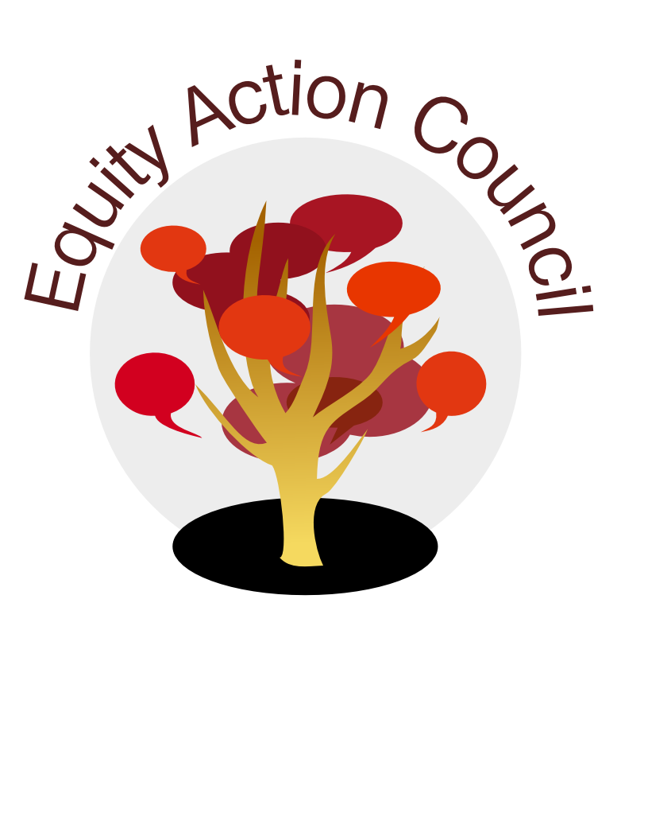
Time | Topic | Process | Facilitator(s)
2:30 | Welcome and Introduction | - Whip Around  - Sign In Sheet | Tony
2:45 | Guests | - Los Medanos College
3:00 | Organizational | - Shared Governance Handbook - confirmation of members, etc. | Veronica
3:45 | Report Back | - Book Game Presentation | Virginia, David, Sandy
4:15 | Closing | - Calendaring and Announcements  - Appreciations | Tony
4:30 | End | Thank you!
EAC Community Agreements
Show up, and choose to be present
Pay attention to what has heart and meaning
Tell the truth without blame or judgment
Be open to outcome, not attached to outcome
From The Four-Fold Way® by Angeles Arrien, Ph.D.

