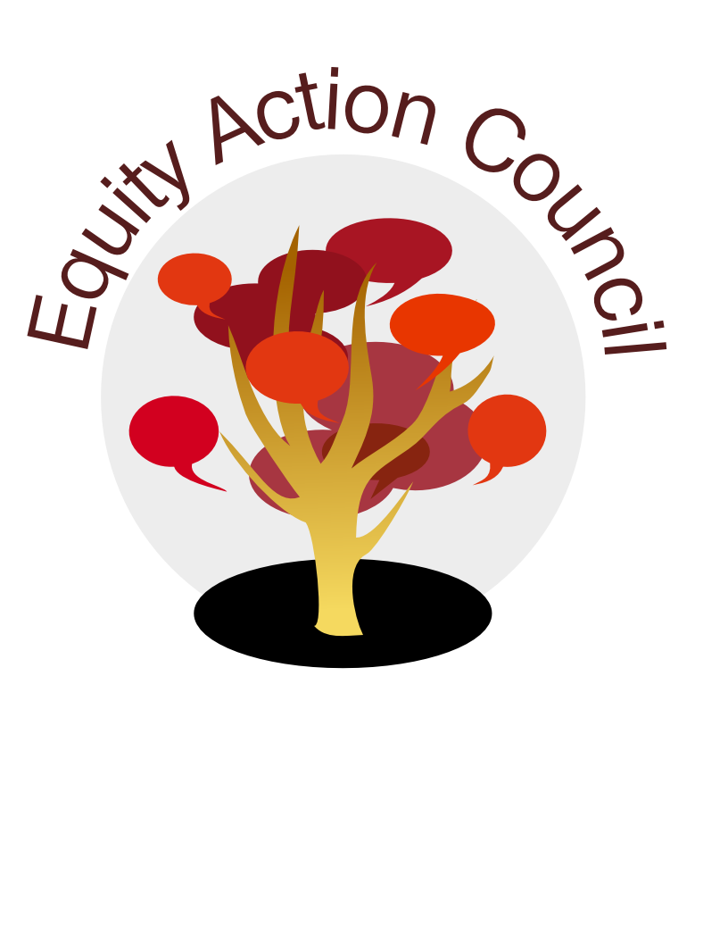
Equity Action Council Agenda: 4/13/2016
Time | Topic | Process | Facilitator(s)
2:30 | Welcome/Agenda Review and Check-in | Whip Around
 | -Icebreaker/team building | The Addressing Framework | Adriana
3:00 | Program and Committee Updates | - Representatives from other councils/committees  - Burning Issues | All
3:30 | Discussion | - Equity successes and challenges - report outs  - Identifying priorities for spring quarter | All
3:45 | Organizational Planning | - Upcoming events,  - recruitment for EAC Retreat planning committee,  - other
4:15 | Closing | Announcements  Appreciations
4:30 | End | Thank you!
EAC Community Agreements
Show up, and choose to be present
Pay attention to what has heart and meaning
Tell the truth without blame or judgment
Be open to outcome, not attached to outcome
From The Four-Fold Way® by Angeles Arrien, Ph.D.

