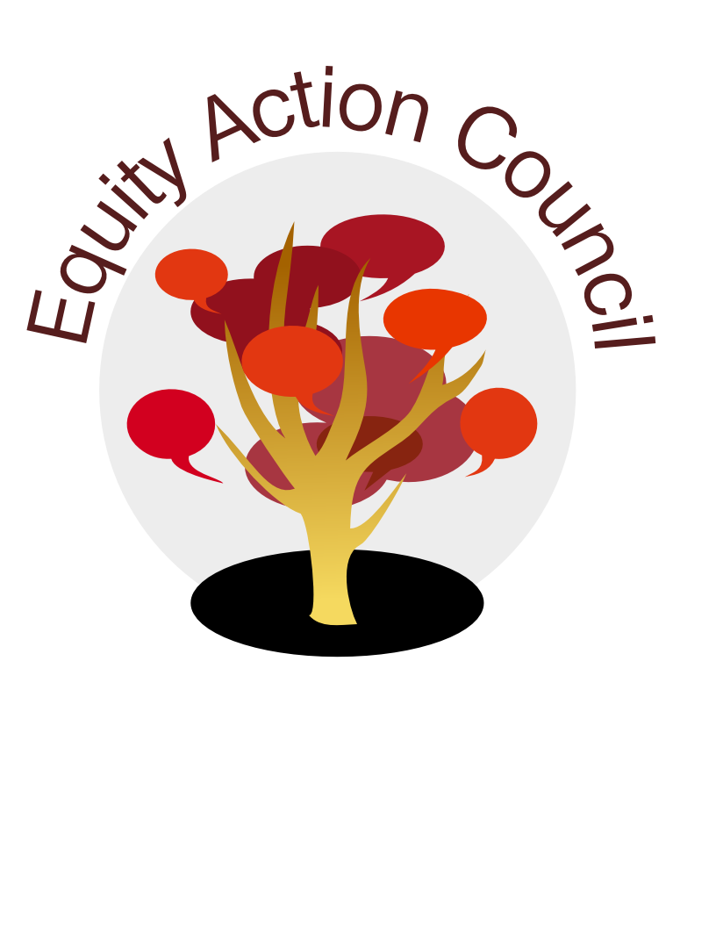
Time | Topic | Process | Facilitator(s)
2:30 pm | Introduction | Welcome and Introductions | Edmundo Norte
2:30 pm | Introduction | EAC Community Agreements | Tony Santa Ana
2:50 pm | Organization | Equity and Engagement Division –  - Organizational Structure & Programs  - Mission of EAC and Governance Group | Alicia Cortez
3:00pm | Past, Present and Vision for EAC | Roots, Branches and Seeds Activity | Alicia Cortez, Tony Santa Ana Edmundo Norte Anita Muthyala-Kandula
3:35pm | Past, Present and Vision for EAC | Gallery Walk – Look for common themes and reflections | Alicia Cortez and Tony Santa Ana
3:45pm | Discussion, Reflection and Action | - Shared Governance  - Equity Core Teams  - Meeting Times | Alicia Cortez

EAC Community Agreements
Show up, and choose to be present
Pay attention to what has heart and meaning
Tell the truth without blame or judgment
Be open to outcome, not attached to outcome
From The Four-Fold Way® by Angeles Arrien, Ph.D

