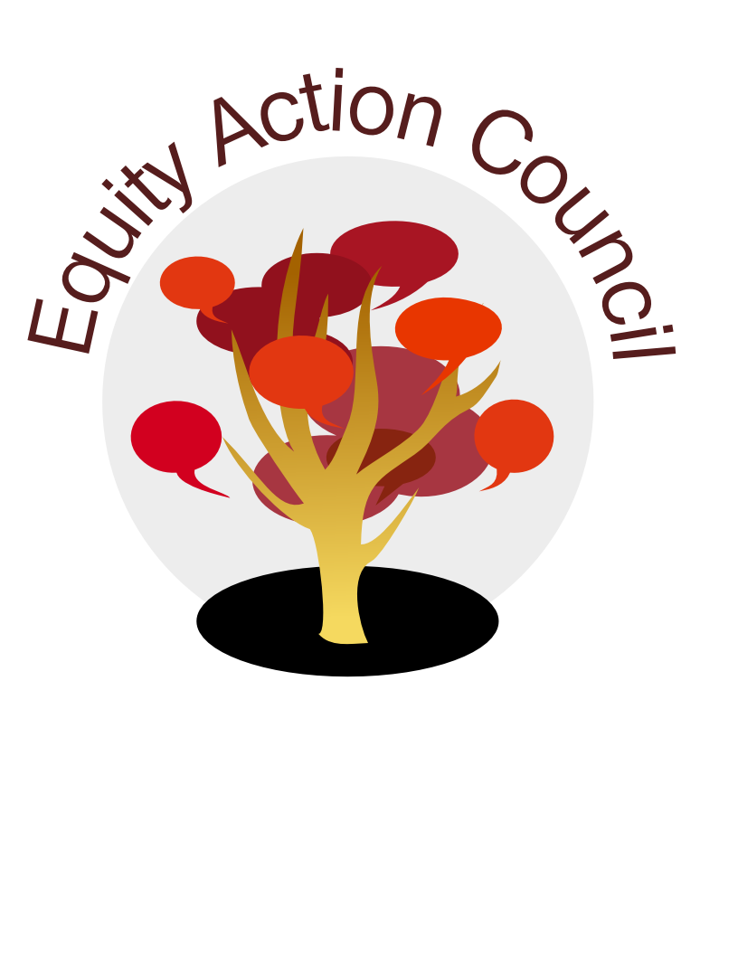
Time | Topic | Process | Facilitator(s)
2:30 pm | Introduction | Welcome and Overview | Edmundo Norte
2:40 pm | Organization | Integration Plan for SSP/BSI/Student Equity | Rob Mieso  Lorrie Ranck
3:10-3:35pm | Conocimiento | Social Justice Creation Stories | Edmundo Norte
3:35-3:45pm | Information and Invite | Committee Membership and Structure | Alicia Cortez
3:45-4:05pm | Report and Invite | Community Policing Task Force | Edmundo Norte
4:05-4:15pm | Report | Office of Equity and Jean Miller Resource Room | Tony Santa Ana  Adriana Garcia
4:15-4:30pm | Closure | Announcements, Sharing, Appreciations  UnDocuAlly  Lit Lunch  Cultural Humility Training | All  Angelica Esquivel  Tony Santa Ana  Alicia Cortez

EAC Community Agreements
Show up, and choose to be present
Pay attention to what has heart and meaning
Tell the truth without blame or judgment
Be open to outcome, not attached to outcome
From The Four-Fold Way® by Angeles Arrien, Ph.D

