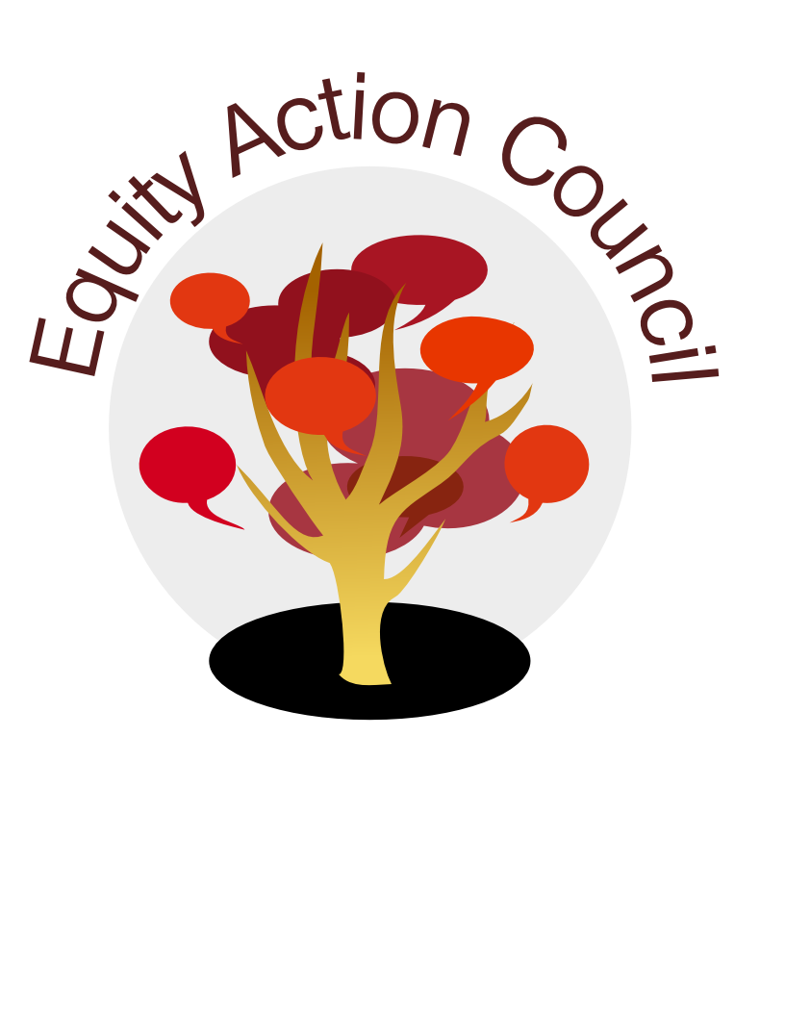
Equity Action Council Agenda: 3/9/2016
Time | Topic | Process | Facilitator(s)
2:30 | Welcome/Agenda Review and  Check-in | Whip Around  Pair-share: How are you helping to deepen our equity work within your department or Division? | Edmundo  Shannon
3:00 | Program and Committee Updates | -Representatives from other councils/committees  -Burning Issues | All
3:30 | Discussion | America’s Unmet Promise: The Imperative for Equity In Higher Education | Anita
3:45 | Queer & Now Conference | -Update and Overview  -Support and Needs | Cassie & Maximus
4:15 | Closing | Announcements  Appreciations | Edmundo
4:30 | End | Thank you!
EAC Community Agreements
Show up, and choose to be present
Pay attention to what has heart and meaning
Tell the truth without blame or judgment
Be open to outcome, not attached to outcome
From The Four-Fold Way® by Angeles Arrien, Ph.D.

